Jess Laudie

DS 3002

27 March 2022

MongoDB Lab Exercise 1

Using your mongo shell, list your databases, select the sample_weatherdata set, then show collections within that:

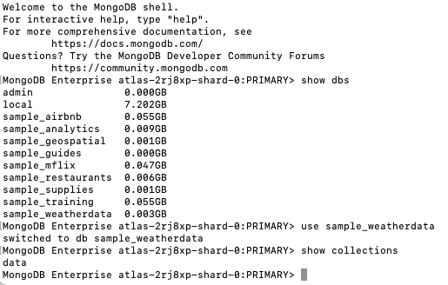

This should show you there is a data collection within that database. Find all documents in the collection, then display them using the .pretty() flag, and finally count them:

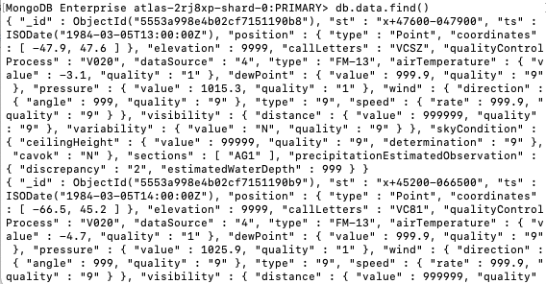

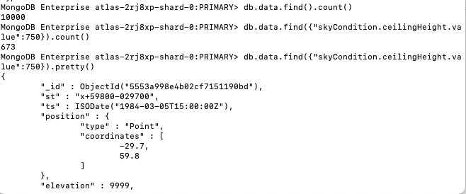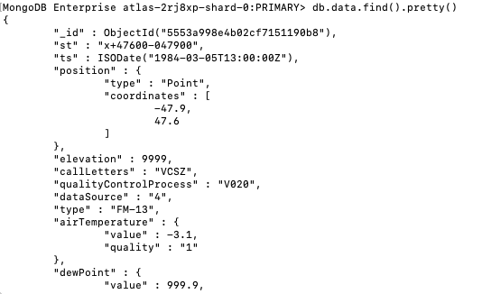

Search for all documents containing a skyCondition.ceilingHeight.value of 750 and count the results. Then display the results:

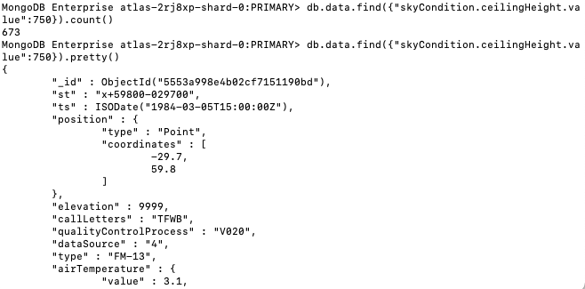

Retrieve a single document based on ObjectId:

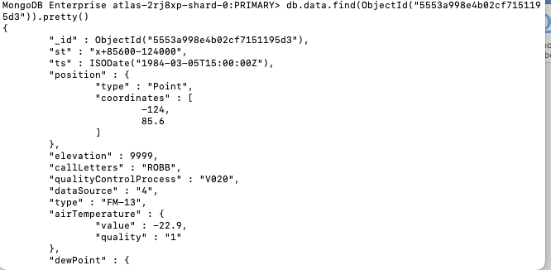

Finally, using the code below insert a new document. After insertion, can you retrieve this document?

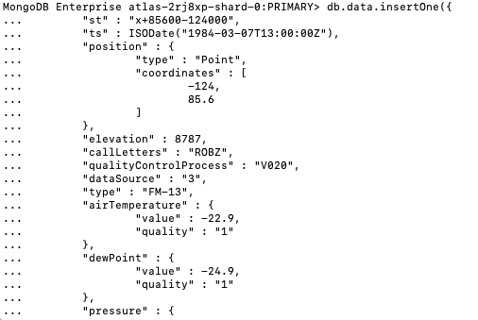

Object ID:



