Jessica Li

Assignment 2

In this project I was able to tackle multiple ways to analyze and predict gestures with a shape-matching approach and a model-based classification approach. Both had their benefits and that was what was analyzed below. I repeated both processes with the given Jon’s Gestures and my own gestures.

1. Towards my approach to shape matching I had used the DTW and tested with k-folds. I would to calculate the distance between the points in a test trial of the test fold with trials of the other folds. I would find the closest distance with the Euclidian model between the two trials and that would be the gesture predicted. The points would also be detrended before being put into the DTW.
   1. The overall accuracy is:
      1. Jon: 1.0 🡨 Perfect score.
      2. Personal: 1.0 🡨 Perfect score.
   2. the per-gesture accuracy:
      1. Jon:
         1. Accuracy score for gesture: Backhand Tennis 1.0
         2. Accuracy score for gesture: Forehand Tennis 1.0
         3. Accuracy score for gesture: Underhand Bowling 1.0
         4. Accuracy score for gesture: Baseball Throw 1.0
         5. Accuracy score for gesture: At Rest 1.0
         6. Accuracy score for gesture: Midair Clockwise O 1.0
         7. Accuracy score for gesture: Midair Counter Clockwise O 1.0
         8. Accuracy score for gesture: Midair Zorro Z 1.0
         9. Accuracy score for gesture: Midair S 1.0
         10. Accuracy score for gesture: Shake 1.0
      2. Personal:
         1. Accuracy score for gesture: Backhand Tennis 1.0
         2. Accuracy score for gesture: Forehand Tennis 1.0
         3. Accuracy score for gesture: Underhand Bowling 1.0
         4. Accuracy score for gesture: Baseball Throw 1.0
         5. Accuracy score for gesture: At Rest 1.0
         6. Accuracy score for gesture: Midair Clockwise O 1.0
         7. Accuracy score for gesture: Midair Counter Clockwise O 1.0
         8. Accuracy score for gesture: Midair Zorro Z 1.0
         9. Accuracy score for gesture: Midair S 1.0
      3. Accuracy score for gesture: Shake 1.0
   3. the confusion matrix:
      1. Jon:

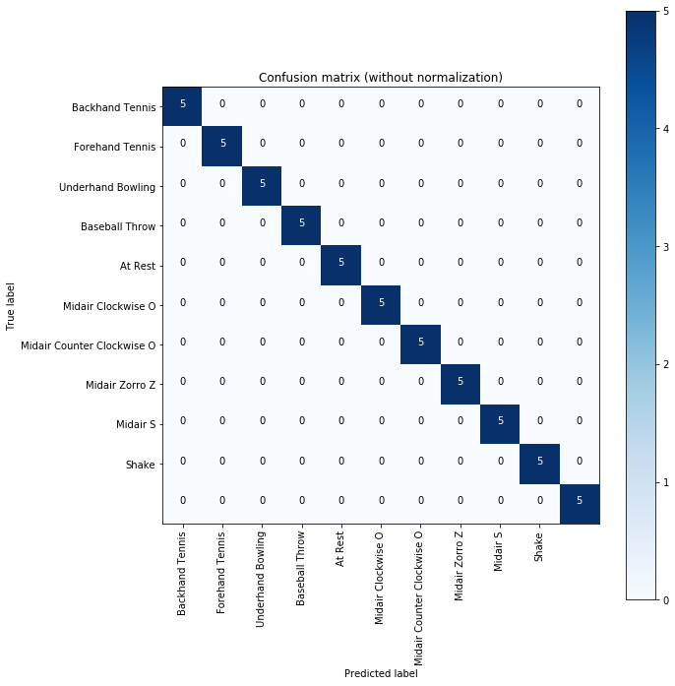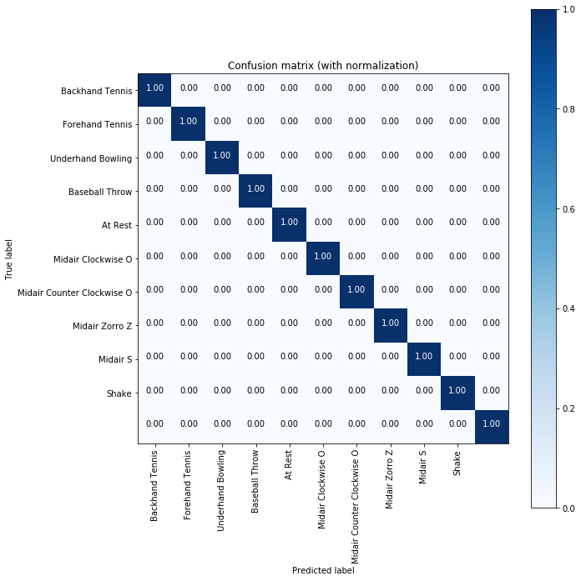

* + 1. Personal:



1. For my model-based classification I used the SVM, mostly given by the generous Jeffrey Bingham, and with that SVM I trained all of the trials again with the k-folds. For each test fold I had four other training folds that were compared based on the accelerator’s maximum magnitude. When I was comparing the different gestures with the 1D line charts I noticed that the accelerator’s magnitude had the most differentiation. After, I had trained the data I then tested it and with that I had gotten the following accuracies:
   1. the overall accuracy:
      1. Jon: 0.4
      2. Personal: 0.418181818…
   2. the per-gesture accuracy:
      1. Jon:
         1. Accuracy score for gesture: Backhand Tennis 0.6
         2. Accuracy score for gesture: Forehand Tennis 0.4
         3. Accuracy score for gesture: Underhand Bowling 0.4
         4. Accuracy score for gesture: Baseball Throw 0.6
         5. Accuracy score for gesture: At Rest 1.0
         6. Accuracy score for gesture: Midair Clockwise O 0.4
         7. Accuracy score for gesture: Midair Counter Clockwise O 0.0
         8. Accuracy score for gesture: Midair Zorro Z 0.0
         9. Accuracy score for gesture: Midair S 0.2
         10. Accuracy score for gesture: Shake 0.4
      2. Personal:
         1. Accuracy score for gesture: Backhand Tennis 0.2
         2. Accuracy score for gesture: Forehand Tennis 0.6
         3. Accuracy score for gesture: Underhand Bowling 0.2
         4. Accuracy score for gesture: Baseball Throw 0.2
         5. Accuracy score for gesture: At Rest 1.0
         6. Accuracy score for gesture: Midair Clockwise O 0.4
         7. Accuracy score for gesture: Midair Counter Clockwise O 0.6
         8. Accuracy score for gesture: Midair Zorro Z 0.2
         9. Accuracy score for gesture: Midair S 0.0
         10. Accuracy score for gesture: Shake 0.4
   3. Confusion Matrix:
      1. Jon:

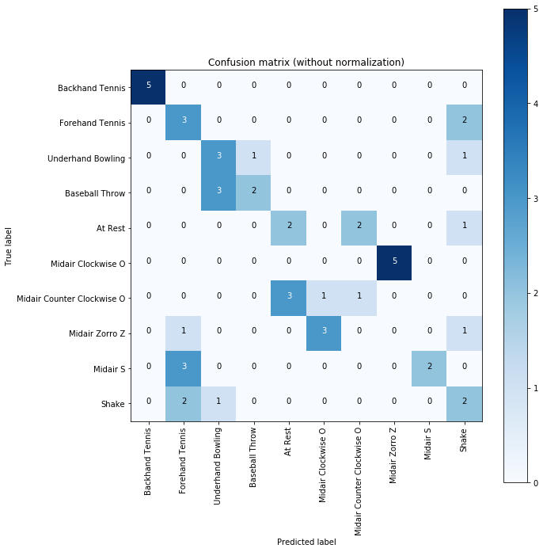 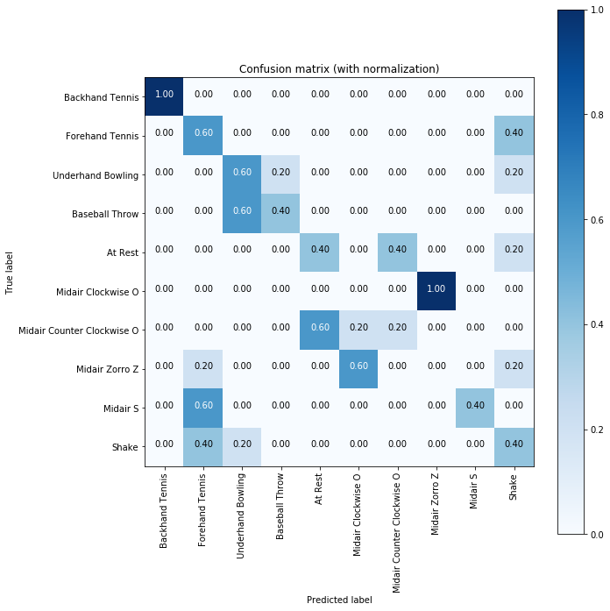

* + 1. Personal

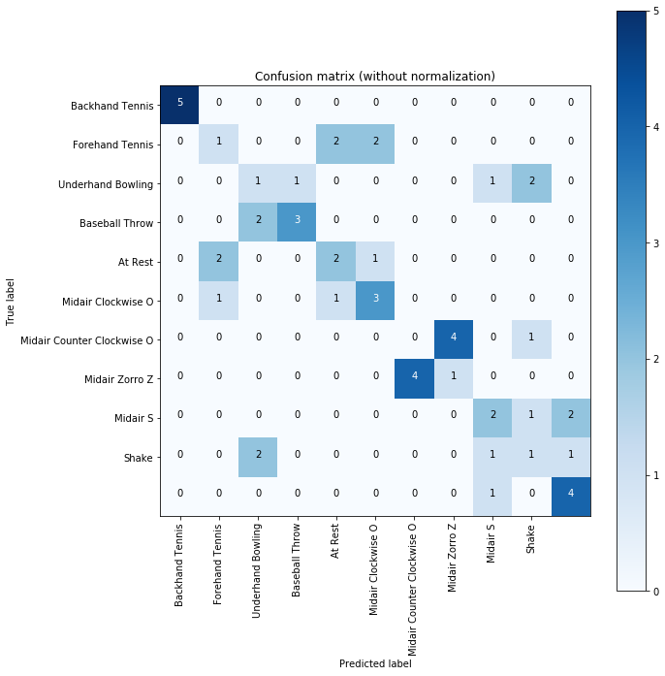 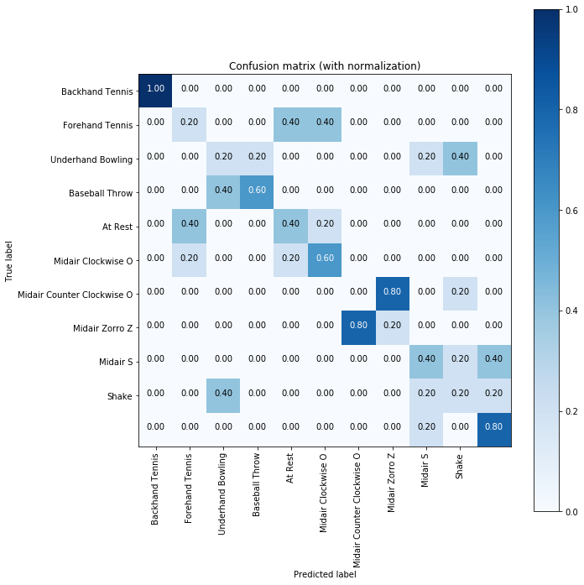

1. The key challenges in the assignment were understanding the different concepts at work: the k-folds, the SVM and using a shape matching function/package. It was also quite confusing what was initially being asked of us and sifting through the given code. The code given, though, was very useful and was quite imperative to my completion of the assignment.
2. There were various concepts that I had learned, which were also stated above, and I had also learned a new way of computing of having more ambiguous and free way in doing a project. There was less structure in how to do a certain problem and it taught me how to approach things differently and without a set plan. I had to really research how to do a problem and the packages that I wanted to use.