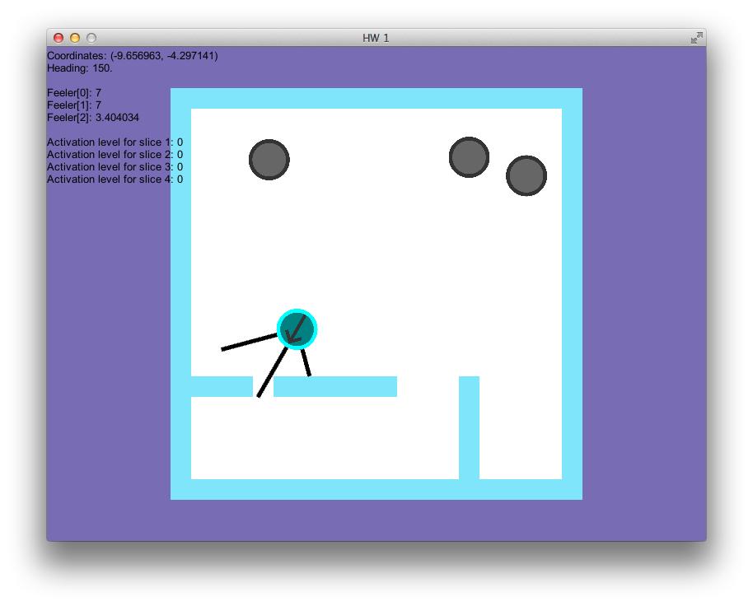

i. Position 1: Feelers are interacting with a wall.

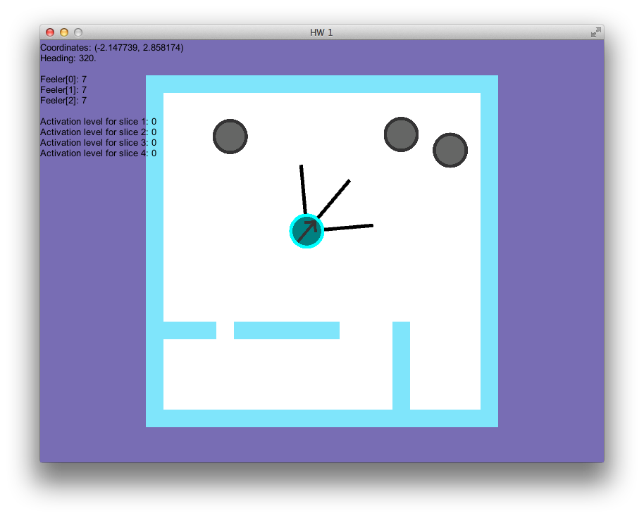

i. Position 2: Player is near the center of the map.

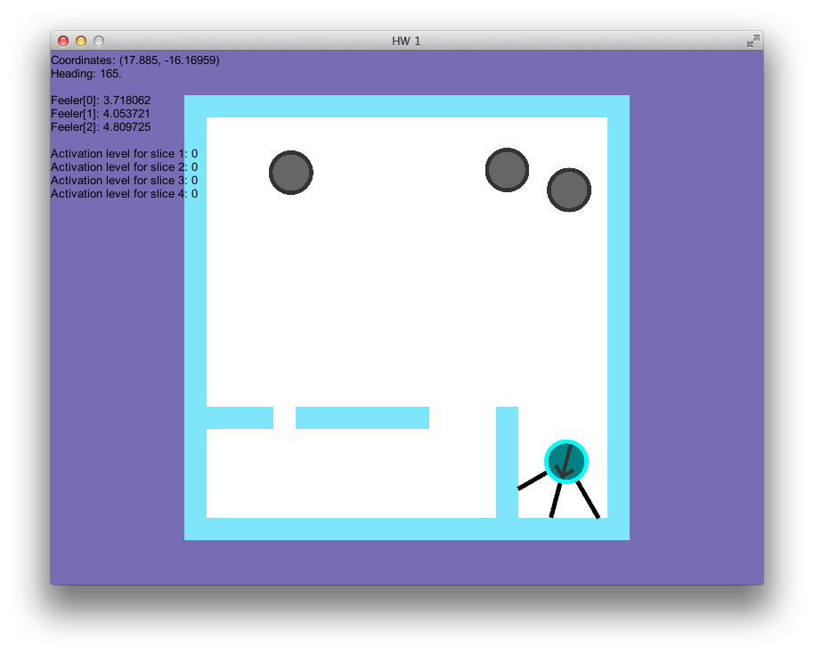

i. Position 3: Player is investigating a corner.

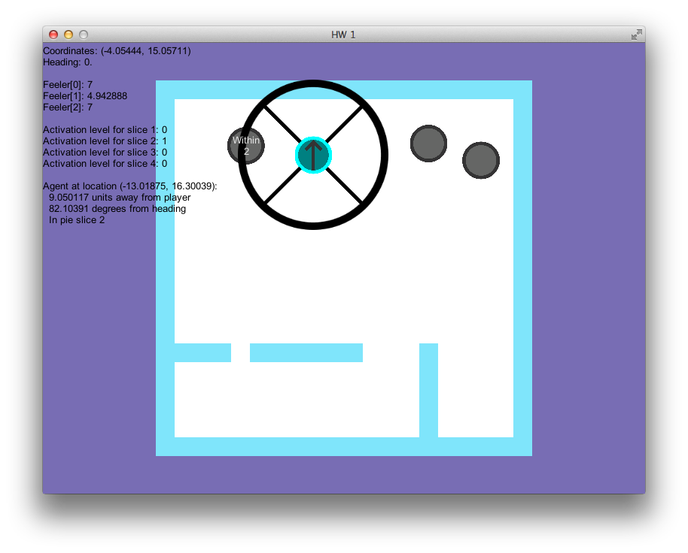

ii. Facing north with adjacent angle sensors and pie slices activated.

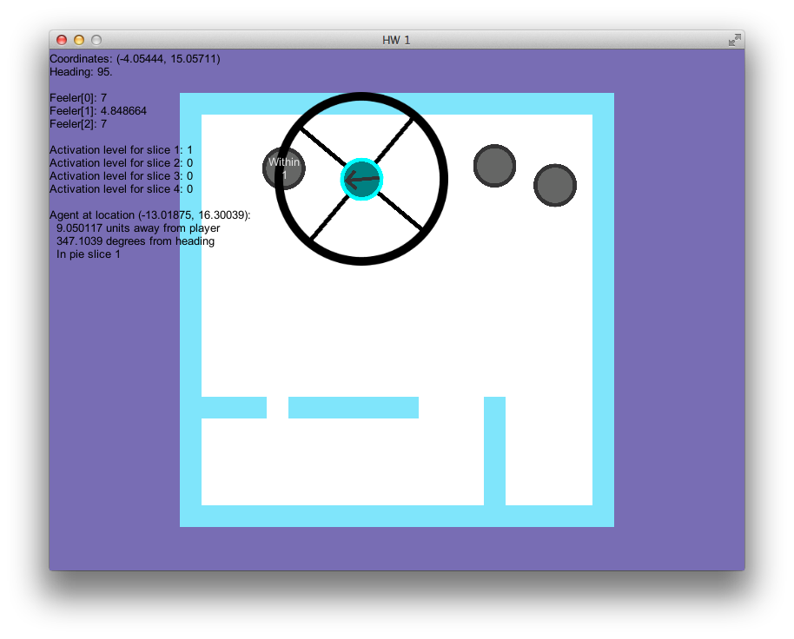

ii. Facing west with adjacent angle sensors and pie slices activated.

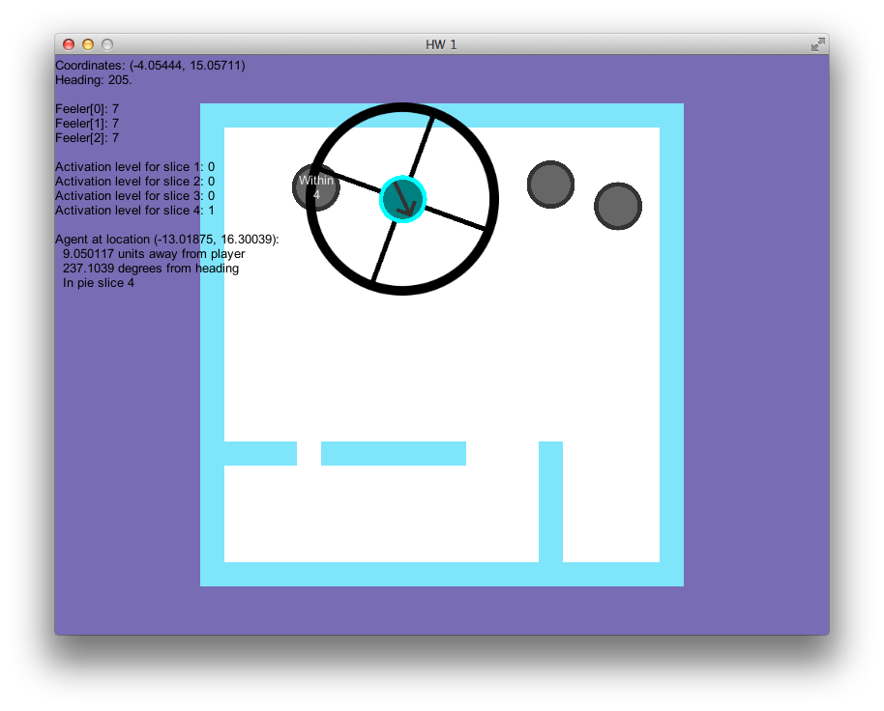

ii. Facing south with adjacent angle sensors and pie slices activated.

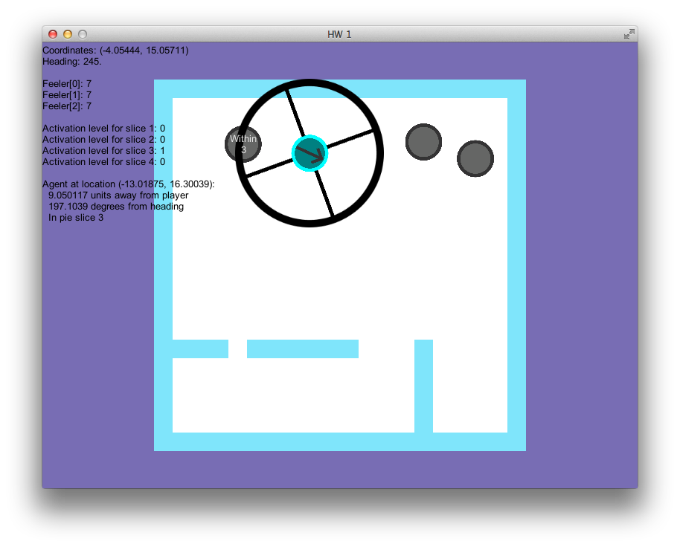

ii. Facing east with adjacent angle sensors and pie slices activated.

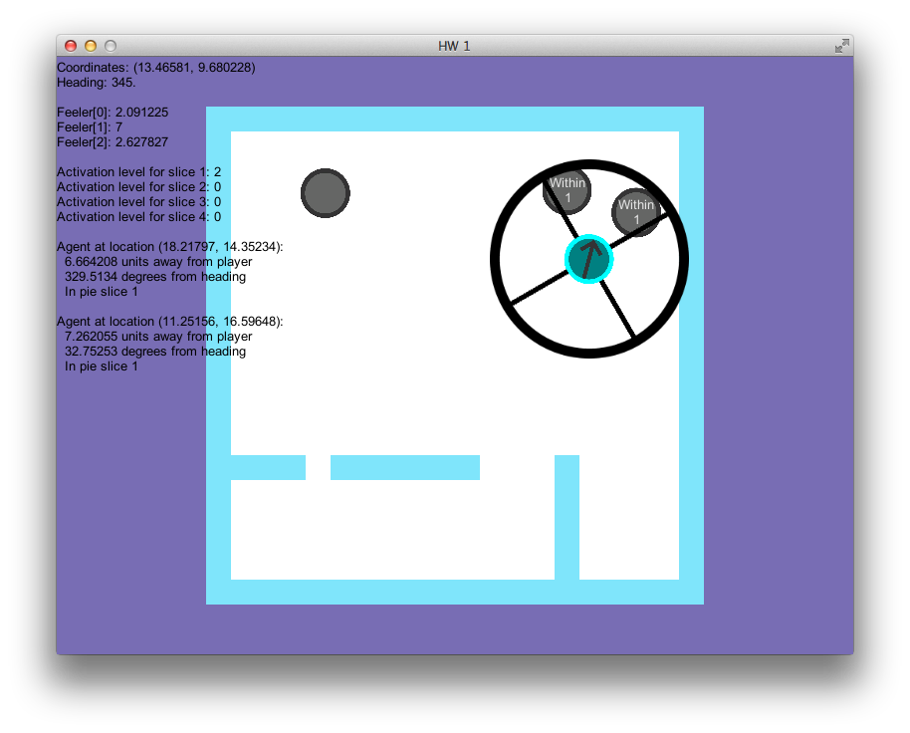

ii. Multiple agents within one pie slice sensor.

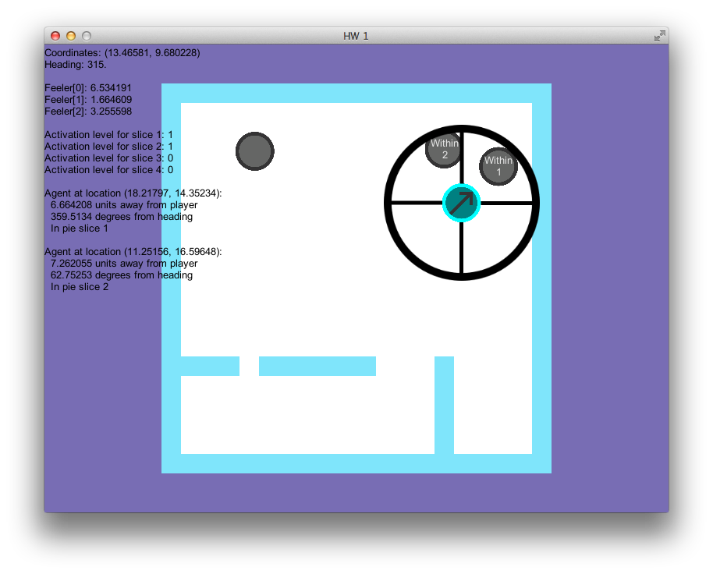

ii. Multiple agents within the sensors, but different pie slices.

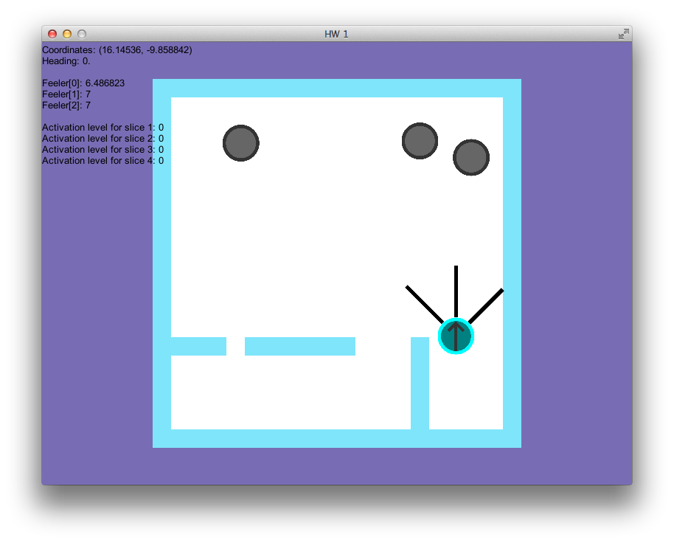

iii. Wall sensors facing north with right feeler encountering a wall.

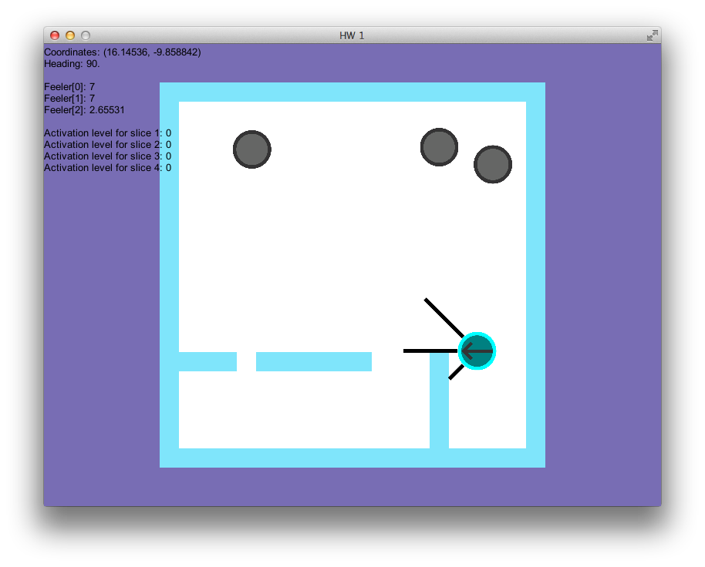

iii. Wall sensors facing west with left feeler encountering a wall.

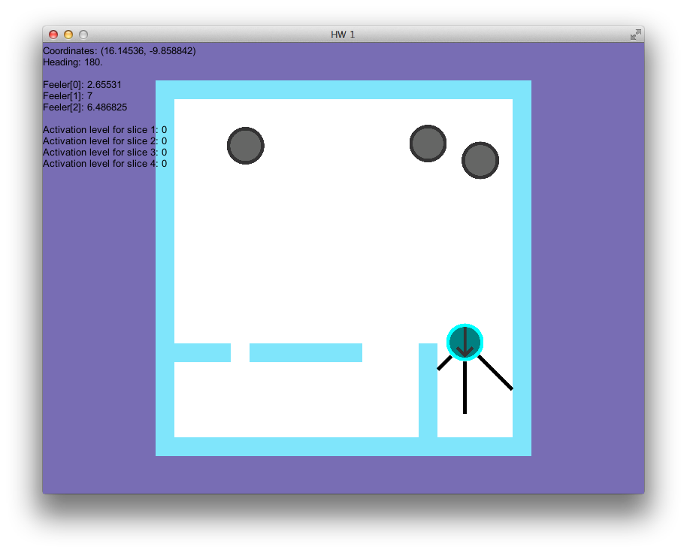

iii. Wall sensors facing south with left and right feelers encountering walls.

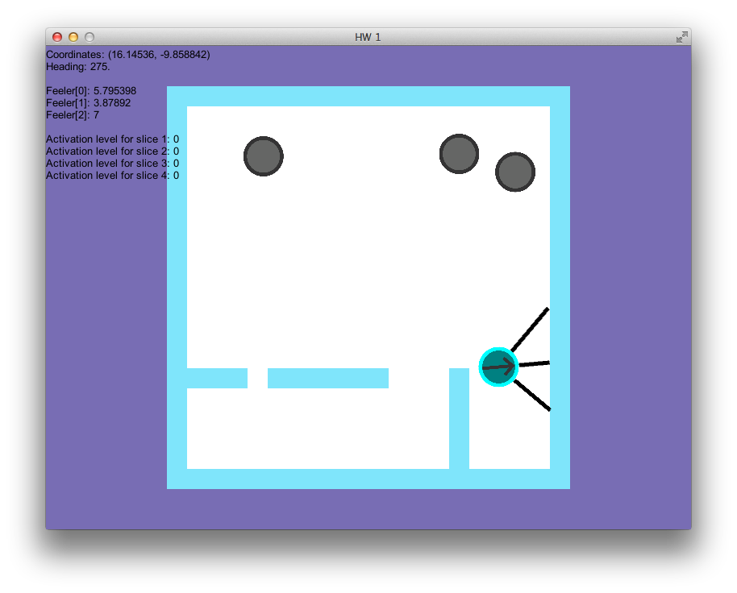

iii. Wall sensors facing east with middle and right feelers encountering the wall.