Jessica Monnier

CSD-310 Assignment 5.2

30 January 2025

MySQL Functions

For me, it’s hard to divorce learning about the functions without the context for using them, so I used the built-in world database that came with the MySQL installation to play around until I figured out a couple of functions. This means that my examples double as an explanation of when the function might be used. For the first, I’ll show a couple of the bumps along my journey to figure out how to use it. The screenshots of just the three functions start on page 3.

In this first screenshot I was bumbling around even figuring out how to access the data in the databases:

I had to google-fu my way to victory.

Next, I selected everything in the city table, which turned out to be *a lot* of data:

So I figured out how to limit it:

Next, I tried actually applying a function, with mixed results at first:

And then I finally got it right!

select format(population, 0) as 'Population of New York City' from city where id = 3793;

For this next one, I combined the format function I used in the previous one with MAX() to get some info about the country with the highest population in the country table:

select Code,Name,format(Population,0) as Population from country where population = (select max(population) from country);

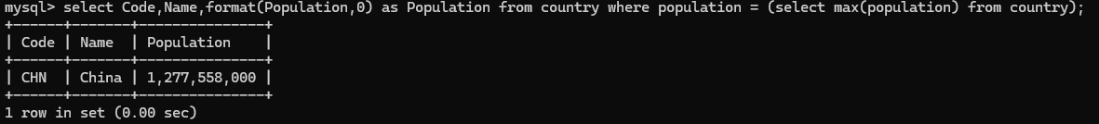

And finally I got the average population of cities in the city table with USA as their country code:

select format(avg(population),2) as 'Average Population of US Cities' from city where countrycode = 'usa';

