Jess Monnier

CSD325 Assignment 7.2

16 February 2025

Unit Tests in Python

Initial test cases in city_functions.py:

First run of test_cities.py to check test_city_country method:

Result of running test_cities.py after adding mandatory population parameter:

Result of running test_cities.py after making population parameter optional:

After adding mandatory language parameter:

After making language parameter optional:

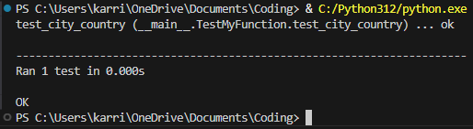

Final set of calls in city_functions.py; I un-commented the initial three tests and added three more:

