Jess Monnier
CSD-380 Assignment 5.2
14 September 2025
Value Stream Mapping: Sunday Night Routine
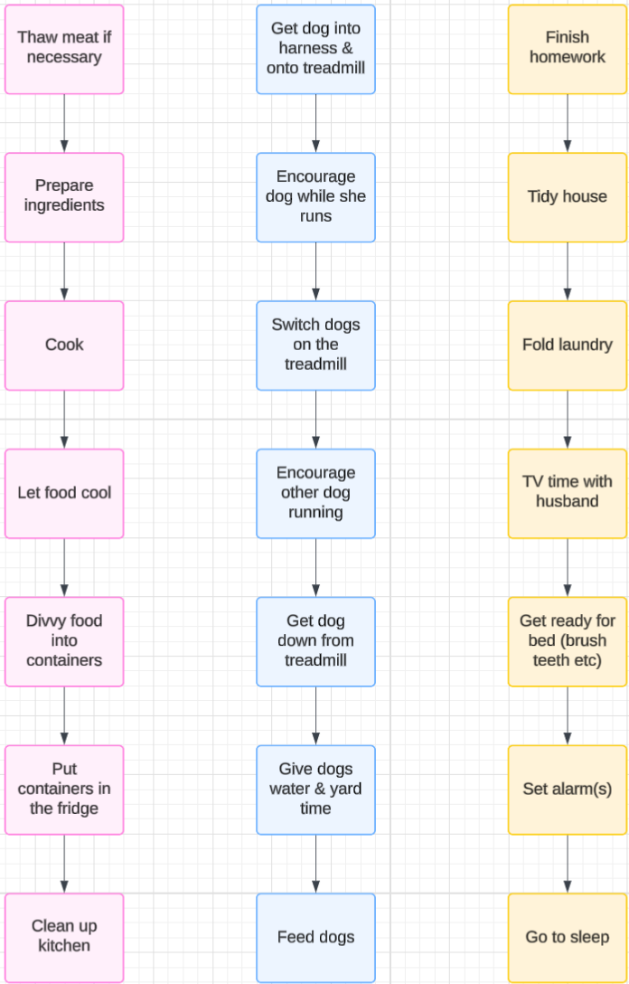
Meal Prep Take Care of Dogs General Domestic Stuff
Category | Average Flow Time
Meal Prep | 150 mins
Take Care of Dogs | 60 mins
General Domestic Stuff | 210 mins

That comes out to a total of 420 minutes or 7 hours, which really makes this seem like an all day routine, but it’s not at all. These don’t happen back to back; I already overlap them quite a bit, but I’m sure I could make it even more efficient.
Some of the bigger time sinks:
- Finishing homework. This could be from no time at all if I’ve been proactive to 4+ hours at the extreme end (if I’ve been procrastinating).
- TV time with my husband: We like to watch for at least an hour. I don’t fully consider this a time sink because it’s bonding time and makes us happy.
- Meal prep in general takes a long time, but how long depends on what I make. Spaghetti is pretty easy and leaves me a lot of down time for doing other things, but if I’m making something that requires chopping ingredients and/or monitoring multiple things cooking at once that require stirring and adding to, it can take a lot longer.
Some things I already do to cut down on time:
- The dogs run on their treadmill while I meal prep, typically. It only takes maybe a minute to get them on/off the treadmill, so that’s easy to fit between other things, and I can see them and encourage them from the kitchen.
- When there are clothes to fold, my husband and I try to do that during the beginning of our TV time.
- Some of the house tidying tends to happen during downtime when I’m working on meal prep, and homework tends to happen while meat thaws, etc.
Some things I could definitely work on to improve my routine:
- I usually let the food cool in the cook pots, but there’s really no reason I couldn’t put it in containers and let it cool there before putting it in the fridge. Then I could maximize food cooling time to clean up the cooking implements/kitchen and tidying the house.
- In general I could do better about not procrastinating my homework during the week… (I say, doing all but the initial discussion posts on this Sunday…)
- I could do a better job of planning meat thawing on weeks when I’m cooking with a meat that has been frozen. I could put it in the fridge Friday afternoon after work to ensure it has time to safely thaw, for example.
Some things that cannot change:
- The dogs need exercise, and the exercise needs to happen before they eat to keep them safe and healthy, so that routine is pretty set but does leave a lot of room to work on things while they are running.
- Homework does need to be done by Sunday night, and it has higher priority than meal prep if need be because we can always bring canned soup or something like that to work.
Silly oddball notes:
- Yeah, we’re extra and got the dogs a dedicated dog treadmill. They still get walks in the morning and lunch time. 😊
- I’m fortunate that my husband helps me with many and sometimes all of these processes, and sometimes he takes the lead on them while I do other things, so this can vary a lot.

