Vee Bell, DeJanae Faison, Jess Monnier
Blue Team
CSD-380 Assignment 10.2
4 October 2025
Team GitHub
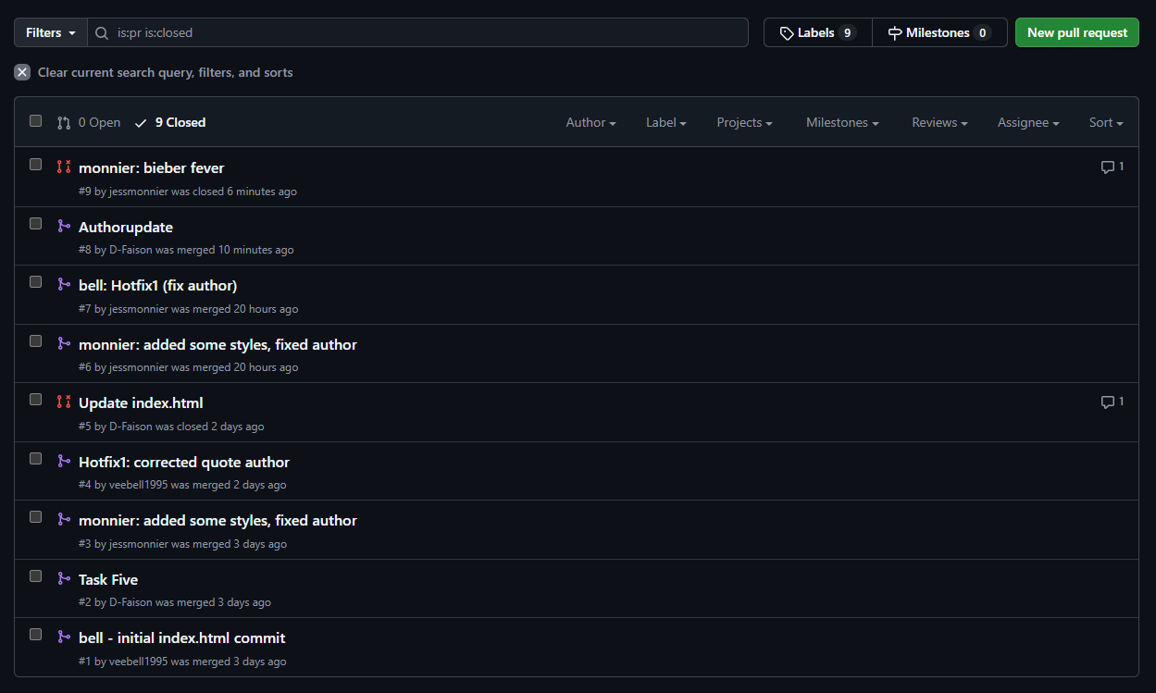
We have some extra pull requests because we accidentally had a change posted directly to main, had to roll it back, accidentally rolled it back too far, and resubmitted a couple pull requests to get it back to where it should be. Oops!
Roles:
Vee – Dev 1
DeJanae – Dev 2
Jess – Dev 3, Release Manager
https://github.com/jessmonnier/gitlab/

