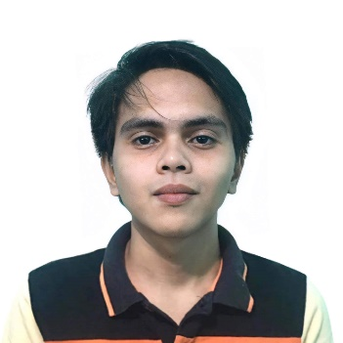**JESSON MAURICE B. ANTIPORDA**Purok 6 Barangay 17 Fort Poyohon, Butuan City 8600   
[antiporda.dendi@gmail.com](mailto:antiporda.dendi@gmail.com)+639353606427

## OBJECTIVE

Currently studying Bachelor of Science in Computer Science and seeking an internship/part time opportunity to apply and further develop my skills in Software/Web Developer, where I can contribute to the success of the organization while gaining valuable hands-on experience and professional growth.



## EDUCATION

Bachelor of Science in Computer Science (2021-Present) Caraga State University  
Amapayon, Butuan City 8600



## SKILLS

-Basic knowledge in C language

-Basic knowledge in Java

-Basic knowledge in PostgreSQL

-High Intermediate level of English (written and verbal communication skills)

-Highly efficient

-Ability to work independently or as part of a team



## REFERENCES

**ALYSSA CUBILLA GONO**  
Instructor, CCIS Department  
Caraga State University  
Amapayon, Butuan City  
+639309999214ǀ alyssacubilla@gmail.com

**MANNY LUCAS A. BACO**  
Merchandiser  
Happy Enterprises & Resources Inc.  
Fort Poyohon, Butuan City  
+63946 663 7014ǀ mannylucas.baco@gmail.com

## 