Jessica Rieger

Lab 8

11/06/2016

1.

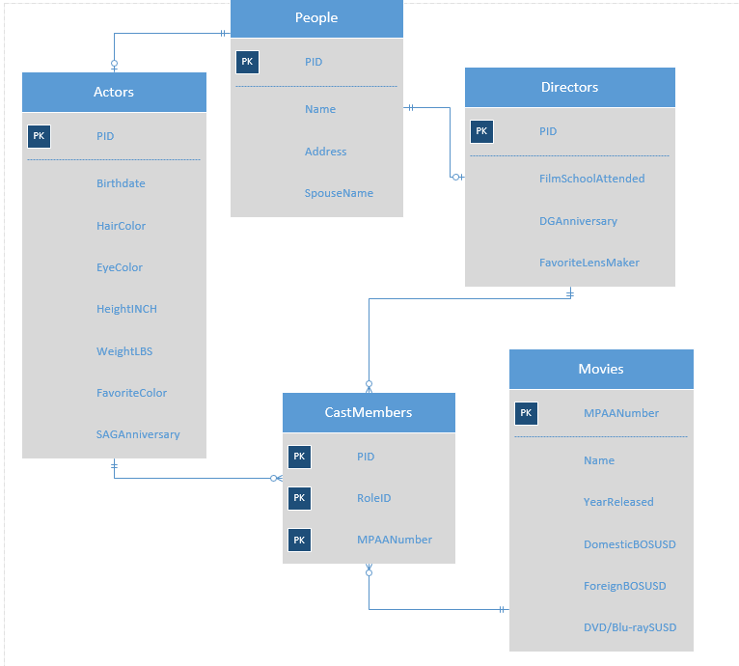

2. See .sql file

3. Functional Dependencies

People: PID -> Name, Address, SpouseName

Directors: PID -> FilmSchoolAttended, DGAnniversary, FavoriteLensMaker

Actors: PID -> BirthDate, HairColor, EyeColor, HeightINCH, WeightLBS, FavoriteColor, SAGAnniversary

CastMembers: PID, RoleID, MPAANumber ->

4. See .sql file