This test is designed for a duration of 4 hours

Activities:

1. Make a Docker container with Mysql

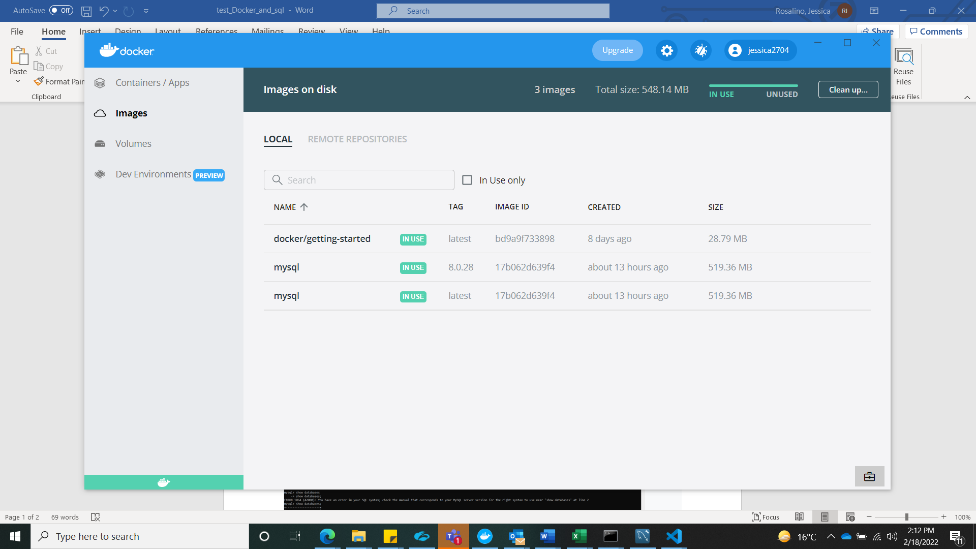

1. Load into mysql sakila db <https://downloads.mysql.com/docs/sakila-db.tar.gz>

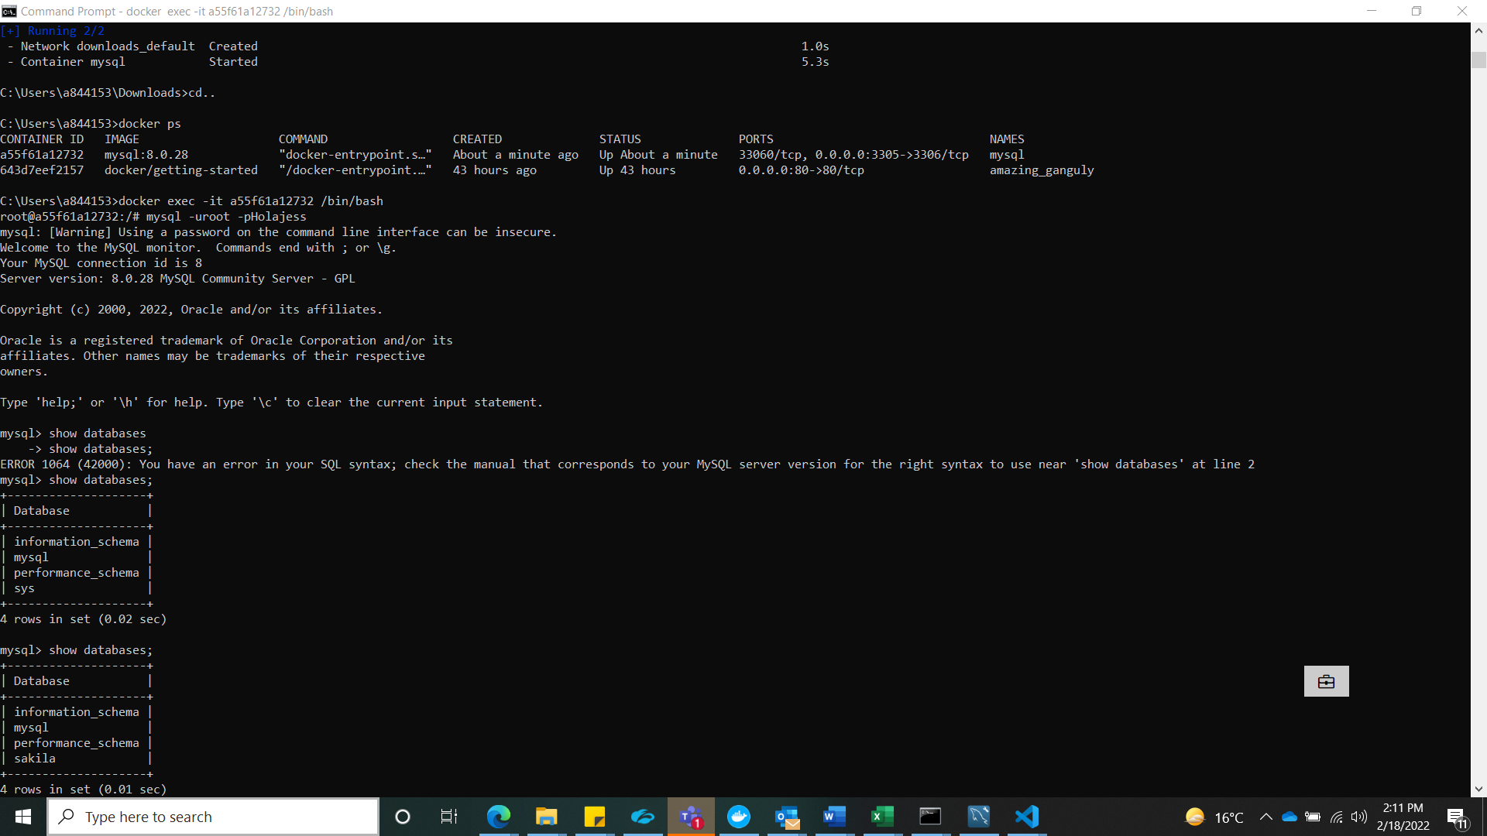

1. Inside sakila db modify 2 film records values

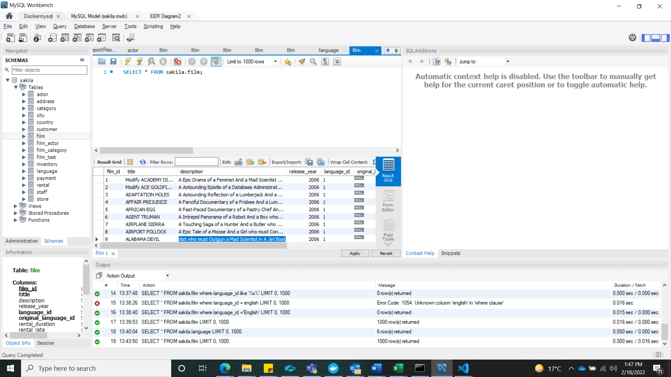

1. List of movies by actor

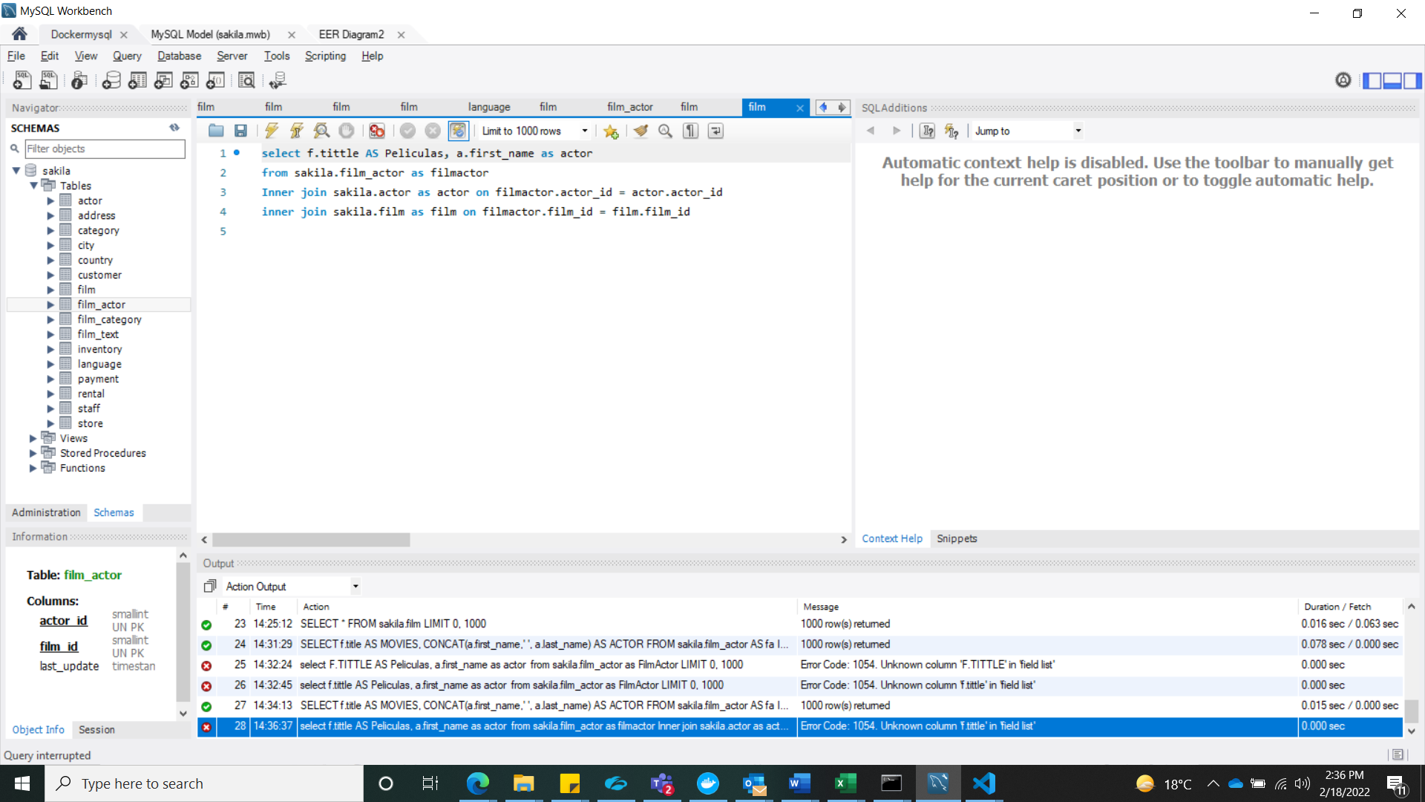

1. Count number of movies per actor

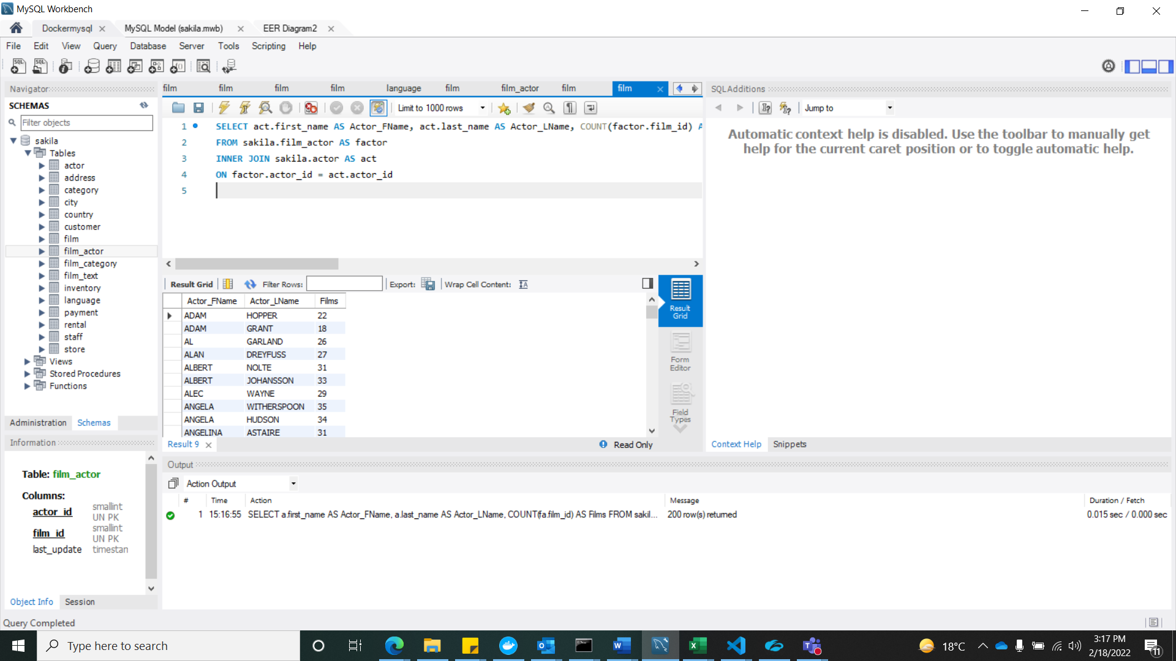

1. Count movie languages

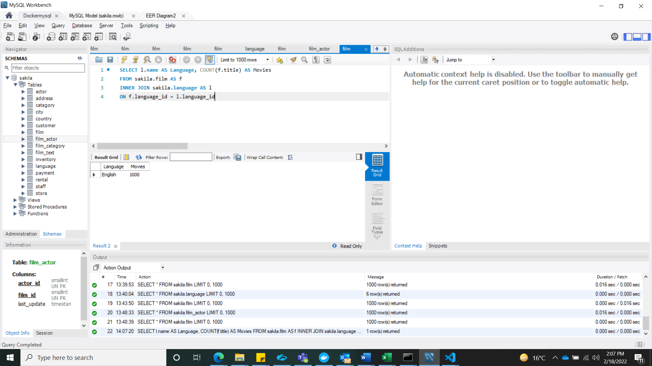

1. Calculate average cost for replacement of a film
2. do a store procedure to update the film