环境：nginx1.22+MySQL5.7.44+php7.4+phpmyadmin5.1
Php扩展：redis+igbinary

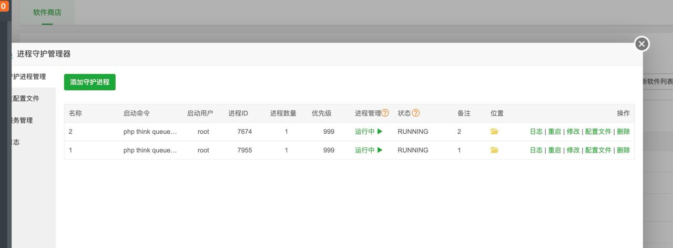
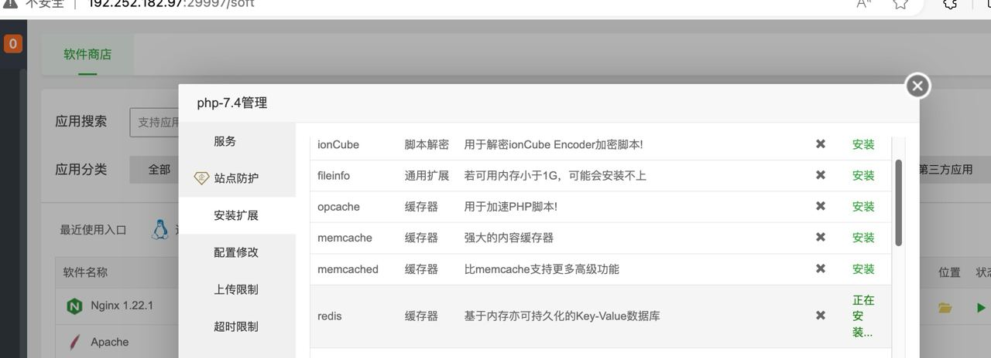

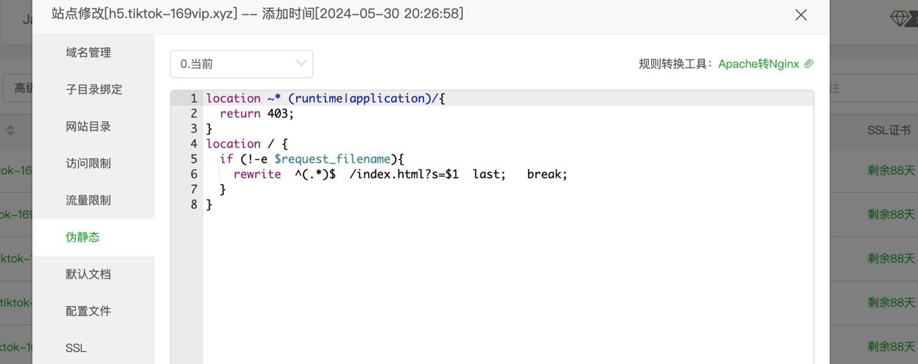

2个进程守护
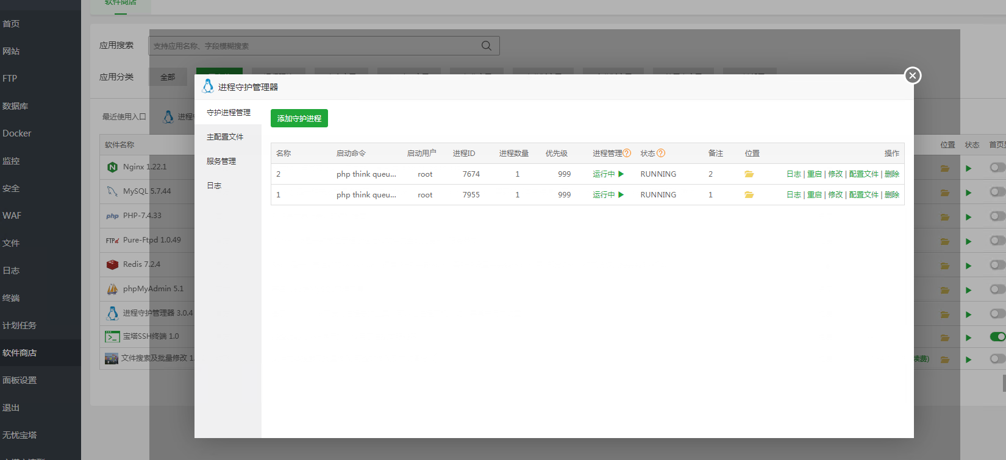
第一个
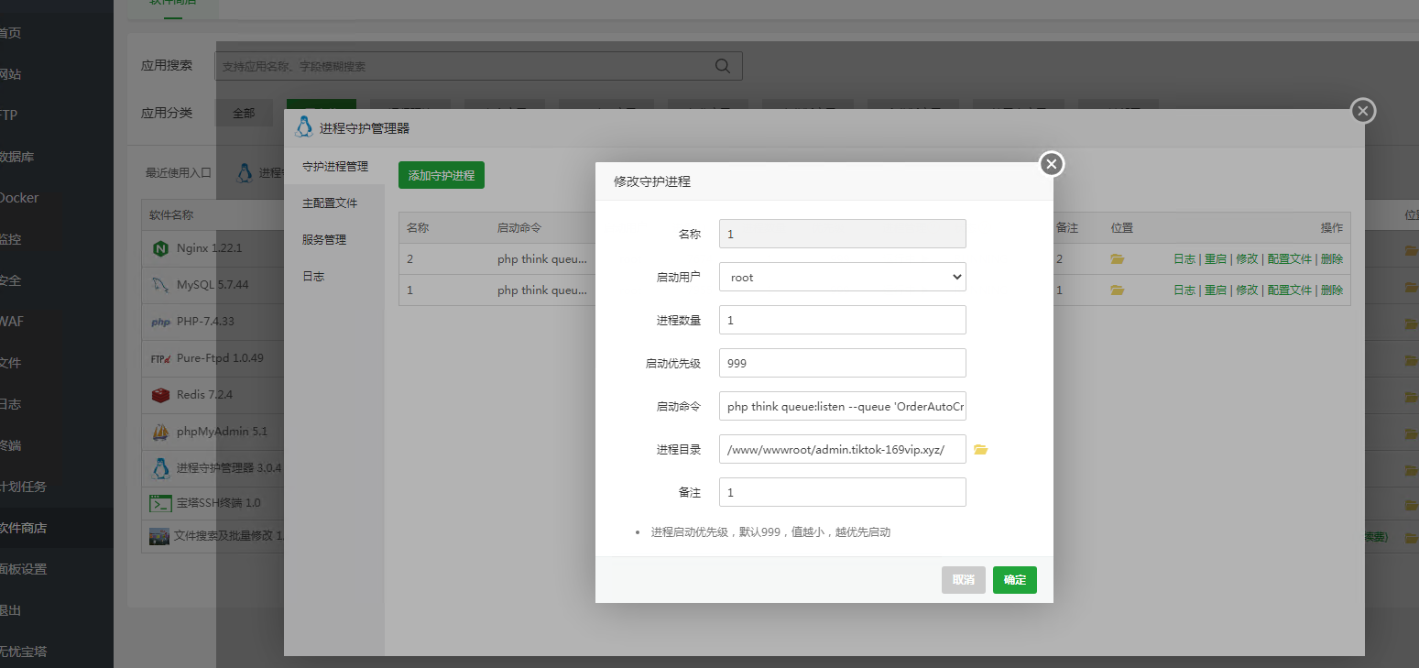
启动命令：
php think queue:listen --queue 'OrderAutoCreate'
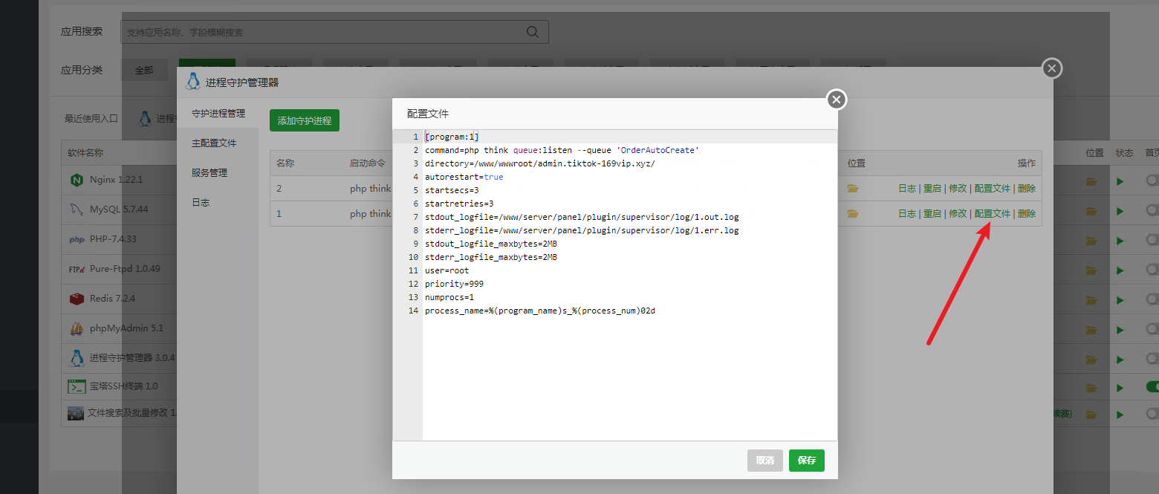
配置文件：
[program:1]
command=php think queue:listen --queue 'OrderAutoCreate'
directory=/www/wwwroot/admin.tiktok-169vip.xyz/
autorestart=true
startsecs=3
startretries=3
stdout_logfile=/www/server/panel/plugin/supervisor/log/1.out.log
stderr_logfile=/www/server/panel/plugin/supervisor/log/1.err.log
stdout_logfile_maxbytes=2MB
stderr_logfile_maxbytes=2MB
user=root
priority=999
numprocs=1
process_name=%(program_name)s_%(process_num)02d

进程守护2：
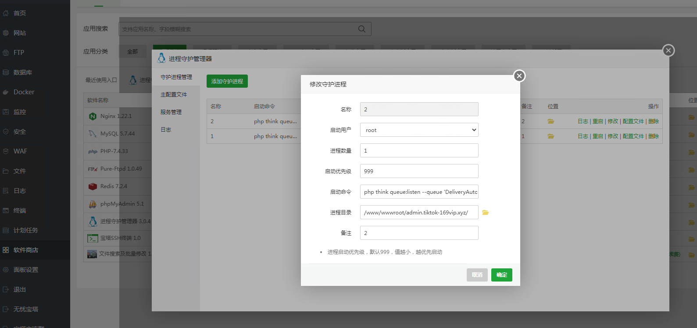
启动命令：
php think queue:listen --queue 'DeliveryAutoFinish'

配置文件：
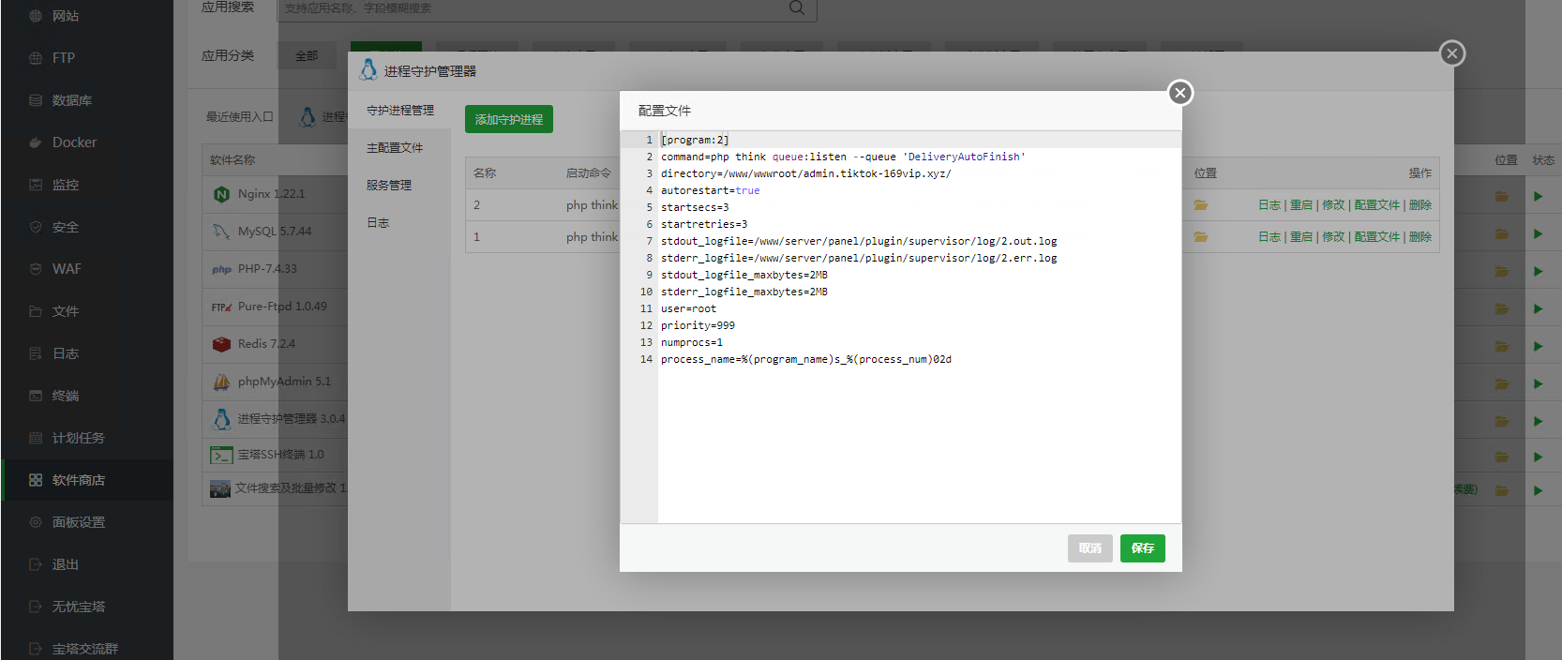

[program:2]
command=php think queue:listen --queue 'DeliveryAutoFinish'
directory=/www/wwwroot/admin.tiktok-169vip.xyz/
autorestart=true
startsecs=3
startretries=3
stdout_logfile=/www/server/panel/plugin/supervisor/log/2.out.log
stderr_logfile=/www/server/panel/plugin/supervisor/log/2.err.log
stdout_logfile_maxbytes=2MB
stderr_logfile_maxbytes=2MB
user=root
priority=999
numprocs=1
process_name=%(program_name)s_%(process_num)02d

计划任务
每小时一次，访问URL
https://admin.tiktok-169vip.xyz/api/plantask/task_auto_nums
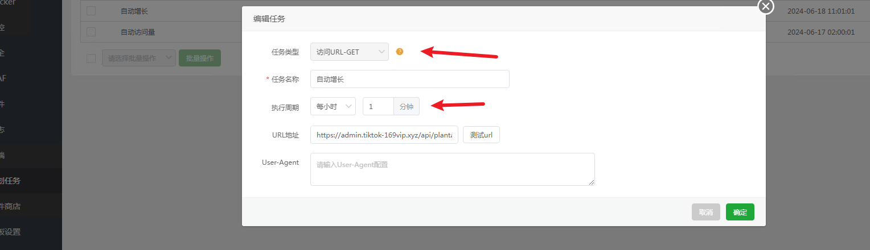

计划任务客服系统 shell脚本

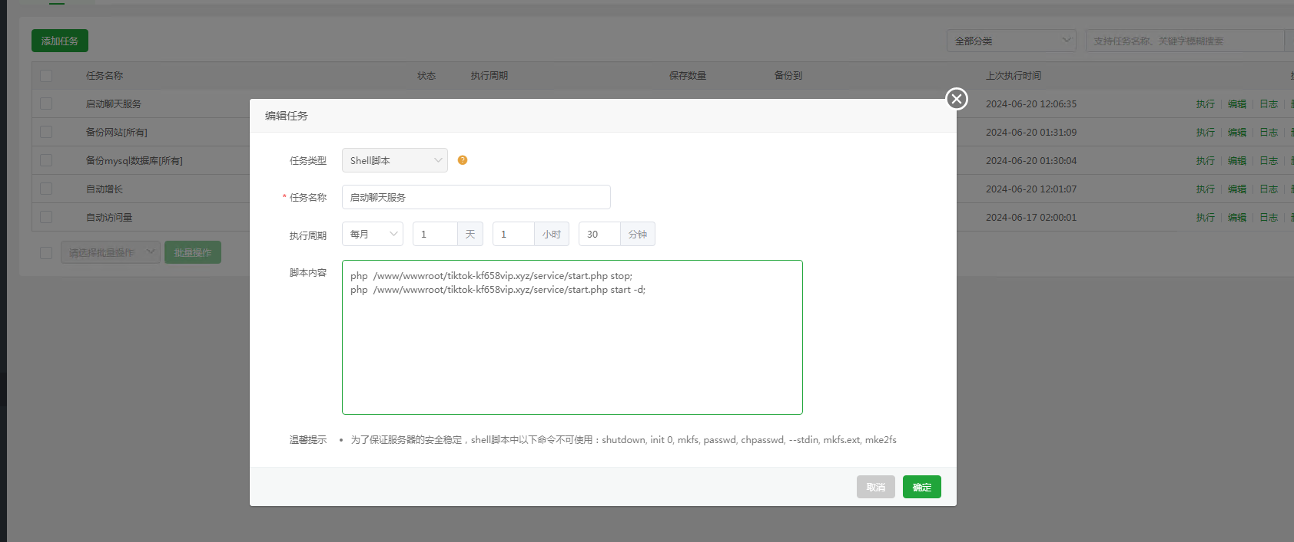
php /www/wwwroot/tiktok-kf658vip.xyz/service/start.php stop;
php /www/wwwroot/tiktok-kf658vip.xyz/service/start.php start -d;

