Jandayan, jessa a.

Ac192

A1- FLOWCHARTS AND PSUEDOCODES

**WHAT ARE *FLOWCHARTS?***

**Flowchart**is a **type of “diagram” that represents an algorithm, workflow or process, showing the steps-by-step approach in solving task.**

**Flowcharts** are written with program flow from the top of a page to the bottom. Each command is placed in a box of the appropriate shape, and arrows are used to direct program flow. The following shapes are often used in flowcharts:

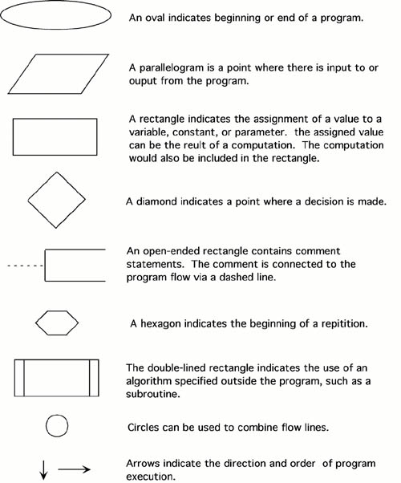

**WHAT IS *PSEUDOCODE*?**

**Pseudocode**is a **simple way writing of programming codes in English thus, it’s a detailed and readable description of what a computer programs or algorithm is supposed to do.**

**-  Pseudocode**is a **method of describing computer algorithms using a combination of natural language and programming language.  It is essentially an intermittent step towards the development of the actual code.  It allows the programmer to formulate their thoughts on the organization and sequence of a computer algorithm without the need for actually following the exact coding syntax.**

 In general, here are some rules that are frequently followed when writing pseudocode:

* The usual Fortran symobols are used for arithmetic operations (+, -, *, / , **).
* Symbolic names are used to indicate the quantities being processed.
* Certain Fortran keywords can be used, such as PRINT, WRITE, READ, etc.
* Indentation should be used to indicate branches and loops of instruction.

Pseudocode:

* Input:    An integer *Limit*  
      Ouput:   Two integers: *Number* and *Sum*
* 1.  Enter *Limit*  
  2.  Set *Number* = 0.  
  3.  Set *Sum* = 0.  
  4.  Repeat the following:  
      a.  If *Sum*> *Limit*, terminate the repitition, otherwise.  
      b.  Increment *Number*by one.  
      c.  Add *Number*to *Sum*and set equal to *Sum*.  
  5.  Print *Number* and *Sum*.

**REFERENCES:**

* Codeinminutes. (2017, January 25). FLOWCHART VS PSEUDOCODE. Retrieved from <https://codeinminutes.wordpress.com/2016/04/04/flowchart-vs-pseudocode/>.
* Retrieved from <https://study.com/academy/lesson/pseudocode-definition-examples-quiz.html>.
* (Retrieved from http://www.owlnet.rice.edu/~ceng303/manuals/fortran/FOR3_3.html.)