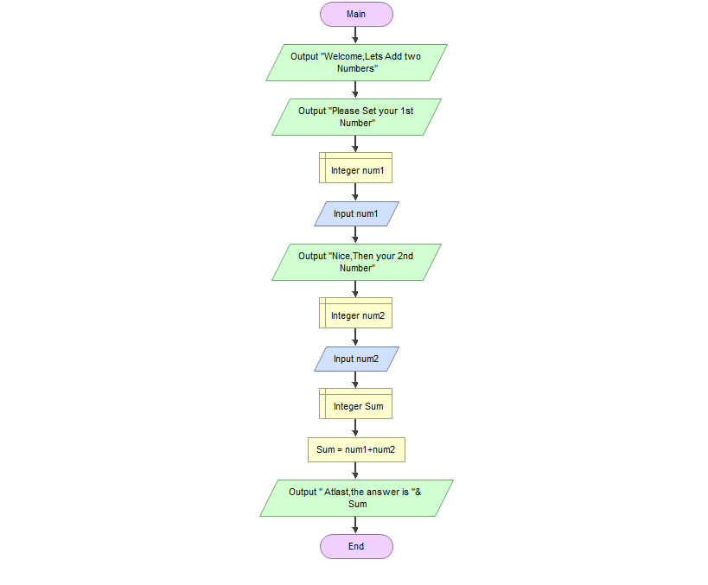JANDAYAN, JESSA A. (AC192)

Procedures in M1:

Function Main

Output "Welcome,Lets Add two Numbers"

Output "Please Set your 1st Number"

Declare Integer num1

Input num1

Output "Nice,Then your 2nd Number"

Declare Integer num2

Input num2

Declare Integer Sum

Assign Sum = num1+num2

Output " Atlast,the answer is "& Sum

End

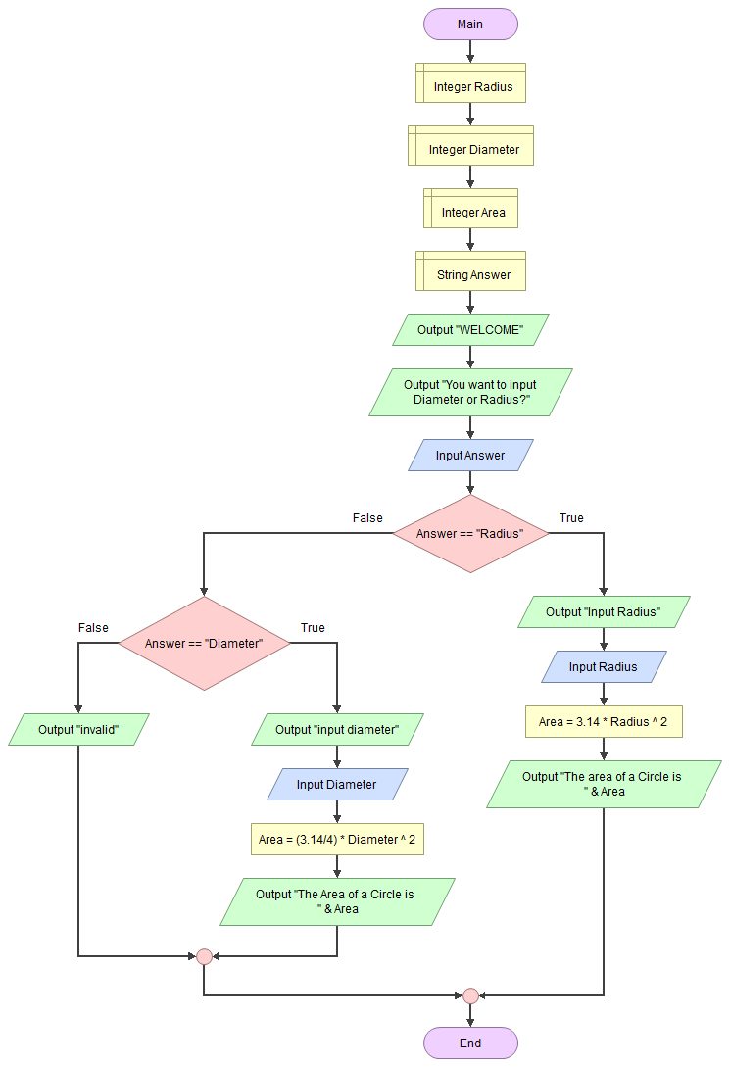

Procedures in M2:

Function Main

Declare Integer Radius

Declare Integer Diameter

Declare Integer Area

Declare String Answer

Output "WELCOME"

Output "You want to input Diameter or Radius?"

Input Answer

If Answer == "Radius"

Output "Input Radius"

Input Radius

Assign Area = 3.14 \* Radius ^ 2

Output "The area of a Circle is " & Area

False:

If Answer == "Diameter"

Output "input diameter"

Input Diameter

Assign Area = (3.14/4) \* Diameter ^ 2

Output "The Area of a Circle is " & Area

False:

Output "invalid"

End

End

End