Jandayan, jessa a.

Ac192

Reflection

My First program using Flowgarithm

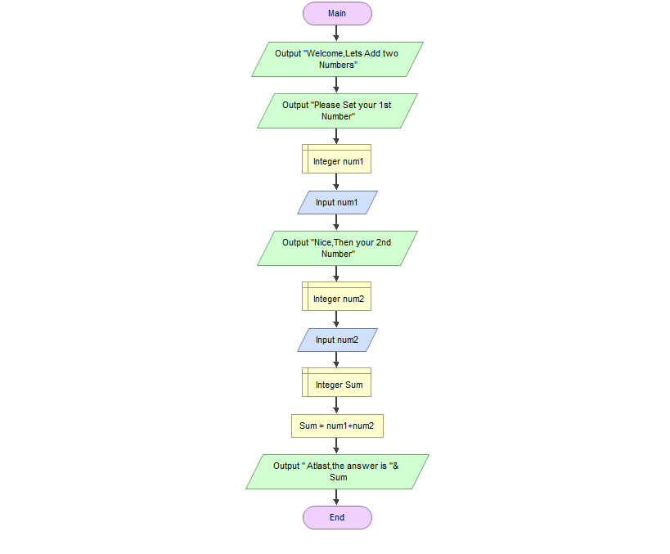 In my first time in using the flowgarithm is so easy and I find it amazing because it really appear what I want to see in the program. The things that make it difficult if I don’t know what symbols should I use and at that time I haven’t memorize yet the symbols and their function even there are already an definition on the past research.(See photo)

This photo is my first program in flowgarithm although i look simple than my other blockmates but I am very proud of myself that I was able to create a program on my own.