**Váradi-Szabó András**

Around 2018, I first started dealing with cryptocurrencies as an interesting topic. My main goal was to understand and learn about technology. In 2020, I started investing more energy in dealing with the topic and learning about profit opportunities. In addition, the world of NFTs has begun to occupy and what the future holds for these technologies.

2018 környékén kezdtem el először foglalkozni a kriptovalutákkal, mint érdekes témakörrel. Fő célom a technológia megértése és megismerése volt. 2020-ban elkezdtem több energiát fektetni a témakörbe és a profitlehetőségek megismerésébe. Ezenkívül az NFT-k világa is elkezdett érdekelni és az, hogy a jövőben milyen felhasználása lesz ezeknek a technológiáknak.

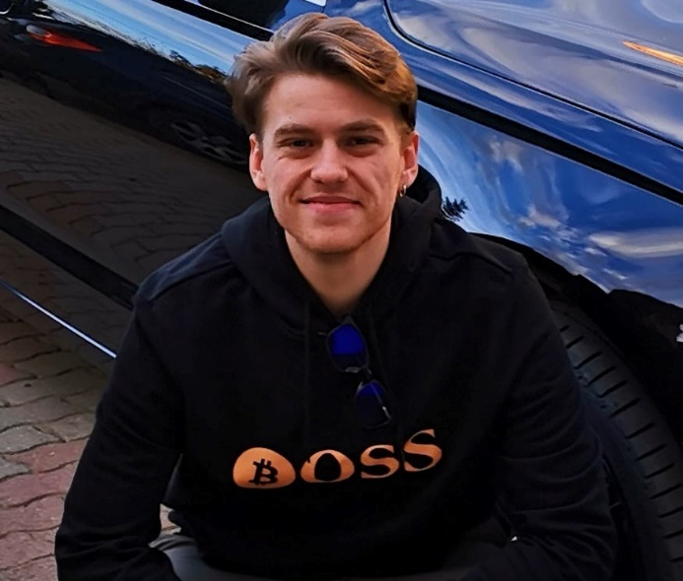

**Kovács Konrád**

I started working in the world of cryptocurrency in 2016, from the first minute I was interested in technology, the big profit (s) was only second to him. I worked on several of my own smart contracts (in Solidity and Rust) but had the opportunity to work in an ICO-related startup as a frontend / smart contract developer. In this project, I see fantasy because with my experience so far, I can create value for both beginners and advanced people from a business, but mostly technological side.

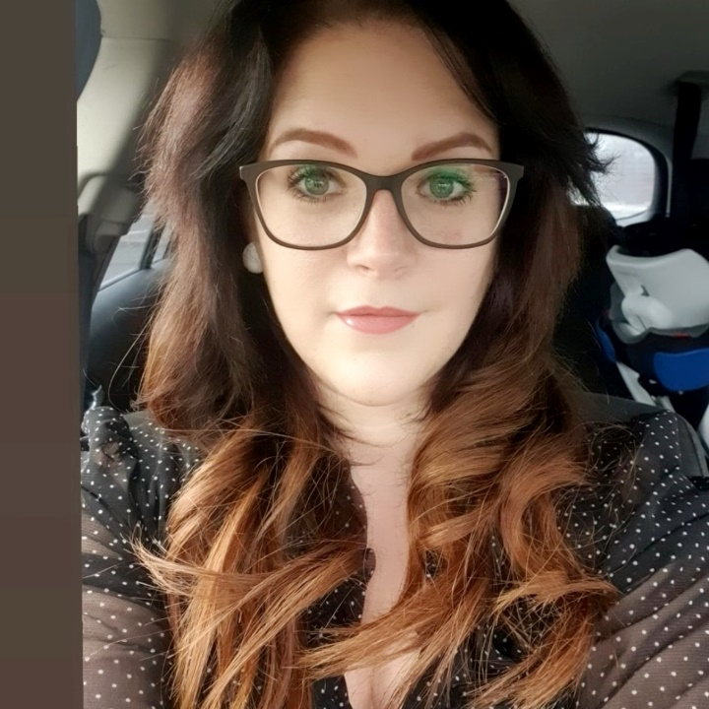

**Tihanyi Krisztina**

The world of numbers has attracted me since I was a kid, so it was obvious that I would find my profession in the financial sector as well. I soon realized that the precision and predictability sought by many is given to me by the world of finance and accounting. I became acquainted with the crypto world in 2018, I was attracted by its variety and its novelty.