MOBILE APP FINAL PROJECT

BS INFOTECH 3B

**LEADER:** DE LA CRUZ, JESTER V.

**MEMBERS:**   
BAYANAY, ANGELA  
CENTENO, ISMAEL  
SARMIENTO PHILIP JOSUA

**USER MANUAL:**

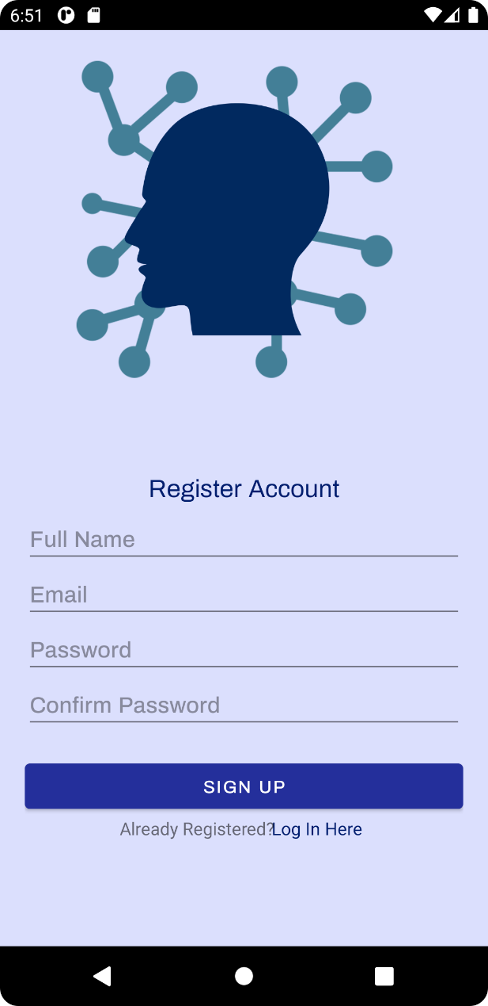 **LOG IN REGISTER**

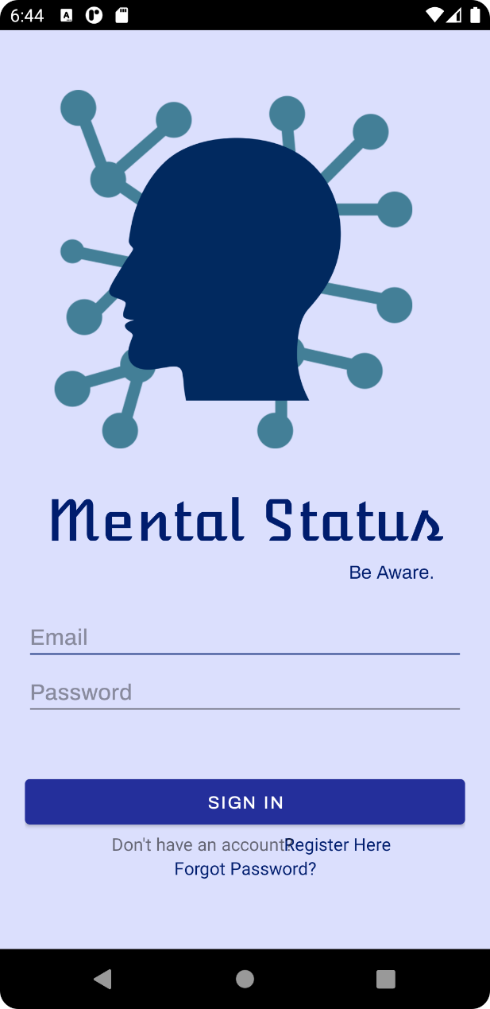

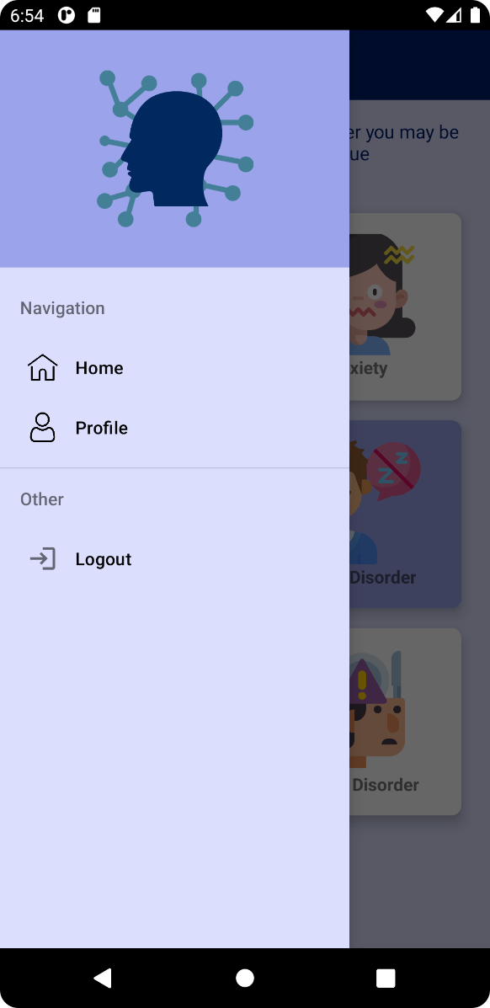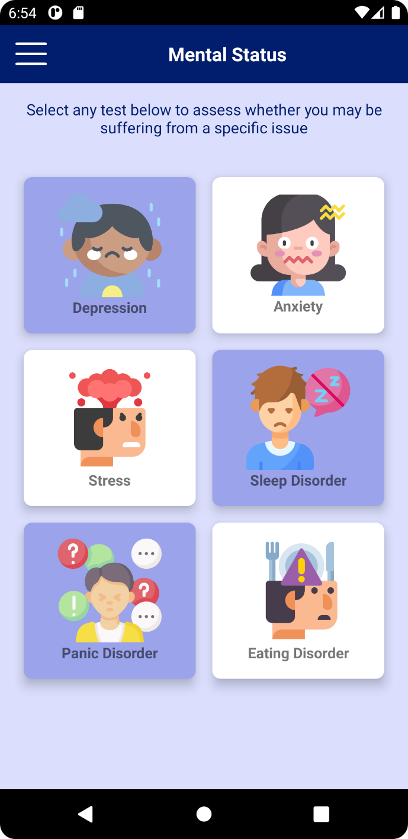 **HOME NAV DRAWER**

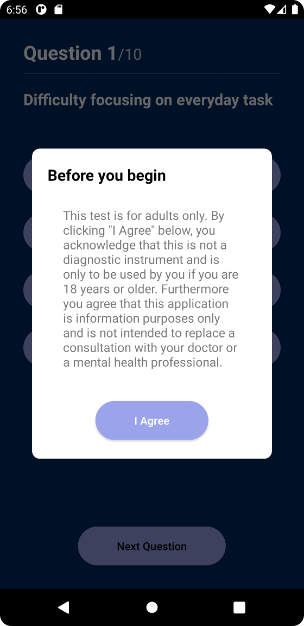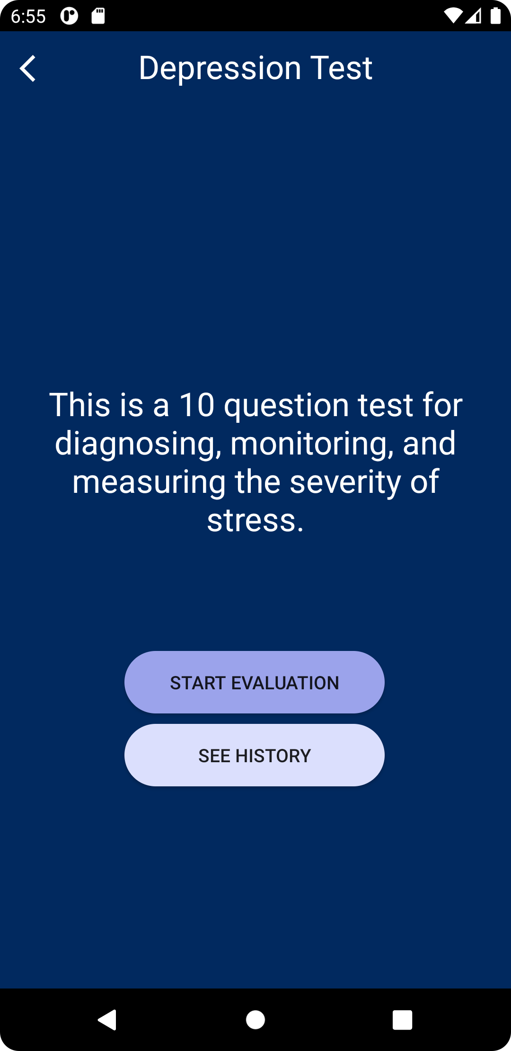 **TEST LANDING PAGE AGREEMENT DIALOG**

**QUESTIONS/EVALUATION PAGE**

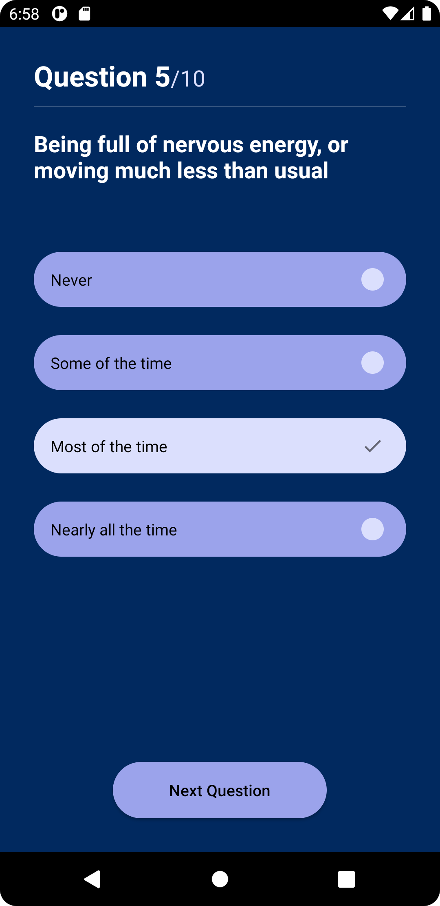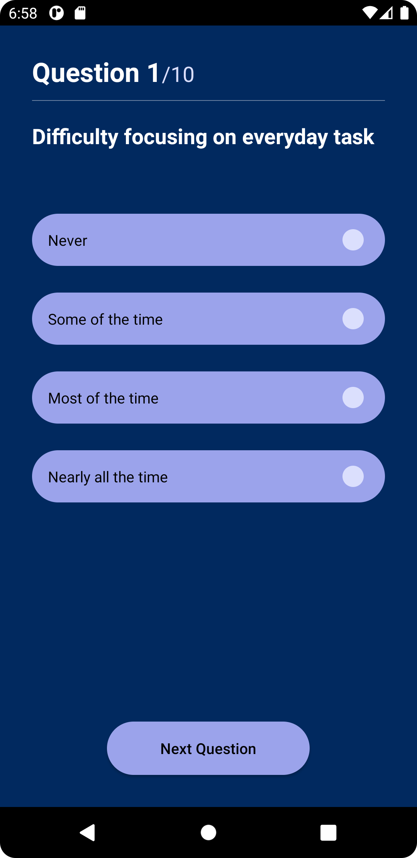

**RESULT PAGE**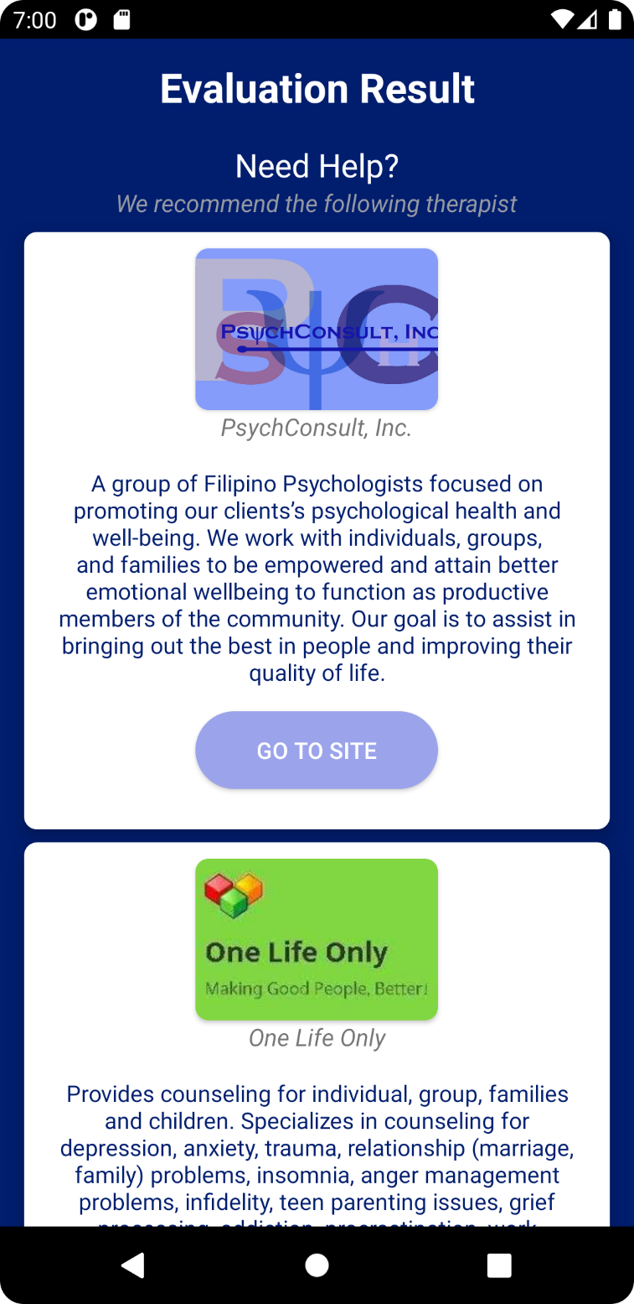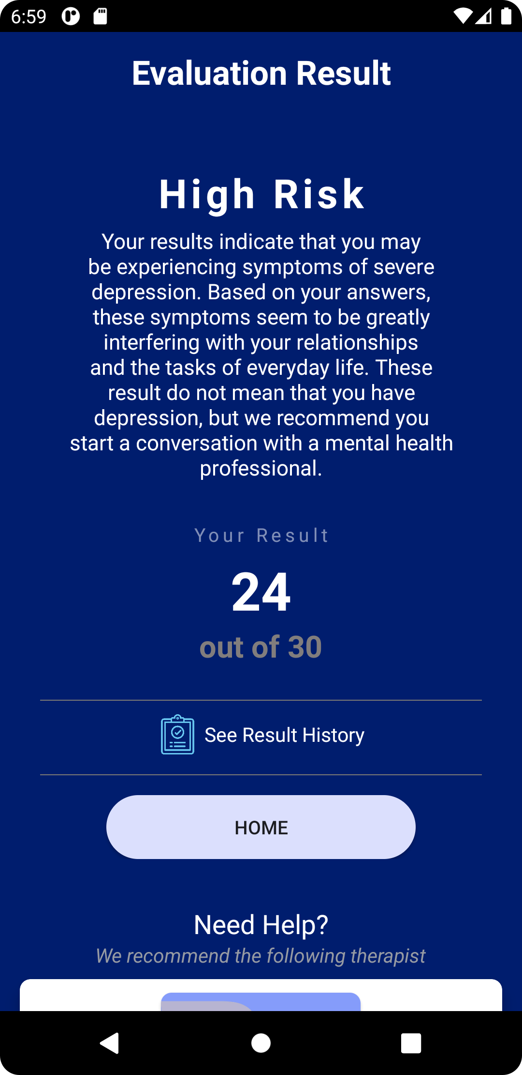

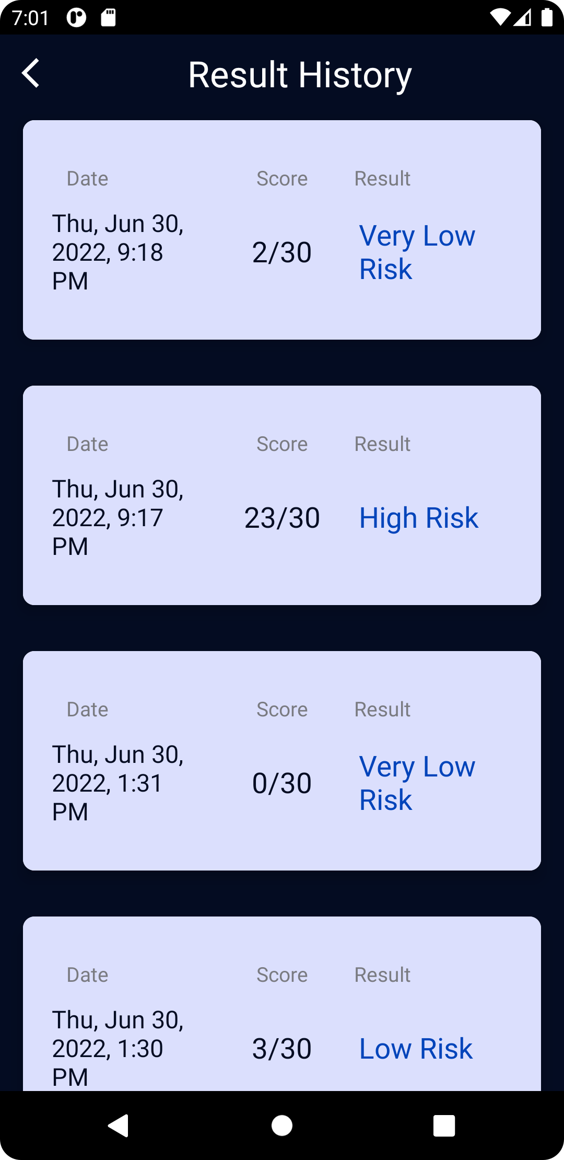 **RESULT HISTORY**

**PROFILE PAGE**

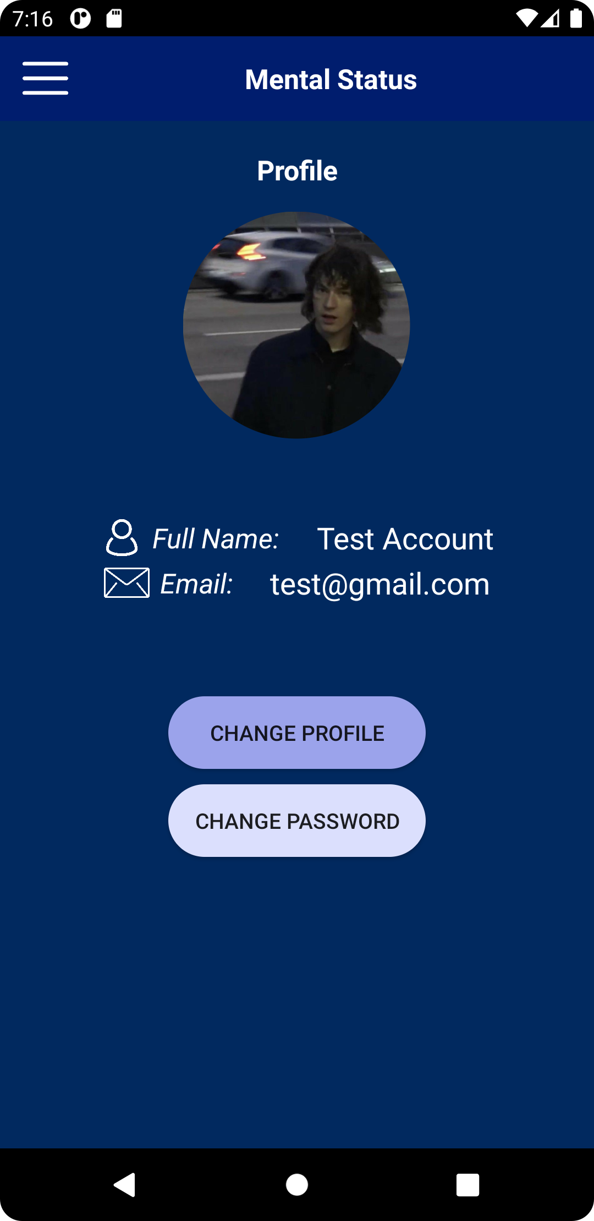

**FIREBASE DATABASE:**

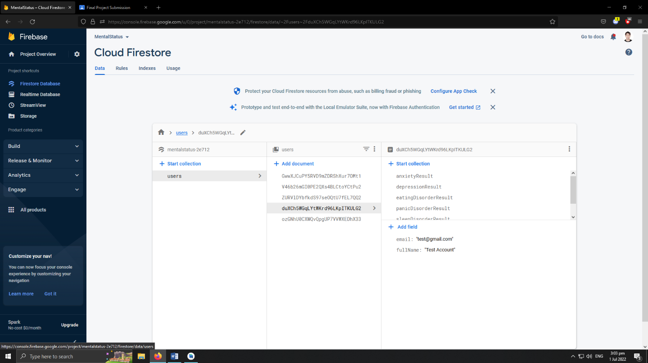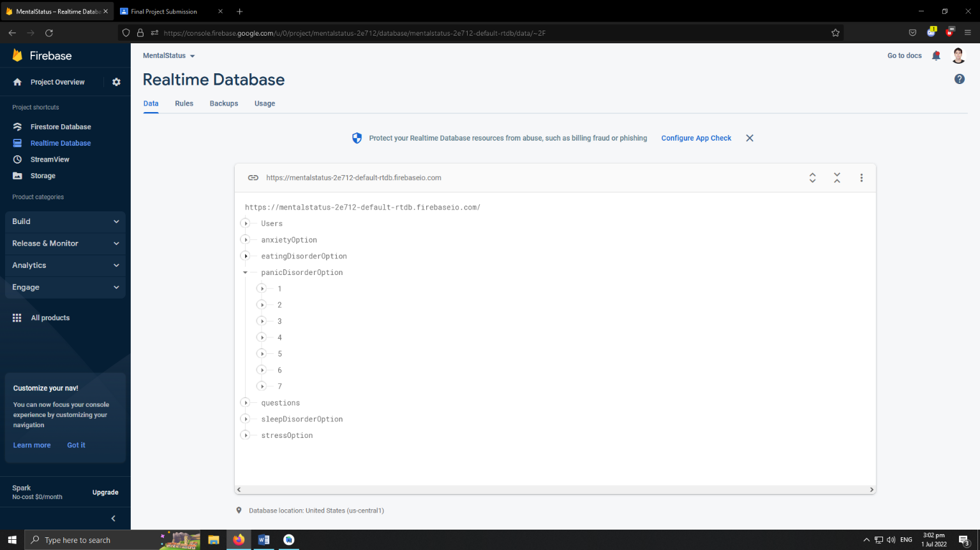

**SOURCE CODE:**

**MAIN_ACTIVITY.JAVA**

package com.example.mentalstatus;  
  
import androidx.appcompat.app.AppCompatActivity;  
import androidx.cardview.widget.CardView;  
import androidx.core.view.GravityCompat;  
import androidx.drawerlayout.widget.DrawerLayout;  
import androidx.navigation.NavController;  
import androidx.navigation.Navigation;  
import androidx.navigation.ui.NavigationUI;  
  
import android.content.Intent;  
import android.os.Bundle;  
import android.view.View;  
  
import com.google.android.material.navigation.NavigationView;  
import com.google.firebase.auth.FirebaseAuth;  
  
public class MainActivity extends AppCompatActivity {  
  
 CardView depressionTest, anxietyTest, stressTest, sleepdisorderTest, panicdisorderTest, eatingdisorderTest;  
  
 @Override  
 protected void onCreate(Bundle savedInstanceState) {  
 super.onCreate(savedInstanceState);  
 setContentView(R.layout.activity_main);  
  
 depressionTest = findViewById(R.id.DepressionTest);  
 anxietyTest = findViewById(R.id.AnxietyTest);  
 stressTest = findViewById(R.id.StressTest);  
 sleepdisorderTest = findViewById(R.id.SleepDisorderTest);  
 panicdisorderTest = findViewById(R.id.PanicDisorderTest);  
 eatingdisorderTest = findViewById(R.id.EatingDisorderTest);  
  
 DrawerLayout drawerLayout = findViewById(R.id.drawerLayout);  
  
 findViewById(R.id.imageMenu).setOnClickListener(new View.OnClickListener() {  
 @Override  
 public void onClick(View view) {  
 drawerLayout.openDrawer(GravityCompat.*START*);  
 }  
 });  
  
 NavigationView navigationView = findViewById(R.id.*navigationView*);  
 navigationView.getMenu().findItem(R.id.*menuLogout*).setOnMenuItemClickListener(menuItem -> {  
 logout();  
 return true;  
 });  
 navigationView.setItemIconTintList(null);  
  
 NavController navController = Navigation.*findNavController*(this, R.id.*navHostFragment*);  
 NavigationUI.*setupWithNavController*(navigationView, navController);  
  
  
  
  
 depressionTest.setOnClickListener(new View.OnClickListener() {  
 @Override  
 public void onClick(View view) {  
 depTest();  
 }  
 });  
  
 anxietyTest.setOnClickListener(new View.OnClickListener() {  
 @Override  
 public void onClick(View view) {  
 anxTest();  
 }  
 });  
  
 stressTest.setOnClickListener(new View.OnClickListener() {  
 @Override  
 public void onClick(View view) {  
 strTest();  
 }  
 });  
  
 sleepdisorderTest.setOnClickListener(new View.OnClickListener() {  
 @Override  
 public void onClick(View view) {  
 sleepTest();  
 }  
 });  
  
 panicdisorderTest.setOnClickListener(new View.OnClickListener() {  
 @Override  
 public void onClick(View view) {  
 panicTest();  
 }  
 });  
  
 eatingdisorderTest.setOnClickListener(new View.OnClickListener() {  
 @Override  
 public void onClick(View view) {  
 eatingTest();  
 }  
 });  
  
  
 }  
  
 public void depTest(){  
 startActivity(new Intent(getApplicationContext(),Landing_DepTest.class));  
 }  
  
 public void anxTest(){  
 startActivity(new Intent(getApplicationContext(),Landing_AnxTest.class));  
 }  
  
 public void strTest(){  
 startActivity(new Intent(getApplicationContext(), Landing_StrTest.class));  
 }  
  
 public void sleepTest(){  
 startActivity(new Intent(getApplicationContext(), Landing_SleepDisorderTest.class));  
 }  
  
 public void panicTest(){  
 startActivity(new Intent(getApplicationContext(), Landing_PanicDisorder.class));  
 }  
  
 public void eatingTest(){  
 startActivity(new Intent(getApplicationContext(), Landing_EatingDisorderTest.class));  
 }  
  
 @Override  
 public void onBackPressed() {  
 return;  
 }  
  
 public void logout() {  
 FirebaseAuth.getInstance().signOut();//logout  
 startActivity(new Intent(getApplicationContext(),Login.class));  
 finish();  
 }  
  
}

**ADAPTER_ANXIETY:**

package com.example.mentalstatus;  
  
import android.content.Context;  
import android.view.LayoutInflater;  
import android.view.View;  
import android.view.ViewGroup;  
import android.widget.TextView;  
  
import androidx.annotation.NonNull;  
import androidx.recyclerview.widget.RecyclerView;  
  
import com.google.firebase.firestore.auth.User;  
  
import java.util.ArrayList;  
  
public class Adapter_Anxiety extends RecyclerView.Adapter<Adapter_Anxiety.MyViewHolder> {  
  
 Context context;  
 ArrayList<ResultClass_Anxiety> resultArrayList;  
  
 public Adapter_Anxiety(Context context, ArrayList<ResultClass_Anxiety> resultArrayList) {  
 this.context = context;  
 this.resultArrayList = resultArrayList;  
 }  
  
 @NonNull  
 @Override  
 public Adapter_Anxiety.MyViewHolder onCreateViewHolder(@NonNull ViewGroup parent, int viewType) {  
  
 View v = LayoutInflater.*from*(context).inflate(R.layout.*item_result_depression*,parent, false);  
  
 return new MyViewHolder(v);  
 }  
  
 @Override  
 public void onBindViewHolder(@NonNull Adapter_Anxiety.MyViewHolder holder, int position) {  
  
 ResultClass_Anxiety resultList = resultArrayList.get(position);  
  
 holder.date.setText(resultList.date);  
 holder.score.setText(resultList.score+"/21");  
 holder.result.setText(resultList.result);  
  
  
 }  
  
 @Override  
 public int getItemCount() {  
 return resultArrayList.size();  
 }  
  
 public static class MyViewHolder extends RecyclerView.ViewHolder{  
  
 TextView date, score, result;  
  
 public MyViewHolder(@NonNull View itemView) {  
 super(itemView);  
 date = itemView.findViewById(R.id.*dateTV*);  
 score = itemView.findViewById(R.id.*scoreTV*);  
 result = itemView.findViewById(R.id.*resultTV*);  
 }  
 }  
}

**ADAPTER_DEPRESSION:**

package com.example.mentalstatus;  
  
import android.content.Context;  
import android.view.LayoutInflater;  
import android.view.View;  
import android.view.ViewGroup;  
import android.widget.TextView;  
  
import androidx.annotation.NonNull;  
import androidx.recyclerview.widget.RecyclerView;  
  
import com.google.firebase.firestore.auth.User;  
  
import java.util.ArrayList;  
  
public class Adapter_Depression extends RecyclerView.Adapter<Adapter_Depression.MyViewHolder> {  
  
 Context context;  
 ArrayList<ResultClass_Depression> resultArrayList;  
  
 public Adapter_Depression(Context context, ArrayList<ResultClass_Depression> resultArrayList) {  
 this.context = context;  
 this.resultArrayList = resultArrayList;  
 }  
  
 @NonNull  
 @Override  
 public Adapter_Depression.MyViewHolder onCreateViewHolder(@NonNull ViewGroup parent, int viewType) {  
  
 View v = LayoutInflater.*from*(context).inflate(R.layout.*item_result_depression*,parent, false);  
  
 return new MyViewHolder(v);  
 }  
  
 @Override  
 public void onBindViewHolder(@NonNull Adapter_Depression.MyViewHolder holder, int position) {  
  
 ResultClass_Depression resultList = resultArrayList.get(position);  
  
 holder.date.setText(resultList.date);  
 holder.score.setText(resultList.score+"/30");  
 holder.result.setText(resultList.result);  
  
  
 }  
  
 @Override  
 public int getItemCount() {  
 return resultArrayList.size();  
 }  
  
 public static class MyViewHolder extends RecyclerView.ViewHolder{  
  
 TextView date, score, result;  
  
 public MyViewHolder(@NonNull View itemView) {  
 super(itemView);  
 date = itemView.findViewById(R.id.*dateTV*);  
 score = itemView.findViewById(R.id.*scoreTV*);  
 result = itemView.findViewById(R.id.*resultTV*);  
 }  
 }  
}

**ADAPTER_EATINGDISORDER.JAVA**

package com.example.mentalstatus;  
  
import android.content.Context;  
import android.view.LayoutInflater;  
import android.view.View;  
import android.view.ViewGroup;  
import android.widget.TextView;  
  
import androidx.annotation.NonNull;  
import androidx.recyclerview.widget.RecyclerView;  
  
import com.google.firebase.firestore.auth.User;  
  
import java.util.ArrayList;  
  
public class Adapter_EatingDisorder extends RecyclerView.Adapter<Adapter_EatingDisorder.MyViewHolder> {  
  
 Context context;  
 ArrayList<ResultClass_EatingDisorder> resultArrayList;  
  
 public Adapter_EatingDisorder(Context context, ArrayList<ResultClass_EatingDisorder> resultArrayList) {  
 this.context = context;  
 this.resultArrayList = resultArrayList;  
 }  
  
 @NonNull  
 @Override  
 public Adapter_EatingDisorder.MyViewHolder onCreateViewHolder(@NonNull ViewGroup parent, int viewType) {  
  
 View v = LayoutInflater.*from*(context).inflate(R.layout.*item_result_depression*,parent, false);  
  
 return new MyViewHolder(v);  
 }  
  
 @Override  
 public void onBindViewHolder(@NonNull Adapter_EatingDisorder.MyViewHolder holder, int position) {  
  
 ResultClass_EatingDisorder resultList = resultArrayList.get(position);  
  
 holder.date.setText(resultList.date);  
 holder.score.setText(resultList.score+"/30");  
 holder.result.setText(resultList.result);  
  
  
 }  
  
 @Override  
 public int getItemCount() {  
 return resultArrayList.size();  
 }  
  
 public static class MyViewHolder extends RecyclerView.ViewHolder{  
  
 TextView date, score, result;  
  
 public MyViewHolder(@NonNull View itemView) {  
 super(itemView);  
 date = itemView.findViewById(R.id.*dateTV*);  
 score = itemView.findViewById(R.id.*scoreTV*);  
 result = itemView.findViewById(R.id.*resultTV*);  
 }  
 }  
}

**ADAPTER_STRESS:**

package com.example.mentalstatus;  
  
import android.content.Context;  
import android.view.LayoutInflater;  
import android.view.View;  
import android.view.ViewGroup;  
import android.widget.TextView;  
  
import androidx.annotation.NonNull;  
import androidx.recyclerview.widget.RecyclerView;  
  
import com.google.firebase.firestore.auth.User;  
  
import java.util.ArrayList;  
  
public class Adapter_Stress extends RecyclerView.Adapter<Adapter_Stress.MyViewHolder> {  
  
 Context context;  
 ArrayList<ResultClass_Stress> resultArrayList;  
  
 public Adapter_Stress(Context context, ArrayList<ResultClass_Stress> resultArrayList) {  
 this.context = context;  
 this.resultArrayList = resultArrayList;  
 }  
  
 @NonNull  
 @Override  
 public Adapter_Stress.MyViewHolder onCreateViewHolder(@NonNull ViewGroup parent, int viewType) {  
  
 View v = LayoutInflater.*from*(context).inflate(R.layout.*item_result_depression*,parent, false);  
  
 return new MyViewHolder(v);  
 }  
  
 @Override  
 public void onBindViewHolder(@NonNull Adapter_Stress.MyViewHolder holder, int position) {  
  
 ResultClass_Stress resultList = resultArrayList.get(position);  
  
 holder.date.setText(resultList.date);  
 holder.score.setText(resultList.score+"/30");  
 holder.result.setText(resultList.result);  
  
  
 }  
  
 @Override  
 public int getItemCount() {  
 return resultArrayList.size();  
 }  
  
 public static class MyViewHolder extends RecyclerView.ViewHolder{  
  
 TextView date, score, result;  
  
 public MyViewHolder(@NonNull View itemView) {  
 super(itemView);  
 date = itemView.findViewById(R.id.*dateTV*);  
 score = itemView.findViewById(R.id.*scoreTV*);  
 result = itemView.findViewById(R.id.*resultTV*);  
 }  
 }  
}

**AGREEMENT_DIALOG.JAVA**

package com.example.mentalstatus;  
  
import android.app.Dialog;  
import android.content.Context;  
import android.content.Intent;  
import android.os.Bundle;  
import android.view.View;  
import android.widget.TextView;  
  
import androidx.annotation.NonNull;  
import androidx.appcompat.widget.AppCompatButton;  
  
public class Agreement_Dialog extends Dialog {  
 public Agreement_Dialog(@NonNull Context context) {  
 super(context);  
 }  
  
 @Override  
 protected void onCreate(Bundle savedInstanceState) {  
 super.onCreate(savedInstanceState);  
 setContentView(R.layout.*agreement_dialog*);  
  
 final AppCompatButton agreeBtn = findViewById(R.id.*agreeBtn*);  
 final TextView agreementTV = findViewById(R.id.*agreementTV*);  
  
  
  
 setAgreement(agreementTV, "This test is for adults only. By clicking \"I Agree\" below, you acknowledge that this is not a diagnostic instrument and is only to be used by you if you are 18 years or older. Furthermore you agree that this application is information purposes only and is not intended to replace a consultation with your doctor or a mental health professional.");  
  
 agreeBtn.setOnClickListener(new View.OnClickListener() {  
 @Override  
 public void onClick(View view) {  
 dismiss();  
 }  
 });  
 }  
  
 private void setAgreement(TextView agreementTV, String agreementPoint){  
 agreementTV.setText(agreementPoint);  
 }  
  
}

**DRAWER_BASE.JAVA**

package com.example.mentalstatus;  
  
import androidx.annotation.NonNull;  
import androidx.appcompat.app.ActionBarDrawerToggle;  
import androidx.appcompat.app.AppCompatActivity;  
import androidx.appcompat.widget.Toolbar;  
import androidx.drawerlayout.widget.DrawerLayout;  
  
import android.os.Bundle;  
import android.view.MenuItem;  
import android.view.View;  
import android.widget.FrameLayout;  
  
import com.google.android.material.navigation.NavigationView;  
  
public class DrawerBaseActivity extends AppCompatActivity implements NavigationView.OnNavigationItemSelectedListener {  
  
 DrawerLayout drawerLayout;  
  
 @Override  
 public void setContentView(View view) {  
 drawerLayout = (DrawerLayout) getLayoutInflater().inflate(R.layout.*activity_drawer_base*, null);  
 FrameLayout container = drawerLayout.findViewById(R.id.*activityContainer*);  
 container.addView(view);  
 super.setContentView(view);  
  
 Toolbar toolbar = drawerLayout.findViewById(R.id.*toolBar*);  
 setSupportActionBar(toolbar);  
  
 NavigationView navigationView = drawerLayout.findViewById(R.id.*nav_view*);  
 navigationView.setNavigationItemSelectedListener(this);  
  
 ActionBarDrawerToggle toggle = new ActionBarDrawerToggle(this, drawerLayout, toolbar, R.string.*drOpen*, R.string.*drClose*);  
 drawerLayout.addDrawerListener(toggle);  
 toggle.syncState();  
 }  
  
 @Override  
 public boolean onNavigationItemSelected(@NonNull MenuItem item) {  
 return false;  
 }  
  
 protected void allocateActivityTitle(String titleString){  
 if(getSupportActionBar() !=null){  
 getSupportActionBar().setTitle(titleString);  
 }  
 }  
  
  
}

**HOME_FRAGMENT.JAVA**

package com.example.mentalstatus;  
  
import android.content.Intent;  
import android.os.Bundle;  
  
import androidx.cardview.widget.CardView;  
import androidx.fragment.app.Fragment;  
  
import android.view.LayoutInflater;  
import android.view.View;  
import android.view.ViewGroup;  
  
  
public class HomeFragment extends Fragment {  
  
 @Override  
 public void onCreate(Bundle savedInstanceState) {  
 super.onCreate(savedInstanceState);  
 }  
  
 @Override  
 public View onCreateView(LayoutInflater inflater, ViewGroup container,  
 Bundle savedInstanceState) {  
 View view = inflater.inflate(R.layout.fragment_home, container, false);  
  
 CardView depressionTest = (CardView) view.findViewById(R.id.DepressionTest);  
 depressionTest.setOnClickListener(new View.OnClickListener() {  
 @Override  
 public void onClick(View view) {  
 Intent intent = new Intent(getActivity(), Test_Depression.class);  
 intent.putExtra("some", "some data");  
 startActivity(intent);  
 }  
 });  
  
 CardView anxietyTest = (CardView) view.findViewById(R.id.AnxietyTest);  
 anxietyTest.setOnClickListener(new View.OnClickListener() {  
 @Override  
 public void onClick(View view) {  
 Intent intent = new Intent(getActivity(), Test_Anxiety.class);  
 intent.putExtra("some", "some data");  
 startActivity(intent);  
 }  
 });  
  
 CardView stressTest = (CardView) view.findViewById(R.id.StressTest);  
 stressTest.setOnClickListener(new View.OnClickListener() {  
 @Override  
 public void onClick(View view) {  
 Intent intent = new Intent(getActivity(), Test_Stress.class);  
 intent.putExtra("some", "some data");  
 startActivity(intent);  
 }  
 });  
  
 CardView sdTest = (CardView) view.findViewById(R.id.SleepDisorderTest);  
 sdTest.setOnClickListener(new View.OnClickListener() {  
 @Override  
 public void onClick(View view) {  
 Intent intent = new Intent(getActivity(), Test_SleepDisorder.class);  
 intent.putExtra("some", "some data");  
 startActivity(intent);  
 }  
 });  
  
 CardView pdTest = (CardView) view.findViewById(R.id.PanicDisorderTest);  
 pdTest.setOnClickListener(new View.OnClickListener() {  
 @Override  
 public void onClick(View view) {  
 Intent intent = new Intent(getActivity(), Test_PanicDisorder.class);  
 intent.putExtra("some", "some data");  
 startActivity(intent);  
 }  
 });  
  
 CardView edTest = (CardView) view.findViewById(R.id.EatingDisorderTest);  
 edTest.setOnClickListener(new View.OnClickListener() {  
 @Override  
 public void onClick(View view) {  
 Intent intent = new Intent(getActivity(), Test_EatingDisorder.class);  
 intent.putExtra("some", "some data");  
 startActivity(intent);  
 }  
 });  
  
 return view;  
 }  
}

**LANDING_PAGE.JAVA**

package com.example.mentalstatus;  
  
import androidx.appcompat.app.AppCompatActivity;  
import androidx.appcompat.widget.AppCompatButton;  
  
import android.content.Intent;  
import android.os.Bundle;  
import android.view.View;  
import android.widget.ImageView;  
  
public class Landing_DepTest extends AppCompatActivity {  
  
 AppCompatButton startButton, historyButton;  
 ImageView backButton;  
  
 @Override  
 protected void onCreate(Bundle savedInstanceState) {  
 super.onCreate(savedInstanceState);  
 setContentView(R.layout.*landing_dep_test*);  
  
 startButton= findViewById(R.id.*startBtn*);  
 historyButton = findViewById(R.id.*historyBtn*);  
 backButton = findViewById(R.id.*backBtn*);  
  
  
 startButton.setOnClickListener(new View.OnClickListener() {  
 @Override  
 public void onClick(View view) {  
 startActivity(new Intent(Landing_DepTest.this, Test_Depression.class));  
 }  
 });  
  
 historyButton.setOnClickListener(new View.OnClickListener() {  
 @Override  
 public void onClick(View view) {  
 startActivity(new Intent(Landing_DepTest.this, Result_History_Depression.class));  
 }  
 });  
  
 backButton.setOnClickListener(new View.OnClickListener() {  
 @Override  
 public void onClick(View view) {  
 onBackPressed();  
 }  
 });  
  
 }  
  
 @Override  
 public void onBackPressed() {  
 super.onBackPressed();  
 }  
}

**LOGIN.JAVA**

package com.example.mentalstatus;  
  
import android.content.DialogInterface;  
import android.content.Intent;  
import android.os.Bundle;  
import android.text.TextUtils;  
import android.view.View;  
import android.widget.Button;  
import android.widget.EditText;  
import android.widget.ProgressBar;  
import android.widget.TextView;  
import android.widget.Toast;  
  
import androidx.annotation.NonNull;  
import androidx.appcompat.app.AlertDialog;  
import androidx.appcompat.app.AppCompatActivity;  
  
import com.google.android.gms.tasks.OnCompleteListener;  
import com.google.android.gms.tasks.OnFailureListener;  
import com.google.android.gms.tasks.OnSuccessListener;  
import com.google.android.gms.tasks.Task;  
import com.google.firebase.auth.AuthResult;  
import com.google.firebase.auth.FirebaseAuth;  
  
public class Login extends AppCompatActivity {  
  
 EditText mEmail, mPassword;  
 Button mLoginBtn;  
 TextView mCreateBtn, forgotTextLink;  
 FirebaseAuth fAuth;  
 ProgressBar progressBar;  
  
 @Override  
 protected void onCreate(Bundle savedInstanceState) {  
 super.onCreate(savedInstanceState);  
 setContentView(R.layout.activity_login);  
  
 mEmail = findViewById(R.id.Email);  
 mPassword = findViewById(R.id.password);  
 mLoginBtn = findViewById(R.id.loginBtn);  
 mCreateBtn = findViewById(R.id.createText);  
 forgotTextLink = findViewById(R.id.forgotPassword);  
  
 fAuth = FirebaseAuth.getInstance();  
 progressBar = findViewById(R.id.progressBar);  
  
 mCreateBtn.setOnClickListener(new View.OnClickListener() {  
 @Override  
 public void onClick(View v) {  
 registerAcc();  
 }  
 });  
  
 forgotTextLink.setOnClickListener(new View.OnClickListener() {  
 @Override  
 public void onClick(View view) {  
  
 final EditText resetMail = new EditText(view.getContext());  
 final AlertDialog.Builder passwordResetDialog = new AlertDialog.Builder(view.getContext());  
 passwordResetDialog.setTitle("Reset Password");  
 passwordResetDialog.setMessage("Enter your Email to receive password reset link.");  
 passwordResetDialog.setView(resetMail);  
  
  
 passwordResetDialog.setPositiveButton("Send", new DialogInterface.OnClickListener() {  
 @Override  
 public void onClick(DialogInterface dialogInterface, int i) {  
 String mail = resetMail.getText().toString().trim();  
 fAuth.sendPasswordResetEmail(mail).addOnSuccessListener(new OnSuccessListener<Void>() {  
 @Override  
 public void onSuccess(Void unused) {  
 Toast.makeText(Login.this, "Reset Password Link sent to your Email", Toast.LENGTH_SHORT).show();  
 }  
 }).addOnFailureListener(new OnFailureListener() {  
 @Override  
 public void onFailure(@NonNull Exception e) {  
 Toast.makeText(Login.this, "Error! " + e.getMessage(), Toast.LENGTH_SHORT).show();  
 }  
 });  
  
 }  
 });  
  
 passwordResetDialog.setNegativeButton("Cancel", new DialogInterface.OnClickListener() {  
 @Override  
 public void onClick(DialogInterface dialogInterface, int i) {  
  
 }  
 });  
  
 passwordResetDialog.create().show();  
 }  
 });  
  
  
 mLoginBtn.setOnClickListener(new View.OnClickListener() {  
 @Override  
 public void onClick(View view) {  
 final String email = mEmail.getText().toString().trim();  
 final String password = mPassword.getText().toString().trim();  
  
 if(TextUtils.isEmpty(email)){  
 mEmail.setError("Email is Required.");  
 return;  
 }  
  
 if(TextUtils.isEmpty(password)){  
 mPassword.setError("Password is Required.");  
 return;  
 }  
  
 if(password.length() < 6){  
 mPassword.setError("Password must be 6 Characters or longer");  
 return;  
 }  
  
  
 //Authenticate Users  
 fAuth.signInWithEmailAndPassword(email,password).addOnCompleteListener(new OnCompleteListener<AuthResult>() {  
 @Override  
 public void onComplete(@NonNull Task<AuthResult> task) {  
 if(task.isSuccessful()){  
 Toast.makeText(Login.this, "Logged in Successfully", Toast.LENGTH_SHORT).show();  
 startActivity(new Intent(getApplicationContext(),MainActivity.class));  
 }else {  
 Toast.makeText(Login.this, "Error! " + task.getException().getMessage(), Toast.LENGTH_SHORT).show();  
 }  
  
 }  
 });  
 }  
 });  
  
  
 }  
  
 public void registerAcc(){  
 startActivity(new Intent(getApplicationContext(),Register.class));  
 }  
  
 @Override  
 public void onBackPressed() {  
 return;  
 }  
}

**PROFILE_FRAGMENT.JAVA**

package com.example.mentalstatus;  
  
import android.app.Activity;  
import android.content.DialogInterface;  
import android.content.Intent;  
import android.net.Uri;  
import android.os.Bundle;  
  
import androidx.annotation.NonNull;  
import androidx.annotation.Nullable;  
import androidx.appcompat.app.AlertDialog;  
import androidx.appcompat.widget.AppCompatButton;  
import androidx.fragment.app.Fragment;  
  
import android.provider.MediaStore;  
import android.view.LayoutInflater;  
import android.view.View;  
import android.view.ViewGroup;  
import android.widget.EditText;  
import android.widget.ImageView;  
import android.widget.TextView;  
import android.widget.Toast;  
  
import com.google.android.gms.tasks.OnFailureListener;  
import com.google.android.gms.tasks.OnSuccessListener;  
import com.google.firebase.auth.FirebaseAuth;  
import com.google.firebase.auth.FirebaseUser;  
import com.google.firebase.firestore.DocumentReference;  
import com.google.firebase.firestore.DocumentSnapshot;  
import com.google.firebase.firestore.EventListener;  
import com.google.firebase.firestore.FirebaseFirestore;  
import com.google.firebase.firestore.FirebaseFirestoreException;  
import com.google.firebase.storage.FirebaseStorage;  
import com.google.firebase.storage.StorageReference;  
import com.google.firebase.storage.UploadTask;  
import com.squareup.picasso.Picasso;  
  
import java.util.concurrent.Executor;  
  
import de.hdodenhof.circleimageview.CircleImageView;  
  
  
public class ProfileFragment extends Fragment {  
  
 TextView fnameTV,emailTV;  
 FirebaseAuth fAuth;  
 FirebaseFirestore fStore;  
 String userID;  
 AppCompatButton changePass, changeProfile;  
 FirebaseUser user;  
 CircleImageView profilePic;  
 StorageReference storageReference;  
  
  
 @Override  
 public void onCreate(Bundle savedInstanceState) {  
 super.onCreate(savedInstanceState);  
 }  
  
 @Override  
 public View onCreateView(LayoutInflater inflater, ViewGroup container,  
 Bundle savedInstanceState) {  
 View view = inflater.inflate(R.layout.*fragment_profile*, container, false);  
 fnameTV = view.findViewById(R.id.*fnameTV*);  
 emailTV = view.findViewById(R.id.*emailTV*);  
 changePass = view.findViewById(R.id.*changePass*);  
 changeProfile = view.findViewById(R.id.*changeProfile*);  
 profilePic = view.findViewById(R.id.*profilePic*);  
  
 fAuth = FirebaseAuth.*getInstance*();  
 fStore = FirebaseFirestore.*getInstance*();  
  
 userID = fAuth.getCurrentUser().getUid();  
 user = fAuth.getCurrentUser();  
 storageReference = FirebaseStorage.*getInstance*().getReference();  
  
 StorageReference profileRef = storageReference.child("users/"+ fAuth.getCurrentUser().getUid()+"profile.jpg");  
 profileRef.getDownloadUrl().addOnSuccessListener(new OnSuccessListener<Uri>() {  
 @Override  
 public void onSuccess(Uri uri) {  
 Picasso.*get*().load(uri).into(profilePic);  
 }  
 });  
  
 DocumentReference documentReference = fStore.collection("users").document(userID);  
 documentReference.addSnapshotListener(new EventListener<DocumentSnapshot>() {  
 @Override  
 public void onEvent(@Nullable DocumentSnapshot documentSnapshot, @Nullable FirebaseFirestoreException error) {  
 fnameTV.setText(documentSnapshot.getString("fullName"));  
 emailTV.setText(documentSnapshot.getString("email"));  
 }  
 });  
  
 changeProfile.setOnClickListener(new View.OnClickListener() {  
 @Override  
 public void onClick(View view) {  
 Intent openGalleryIntent = new Intent(Intent.*ACTION_PICK*, MediaStore.Images.Media.*EXTERNAL_CONTENT_URI*);  
 startActivityForResult(openGalleryIntent, 1000);  
 }  
 });  
  
  
 changePass.setOnClickListener(new View.OnClickListener() {  
 @Override  
 public void onClick(View view) {  
  
 final EditText resetPassword = new EditText(view.getContext());  
 final androidx.appcompat.app.AlertDialog.Builder passwordResetDialog = new AlertDialog.Builder(view.getContext());  
 passwordResetDialog.setTitle("Change Password");  
 passwordResetDialog.setMessage("Enter new password with 6 characters or more long");  
 passwordResetDialog.setView(resetPassword);  
  
  
 passwordResetDialog.setPositiveButton("Change", new DialogInterface.OnClickListener() {  
 @Override  
 public void onClick(DialogInterface dialogInterface, int i) {  
 String newPassword = resetPassword.getText().toString().trim();  
 user.updatePassword(newPassword).addOnSuccessListener(new OnSuccessListener<Void>() {  
 @Override  
 public void onSuccess(Void unused) {  
 Toast.*makeText*(getActivity(), "Password successfully changed", Toast.*LENGTH_SHORT*).show();  
 }  
 })  
 .addOnFailureListener(new OnFailureListener() {  
 @Override  
 public void onFailure(@NonNull Exception e) {  
 Toast.makeText(getActivity(), "Change password failed. " + e.getMessage(), Toast.LENGTH_SHORT).show();  
 }  
 });  
  
 }  
 });  
  
 passwordResetDialog.setNegativeButton("Cancel", new DialogInterface.OnClickListener() {  
 @Override  
 public void onClick(DialogInterface dialogInterface, int i) {  
  
 }  
 });  
  
 passwordResetDialog.create().show();  
 }  
 });  
  
  
 return view;  
}  
  
 @Override  
 public void onActivityResult(int requestCode, int resultCode, @Nullable Intent data) {  
 super.onActivityResult(requestCode, resultCode, data);  
 if(requestCode==1000){  
 if(resultCode== Activity.RESULT_OK){  
 Uri imageUri = data.getData();  
 // profilePic.setImageURI(imageUri);  
 uploadImageToFirebase(imageUri);  
 }  
 }  
 }  
  
 private void uploadImageToFirebase(Uri imageUri){  
 StorageReference fileRef = storageReference.child("users/"+ fAuth.getCurrentUser().getUid()+"profile.jpg");  
 fileRef.putFile(imageUri).addOnSuccessListener(new OnSuccessListener<UploadTask.TaskSnapshot>() {  
 @Override  
 public void onSuccess(UploadTask.TaskSnapshot taskSnapshot) {  
 fileRef.getDownloadUrl().addOnSuccessListener(new OnSuccessListener<Uri>() {  
 @Override  
 public void onSuccess(Uri uri) {  
 Picasso.get().load(uri).into(profilePic);  
 }  
 });  
 Toast.makeText(getActivity(), "Image Uploaded", Toast.LENGTH_SHORT).show();  
  
 }  
 }).addOnFailureListener(new OnFailureListener() {  
 @Override  
 public void onFailure(@NonNull Exception e) {  
 Toast.makeText(getActivity(), "Image Upload Failed", Toast.LENGTH_SHORT).show();  
 }  
 });  
 }  
  
}

**QUESTION_LIST.JAVA**

package com.example.mentalstatus;  
  
import java.io.Serializable;  
  
public class QuestionList_Anxiety implements Serializable {  
  
 private final String question;  
 private final String option1, option2, option3, option4;  
 private int equivalent;  
  
  
 public QuestionList_Anxiety(String question, String option1, String option2, String option3, String option4, int equivalent) {  
 this.question = question;  
 this.option1 = option1;  
 this.option2 = option2;  
 this.option3 = option3;  
 this.option4 = option4;  
 this.equivalent = 0;  
 }  
  
  
 public String getQuestion() {  
 return question;  
 }  
  
  
  
 public String getOption1() {  
 String option1 = "Never";  
 return option1;  
 }  
  
 public String getOption2() {  
 String option2 = "Some of the time";  
 return option2;  
 }  
  
 public String getOption3() {  
 String option3 = "Much of the time";  
 return option3;  
 }  
  
 public String getOption4() {  
 String option4 = "Nearly all the time";  
 return option4;  
 }  
  
  
 public int getUserSelectedAnswerEquivalent() {  
 return equivalent;  
 }  
  
 public void setAnswerEquivalent (int equivalent){  
 this.equivalent = equivalent;  
 }  
}

**QUIZ_RESULT.JAVA**

package com.example.mentalstatus;  
  
import androidx.appcompat.app.AppCompatActivity;  
import androidx.appcompat.widget.AppCompatButton;  
  
import android.content.Intent;  
import android.os.Bundle;  
import android.view.View;  
import android.widget.TextView;  
  
import com.google.firebase.auth.FirebaseAuth;  
import com.google.firebase.firestore.FirebaseFirestore;  
  
import java.text.DateFormat;  
import java.text.SimpleDateFormat;  
import java.util.ArrayList;  
import java.util.Calendar;  
import java.util.HashMap;  
import java.util.List;  
  
public class QuizResult_Anxiety extends AppCompatActivity {  
  
 private List<QuestionList_Anxiety> anxietyQuestionLists = new ArrayList<>();  
  
  
 TextView evaluationResult, evalDes, score, totalQuestion, resultButton;  
 AppCompatButton backHome;  
 FirebaseFirestore fStore = FirebaseFirestore.*getInstance*();  
 FirebaseAuth fAuth;  
 String userID;  
  
 @Override  
 protected void onCreate(Bundle savedInstanceState) {  
 super.onCreate(savedInstanceState);  
 setContentView(R.layout.*quiz_result_anxiety*);  
  
  
 evaluationResult = findViewById(R.id.*evalResult*);  
 evalDes = findViewById(R.id.*evalDesc*);  
 score = findViewById(R.id.*score*);  
 totalQuestion = findViewById(R.id.*questionTotal*);  
 resultButton = findViewById(R.id.*resultBtn*);  
  
 fAuth = FirebaseAuth.*getInstance*();  
  
  
  
 backHome = findViewById(R.id.*homeBtn*);  
  
 //Getting list from Depression Test Activity  
 anxietyQuestionLists = (List<QuestionList_Anxiety>) getIntent().getSerializableExtra("anxietyOption");  
  
 totalQuestion.setText("out of " + 21);  
 score.setText(getTotalScore() + "");  
  
 resultButton.setOnClickListener(new View.OnClickListener() {  
 @Override  
 public void onClick(View view) {  
 startActivity(new Intent(QuizResult_Anxiety.this, Result_History_Anxiety.class));  
 }  
 });  
  
 backHome.setOnClickListener(new View.OnClickListener() {  
 @Override  
 public void onClick(View view) {  
 startActivity(new Intent(QuizResult_Anxiety.this, MainActivity.class));  
 }  
 });  
 }  
  
 private int getTotalScore(){  
 int equivalentScore = 0;  
 String evalResult;  
 int evalScore;  
  
 for(int i = 0; i < anxietyQuestionLists.size(); i++) {  
  
 int getUserAnswerEquivalent = anxietyQuestionLists.get(i).getUserSelectedAnswerEquivalent();  
 equivalentScore += getUserAnswerEquivalent;  
 if(equivalentScore>=15){  
 evaluationResult.setText("Severe Anxiety");  
 evalDes.setText("Your results indicate that you may be experiencing symptoms of severe anxiety. Based on your answers, these symptoms seem to be greatly interfering with your relationships and the tasks of everyday life. These result do not mean that you have depression, but we recommend you start a conversation with a mental health professional.");  
 }  
 else if(equivalentScore<15&&equivalentScore>9){  
 evaluationResult.setText("Moderate Anxiety");  
 evalDes.setText("Your results indicate that you may be experiencing symptoms of moderate depression. Based on your answers, living with these symptoms could be causing difficulty managing relationships and even the task of everyday life. These result do not mean that you have anxiety, but it may be time to start a conversation with a mental health professional");  
 }  
 else if(equivalentScore<10&&equivalentScore>4){  
 evaluationResult.setText("Mild Anxiety");  
 evalDes.setText("Your results indicate that you may be experiencing symptoms of mild anxiety. While your symptoms are not likely having a major impact on your life, it is important to monitor them. These result do not mean that you have depression, but it may be time to start a conversation with a mental health professional");  
 }  
 else if(equivalentScore<5){  
 evaluationResult.setText("Minimal Anxiety");  
 evalDes.setText("Your results indicate that you have none, or vey few symptoms of anxiety. If you notice that your symptoms aren't improving, you may want to bring them up with a mental health professional or someone who is supporting you");  
 }  
 }  
  
 if(equivalentScore>=15){  
 evalResult = "Severe Anxiety";  
 evalScore = equivalentScore;  
 getResult(evalResult, evalScore);  
 }  
 else if(equivalentScore<15&&equivalentScore>9){  
 evalResult = "Moderate Anxiety";  
 evalScore = equivalentScore;  
 getResult(evalResult, evalScore);  
 }  
 else if(equivalentScore<10&&equivalentScore>4){  
 evalResult = "Mild Anxiety";  
 evalScore = equivalentScore;  
 getResult(evalResult, evalScore);  
 }  
 else if(equivalentScore<5){  
 evalResult = "Minimal Anxiety";  
 evalScore = equivalentScore;  
 getResult(evalResult, evalScore);  
 }  
  
 return equivalentScore;  
  
 }  
  
 public void getResult(String evalResult, int evalScore){  
 DateFormat df = new SimpleDateFormat("EEE, MMM d, yyyy, h:mm a");  
 String currentDateandTime = df.format(Calendar.getInstance().getTime());  
 userID = fAuth.getCurrentUser().getUid();  
 HashMap<String, String> resultMap = new HashMap<>();  
 resultMap.put("result", evalResult);  
 resultMap.put("score", String.valueOf(evalScore));  
 resultMap.put("date", currentDateandTime);  
 fStore.collection("users/"+userID+"/anxietyResult").add(resultMap);  
 }  
  
}

**REGISTER.JAVA**

package com.example.mentalstatus;  
  
import androidx.annotation.NonNull;  
import androidx.appcompat.app.AppCompatActivity;  
  
import android.content.Intent;  
import android.os.Bundle;  
import android.text.TextUtils;  
import android.util.Log;  
import android.view.View;  
import android.widget.Button;  
import android.widget.EditText;  
import android.widget.ProgressBar;  
import android.widget.TextView;  
import android.widget.Toast;  
  
import com.google.android.gms.tasks.OnCompleteListener;  
import com.google.android.gms.tasks.OnFailureListener;  
import com.google.android.gms.tasks.OnSuccessListener;  
import com.google.android.gms.tasks.Task;  
import com.google.firebase.auth.AuthResult;  
import com.google.firebase.auth.FirebaseAuth;  
import com.google.firebase.database.DataSnapshot;  
import com.google.firebase.database.DatabaseError;  
import com.google.firebase.database.DatabaseReference;  
import com.google.firebase.database.FirebaseDatabase;  
import com.google.firebase.database.ValueEventListener;  
import com.google.firebase.firestore.DocumentReference;  
import com.google.firebase.firestore.FirebaseFirestore;  
  
import java.text.DateFormat;  
import java.text.SimpleDateFormat;  
import java.time.LocalDateTime;  
import java.util.Calendar;  
import java.util.Date;  
import java.util.HashMap;  
import java.util.Map;  
  
public class Register extends AppCompatActivity {  
  
 public static final String *TAG* = "TAG";  
 EditText mFullName, mEmail, mPassword, mConfirmPassword;  
 Button mRegisterBtn;  
 TextView mLoginBtn;  
 FirebaseAuth fAuth;  
 ProgressBar progressBar;  
 String currentDate;  
 String userID;  
 Calendar calendar;  
 FirebaseFirestore fstore;  
  
 private final DatabaseReference databaseReference = FirebaseDatabase.*getInstance*().getReference();  
  
 private int availableUsers = 0;  
  
 @Override  
 protected void onCreate(Bundle savedInstanceState) {  
 super.onCreate(savedInstanceState);  
 setContentView(R.layout.*activity_register*);  
  
 mFullName = findViewById(R.id.*fullName*);  
 mEmail = findViewById(R.id.*Email*);  
 mPassword = findViewById(R.id.*password*);  
 mConfirmPassword = findViewById(R.id.*cfpassword*);  
 mRegisterBtn = findViewById(R.id.*regsiterBtn*);  
 mLoginBtn = findViewById(R.id.*createText*);  
  
 fstore = FirebaseFirestore.*getInstance*();  
 fAuth = FirebaseAuth.*getInstance*();  
 progressBar = findViewById(R.id.*progressBar*);  
  
 databaseReference.addValueEventListener(new ValueEventListener() {  
 @Override  
 public void onDataChange(@NonNull DataSnapshot snapshot) {  
 if(snapshot.hasChild("users")){  
 availableUsers = (int) snapshot.child("users").getChildrenCount();  
 }  
 else {  
  
 }  
 }  
  
 @Override  
 public void onCancelled(@NonNull DatabaseError error) {  
  
 }  
 });  
  
 mRegisterBtn.setOnClickListener(new View.OnClickListener() {  
 @Override  
 public void onClick(View v) {  
 String fname = mFullName.getText().toString().trim();  
 String email = mEmail.getText().toString().trim();  
 String password = mPassword.getText().toString().trim();  
 String cfpassword = mConfirmPassword.getText().toString().trim();  
 calendar = Calendar.*getInstance*();  
 currentDate = DateFormat.*getDateInstance*(DateFormat.*FULL*).format(calendar.getTime());  
  
 if(TextUtils.*isEmpty*(fname)){  
 mFullName.setError("Please input your name.");  
 return;  
 }  
  
 if(TextUtils.*isEmpty*(email)){  
 mEmail.setError("Email is Required.");  
 return;  
 }  
  
 if(TextUtils.*isEmpty*(password)){  
 mPassword.setError("Password is Required.");  
 return;  
 }  
  
 if(TextUtils.*isEmpty*(cfpassword)){  
 mConfirmPassword.setError("Password Confirmation is Required.");  
 return;  
 }  
  
 if(password.length() < 6){  
 mPassword.setError("Oops, Password must be 6 Characters or longer.");  
 return;  
 }  
  
 if(password.equals(cfpassword)){  
 fAuth.createUserWithEmailAndPassword(email,password).addOnCompleteListener(new OnCompleteListener<AuthResult>() {  
 @Override  
 public void onComplete(@NonNull Task<AuthResult> task) {  
 if(task.isSuccessful()){  
// databaseReference.child("Users").child(String.valueOf(availableUsers + 1)).child("Full Name").setValue(fname);  
// databaseReference.child("Users").child(String.valueOf(availableUsers + 1)).child("Email").setValue(email);  
// databaseReference.child("Users").child(String.valueOf(availableUsers + 1)).child("Date Created").setValue(currentDate);  
 userID = fAuth.getCurrentUser().getUid();  
 DocumentReference documentReference = fstore.collection("users").document(userID);  
 Map<String,Object> user = new HashMap<>();  
 user.put("fullName", fname);  
 user.put("email", email);  
 documentReference.set(user).addOnSuccessListener(new OnSuccessListener<Void>() {  
 @Override  
 public void onSuccess(Void unused) {  
 Log.*d*(*TAG*, "onSucess: User Profile is created for "+ userID);  
 }  
 }).addOnFailureListener(new OnFailureListener() {  
 @Override  
 public void onFailure(@NonNull Exception e) {  
 Log.*d*(*TAG*, "onFailure: "+ e.toString());  
 }  
 });  
 Toast.*makeText*(Register.this, "User Created", Toast.*LENGTH_SHORT*).show();  
 startActivity(new Intent(getApplicationContext(), MainActivity.class));  
 }  
 else {  
 Toast.*makeText*(Register.this, "Error! " + task.getException().getMessage(), Toast.*LENGTH_SHORT*).show();  
 progressBar.setVisibility(View.*INVISIBLE*);  
 }  
 }  
 });  
 }  
  
 else {  
 mConfirmPassword.setError("Password doesn't match");  
 return;  
 }  
  
 progressBar.setVisibility(View.*VISIBLE*);  
  
 // Register the user in firebase  
  
  
 }  
 });  
  
  
 mLoginBtn.setOnClickListener(new View.OnClickListener() {  
 @Override  
 public void onClick(View v) {  
 startActivity(new Intent(getApplicationContext(),Login.class));  
 }  
 });  
  
  
 }  
  
 @Override  
 public void onBackPressed() {  
 startActivity(new Intent(getApplicationContext(),Login.class));  
 }  
}

**RESULT_HISTORY.JAVA**

package com.example.mentalstatus;  
  
import androidx.annotation.Nullable;  
import androidx.appcompat.app.AppCompatActivity;  
import androidx.recyclerview.widget.LinearLayoutManager;  
import androidx.recyclerview.widget.RecyclerView;  
  
import android.app.ProgressDialog;  
import android.os.Bundle;  
import android.util.Log;  
import android.view.View;  
import android.widget.ImageView;  
  
import com.google.firebase.auth.FirebaseAuth;  
import com.google.firebase.firestore.DocumentChange;  
import com.google.firebase.firestore.EventListener;  
import com.google.firebase.firestore.FirebaseFirestore;  
import com.google.firebase.firestore.FirebaseFirestoreException;  
import com.google.firebase.firestore.Query;  
import com.google.firebase.firestore.QuerySnapshot;  
  
import java.util.ArrayList;  
  
public class Result_History_Anxiety extends AppCompatActivity {  
  
 RecyclerView recyclerView;  
 ArrayList<ResultClass_Anxiety> resultList;  
 Adapter_Anxiety myAdapter;  
 FirebaseFirestore db;  
 ProgressDialog progressDialog;  
 FirebaseAuth fAuth;  
 ImageView backButton;  
 String userID;  
  
 @Override  
 protected void onCreate(Bundle savedInstanceState) {  
 super.onCreate(savedInstanceState);  
 setContentView(R.layout.result_history_anxiety);  
  
  
 progressDialog = new ProgressDialog(this);  
 progressDialog.setCancelable(false);  
 progressDialog.setMessage("Fetching Data..");  
 progressDialog.show();  
  
 fAuth = FirebaseAuth.getInstance();  
 userID = fAuth.getCurrentUser().getUid();  
  
 recyclerView = findViewById(R.id.recyclerView);  
 recyclerView.setHasFixedSize(true);  
 recyclerView.setLayoutManager(new LinearLayoutManager(this));  
  
 db = FirebaseFirestore.getInstance();  
 resultList = new ArrayList<ResultClass_Anxiety>();  
 myAdapter = new Adapter_Anxiety(Result_History_Anxiety.this, resultList);  
 backButton = findViewById(R.id.backBtn);  
 recyclerView.setAdapter(myAdapter);  
  
 backButton.setOnClickListener(new View.OnClickListener() {  
 @Override  
 public void onClick(View view) {  
 onBackPressed();  
 }  
 });  
  
 EventChaneListener();  
 }  
  
 private void EventChaneListener(){  
 db.collection("users/"+userID+"/anxietyResult").orderBy("date", Query.Direction.DESCENDING)  
 .addSnapshotListener(new EventListener<QuerySnapshot>() {  
 @Override  
 public void onEvent(@Nullable QuerySnapshot value, @Nullable FirebaseFirestoreException error) {  
  
 if (error != null){  
 if(progressDialog.isShowing())  
 progressDialog.dismiss();  
 Log.e("Firestore error", error.getMessage());  
 return;  
 }  
  
 for (DocumentChange dc : value.getDocumentChanges()){  
 if(dc.getType()==DocumentChange.Type.ADDED){  
 resultList.add(dc.getDocument().toObject(ResultClass_Anxiety.class));  
 }  
  
 myAdapter.notifyDataSetChanged();  
 if(progressDialog.isShowing())  
 progressDialog.dismiss();  
 }  
 }  
 });  
 }  
}

**RESULT_CLASS.JAVA**

package com.example.mentalstatus;  
  
public class ResultClass_Anxiety {  
  
 String date, score, result;  
  
 public ResultClass_Anxiety(){  
  
 }  
  
 public ResultClass_Anxiety(String date, String score, String result) {  
 this.date = date;  
 this.score = score;  
 this.result = result;  
 }  
  
 public String getDate() {  
 return date;  
 }  
  
 public void setDate(String date) {  
 this.date = date;  
 }  
  
 public String getScore() {  
 return score;  
 }  
  
 public void setScore(String score) {  
 this.score = score;  
 }  
  
 public String getResult() {  
 return result;  
 }  
  
 public void setResult(String result) {  
 this.result = result;  
 }  
}

**SETTINGS_FRAGMENT.JAVA**

package com.example.mentalstatus;  
  
import android.os.Bundle;  
  
import androidx.fragment.app.Fragment;  
  
import android.view.LayoutInflater;  
import android.view.View;  
import android.view.ViewGroup;  
  
  
public class SettingsFragment extends Fragment {  
 @Override  
 public void onCreate(Bundle savedInstanceState) {  
 super.onCreate(savedInstanceState);  
 }  
  
 @Override  
 public View onCreateView(LayoutInflater inflater, ViewGroup container,  
 Bundle savedInstanceState) {  
 // Inflate the layout for this fragment  
 return inflater.inflate(R.layout.*fragment_settings*, container, false);  
 }  
}

**TEST.JAVA**

package com.example.mentalstatus;  
  
import androidx.annotation.NonNull;  
import androidx.appcompat.app.AppCompatActivity;  
import androidx.appcompat.widget.AppCompatButton;  
  
import android.content.Intent;  
import android.graphics.Color;  
import android.graphics.drawable.ColorDrawable;  
import android.os.Bundle;  
import android.view.View;  
import android.widget.ImageView;  
import android.widget.RelativeLayout;  
import android.widget.TextView;  
import android.widget.Toast;  
  
import com.google.firebase.database.DataSnapshot;  
import com.google.firebase.database.DatabaseError;  
import com.google.firebase.database.DatabaseReference;  
import com.google.firebase.database.FirebaseDatabase;  
import com.google.firebase.database.ValueEventListener;  
  
import java.io.Serializable;  
import java.util.ArrayList;  
import java.util.List;  
  
public class Test_Depression extends AppCompatActivity {  
  
 private final List<QuestionList_Depression> depressionquestionListDepressions = new ArrayList<>();  
  
 private RelativeLayout option1Layout, option2Layout, option3Layout, option4Layout;  
 private TextView option1TV, option2TV, option3TV, option4TV;  
 private ImageView option1Icon, option2Icon, option3Icon, option4Icon;  
  
 private TextView questionTV;  
 private TextView totalQuestionTV;  
 private TextView currentQuestionTV;  
  
 //Database reference from URL  
 private DatabaseReference databaseReference = FirebaseDatabase.*getInstance*().getReferenceFromUrl("https://mentalstatus-2e712-default-rtdb.firebaseio.com/");  
  
 //Current question position  
 private int currentQuestionPosition = 0;  
  
 //Selected option number. Value must be between 1-4 (We have 4 options). 0 means no option is selected  
 private int selectedOption = 0;  
 private int scoreEquivalent;  
  
 @Override  
 protected void onCreate(Bundle savedInstanceState) {  
 super.onCreate(savedInstanceState);  
 setContentView(R.layout.*activity_depression_test*);  
  
 //Option Layout  
 option1Layout = findViewById(R.id.*option1Layout*);  
 option2Layout = findViewById(R.id.*option2Layout*);  
 option3Layout = findViewById(R.id.*option3Layout*);  
 option4Layout = findViewById(R.id.*option4Layout*);  
  
  
 //Options Text View  
 option1TV = findViewById(R.id.*option1TV*);  
 option2TV = findViewById(R.id.*option2TV*);  
 option3TV = findViewById(R.id.*option3TV*);  
 option4TV = findViewById(R.id.*option4TV*);  
  
  
 //Option Radio Icon  
 option1Icon = findViewById(R.id.*option1Icon*);  
 option2Icon = findViewById(R.id.*option2Icon*);  
 option3Icon = findViewById(R.id.*option3Icon*);  
 option4Icon = findViewById(R.id.*option4Icon*);  
  
 questionTV = findViewById(R.id.*questionTV*);  
 totalQuestionTV = findViewById(R.id.*totalQuestionTV*);  
 currentQuestionTV = findViewById(R.id.*currentQuestionTV*);  
  
 final AppCompatButton nextBtn = findViewById(R.id.*nextQuestion*);  
  
 //Show agreement dialog  
 Agreement_Dialog agreementDialog = new Agreement_Dialog(Test_Depression.this);  
 agreementDialog.setCancelable(false);  
 agreementDialog.getWindow().setBackgroundDrawable(new ColorDrawable(Color.*TRANSPARENT*));  
 agreementDialog.show();  
  
  
  
  
 databaseReference.addListenerForSingleValueEvent(new ValueEventListener() {  
 @Override  
 public void onDataChange(@NonNull DataSnapshot snapshot) {  
  
 for(DataSnapshot questions : snapshot.child("questions").getChildren()){  
  
 String getQuestion = questions.child("question").getValue(String.class);  
 String getOption1 = questions.child("option1").getValue(String.class);  
 String getOption2 = questions.child("option2").getValue(String.class);  
 String getOption3 = questions.child("option3").getValue(String.class);  
 String getOption4 = questions.child("option4").getValue(String.class);  
 int getEquivalent = Integer.*parseInt*(questions.child("equivalent").getValue(String.class));  
  
  
  
 //Creating question list object and add details  
 QuestionList_Depression questionListDepression = new QuestionList_Depression(getQuestion, getOption1, getOption2, getOption3, getOption4, getEquivalent);  
  
 //Adding depressionquestionlist object into list  
 depressionquestionListDepressions.add(questionListDepression);  
 }  
  
 //Setting total questions to Text View  
 totalQuestionTV.setText("/"+ depressionquestionListDepressions.size());  
  
 //Select first question to TextView  
 selectQuestion(currentQuestionPosition);  
  
 }  
  
 @Override  
 public void onCancelled(@NonNull DatabaseError error) {  
 Toast.*makeText*(Test_Depression.this, "Failed to get data from database", Toast.*LENGTH_SHORT*).show();  
 }  
 });  
  
 option1Layout.setOnClickListener(new View.OnClickListener() {  
 @Override  
 public void onClick(View view) {  
  
 //Assign 1 as first option is selected  
 selectedOption = 1;  
 scoreEquivalent = 0;  
  
 //Select option  
 selectOption(option1Layout, option1Icon);  
 }  
 });  
 option2Layout.setOnClickListener(new View.OnClickListener() {  
 @Override  
 public void onClick(View view) {  
  
 //Assign 2 as second option is selected  
 selectedOption = 2;  
 scoreEquivalent = 1;  
  
 //Select option  
 selectOption(option2Layout, option2Icon);  
 }  
 });  
 option3Layout.setOnClickListener(new View.OnClickListener() {  
 @Override  
 public void onClick(View view) {  
  
 //Assign 3 as third option is selected  
 selectedOption = 3;  
 scoreEquivalent = 2;  
  
 //Select option  
 selectOption(option3Layout, option3Icon);  
 }  
 });  
 option4Layout.setOnClickListener(new View.OnClickListener() {  
 @Override  
 public void onClick(View view) {  
  
 //Assign 4 as fourth option is selected  
 selectedOption = 4;  
 scoreEquivalent = 3;  
  
 //Select option  
 selectOption(option4Layout, option4Icon);  
 }  
 });  
  
 nextBtn.setOnClickListener(new View.OnClickListener() {  
 @Override  
 public void onClick(View view) {  
  
 //Check is user has selected an option or not  
 if(selectedOption != 0){  
  
 //Set user selected answer  
 depressionquestionListDepressions.get(currentQuestionPosition).setAnswerEquivalent(scoreEquivalent);  
  
 //Reset selected option to default value(0)  
 selectedOption = 0;  
 currentQuestionPosition++; //Increase current question value to getting next question  
  
 //Check if list has more questions  
 if(currentQuestionPosition< depressionquestionListDepressions.size()){  
 selectQuestion(currentQuestionPosition); //Select question, next question  
 }  
 else{  
 //List has no questions left so finish the quiz  
 finishQuiz();  
 }  
 }  
 else {  
 Toast.*makeText*(Test_Depression.this, "Please select an Option", Toast.*LENGTH_SHORT*).show();  
 }  
 }  
 });  
  
  
  
 Bundle bundle = getIntent().getExtras();  
 if(bundle != null){  
 if (bundle.getString("some") != null){  
 Toast.*makeText*(getApplicationContext(), "" + bundle.getString(""), Toast.*LENGTH_SHORT*);  
 }  
 }  
 }  
  
 private void finishQuiz(){  
 //Creating intent to open Result Activity  
 Intent intent = new Intent(Test_Depression.this, QuizResult_Depression.class);  
  
 //Bundle to pass QuestionList  
 Bundle bundle = new Bundle();  
 bundle.putSerializable("questions", (Serializable) depressionquestionListDepressions);  
  
 //Add bundle to intent  
 intent.putExtras(bundle);  
  
 //Start activity  
 startActivity(intent);  
  
 //Destroy current Activity  
 finish();  
 }  
  
 private void selectQuestion(int questionListPosition){  
 //Reset options for new question  
 resetOptions();  
  
 //Getting question details and set to TextViews  
 questionTV.setText(depressionquestionListDepressions.get(questionListPosition).getQuestion());  
 option1TV.setText(depressionquestionListDepressions.get(questionListPosition).getOption1());  
 option2TV.setText(depressionquestionListDepressions.get(questionListPosition).getOption2());  
 option3TV.setText(depressionquestionListDepressions.get(questionListPosition).getOption3());  
 option4TV.setText(depressionquestionListDepressions.get(questionListPosition).getOption4());  
  
 //Setting current question number to TextView  
 currentQuestionTV.setText("Question "+(questionListPosition+1));  
  
 }  
  
 private void resetOptions(){  
 option1Layout.setBackgroundResource(R.drawable.*round_border*);  
 option2Layout.setBackgroundResource(R.drawable.*round_border*);  
 option3Layout.setBackgroundResource(R.drawable.*round_border*);  
 option4Layout.setBackgroundResource(R.drawable.*round_border*);  
  
 option1Icon.setImageResource(R.drawable.*round_border2*);  
 option2Icon.setImageResource(R.drawable.*round_border2*);  
 option3Icon.setImageResource(R.drawable.*round_border2*);  
 option4Icon.setImageResource(R.drawable.*round_border2*);  
 }  
  
 private void selectOption(RelativeLayout selectedOptionLayout, ImageView selectedOptionIcon){  
 //Reset options to select new option  
 resetOptions();  
  
 selectedOptionIcon.setImageResource(R.drawable.*check*);  
 selectedOptionLayout.setBackgroundResource(R.drawable.*round_border2*);  
 }  
  
}

**XML CODES:**

**ACTIVITIES XML**

<?xml version="1.0" encoding="utf-8"?>  
<RelativeLayout xmlns:android="http://schemas.android.com/apk/res/android"  
 xmlns:app="http://schemas.android.com/apk/res-auto"  
 xmlns:tools="http://schemas.android.com/tools"  
 android:layout_width="match_parent"  
 android:layout_height="match_parent"  
 tools:context=".Test_Anxiety"  
 android:background="@color/Dark_Logo">  
  
 <RelativeLayout  
 android:id="@+id/topBar"  
 android:layout_width="match_parent"  
 android:layout_height="60dp"  
 android:layout_marginStart="30dp"  
 android:layout_marginEnd="30dp">  
  
 <LinearLayout  
 android:layout_width="wrap_content"  
 android:layout_height="wrap_content"  
 android:orientation="horizontal"  
 android:layout_alignParentBottom="true">  
  
 <TextView  
 android:id="@+id/currentQuestionTV"  
 android:layout_width="wrap_content"  
 android:layout_height="wrap_content"  
 android:text="Question 1"  
 android:textColor="@color/white"  
 android:textStyle="bold"  
 android:textSize="25sp"/>  
  
 <TextView  
 android:id="@+id/totalQuestionTV"  
 android:layout_width="wrap_content"  
 android:layout_height="wrap_content"  
 android:text="/10"  
 android:textColor="@color/Lightest"  
 android:textSize="20sp"/>  
 </LinearLayout>  
 </RelativeLayout>  
  
 <View  
 android:layout_width="match_parent"  
 android:layout_height="0.8dp"  
 android:layout_below="@id/topBar"  
 android:layout_marginTop="10dp"  
 android:background="#66FFFFFF"  
 android:layout_marginStart="30dp"  
 android:layout_marginEnd="30dp"/>  
  
 <LinearLayout  
 android:id="@+id/divider"  
 android:layout_width="match_parent"  
 android:layout_height="wrap_content"  
 android:layout_marginStart="30dp"  
 android:layout_marginEnd="30dp"  
 android:layout_marginTop="60dp"  
 android:orientation="vertical">  
  
 <TextView  
 android:layout_width="match_parent"  
 android:layout_height="wrap_content"  
 android:layout_marginTop="30dp"  
 android:textColor="#FFFFFF"  
 android:textSize="20sp"  
 android:textStyle="bold"  
 android:id="@+id/questionTV"/>  
  
  
 <RelativeLayout  
 android:id="@+id/option1Layout"  
 android:layout_width="match_parent"  
 android:layout_height="wrap_content"  
 android:layout_marginTop="60dp"  
 android:background="@drawable/round_border2">  
  
 <TextView  
 android:id="@+id/option1TV"  
 android:layout_toStartOf="@id/option1Icon"  
 android:layout_width="match_parent"  
 android:layout_height="wrap_content"  
 android:layout_margin="15sp"  
 android:text="Option 1"  
 android:textColor="@color/black"/>  
  
 <ImageView  
 android:id="@+id/option1Icon"  
 android:layout_width="20dp"  
 android:layout_height="20dp"  
 android:src="@drawable/radio"  
 android:layout_alignParentEnd="true"  
 android:layout_centerVertical="true"  
 android:layout_marginEnd="20dp" />  
 </RelativeLayout>  
  
 <RelativeLayout  
 android:id="@+id/option2Layout"  
 android:layout_width="match_parent"  
 android:layout_height="wrap_content"  
 android:layout_marginTop="25dp"  
 android:background="@drawable/round_border2">  
  
 <TextView  
 android:id="@+id/option2TV"  
 android:layout_toStartOf="@id/option2Icon"  
 android:layout_width="match_parent"  
 android:layout_height="wrap_content"  
 android:layout_margin="15sp"  
 android:text="Option 2"  
 android:textColor="@color/black"/>  
  
 <ImageView  
 android:id="@+id/option2Icon"  
 android:layout_width="20dp"  
 android:layout_height="20dp"  
 android:src="@drawable/radio"  
 android:layout_alignParentEnd="true"  
 android:layout_centerVertical="true"  
 android:layout_marginEnd="20dp" />  
 </RelativeLayout>  
 <RelativeLayout  
 android:id="@+id/option3Layout"  
 android:layout_width="match_parent"  
 android:layout_height="wrap_content"  
 android:layout_marginTop="25dp"  
 android:background="@drawable/round_border2">  
  
 <TextView  
 android:id="@+id/option3TV"  
 android:layout_toStartOf="@id/option3Icon"  
 android:layout_width="match_parent"  
 android:layout_height="wrap_content"  
 android:layout_margin="15sp"  
 android:text="Option 3"  
 android:textColor="@color/black"/>  
  
 <ImageView  
 android:id="@+id/option3Icon"  
 android:layout_width="20dp"  
 android:layout_height="20dp"  
 android:src="@drawable/radio"  
 android:layout_alignParentEnd="true"  
 android:layout_centerVertical="true"  
 android:layout_marginEnd="20dp" />  
 </RelativeLayout>  
 <RelativeLayout  
 android:id="@+id/option4Layout"  
 android:layout_width="match_parent"  
 android:layout_height="wrap_content"  
 android:layout_marginTop="25dp"  
 android:background="@drawable/round_border2">  
  
 <TextView  
 android:id="@+id/option4TV"  
 android:layout_toStartOf="@id/option4Icon"  
 android:layout_width="match_parent"  
 android:layout_height="wrap_content"  
 android:layout_margin="15sp"  
 android:text="Option 4"  
 android:textColor="@color/black"/>  
  
 <ImageView  
 android:id="@+id/option4Icon"  
 android:layout_width="20dp"  
 android:layout_height="20dp"  
 android:src="@drawable/radio"  
 android:layout_alignParentEnd="true"  
 android:layout_centerVertical="true"  
 android:layout_marginEnd="20dp" />  
 </RelativeLayout>  
  
 </LinearLayout>  
  
 <androidx.appcompat.widget.AppCompatButton  
 android:id="@+id/nextQuestion"  
 android:layout_width="wrap_content"  
 android:layout_height="50dp"  
 android:paddingStart="50dp"  
 android:paddingEnd="50dp"  
 android:layout_alignParentBottom="true"  
 android:layout_centerHorizontal="true"  
 android:layout_marginBottom="30dp"  
 android:textAllCaps="false"  
 android:textColor="@color/black"  
 android:background="@drawable/round_border"  
 android:text="Next Question"/>  
  
  
</RelativeLayout>

**AGREEMENT_DIALOG.XML**

<?xml version="1.0" encoding="utf-8"?>  
<RelativeLayout xmlns:android="http://schemas.android.com/apk/res/android"  
 android:layout_width="match_parent"  
 android:layout_height="match_parent"  
 xmlns:app="http://schemas.android.com/apk/res-auto">  
  
 <androidx.cardview.widget.CardView  
 android:layout_width="match_parent"  
 android:layout_height="wrap_content"  
 app:cardUseCompatPadding="true"  
 app:cardCornerRadius="10dp">  
  
 <LinearLayout  
 android:layout_width="match_parent"  
 android:layout_height="400dp"  
 android:orientation="vertical"  
 android:padding="20dp">  
  
 <TextView  
 android:layout_width="match_parent"  
 android:layout_height="55dp"  
 android:text="Before you begin"  
 android:textColor="@color/black"  
 android:textSize="20sp"  
 android:textStyle="bold"/>  
  
 <TextView  
 android:layout_width="match_parent"  
 android:layout_height="wrap_content"  
 android:layout_marginStart="20dp"  
 android:layout_marginEnd="20dp"  
 android:layout_marginBottom="20dp"  
 android:textSize="16sp"  
 android:id="@+id/agreementTV"/>  
  
  
 <androidx.appcompat.widget.AppCompatButton  
 android:id="@+id/agreeBtn"  
 android:layout_width="wrap_content"  
 android:layout_marginTop="20dp"  
 android:layout_height="50dp"  
 android:layout_gravity="center|bottom"  
 android:background="@drawable/round_border"  
 android:paddingStart="50dp"  
 android:paddingEnd="50dp"  
 android:text="I Agree"  
 android:textAllCaps="false"  
 android:textColor="#FFFFFF" />  
 </LinearLayout>  
  
 </androidx.cardview.widget.CardView>  
  
</RelativeLayout>  
  
<!-- <LinearLayout  
 android:layout_width="match_parent"  
 android:layout_height="100dp">  
  
 <TextView  
 android:id="@+id/goBack"  
 android:layout_width="wrap_content"  
 android:paddingStart="30dp"  
 android:paddingEnd="40dp"  
 android:layout_height="wrap_content"  
 android:layout_gravity="center"  
 android:text="Go Back"  
 android:textColor="#BEBEBE"/>  
  
 <androidx.appcompat.widget.AppCompatButton  
 android:id="@+id/agreeBtn"  
 android:layout_width="wrap_content"  
 android:layout_height="50dp"  
 android:layout_gravity="center"  
 android:background="@drawable/round_border"  
 android:paddingStart="50dp"  
 android:paddingEnd="50dp"  
 android:text="I Agree"  
 android:textAllCaps="false"  
 android:textColor="#FFFFFF" />  
 </LinearLayout>-->

**MAIN_ACTIVITY.XML**

<?xml version="1.0" encoding="utf-8"?>  
<androidx.drawerlayout.widget.DrawerLayout xmlns:android="http://schemas.android.com/apk/res/android"  
 xmlns:app="http://schemas.android.com/apk/res-auto"  
 xmlns:tools="http://schemas.android.com/tools"  
 android:id="@+id/drawerLayout"  
 android:layout_width="match_parent"  
 android:layout_height="match_parent"  
 tools:context=".MainActivity">  
  
 <androidx.constraintlayout.widget.ConstraintLayout  
 android:layout_width="match_parent"  
 android:layout_height="match_parent">  
  
 <LinearLayout  
 android:id="@+id/layouttoolbar"  
 android:layout_width="match_parent"  
 android:layout_height="?actionBarSize"  
 android:background="@color/Text_Dark"  
 android:gravity="center_vertical"  
 android:orientation="horizontal"  
 android:paddingStart="15dp"  
 app:layout_constraintTop_toTopOf="parent">  
  
 <ImageView  
 android:id="@+id/imageMenu"  
 android:layout_width="30dp"  
 android:layout_height="30dp"  
 android:contentDescription="@string/app_name"  
 android:src="@drawable/menu"  
 app:tint="@color/white" />  
  
 <TextView  
 android:id="@+id/textTitle"  
 android:layout_width="match_parent"  
 android:layout_height="wrap_content"  
 android:gravity="center"  
 android:text="@string/app_name"  
 android:textColor="@color/white"  
 android:textSize="18sp"  
 android:textStyle="bold"/>  
 </LinearLayout>  
  
 <fragment  
 android:layout_width="match_parent"  
 android:layout_height="0dp"  
 app:layout_constraintTop_toBottomOf="@id/layouttoolbar"  
 app:layout_constraintBottom_toBottomOf="parent"  
 android:id="@+id/navHostFragment"  
 android:name="androidx.navigation.fragment.NavHostFragment"  
 app:defaultNavHost="true"  
 app:navGraph="@navigation/main"/>  
  
  
  
 </androidx.constraintlayout.widget.ConstraintLayout>  
  
  
 <com.google.android.material.navigation.NavigationView  
 android:id="@+id/navigationView"  
 android:layout_width="wrap_content"  
 android:background="@color/Lightest"  
 app:menu="@menu/navigation_menu"  
 app:headerLayout="@layout/layout_navigation_header"  
 android:layout_height="match_parent"  
 android:layout_gravity="start" />  
  
  
  
</androidx.drawerlayout.widget.DrawerLayout>

**LOGIN.XML**

<?xml version="1.0" encoding="utf-8"?>  
<androidx.constraintlayout.widget.ConstraintLayout xmlns:android="http://schemas.android.com/apk/res/android"  
 xmlns:app="http://schemas.android.com/apk/res-auto"  
 xmlns:tools="http://schemas.android.com/tools"  
 android:layout_width="match_parent"  
 android:layout_height="match_parent"  
 tools:context=".Register"  
 android:background="@color/Lightest"  
 android:padding="20dp">  
  
  
 <TextView  
 android:id="@+id/textView"  
 android:layout_width="wrap_content"  
 android:layout_height="wrap_content"  
 android:fontFamily="@font/atomic_age"  
 android:text="Mental Status"  
 android:textColor="@color/Text_Dark"  
 android:textSize="45sp"  
 app:layout_constraintBottom_toBottomOf="parent"  
 app:layout_constraintEnd_toEndOf="parent"  
 app:layout_constraintHorizontal_bias="0.494"  
 app:layout_constraintStart_toStartOf="parent"  
 app:layout_constraintTop_toTopOf="parent"  
 app:layout_constraintVertical_bias="0.54" />  
  
 <TextView  
 android:id="@+id/title2"  
 android:layout_width="wrap_content"  
 android:layout_height="wrap_content"  
 android:fontFamily="@font/archivo"  
 android:text="Be Aware."  
 android:textColor="@color/Text_Dark"  
 android:textSize="15sp"  
 app:layout_constraintEnd_toEndOf="parent"  
 app:layout_constraintHorizontal_bias="0.914"  
 app:layout_constraintStart_toStartOf="parent"  
 app:layout_constraintTop_toBottomOf="@+id/textView" />  
  
 <EditText  
 android:id="@+id/Email"  
 android:layout_width="0dp"  
 android:layout_height="wrap_content"  
 android:layout_marginTop="40dp"  
 android:ems="10"  
 android:fontFamily="@font/archivo_medium"  
 android:hint="Email"  
 android:backgroundTint="@color/Text_Dark"  
 android:inputType="textEmailAddress"  
 app:layout_constraintEnd_toEndOf="parent"  
 app:layout_constraintStart_toStartOf="parent"  
 app:layout_constraintTop_toBottomOf="@+id/textView" />  
  
 <EditText  
 android:id="@+id/password"  
 android:layout_width="0dp"  
 android:layout_height="wrap_content"  
 android:layout_marginTop="84dp"  
 android:ems="10"  
 android:hint="Password"  
 android:fontFamily="@font/archivo_medium"  
 android:inputType="textPassword"  
 app:layout_constraintEnd_toEndOf="parent"  
 app:layout_constraintStart_toStartOf="parent"  
 app:layout_constraintTop_toBottomOf="@+id/textView" />  
  
 <ImageView  
 android:id="@+id/imageView"  
 android:layout_width="343dp"  
 android:layout_height="343dp"  
 app:layout_constraintBottom_toBottomOf="parent"  
 app:layout_constraintEnd_toEndOf="parent"  
 app:layout_constraintHorizontal_bias="0.676"  
 app:layout_constraintStart_toStartOf="parent"  
 app:layout_constraintTop_toTopOf="parent"  
 app:layout_constraintVertical_bias="0.0"  
 app:srcCompat="@drawable/ms_logo" />  
  
 <Button  
 android:id="@+id/loginBtn"  
 android:layout_width="0dp"  
 android:layout_height="wrap_content"  
 android:layout_marginBottom="32dp"  
 android:text="Sign in"  
 android:fontFamily="@font/archivo_medium"  
 app:layout_constraintBottom_toBottomOf="parent"  
 app:layout_constraintEnd_toEndOf="parent"  
 app:layout_constraintStart_toStartOf="parent"  
 app:layout_constraintTop_toBottomOf="@+id/password" />  
  
 <TextView  
 android:id="@+id/createText"  
 android:layout_width="wrap_content"  
 android:layout_height="wrap_content"  
 android:text="Register Here"  
 android:textColor="@color/Text_Dark"  
 app:layout_constraintBottom_toBottomOf="parent"  
 app:layout_constraintEnd_toEndOf="parent"  
 app:layout_constraintHorizontal_bias="0.778"  
 app:layout_constraintStart_toStartOf="parent"  
 app:layout_constraintTop_toBottomOf="@+id/loginBtn"  
 app:layout_constraintVertical_bias="0.0" />  
  
 <TextView  
 android:id="@+id/textView3"  
 android:layout_width="wrap_content"  
 android:layout_height="wrap_content"  
 android:text="Don't have an account?"  
 app:layout_constraintBottom_toBottomOf="parent"  
 app:layout_constraintEnd_toEndOf="parent"  
 app:layout_constraintHorizontal_bias="0.335"  
 app:layout_constraintStart_toStartOf="parent"  
 app:layout_constraintTop_toBottomOf="@+id/loginBtn"  
 app:layout_constraintVertical_bias="0.0" />  
  
  
 <TextView  
 android:id="@+id/forgotPassword"  
 android:layout_width="wrap_content"  
 android:layout_height="wrap_content"  
 android:text="Forgot Password?"  
 android:textColor="@color/Text_Dark"  
 app:layout_constraintBottom_toBottomOf="parent"  
 app:layout_constraintEnd_toEndOf="parent"  
 app:layout_constraintStart_toStartOf="parent"  
 app:layout_constraintTop_toBottomOf="@+id/textView3"  
 app:layout_constraintVertical_bias="0.0" />  
  
  
</androidx.constraintlayout.widget.ConstraintLayout>

**REGISTER.XML**

<?xml version="1.0" encoding="utf-8"?>  
<androidx.constraintlayout.widget.ConstraintLayout xmlns:android="http://schemas.android.com/apk/res/android"  
 xmlns:app="http://schemas.android.com/apk/res-auto"  
 xmlns:tools="http://schemas.android.com/tools"  
 android:layout_width="match_parent"  
 android:layout_height="match_parent"  
 tools:context=".Register"  
 android:background="@color/Lightest"  
 android:paddingLeft="20dp"  
 android:paddingRight="20dp">  
  
  
 <TextView  
 android:id="@+id/textView"  
 android:layout_width="wrap_content"  
 android:layout_height="wrap_content"  
 android:fontFamily="@font/archivo"  
 android:text="Register Account"  
 android:textColor="@color/Text_Dark"  
 android:textSize="20sp"  
 app:layout_constraintBottom_toBottomOf="parent"  
 app:layout_constraintEnd_toEndOf="parent"  
 app:layout_constraintStart_toStartOf="parent"  
 app:layout_constraintTop_toTopOf="parent"  
 app:layout_constraintVertical_bias="0.499" />  
  
 <ImageView  
 android:id="@+id/imageView"  
 android:layout_width="343dp"  
 android:layout_height="304dp"  
 app:layout_constraintBottom_toBottomOf="parent"  
 app:layout_constraintEnd_toEndOf="parent"  
 app:layout_constraintHorizontal_bias="0.705"  
 app:layout_constraintStart_toStartOf="parent"  
 app:layout_constraintTop_toTopOf="parent"  
 app:layout_constraintVertical_bias="0.0"  
 app:srcCompat="@drawable/ms_logo" />  
  
 <EditText  
 android:id="@+id/fullName"  
 android:layout_width="0dp"  
 android:layout_height="wrap_content"  
 android:layout_marginTop="32dp"  
 android:ems="10"  
 android:fontFamily="@font/archivo_medium"  
 android:hint="Full Name"  
 android:inputType="textPersonName"  
 app:layout_constraintEnd_toEndOf="parent"  
 app:layout_constraintStart_toStartOf="parent"  
 app:layout_constraintTop_toTopOf="@+id/textView" />  
  
 <EditText  
 android:id="@+id/Email"  
 android:layout_width="0dp"  
 android:layout_height="wrap_content"  
 android:ems="10"  
 android:fontFamily="@font/archivo_medium"  
 android:hint="Email"  
 android:inputType="textEmailAddress"  
 app:layout_constraintEnd_toEndOf="parent"  
 app:layout_constraintStart_toStartOf="parent"  
 app:layout_constraintTop_toBottomOf="@+id/fullName" />  
  
 <EditText  
 android:id="@+id/password"  
 android:layout_width="0dp"  
 android:layout_height="wrap_content"  
 android:fontFamily="@font/archivo_medium"  
 android:hint="Password"  
 android:inputType="textPassword"  
 app:layout_constraintEnd_toEndOf="parent"  
 app:layout_constraintStart_toStartOf="parent"  
 app:layout_constraintTop_toBottomOf="@+id/Email" />  
  
 <EditText  
 android:id="@+id/cfpassword"  
 android:layout_width="0dp"  
 android:layout_height="wrap_content"  
 android:fontFamily="@font/archivo_medium"  
 android:hint="Confirm Password"  
 android:inputType="textPassword"  
 app:layout_constraintEnd_toEndOf="parent"  
 app:layout_constraintHorizontal_bias="0.6"  
 app:layout_constraintStart_toStartOf="parent"  
 app:layout_constraintTop_toBottomOf="@+id/password" />  
  
 <Button  
 android:id="@+id/regsiterBtn"  
 android:layout_width="0dp"  
 android:layout_height="wrap_content"  
 android:text="Sign up"  
 android:fontFamily="@font/archivo_medium"  
 app:layout_constraintBottom_toBottomOf="parent"  
 app:layout_constraintEnd_toEndOf="parent"  
 app:layout_constraintStart_toStartOf="parent"  
 app:layout_constraintTop_toBottomOf="@+id/cfpassword"  
 app:layout_constraintVertical_bias="0.155" />  
  
 <TextView  
 android:id="@+id/createText"  
 android:layout_width="wrap_content"  
 android:layout_height="wrap_content"  
 android:text="Log In Here"  
 android:textColor="@color/Text_Dark"  
 app:layout_constraintBottom_toBottomOf="parent"  
 app:layout_constraintEnd_toEndOf="parent"  
 app:layout_constraintHorizontal_bias="0.71"  
 app:layout_constraintStart_toStartOf="parent"  
 app:layout_constraintTop_toBottomOf="@+id/regsiterBtn"  
 app:layout_constraintVertical_bias="0.0" />  
  
 <TextView  
 android:id="@+id/createText2"  
 android:layout_width="wrap_content"  
 android:layout_height="wrap_content"  
 android:text="Already Registered?"  
 app:layout_constraintBottom_toBottomOf="parent"  
 app:layout_constraintEnd_toEndOf="parent"  
 app:layout_constraintHorizontal_bias="0.335"  
 app:layout_constraintStart_toStartOf="parent"  
 app:layout_constraintTop_toBottomOf="@+id/regsiterBtn"  
 app:layout_constraintVertical_bias="0.0" />  
  
 <ProgressBar  
 android:id="@+id/progressBar"  
 style="?android:attr/progressBarStyle"  
 android:layout_width="wrap_content"  
 android:layout_height="wrap_content"  
 android:visibility="invisible"  
 app:layout_constraintBottom_toBottomOf="parent"  
 app:layout_constraintEnd_toEndOf="parent"  
 app:layout_constraintHorizontal_bias="0.498"  
 app:layout_constraintStart_toStartOf="parent"  
 app:layout_constraintTop_toBottomOf="@+id/createText"  
 app:layout_constraintVertical_bias="0.6" />  
  
</androidx.constraintlayout.widget.ConstraintLayout>

**FRAGMENT XML**

<?xml version="1.0" encoding="utf-8"?>  
<RelativeLayout xmlns:android="http://schemas.android.com/apk/res/android"  
 xmlns:app="http://schemas.android.com/apk/res-auto"  
 xmlns:tools="http://schemas.android.com/tools"  
 android:layout_width="match_parent"  
 android:layout_height="match_parent"  
 android:background="@color/Lightest"  
 tools:context=".HomeFragment">  
  
 <ScrollView  
 android:layout_width="match_parent"  
 android:layout_height="match_parent">  
  
 <LinearLayout  
 android:layout_width="match_parent"  
 android:layout_height="match_parent"  
 android:orientation="vertical" >  
  
 <TextView  
 android:id="@+id/title_view"  
 android:layout_width="wrap_content"  
 android:layout_height="wrap_content"  
 android:gravity="center"  
 android:padding="15dp"  
 android:text="Select any test below to assess whether you may be suffering from a specific issue"  
 android:textColor="@color/Text_Dark"  
 android:textSize="15sp" />  
  
 <GridLayout  
 android:id="@+id/grid"  
 android:layout_width="match_parent"  
 android:layout_height="wrap_content"  
 android:columnCount="3"  
 android:padding="15dp"  
 android:rowCount="3">  
  
 <androidx.cardview.widget.CardView  
 android:id="@+id/DepressionTest"  
 android:layout_width="wrap_content"  
 android:layout_height="150dp"  
 android:layout_row="0"  
 android:layout_rowWeight="1"  
 android:layout_column="0"  
 android:layout_columnWeight="1"  
 android:layout_gravity="fill"  
 android:layout_margin="8dp"  
 app:cardBackgroundColor="@color/Light"  
 app:cardCornerRadius="8dp"  
 app:cardElevation="8dp"  
 app:cardPreventCornerOverlap="false">  
  
 <LinearLayout  
 android:layout_width="wrap_content"  
 android:layout_height="wrap_content"  
 android:layout_gravity="center_vertical|center_horizontal"  
 android:gravity="center"  
 android:orientation="vertical">  
  
 <ImageView  
 android:layout_width="100dp"  
 android:layout_height="wrap_content"  
 android:adjustViewBounds="true"  
 android:scaleType="centerCrop"  
 android:src="@drawable/depression" />  
  
 <TextView  
 android:layout_width="wrap_content"  
 android:layout_height="wrap_content"  
 android:text="Depression"  
 android:textAlignment="center"  
 android:textStyle="bold" />  
  
  
 </LinearLayout>  
 </androidx.cardview.widget.CardView>  
  
 <androidx.cardview.widget.CardView  
 android:id="@+id/AnxietyTest"  
 android:layout_width="wrap_content"  
 android:layout_height="wrap_content"  
 android:layout_row="0"  
 android:layout_rowWeight="1"  
 android:layout_column="1"  
 android:layout_columnWeight="1"  
 android:layout_gravity="fill"  
 android:layout_margin="8dp"  
 app:cardCornerRadius="8dp"  
 app:cardElevation="8dp"  
 app:cardPreventCornerOverlap="false">  
  
 <LinearLayout  
 android:layout_width="wrap_content"  
 android:layout_height="wrap_content"  
 android:layout_gravity="center_vertical|center_horizontal"  
 android:gravity="center"  
 android:orientation="vertical">  
  
 <ImageView  
 android:layout_width="100dp"  
 android:layout_height="97dp"  
 android:adjustViewBounds="true"  
 android:scaleType="centerCrop"  
 android:src="@drawable/anxiety" />  
  
 <TextView  
 android:layout_width="wrap_content"  
 android:layout_height="wrap_content"  
 android:text="Anxiety"  
 android:textAlignment="center"  
 android:textStyle="bold" />  
  
  
 </LinearLayout>  
 </androidx.cardview.widget.CardView>  
  
 <androidx.cardview.widget.CardView  
 android:id="@+id/StressTest"  
 android:layout_width="wrap_content"  
 android:layout_height="150dp"  
 android:layout_row="1"  
 android:layout_rowWeight="1"  
 android:layout_column="0"  
 android:layout_columnWeight="1"  
 android:layout_gravity="fill"  
 android:layout_margin="8dp"  
 app:cardCornerRadius="8dp"  
 app:cardElevation="8dp"  
 app:cardPreventCornerOverlap="false">  
  
 <LinearLayout  
 android:layout_width="wrap_content"  
 android:layout_height="wrap_content"  
 android:layout_gravity="center_vertical|center_horizontal"  
 android:gravity="center"  
 android:orientation="vertical">  
  
 <ImageView  
 android:layout_width="100dp"  
 android:layout_height="wrap_content"  
 android:adjustViewBounds="true"  
 android:scaleType="centerCrop"  
 android:src="@drawable/stress" />  
  
 <TextView  
 android:layout_width="wrap_content"  
 android:layout_height="wrap_content"  
 android:text="Stress"  
 android:textAlignment="viewStart"  
 android:textStyle="bold" />  
  
  
 </LinearLayout>  
 </androidx.cardview.widget.CardView>  
  
 <androidx.cardview.widget.CardView  
 android:id="@+id/SleepDisorderTest"  
 android:layout_width="wrap_content"  
 android:layout_height="wrap_content"  
 android:layout_row="1"  
 android:layout_rowWeight="1"  
 android:layout_column="1"  
 android:layout_columnWeight="1"  
 android:layout_gravity="fill"  
 android:layout_margin="8dp"  
 app:cardBackgroundColor="@color/Light"  
 app:cardCornerRadius="8dp"  
 app:cardElevation="8dp"  
 app:cardPreventCornerOverlap="false">  
  
 <LinearLayout  
 android:layout_width="wrap_content"  
 android:layout_height="wrap_content"  
 android:layout_gravity="center_vertical|center_horizontal"  
 android:gravity="center"  
 android:orientation="vertical">  
  
 <ImageView  
 android:layout_width="100dp"  
 android:layout_height="wrap_content"  
 android:adjustViewBounds="true"  
 android:scaleType="centerCrop"  
 android:src="@drawable/sleep_disorder" />  
  
 <TextView  
 android:layout_width="wrap_content"  
 android:layout_height="wrap_content"  
 android:text="Sleep Disorder"  
 android:textAlignment="center"  
 android:textStyle="bold" />  
  
  
 </LinearLayout>  
 </androidx.cardview.widget.CardView>  
  
 <androidx.cardview.widget.CardView  
 android:id="@+id/PanicDisorderTest"  
 android:layout_width="wrap_content"  
 android:layout_height="150dp"  
 android:layout_row="2"  
 android:layout_rowWeight="1"  
 android:layout_column="0"  
 android:layout_columnWeight="1"  
 android:layout_gravity="fill"  
 android:layout_margin="8dp"  
 android:layout_marginBottom="20dp"  
 app:cardBackgroundColor="@color/Light"  
 app:cardCornerRadius="8dp"  
 app:cardElevation="8dp"  
 app:cardPreventCornerOverlap="false">  
  
 <LinearLayout  
 android:layout_width="wrap_content"  
 android:layout_height="wrap_content"  
 android:layout_gravity="center_vertical|center_horizontal"  
 android:gravity="center"  
 android:orientation="vertical">  
  
 <ImageView  
 android:layout_width="100dp"  
 android:layout_height="wrap_content"  
 android:adjustViewBounds="true"  
 android:scaleType="centerCrop"  
 android:src="@drawable/panic_disorder" />  
  
 <TextView  
 android:layout_width="wrap_content"  
 android:layout_height="wrap_content"  
 android:text="Panic Disorder"  
 android:textAlignment="center"  
 android:textStyle="bold" />  
  
  
 </LinearLayout>  
 </androidx.cardview.widget.CardView>  
  
 <androidx.cardview.widget.CardView  
 android:id="@+id/EatingDisorderTest"  
 android:layout_width="wrap_content"  
 android:layout_height="wrap_content"  
 android:layout_row="2"  
 android:layout_rowWeight="1"  
 android:layout_column="1"  
 android:layout_columnWeight="1"  
 android:layout_marginBottom="20dp"  
 android:layout_gravity="fill"  
 android:layout_margin="8dp"  
 app:cardCornerRadius="8dp"  
 app:cardElevation="8dp"  
 app:cardPreventCornerOverlap="false">  
  
 <LinearLayout  
 android:layout_width="wrap_content"  
 android:layout_height="wrap_content"  
 android:layout_gravity="center_vertical|center_horizontal"  
 android:gravity="center"  
 android:orientation="vertical">  
  
 <ImageView  
 android:layout_width="100dp"  
 android:layout_height="wrap_content"  
 android:adjustViewBounds="true"  
 android:scaleType="centerCrop"  
 android:src="@drawable/eating_disorder" />  
  
 <TextView  
 android:layout_width="wrap_content"  
 android:layout_height="wrap_content"  
 android:text="Eating Disorder"  
 android:textAlignment="center"  
 android:textStyle="bold" />  
  
  
 </LinearLayout>  
 </androidx.cardview.widget.CardView>  
  
  
 </GridLayout>  
  
 </LinearLayout>  
 </ScrollView>  
  
  
  
</RelativeLayout>

**LANDING XML**

<?xml version="1.0" encoding="utf-8"?>  
<androidx.constraintlayout.widget.ConstraintLayout xmlns:android="http://schemas.android.com/apk/res/android"  
 xmlns:app="http://schemas.android.com/apk/res-auto"  
 xmlns:tools="http://schemas.android.com/tools"  
 android:layout_width="match_parent"  
 android:layout_height="match_parent"  
 tools:context=".Test_Anxiety"  
 android:background="@color/Dark_Logo">  
  
 <ImageView  
 android:id="@+id/backBtn"  
 android:layout_width="25dp"  
 android:layout_height="25dp"  
 android:layout_marginTop="16dp"  
 android:src="@drawable/back"  
 app:layout_constraintEnd_toEndOf="parent"  
 app:layout_constraintHorizontal_bias="0.041"  
 app:layout_constraintStart_toStartOf="parent"  
 app:layout_constraintTop_toTopOf="parent"  
 app:tint="@color/white" />  
  
  
 <TextView  
 android:id="@+id/depTitle"  
 android:layout_width="match_parent"  
 android:layout_height="wrap_content"  
 android:layout_marginTop="10dp"  
 android:gravity="center"  
 android:text="Anxiety Test"  
 android:textColor="@color/white"  
 android:textSize="25sp"  
 app:layout_constraintHorizontal_bias="0.389"  
 app:layout_constraintStart_toEndOf="@+id/backBtn"  
 app:layout_constraintTop_toTopOf="parent" />  
  
 <TextView  
 android:id="@+id/textView4"  
 android:layout_width="wrap_content"  
 android:layout_height="wrap_content"  
 android:gravity="center"  
 android:padding="20dp"  
 android:text="This is a 7 question test for diagnosing, monitoring, and measuring the severity of anxiety."  
 android:textColor="@color/white"  
 android:textSize="25sp"  
 app:layout_constraintBottom_toBottomOf="parent"  
 app:layout_constraintEnd_toEndOf="parent"  
 app:layout_constraintHorizontal_bias="0.0"  
 app:layout_constraintStart_toStartOf="parent"  
 app:layout_constraintTop_toTopOf="parent"  
 app:layout_constraintVertical_bias="0.433" />  
  
  
 <androidx.appcompat.widget.AppCompatButton  
 android:id="@+id/startBtn"  
 android:layout_width="200dp"  
 android:layout_height="wrap_content"  
 android:layout_marginTop="60dp"  
 android:background="@drawable/round_border"  
 android:text="Start Evaluation"  
 app:layout_constraintEnd_toEndOf="parent"  
 app:layout_constraintHorizontal_bias="0.497"  
 app:layout_constraintStart_toStartOf="parent"  
 app:layout_constraintTop_toBottomOf="@+id/textView4" />  
  
 <androidx.appcompat.widget.AppCompatButton  
 android:id="@+id/historyBtn"  
 android:layout_width="200dp"  
 android:layout_height="wrap_content"  
 android:layout_marginTop="8dp"  
 android:background="@drawable/round_border2"  
 android:gravity="center"  
 android:text="See History"  
 app:layout_constraintEnd_toEndOf="parent"  
 app:layout_constraintHorizontal_bias="0.497"  
 app:layout_constraintStart_toStartOf="parent"  
 app:layout_constraintTop_toBottomOf="@+id/startBtn" />  
  
</androidx.constraintlayout.widget.ConstraintLayout>

**LAYOUT_NAVIGATION HEADER XML**

<?xml version="1.0" encoding="utf-8"?>  
<androidx.constraintlayout.widget.ConstraintLayout xmlns:android="http://schemas.android.com/apk/res/android"  
 android:layout_width="match_parent"  
 android:layout_height="wrap_content"  
 xmlns:app="http://schemas.android.com/apk/res-auto"  
 android:background="@color/Light"  
 android:padding="20dp">  
  
 <com.makeramen.roundedimageview.RoundedImageView  
 android:id="@+id/imageProfile"  
 android:layout_width="150dp"  
 android:layout_height="150dp"  
 android:layout_marginStart="50dp"  
 android:src="@drawable/ms_logo"  
 app:layout_constraintStart_toStartOf="parent"  
 app:layout_constraintTop_toTopOf="parent" />  
  
 <View  
 android:id="@+id/viewSupporter"  
 android:layout_width="1dp"  
 android:layout_height="1dp"  
 app:layout_constraintBottom_toBottomOf="@id/imageProfile"  
 app:layout_constraintEnd_toEndOf="@id/imageProfile"  
 app:layout_constraintStart_toStartOf="@id/imageProfile"  
 app:layout_constraintTop_toTopOf="@id/imageProfile"/>  
  
</androidx.constraintlayout.widget.ConstraintLayout>

**MAIN_DRAWER_HEADER XML**

<?xml version="1.0" encoding="utf-8"?>  
<LinearLayout xmlns:android="http://schemas.android.com/apk/res/android"  
 android:layout_width="match_parent"  
 android:layout_height="200dp"  
 android:background="@color/Light"  
 android:orientation="vertical">  
  
 <ImageView  
 android:layout_width="150dp"  
 android:layout_height="150dp"  
 android:layout_gravity="center"  
 android:src="@drawable/ms_logo"/>  
  
 <TextView  
 android:layout_width="wrap_content"  
 android:layout_height="wrap_content"  
 android:text="Mental Status"  
 android:layout_gravity="center"  
 android:textColor="@color/white"  
 android:textSize="18sp"  
 android:textStyle="bold"  
 />  
  
</LinearLayout>

**QUIZ RESULTS XML**

<?xml version="1.0" encoding="utf-8"?>  
<LinearLayout xmlns:android="http://schemas.android.com/apk/res/android"  
 xmlns:app="http://schemas.android.com/apk/res-auto"  
 xmlns:tools="http://schemas.android.com/tools"  
 android:layout_width="match_parent"  
 android:layout_height="match_parent"  
 android:orientation="vertical"  
 android:background="@color/Text_Dark"  
 tools:context=".QuizResult_Anxiety">  
  
 <TextView  
 android:layout_width="match_parent"  
 android:layout_height="60dp"  
 android:gravity="center"  
 android:textColor="@color/white"  
 android:textSize="25sp"  
 android:textStyle="bold"  
 android:text="Evaluation Result"/>  
  
 <ScrollView  
 android:layout_width="match_parent"  
 android:layout_height="match_parent">  
  
 <LinearLayout  
 android:paddingTop="30dp"  
 android:layout_width="match_parent"  
 android:layout_height="wrap_content"  
 android:layout_marginBottom="60dp"  
 android:gravity="center"  
 android:orientation="vertical">  
  
 <TextView  
 android:id="@+id/evalResult"  
 android:layout_width="wrap_content"  
 android:layout_height="wrap_content"  
 android:layout_marginTop="10dp"  
 android:letterSpacing=".1"  
 android:text="Low Risk"  
 android:textColor="@color/white"  
 android:textSize="30sp"  
 android:textStyle="bold" />  
  
 <TextView  
 android:id="@+id/evalDesc"  
 android:layout_width="wrap_content"  
 android:layout_height="wrap_content"  
 android:layout_marginStart="50dp"  
 android:layout_marginTop="5dp"  
 android:layout_marginEnd="50dp"  
 android:gravity="center"  
 android:text="You've completed the evaluation successfully"  
 android:textColor="@color/white"  
 android:textSize="16sp" />  
  
 <TextView  
 android:layout_width="wrap_content"  
 android:layout_height="wrap_content"  
 android:layout_marginTop="30dp"  
 android:letterSpacing=".2"  
 android:text="Your Result"  
 android:textColor="#80FFFFFF" />  
  
 <LinearLayout  
 android:layout_width="match_parent"  
 android:layout_height="wrap_content"  
 android:layout_marginTop="5dp"  
 android:gravity="center"  
 android:orientation="horizontal">  
  
  
 <TextView  
 android:id="@+id/score"  
 android:layout_width="wrap_content"  
 android:layout_height="wrap_content"  
 android:text="0"  
 android:textColor="@color/white"  
 android:textSize="40sp"  
 android:textStyle="bold" />  
  
 </LinearLayout>  
  
 <LinearLayout  
 android:layout_width="match_parent"  
 android:layout_height="wrap_content"  
 android:gravity="center">  
  
 <TextView  
 android:id="@+id/questionTotal"  
 android:layout_width="wrap_content"  
 android:layout_height="wrap_content"  
 android:text="out of 10"  
 android:textColor="#817D7D"  
 android:textSize="23sp"  
 android:textStyle="bold" />  
  
 </LinearLayout>  
 <View  
 android:layout_width="match_parent"  
 android:layout_height="0.8dp"  
 android:layout_marginTop="25dp"  
 android:background="#7C7A75"  
 android:layout_marginStart="30dp"  
 android:layout_marginEnd="30dp"/>  
  
 <LinearLayout  
 android:layout_width="match_parent"  
 android:layout_height="wrap_content"  
 android:layout_gravity="center"  
 android:layout_marginTop="10dp"  
 android:gravity="center"  
 android:orientation="horizontal">  
  
 <ImageView  
 android:layout_width="30dp"  
 android:layout_height="30dp"  
 android:src="@drawable/result"  
 app:tint="#67C5EF" />  
  
 <TextView  
 android:id="@+id/resultBtn"  
 android:layout_width="wrap_content"  
 android:layout_height="wrap_content"  
 android:text="See Result History"  
 android:layout_marginStart="5dp"  
 android:textSize="15sp"  
 android:textColor="@color/white"/>  
  
 </LinearLayout>  
  
 <View  
 android:layout_width="match_parent"  
 android:layout_height="0.8dp"  
 android:layout_marginTop="15dp"  
 android:background="#7C7A75"  
 android:layout_marginStart="30dp"  
 android:layout_marginEnd="30dp"/>  
  
 <LinearLayout  
 android:layout_width="match_parent"  
 android:layout_height="wrap_content"  
 android:orientation="horizontal"  
 android:layout_marginTop="15dp">  
  
 <androidx.appcompat.widget.AppCompatButton  
 android:id="@+id/homeBtn"  
 android:layout_width="wrap_content"  
 android:layout_height="wrap_content"  
 android:layout_marginEnd="80dp"  
 android:layout_marginStart="80dp"  
 android:layout_weight="1"  
 android:background="@drawable/round_border2"  
 android:text="Home"/>  
  
 </LinearLayout>  
  
 <LinearLayout  
 android:layout_width="match_parent"  
 android:layout_height="match_parent"  
 android:gravity="center"  
 android:orientation="vertical"  
 android:layout_marginTop="35dp">  
  
 <TextView  
 android:layout_width="wrap_content"  
 android:layout_height="wrap_content"  
 android:text="Need Help?"  
 android:textSize="20sp"  
 android:textColor="@color/white"/>  
 <TextView  
 android:layout_width="wrap_content"  
 android:layout_height="wrap_content"  
 android:text="We recommend the following therapist"  
 android:textColor="#969AA3"  
 android:textSize="15sp"  
 android:textStyle="italic" />  
  
 </LinearLayout>  
  
  
  
 <androidx.cardview.widget.CardView  
 android:layout_width="match_parent"  
 android:layout_height="wrap_content"  
 android:layout_marginTop="8dp"  
 android:layout_marginLeft="15dp"  
 android:layout_marginRight="15dp"  
 app:cardBackgroundColor="@color/white"  
 app:cardCornerRadius="8dp"  
 app:cardElevation="8dp"  
 app:cardPreventCornerOverlap="false">  
  
 <LinearLayout  
 android:layout_width="match_parent"  
 android:layout_height="match_parent"  
 android:gravity="center"  
 android:orientation="vertical">  
  
 <ImageView  
 android:layout_width="100dp"  
 android:layout_height="100dp"  
 android:layout_marginTop="10dp"  
 android:src="@drawable/dear_future"  
 android:background="@color/white" />  
  
 <TextView  
 android:layout_width="wrap_content"  
 android:layout_height="wrap_content"  
 android:text="Dear Future Self PH"  
 android:textSize="15sp"  
 android:textStyle="italic" />  
  
 <TextView  
 android:layout_width="wrap_content"  
 android:layout_height="wrap_content"  
 android:padding="15dp"  
 android:textColor="@color/Text_Darkest"  
 android:text="Based in Metro Manila, a group of Registered and Licensed Psychologists, Guidance Counselors &amp; Psychometricians, Psychiatrists, Certified Hypnotherapists, Certified Professional Life Coaches, Psychological First Aiders, Mental Health First Responders, Registered Nurses, Medical Doctors, Certified Interprofessional Educators, Certified Performance Specialists and Performance Breathing Coaches address various concerns with specialty in handling mental health concerns through individual or group counselling, consultations or therapy."  
 android:textAlignment="center"/>  
  
 <androidx.appcompat.widget.AppCompatButton  
 android:id="@+id/psyConsultBtn"  
 android:layout_width="150dp"  
 android:layout_height="wrap_content"  
 android:layout_marginEnd="80dp"  
 android:layout_marginStart="80dp"  
 android:layout_weight="1"  
 android:background="@drawable/round_border"  
 android:text="Go to Site"  
 android:textColor="@color/white"  
 android:layout_marginBottom="25dp"/>  
  
 </LinearLayout>  
  
 </androidx.cardview.widget.CardView>  
  
 <androidx.cardview.widget.CardView  
 android:layout_width="match_parent"  
 android:layout_height="wrap_content"  
 android:layout_marginTop="8dp"  
 android:layout_marginLeft="15dp"  
 android:layout_marginRight="15dp"  
 app:cardBackgroundColor="@color/white"  
 app:cardCornerRadius="8dp"  
 app:cardElevation="8dp"  
 app:cardPreventCornerOverlap="false">  
  
 <LinearLayout  
 android:layout_width="match_parent"  
 android:layout_height="match_parent"  
 android:gravity="center"  
 android:orientation="vertical">  
  
 <androidx.cardview.widget.CardView  
 android:layout_width="150dp"  
 android:layout_height="100dp"  
 app:cardCornerRadius="8dp"  
 android:layout_marginTop="10dp"  
 android:elevation="10dp">  
  
 <ImageView  
 android:layout_width="match_parent"  
 android:layout_height="match_parent"  
 android:src="@drawable/ppp"  
 android:background="@color/white"  
 />  
  
 </androidx.cardview.widget.CardView>  
 <TextView  
 android:layout_width="wrap_content"  
 android:layout_height="wrap_content"  
 android:text="Prescription Psychiatrists and Psychologists"  
 android:textSize="15sp"  
 android:textStyle="italic" />  
  
 <TextView  
 android:layout_width="wrap_content"  
 android:layout_height="wrap_content"  
 android:padding="15dp"  
 android:textColor="@color/Text_Darkest"  
 android:text="Our Manila psychiatrists and psychologists are certified doctors and clinical psychologists that are licensed to perform psychiatric evaluations, prescribe medication and/or provide talk-therapy. Our therapists are qualified to help you using a complete and personalized approach to your situation. We may also coordinate treatment plans with multiple doctors in our clinic to best provide for your needs."  
 android:textAlignment="center"/>  
  
 <androidx.appcompat.widget.AppCompatButton  
 android:id="@+id/oneLifeBtn"  
 android:layout_width="150dp"  
 android:layout_height="wrap_content"  
 android:layout_marginEnd="80dp"  
 android:layout_marginStart="80dp"  
 android:layout_weight="1"  
 android:background="@drawable/round_border"  
 android:text="Go to Site"  
 android:textColor="@color/white"  
 android:layout_marginBottom="25dp"/>  
  
 </LinearLayout>  
  
 </androidx.cardview.widget.CardView>  
  
 </LinearLayout>  
 </ScrollView>  
  
</LinearLayout>

**RESULT HISTORY XML**

<?xml version="1.0" encoding="utf-8"?>  
<LinearLayout xmlns:android="http://schemas.android.com/apk/res/android"  
 xmlns:app="http://schemas.android.com/apk/res-auto"  
 xmlns:tools="http://schemas.android.com/tools"  
 android:layout_width="match_parent"  
 android:layout_height="match_parent"  
 tools:context=".Result_History_Anxiety"  
 android:background="@color/Text_Darkest"  
 android:orientation="vertical">  
  
 <LinearLayout  
 android:layout_width="match_parent"  
 android:layout_height="wrap_content"  
 android:layout_marginLeft="15dp"  
 android:layout_marginRight="15dp"  
 android:gravity="center"  
 android:layout_marginTop="10dp">  
  
 <ImageView  
 android:id="@+id/backBtn"  
 android:layout_width="25dp"  
 android:layout_height="25dp"  
 android:src="@drawable/back"  
 app:tint="@color/white" />  
  
 <TextView  
 android:id="@+id/depTitle"  
 android:layout_width="match_parent"  
 android:layout_height="wrap_content"  
 android:gravity="center"  
 android:text="Result History"  
 android:textColor="@color/white"  
 android:textSize="25sp"/>  
  
 </LinearLayout>  
  
 <androidx.recyclerview.widget.RecyclerView  
 android:id="@+id/recyclerView"  
 android:layout_width="match_parent"  
 android:layout_height="match_parent" />  
  
  
</LinearLayout>