Assignment 4 (100pt)
Use heart_disease_uci.csv to answer the questions below. You may refer to the code from previous self-learning days to help you get started. Please present your analysis results in a clear and well-formatted table. All key features, tables, and answers should be included in this document. The code you use and your ChatGPT conversation log should be submitted as separate files.
Q1. Show the histogram of Heart_Disease_Stage. What potential issues can you identify based on the distribution ?
This dataset does not contain balanced classes for Heart_Disease_Stage.
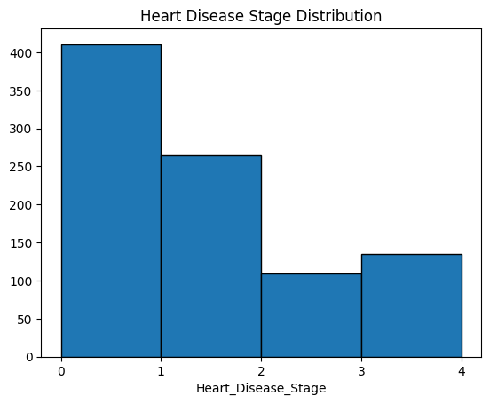
Q2.
- Identify the best decision tree (DT) that predicts Heart_Disease_Stage.
  - A decision tree with a depth of 3 performed best.
- Describe how you reach the final DT. Show necessary steps (e.g., training error vs. testing error) and the results of your model.
  - I tried decision tree depths of 1, 3, 5, 7, 9, and 11 and found that 5 produced the best scores. I noted that lower values such as 3 didn’t ever predict some stages (and were thus affected by imbalance classes) and assume that the higher scores grew worse due to overfitting. It can be seen that the model predicts classes 0, and 1 well, but starts to perform poorly then fail for 3, 4, and 5. The poor performance with less representative classes is the effect of imbalanced classes.
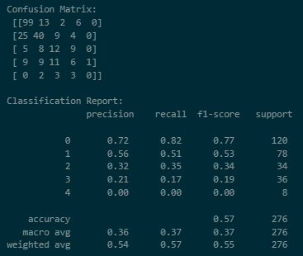
- Perform oversampling technique(s) and report the difference in predictive performance.
  - In order to oversample, I grouped values by each target value then sampled to ensure they each had the same number of samples. I noted that the largest group was 411 so I chose to sample each group 500 times.
Using this technique I built a model that performed slightly worse for the most common case but better for all other cases, thereby making it a far better model. It should also be noted that this case has a lower accuracy, but that serves as an example that you can’t trust accuracy alone.
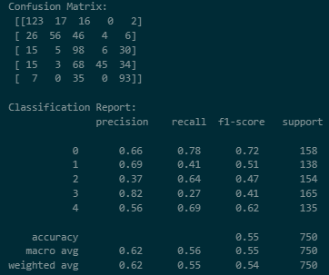
- Discuss possible concerns from the perspective of bias and variance.
  - Oversampling reduces the bias towards the majority class. This can be seen in the first models excellent prediction of the 0 class. Unfortunately by adding copies of the same data multiple times, oversampling can cause the model to overfit the less represented classe.
Q3. Find the best performing RandomForest, AdaBoost, and Gradient Boosting models. Describe your steps for the search, and report the key parameters use, and the results of these three best performing model.
Next I repeated the process above for the Random Forest, AdaBoost, and Gradient Boosting classifiers. The results are as follows.
Random Forest:
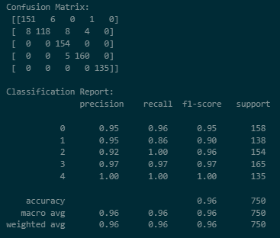
AdaBoost:
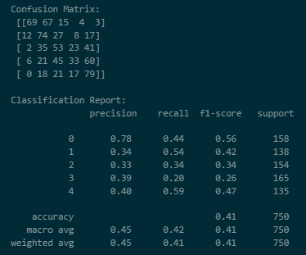
Gradient Boosting Classifier
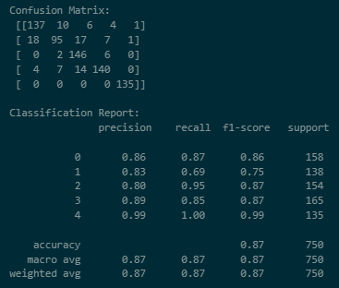
It can be seen that the Random Forest classifier performs the best overall, correctly predicting nearly every class. In the fact that it appears that class 4, the least representative class is has been oversampled due to it’s relative rarity. A similar effect can be seen in the gradient boosting classifier, but could likely be corrected by reducing the learning rate. AdaBoost doesn’t seem to be affected by the oversampling but does not appear to perform well.
Q4.
- Use Lasso Regression to perform feature selection.
  - I used lasso regression but ended up with coefficients of 0 for each variable, meaning that I made a mistake somewhere, but I was not able to find the cause.
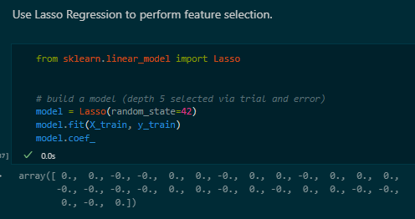
- Then, use multiclass-logistic regression and predict the Heart_Disease_Stage with the selected features. Next, compare the performance with the best performing model you find in #Q3.
I was unable to complete this step as written, so instead I just performed multi class logistic regression. The results don’t appear to be overfitting the more heavily oversampled classes like Gradient Boosting and Random Forest classifiers tended to. These results more closely mirror the results of the AdaBoost classifier.
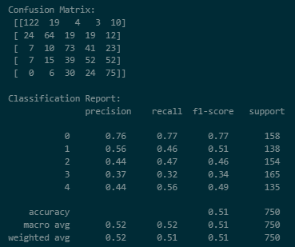
- Multiclass-logistic regression is most likely to receive lower performance than the best performing model from #Q3. Discuss what might be the reasons?
I was unable to complete the lasso regression feature reduction but will answer based on the results of logistic regression regression for all features. Even though some models appear to overfit due to oversampling, this model does not seem affected. Unfortunately, it still seems to perform more poorly than the ensemble methods above. The lower model performance seems to imply that the relationship does not fit logistic behavior well or at least requires further kernel transformation ensures the data matches the regression model.
Q5. Use the same parameter you used for best performing model in #Q3, and run XGboost and compare the predictive performance with the best performing model in #Q3. Note that XGboost uses both L1 and L2 regularization. Discuss why you may see such differences in the performance from the perspective of bias and variance. Notion of regularization and brief explanation of L1 and L2 should be included to gain full points.
XGBoost still appears to overfit the less representative classes and it’s performance appears very similar to Random Forest.. Unfortunately, I did not have time to answer this question fully.
