Song Bench Onboarding Portal
  - Solution Architecture Design (SAD)
Document ID: SONG-SAD-001
Version: 1.2 — Proposed Baseline (dashboard review and mockup)
Status: Proposed; requires product, security and operations approval
Date: 21 October 2026
Classification: Internal working design; contains no production secrets
Purpose: Define the intended solution as if architecture work had preceded development. Existing code informs the baseline but does not constitute a binding product specification. Target-state functionality remains proposed until approved and implemented. This document does not claim current conformance.
Evidence qualification: Repository observations and artifact references are supplied by the source baseline; they have not been independently inspected for this document. Current-state observations are dated 21 October 2026.

Document control
Item | Details
Business owner | Song Bench onboarding owner — to assign
Product owner | Bench coordinator representative — to assign
Architecture / engineering owners | Solution architect / application team — to assign
Reviewers | Identity/security, data/privacy, operations, accessibility and bench coordinators
Decision status | Proposed; not an accepted ADR
Approval gates | Scope and flows; security and data; MVP acceptance; deployment readiness
Version history | 1.0 · 20 October 2026 · Reconstructed product-first architecture baseline from supplied repository observations and proposed target state  1.1 · 21 October 2026 · Reviewed supplied revision; separated target navigation from legacy disposition, reconciled announcement and administration scope, clarified assignment atomicity and retained evidence qualifications.  1.2 · 21 October 2026 · Recorded Welcome/sign-in versus authenticated dashboard boundaries; retained /dashboard as the Song Site management hub; aligned BO-01, FR-02, assignment discovery and screen inventory; specified permission-filtered cards, collapsible sidebar and separated settings; added an illustrative dashboard render and shell acceptance criteria. No implementation or approval status is inferred.
Reading guide: Current-state observation identifies supplied source evidence. Target design identifies proposed functionality or engineering approach. Open decision identifies a choice requiring an accountable owner and formal approval.
Contents
Document control 1
1. Executive summary 3
2. Business context and problem definition 3
2.1 Current-state baseline — supplied observations 4
3. Scope and boundaries 5
4. Stakeholders, actors and access model 5
5. Functional architecture and requirements 6
5.1 Content model and proposed stages 7
6. User experience and end-to-end process flows 7
6.1 Global navigation 7
6.2 Flow A — First visit and assignment discovery 10
6.3 Flow B — Coordinator creates an assignment 10
6.4 Flow C — Member task lifecycle 11
6.5 Flow D — Coordinator monitoring and resolution 12
6.6 Flow E — Assignment completion and closure 12
6.7 Flow F — Template publication 13
6.8 Flow G — Offboarding, re-entry and exceptions 13
7. Information architecture and screen inventory 13
7.1 Existing route disposition 14
7.2 Target page states 15
8. Logical application architecture 15

1. Executive summary
Song Bench Onboarding Portal is a small, secure, task-oriented web application for members entering Song Bench and coordinators managing their onboarding. It provides one entry point for required steps, reference materials, completion evidence metadata and assistance. It does not replace corporate HR, learning, talent, compliance or skills systems.
Primary outcome: Members know their next action, can resume their plan and demonstrate completion. Authorized coordinators can assign, monitor, support and close onboarding without changing another member’s task state.
Architectural choice: Angular web client, versioned Express REST API and PostgreSQL relational persistence in a modular monolith. Identity resolution and authorization are enforced server-side. Existing identity and authoring foundations are reused only where they contribute to the MVP. SQLite may support rapid local tests; PostgreSQL is the database to qualify for production.
Release gate: Two members complete the same template independently through sign-out and service restart without cross-member leakage. A scoped coordinator sees correct aggregate state. Members cannot assign, approve or alter another member’s onboarding.

2. Business context and problem definition
Problem statement. The supplied baseline describes generic site pages, a member-looking journey, shared task tracking, a separate training tracker, links, announcements and privileged content editing. Shared task-status mutation does not reliably support independent per-person onboarding. The target design therefore begins with a product journey rather than with existing technical decisions.
Benefits and success measures. Intended benefits are reduced ambiguity, fewer recurring coordinator questions, visibility into blockers and durable completion records. No numerical efficiency or ROI claim is assumed. Measures include assignment coverage, first-action rate, completion rate and elapsed time by approved template, blocker count and age, coordinator intervention, end-to-end usability and accessibility. Measures are operational and must not become punitive individual rankings.
ID | Business objective | Acceptance
BO-01 | Clear starting point | First authenticated Song Site dashboard shows authorized site areas, assignment summary and next action, or an honest no-assignment state.
BO-02 | Consistent onboarding | Approved templates yield consistent tasks and instruction versions
BO-03 | Individual accountability | Each task state/event belongs to one assignment and actor
BO-04 | Operational visibility | Scoped coordinator sees required tasks and blockers
BO-05 | Minimal operational burden | Ordinary template/resource text and link edits need no code change
BO-06 | Trustworthy completion | Required tasks and approvals determine completion, not an editable percentage

2.1 Current-state baseline — supplied observations
Area | Reported evidence and qualification
Landing/dashboard | The supplied revision identifies / as the Welcome/sign-in entry and /dashboard as the authenticated Song Site hub with shared spotlight, announcements and navigation. Assignment-aware summaries, permission-filtered tools and the shell behavior specified in Section 6.1 remain target design unless separately qualified.
About Us | /aboutus has hardcoded cards; authoring is outside MVP unless approved.
Journey / training | /my-journey mutates shared legacy tasks; /training-tracker is separately API-backed. Neither establishes member-owned assignment state.
Announcements | /announcement supports published versions, draft, preview, publish, restore and audit locally. Production identity/release qualification remain incomplete.
Contact | /contactus is a client-side form; persisted support workflow is not assumed.
Links / leadership | /atcp-song-links and /atcp-song are API-backed; /other-links is static. Resource consolidation requires approval; leadership is separate.
Coordinator / template administration | No assignment/verification UI, onboarding template editor or general audit lookup is reported. Announcement authoring is page-specific.
Identity / storage | Development identity and SQLite exist. Entra API validation and PostgreSQL production parity are incomplete.
Legacy Journey and Training Tracker status must not be represented as independent member completion. Preservation and migration follow Section 16.

3. Scope and boundaries
In-scope MVP: Corporate sign-in and mapped member identity; one active assignment per defined member onboarding cycle; versioned template stages, required/optional tasks, sequencing and instructions; personal transitions and completion evidence metadata; resources/help; scoped coordinator assignment, monitoring, blocker resolution, verification and closure; administrator template publication and limited resource management; audit, standard errors, telemetry and basic runbooks.
Out of scope: Replication/editing of HR, talent, skills, curricula or compliance records; unsanctioned external completion synchronization; employee performance scoring, staffing/ranking, talent matching, timesheets, approval hierarchies, social feeds, organization charts, AI tutors or autonomous agents; general-purpose CMS, custom forms, mass messaging; broad role-management UI unless existing authorized administration is insufficient; CV files and sensitive compliance evidence by default.
Authority boundaries: The identity provider owns authenticated identity. HR, learning, skills and compliance platforms remain authoritative for their own records. The portal database is authoritative only for portal assignment and progress history. Members self-report permitted tasks; scoped coordinators assign and verify; administrators publish configuration. A member’s “done” action does not prove external-system completion. Validation-required tasks need coordinator review or a later approved integration.

4. Stakeholders, actors and access model
Actor | Permitted access/change | Controls
Unauthenticated visitor | Sign-in and approved authentication help/errors only; no persisted changes | No authenticated pages or member records
Member | Own plan/history, public resources; own eligible transitions and support request | No template edits, own verification approval or other member access
Coordinator | Scoped plans, blockers and reports; assign, verify, reopen and close with reason | Mandatory cohort/resource check; no role-grant edits or policy bypass
Administrator | Draft/published templates and resources; controlled publication/settings | No fabricated completion or approval bypass
Support operator — optional | Limited diagnostics and approved support operations | No sensitive evidence access by default
Roles alone are insufficient. Every read and write additionally checks ownership or cohort membership. Missing identity/scope mapping defaults to denial. Client navigation visibility is not a security boundary.

5. Functional architecture and requirements
ID / priority | Capability and acceptance behavior
FR-01 Must | Sign-in resolves enterprise subject to local member ID; safe mismatch error.
FR-02 Must | Song Site dashboard: authorized site navigation, spotlight and published announcements; server-derived assignment summary, required tasks, next action, blockers and help when assigned. Supports an accessible collapsible sidebar and separately permissioned utility settings without expanding MVP administration scope.
FR-03 Must | Assignment pins immutable published template/version.
FR-04 Must | Task lifecycle: start, self-complete, request help, permitted completion note.
FR-05 Must | Coordinator accepts/returns verification tasks; reason and actor retained.
FR-06 Must | Scoped assignment of eligible mapped member; duplicate prevention.
FR-07 Must | Progress derived from required tasks and verification.
FR-08 Must | Blocked, authorized waiver/reopen with reason, overdue advisory.
FR-09 Must | Relevant instructions and canonical resource links per task.
FR-10 Must | Coordinator search/filter by assigned scope, state, stage and blockers.
FR-11 Must | Controlled draft/publication; no silent retroactive template changes.
FR-12 Must | Audit actor, subject, timestamp, prior/new state and required reason.
FR-13 Should | Published announcements; existing guarded editing may initially be reused.
FR-14 Later | Authorized CSV export subject to privacy/minimization/retention.
FR-15 Later | Notifications only after channel, opt-out and governance decisions.

5.1 Content model and proposed stages
Starter content requires bench-owner review and is not a statement of official policy. Each task defines title, purpose, procedure, external URL where applicable, owner, required flag, dependencies, optional expected effort, verification rule, help contact and last review date. Stage names must not imply certification of external completion.
Stage | Examples / proof approach
1. Welcome and orientation | Bench guide, contacts and support path; self-attestation.
2. Personal readiness | Contact and profile-update guidance; links/self-attestation, no protected-data copies.
3. Skills and learning | Skills profile, learning paths and next learning action; self-attestation or approved verification.
4. Engagement readiness | CV/profile guidance, resource and availability processes; links and limited status.
5. Review and closeout | Resolve blockers, review required items; computed eligibility plus coordinator closure.

6. User experience and end-to-end process flows

6.1 Global navigation
Member navigation follows Dashboard → My Onboarding → Task Detail → Resources and Help → Profile/Sign Out. Coordinators additionally access scoped members, verification/resolution and assignment management. Administrators access templates, draft/preview/publication, resources and restricted audit; user administration remains separately permissioned and conditional on approved scope. No-plan state explicitly says “No onboarding assigned” and supplies the correct coordinator contact, rather than misleading 0% progress.
Figure 1 summarizes target navigation only. Section 7 is the canonical target screen and route inventory; Section 7.1 is the canonical legacy route disposition register; Section 16 defines migration sequencing and data treatment. Legacy redirects and separate content surfaces are not additional target onboarding workspaces. Each migration requires an approved owner, target API, authorization rule, review lifecycle and redirect or retention decision.
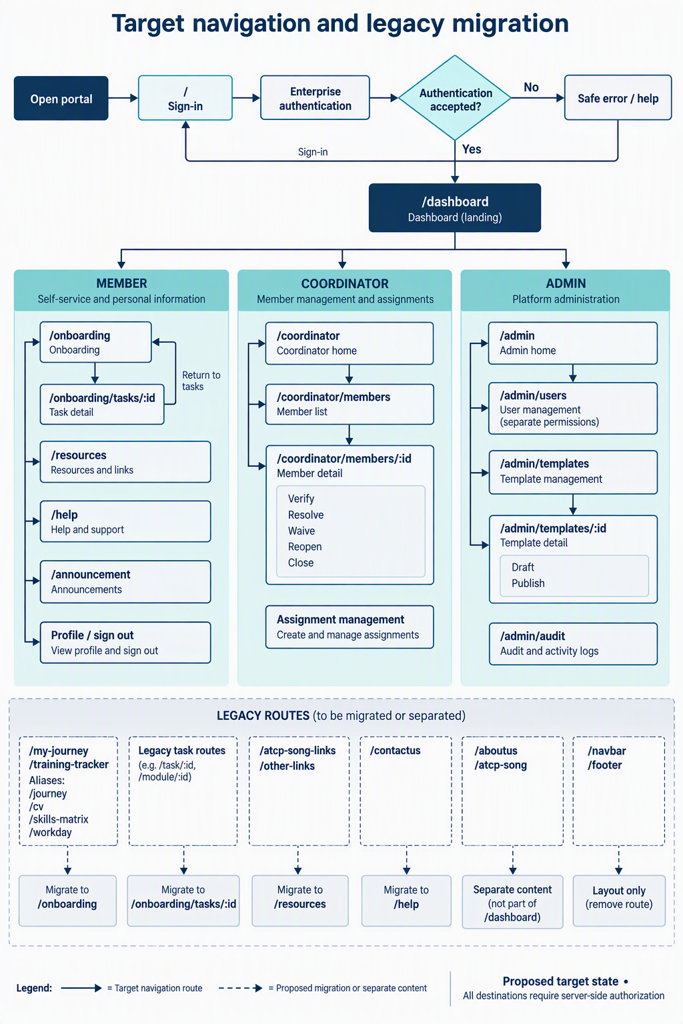
Figure 1. Navigation model for member, coordinator and administrator experiences. Administrator destinations are peers with separate permissions, not a required sequential workflow. Legacy route decisions are maintained in Section 7.1.
6.1.2 Dashboard shell contract and recorded changes
Welcome boundary: / remains the unauthenticated Welcome/sign-in entry with safe authentication help; it exposes no member status. “Welcome and orientation” is an onboarding stage, not a new route. After accepted authentication and identity mapping, the user enters /dashboard.
Dashboard before → target: Retain shared spotlight, published announcements and site navigation; add assignment-aware summaries and authorized workspace entry points. /dashboard is the Song Site management hub, not a task-detail page or an authoritative status/permission store. /onboarding retains the full member plan.
Sidebar: Expanded mode shows icons and labels; collapsed mode shows named icons with discoverable tooltips. Toggling preserves route and domain state. A visible separator divides tools from the lower settings utility. Browser persistence may store presentation preference only.
Permission and scope: Cards and destinations require server-resolved permissions and scoped data. My Onboarding is member-owned; coordinator work is cohort-scoped; Templates and Audit are separately authorized. User Management, Roles and Permissions remain conditional on approved administration scope, API contract, owner, work package and tests; their depiction does not authorize MVP expansion.
Theme and states: Implementation inherits existing Song Site theme tokens, typography, spacing, focus and responsive behavior, without a dashboard theme fork. Each card loads and fails independently and exposes loading, empty, stale, failure or unavailable state honestly. Missing permission hides the relevant tool/card and must never appear as a zero or successful result. Settings are limited to approved user/application settings.
Dashboard visual concept — proposed, illustrative data only
The render depicts the shared shell using a fictional authorized member view, plus expanded/collapsed navigation and a conditional-administration inset. Sample totals are 4 of 8 required tasks satisfied (50%), one blocked task and one awaiting verification; pending verification is not counted complete and the assignment remains active. “No onboarding assigned” is an alternate state, not a zero-progress plan. The palette is provisional because repository theme tokens were not supplied; implementation must reuse the actual Song Site theme. This static image is not a working application or an accessibility conformance claim.
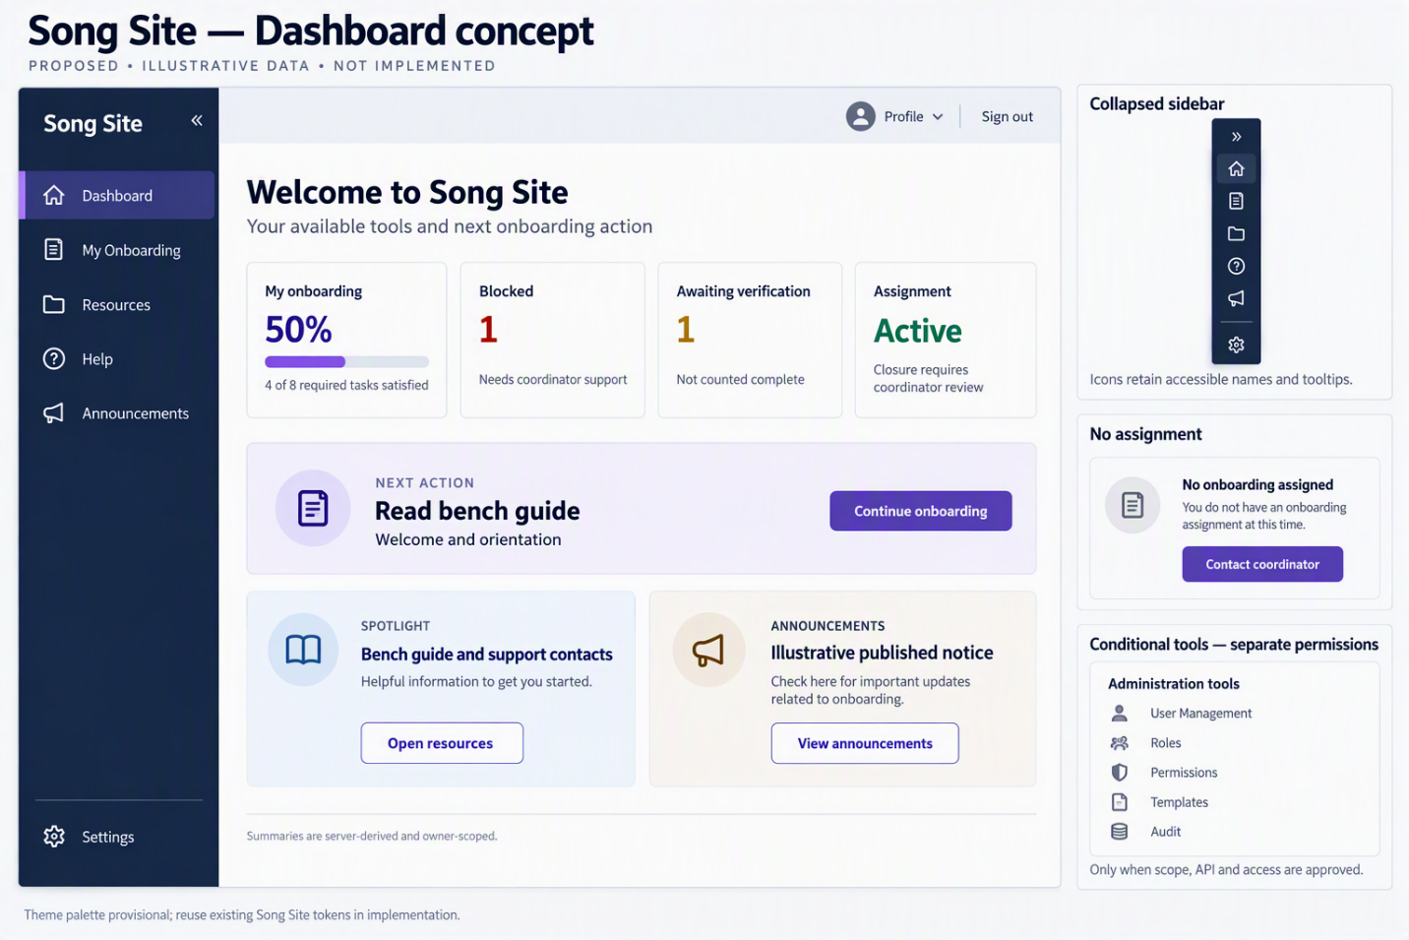

6.2 Flow A — First visit and assignment discovery
Preconditions: Enterprise account, onboarding eligibility and published template. The portal authenticates, calls GET /api/v1/me and /api/v1/me/onboarding, validates identity, resolves the local subject and loads the member’s assignment. Accepted authentication opens the Song Site dashboard with authorized navigation, spotlight and published announcements. An active assignment adds the owner-scoped summary and next action; no assignment adds an honest empty state/help contact without hiding otherwise authorized site areas.
Exceptions: Invalid session returns to sign-in; unrecognized identity receives support guidance without auto-provisioned privileges; inactive assignment is read-only; API failure shows retry/error, never fabricated completion.
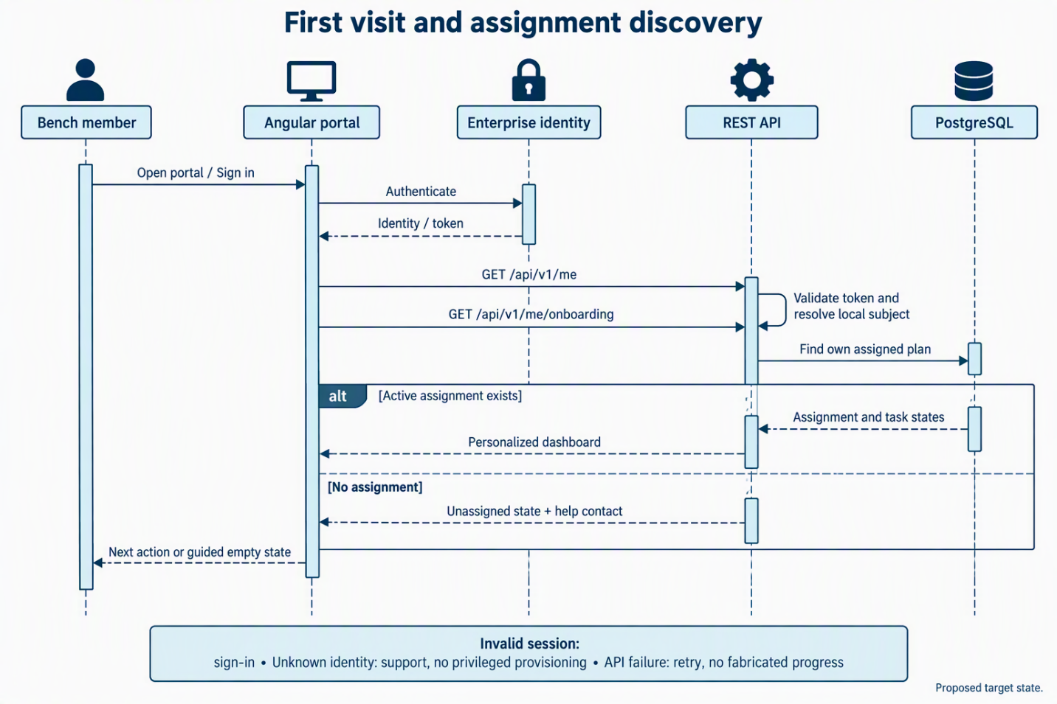
Figure 2. First authenticated visit and owner-scoped assignment discovery.

6.3 Flow B — Coordinator creates an assignment
The server checks onboarding:assign and cohort scope, validates member eligibility and duplicate cycle, and accepts only an active published template. A single transaction creates the assignment, pins its template version, instantiates tasks as not_started and appends the assignment audit event before commit. The member sees the plan on refresh. Duplicate requests return an existing result or deterministic conflict; unpublished templates and out-of-scope assignments are rejected. Partial failure rolls back the complete transaction, including audit.
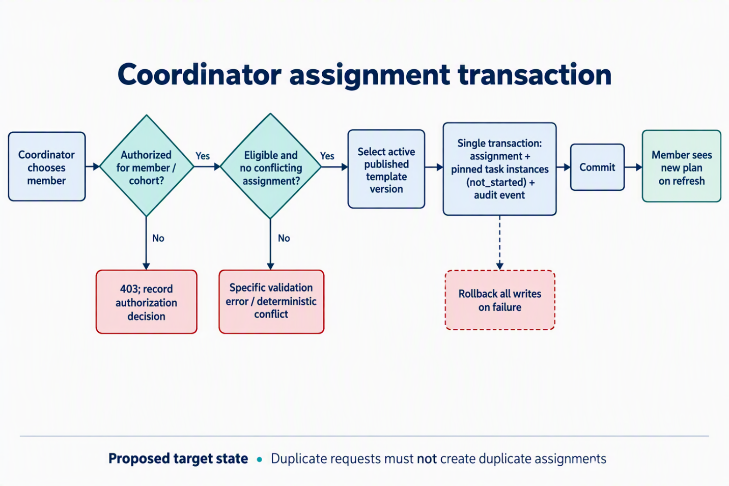
Figure 3. Authorized assignment creation with atomic task initialization and audit.

6.4 Flow C — Member task lifecycle
Members read task goals, instructions, references, acceptance rules and help contact. Start sets in_progress; Need help sets blocked with an optional safe description. Self-attested completion sets completed; verified tasks instead enter awaiting_verification. State and append-only history are written atomically, and the server recalculates progress and next action. Dependencies remain unavailable until satisfied with a clear explanation.
Repeated submissions are idempotent. Stale expectedVersion returns 409 without overwrite. Invalid notes are rejected; disabled/offboarded users cannot mutate. A waiver counts as satisfied only under explicitly approved policy and retains actor/reason. Pending verification never counts as complete.
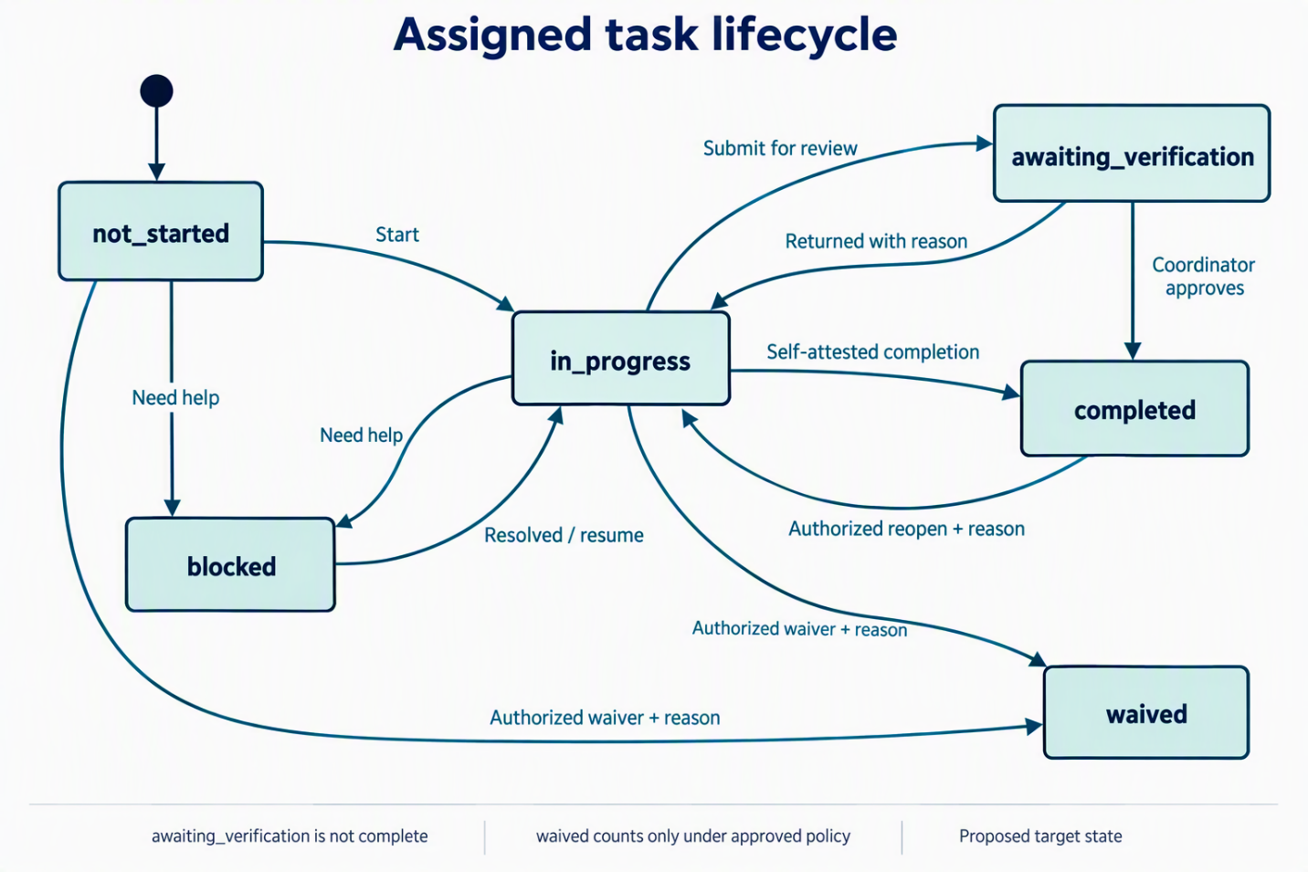
Figure 4. Task state machine, including verification, blocking, controlled reopening and waiver.

6.5 Flow D — Coordinator monitoring and resolution
The coordinator filters scoped blocked or awaiting_verification tasks, opens the permitted plan/activity and approves or returns review items with a reason. Independent-review tasks prohibit self-verification. Resolution records the action/instruction and resumes in_progress, or applies an authorized, reasoned waiver. The member sees the resulting state and explanation.

6.6 Flow E — Assignment completion and closure
Required-task satisfaction determines closure eligibility, not automatic closure. A scoped coordinator reviews the plan and exceptions and explicitly closes it with actor/time. A 100% percentage therefore does not mean approved closure. Closed assignments are read-only under retention policy; reopening needs an authorized transition and reason.
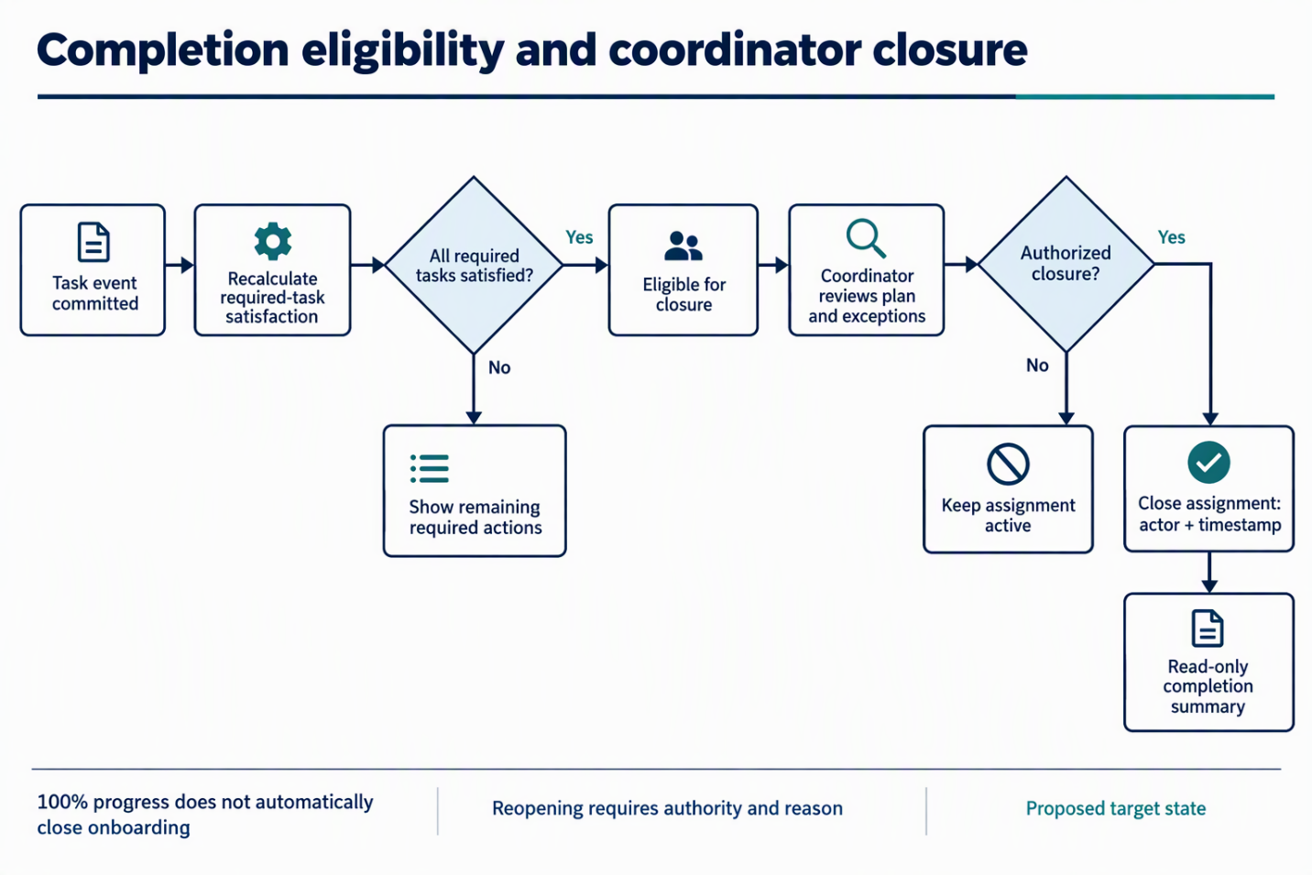
Figure 5. Required-task satisfaction, review and explicit assignment closure.

6.7 Flow F — Template publication
Draft → edit stages/tasks/dependencies/instructions → validate required fields, links and absence of dependency cycles → member preview → publish immutable version → make available to new assignments. Existing plans remain pinned. Migration to a newer version is a separate authorized, audited process, never a silent edit.

6.8 Flow G — Offboarding, re-entry and exceptions
Inactive users cannot create events; retained history follows policy. Re-entry creates a new cycle assignment while preserving prior cycles. Retired templates cannot be newly assigned, but existing plans remain readable. Removed links show reviewed alternatives/help without erasing status. Failed external platforms or connectivity may produce blocked, never an assumed external requirement completion.

7. Information architecture and screen inventory
Target route | Functions / access
/ | Enterprise/approved local development sign-in, safe help/error; unauthenticated entry
/dashboard | Song Site management hub: authorized site navigation, spotlight, published announcements, assignment-aware onboarding summary and role-specific workspace entry points; authenticated user. Task execution remains in /onboarding/tasks/:id.
/onboarding | Ordered stages, filters, state; member
/onboarding/tasks/:id | Instructions, links, transitions, help; owner
/resources; /help | Curated resources/review metadata and coordinator escalation; authenticated
/coordinator | Review queue, blockers, summaries; coordinator
/coordinator/members | Scoped roster/search/assignment; coordinator
/coordinator/members/:id | Verify, waive, resolve, close; scoped coordinator
/admin/templates; /admin/templates/:id | Draft/edit/preview/publish/retire; administrator
/admin/users; /admin/audit | Separate identity/role/account administration and restricted event investigation; separately authorized
Retained content and conditional administration: /announcement remains a separately authorized published-content destination linked from the dashboard where appropriate; it is not an onboarding task workspace. /admin is a navigation entry to separately permissioned administration destinations, not a grant of access. Assignment management is a coordinator function; no additional route is assumed until its screen design is approved. /admin/users remains outside the onboarding MVP unless approved identity administration requires that experience.
Primary navigation avoids implementation-centric page names. The disposition of the existing Journey and Training Tracker routes is defined in Section 7.1.

7.1 Existing route disposition
Existing routes | Disposition / decision
/dashboard | Retain as canonical Song Site management hub; add assignment-aware summaries without making it the task-detail surface. Approve role-specific cards, independent data-loading boundaries and honest no-assignment/unavailable behavior.
/aboutus | Retain informational page outside workflow; confirm owner/authoring.
/my-journey; /training-tracker | Redirect/consolidate only after assignment APIs qualify; define read-only period, parent-task/history migration.
/my-cv, /my-skills-matrix, /my-mycompetency, /my-myriro, /my-workday, /my-asset-tracker, /my-update-contact, /people-lead, /my-compliance, /wd-update-contact, /my-learning-platform | Map each to an approved task and redirect or render through /onboarding/tasks/:id.
/announcement | Retain notices and page-specific authoring separately; decide general versus onboarding content.
/atcp-song-links; /other-links | Candidate /resources catalog only after ownership, canonical URL and review metadata.
/contactus | Retain or redirect to /help; decide persistence, routing, support SLA and retention.
/atcp-song | Retain separate leadership/capability surface; confirm MVP relevance.
/atcp-song2; /song3; /song-bench | Explicit product-owner retention, redirect, retirement or exclusion decision.
/journey; /cv; /skills-matrix; /mycompetency; /workday | Preserve compatibility redirects during migration. /journey resolves to /onboarding after qualification; task-specific aliases resolve through approved task mapping, not a blanket redirect to the plan. Deprecate only after consumer verification.
/navbar; /footer | Layout-only; remove navigable routes after checking external consumers.
No route is migrated until redirect/read-only behavior, owner, target API, authorization and removal evidence are documented.

7.2 Target page states
Every authenticated screen defines loading, empty, forbidden, not-found, API failure/retry, expired-session and read-only states. Dashboard/plan show No onboarding assigned rather than false zero progress. Task detail supports dependency blocking, pending verification, returned-for-rework, waiver, completion and stale conflicts. Coordinator denial does not reveal inaccessible member existence. Template editing covers validation, dependency cycles, publish conflicts, preview and immutable-version confirmation. Resources/help show stale/unavailable links honestly with owned escalation.
Dashboard-specific states: Permission-filtered tools/cards never expose unauthorized data or render missing permission as zero. An assigned plan with zero required tasks shows “Not configured.” A genuinely unassigned member sees “No onboarding assigned” and coordinator contact. Pending verification is excluded from satisfaction, and closure is displayed separately. Failed or stale summaries identify their state and offer permitted retry without blocking unrelated authorized areas.

8. Logical application architecture
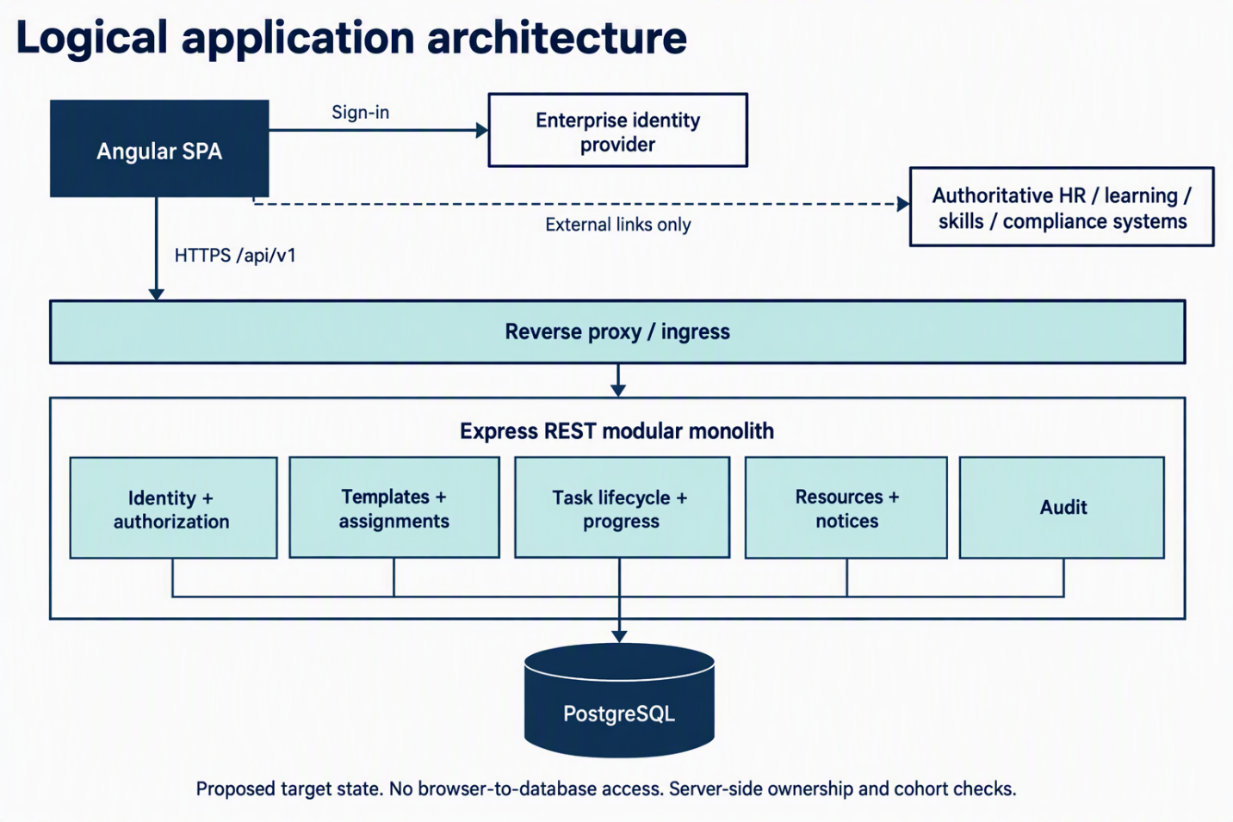
Figure 6 — generated; embedding unverified: Logical application architecture. Angular SPA → HTTPS /api/v1 → reverse proxy/ingress → Express REST modular monolith. Peer modules: identity/authorization, templates/assignments, task lifecycle/progress, resources/notices and audit; all persist to PostgreSQL. Browser redirects to enterprise identity for sign-in and opens authoritative enterprise platforms through external links only. Browser never connects to the database.

8.1 Component responsibilities
Component | Responsibility / invariant
Angular UI | Accessible navigation/forms presenting server state; no authoritative role/progress calculation.
Identity adapter / policy | Validate token/session and stable subject; never trust supplied user ID. RBAC plus owner/cohort checks on every read/write; fail closed.
Template / assignment services | Validate immutable publication, pin versions, transactional enrollment and duplicate active-cycle prevention.
Task / progress services | Validate transitions, audit and optimistic-lock; deterministically derive remaining/completed tasks and closure eligibility.
Resources / audit | Canonical reviewed links; immutable event trail with no secrets/unneeded sensitive payloads.
Repository / database | Transactions, constraints and migrations; PostgreSQL authoritative in production.

8.2 Deployment and implementation constraints
Serve Angular static artifacts behind HTTPS ingress; route /api/v1 to stateless Express instances. PostgreSQL runs on an approved managed/internal service with restricted networking and backups. Approved operations alone access health/readiness and structured diagnostics. Cloud subscription, DNS, network and secrets manager remain deployment decisions.
Principles: modular monolith, versioned API contracts, validated input, single source of truth, independent member state, explicit external-link boundaries, controlled template versions, privacy by design, tested restore and accessible responsive UI. No AI, asynchronous orchestration or automatic external synchronization is required for MVP.

9. Data architecture
Figure 7 — pending image generation: Conceptual entity relationships. Each relationship is one-to-zero-or-many: MEMBER receives ONBOARDING_ASSIGNMENT; COHORT includes COHORT_MEMBERSHIP; MEMBER belongs through COHORT_MEMBERSHIP; TEMPLATE publishes TEMPLATE_VERSION; TEMPLATE_VERSION contains TEMPLATE_TASK and instantiates ONBOARDING_ASSIGNMENT; ONBOARDING_ASSIGNMENT contains ASSIGNED_TASK; TEMPLATE_TASK is the basis of ASSIGNED_TASK; ASSIGNED_TASK has TASK_EVENT; MEMBER acts in TASK_EVENT; ONBOARDING_ASSIGNMENT has ASSIGNMENT_EVENT; RESOURCE is referenced by TEMPLATE_TASK.

9.1 Proposed entity dictionary
Entity | Key fields / meaning
members | id, enterprise_subject UNIQUE, display_name, active; minimal identity mapping.
cohorts | id, code, title, status; coordinator scope.
cohort_memberships | member_id, cohort_id, effective dates; scoped membership.
templates | id, name, status; stable definition.
template_versions | id, template_id, version, published_at, published_by; immutable release.
template_tasks | id, template_version_id, stage, title, order, required, verification_mode, dependency_ids, instructions, resource_id.
assignments | id, member_id, template_version_id, cycle_key, cohort_id, assigned_by, assigned_at, status, closed_at.
assigned_tasks | id, assignment_id, template_task_id, status, version, updated_at, completed_at; member-specific execution.
task_events | id, assigned_task_id, actor_id, event_type, from_status, to_status, reason, timestamp.
assignment_events | id, assignment_id, actor_id, event_type, reason, timestamp.
resources | id, title, url, owner, reviewed_at, status; curated reference material.
Use stable provider subjects, not email-address identity keys. Apply unique (member_id, cycle_key) if business cycle semantics permit, otherwise a partial active-cycle uniqueness constraint. Index assignments by member/cohort/status and tasks by assignment/status. Employ foreign keys, constrained states, server timestamps and versioned migrations.

9.2 Data integrity and progress rules
Published versions remain immutable and assignments retain exact version references. Members mutate only their own active task instances through allowed transitions. Task changes and coordinator overrides append history in the same transaction. Persist task state, not an editable percentage; any future cached projection needs explicit invalidation. Page visits and links prove no external completion. MVP stores minimum evidence metadata and no sensitive uploads. Retention/deletion require privacy approval.
Progress: satisfied required tasks ÷ total required tasks × 100. Satisfaction means completed or an authorized waiver explicitly allowed to count. Zero required tasks displays “Not configured,” not 100%. Optional items remain separate. Closure is a distinct state.

10. Interface and integration architecture
Method / endpoint (prefix /api/v1) | Purpose / authorization
GET /me | Identity/roles; authenticated
GET /me/onboarding | Own active/historic summary; owner
GET /me/onboarding/tasks  GET /me/onboarding/tasks/{id} | Own stages/tasks/details; owner
POST /me/onboarding/tasks/{id}/transitions | Start, complete, block, submit review; owner
GET /resources | Published references; authenticated
GET /coordinator/members | Roster/filter; coordinator cohort
POST /coordinator/assignments  GET /coordinator/assignments/{id} | Assign published version / inspect plan; coordinator cohort
POST /coordinator/tasks/{id}/decisions | Approve, return, waive, reopen; coordinator cohort
POST /coordinator/assignments/{id}/close | Close eligible plan; coordinator cohort
GET /admin/templates  POST /admin/templates | List / create draft; administrator
PUT /admin/templates/{id}/draft  POST /admin/templates/{id}/publish | Edit / validate and publish; administrator
Illustrative transition request
{ "action": "submit_for_verification", "expectedVersion": 3, "note": "Completed the required step in the linked system" }
Responses return stable task ID, state, incremented version, UTC timestamp and derived summary. Error semantics: 400 validation; 401 unauthenticated; 403 unauthorized; 404 unknown/inaccessible as policy permits; 409 stale state; 422 illegal transition; 429 throttling; 5xx internal failure. Every error has a correlation ID and excludes personal records/token details.
Integration boundaries: Validate enterprise issuer, audience, signature, expiry and mapped subject. Disable development identity outside loopback development. External destinations are approved curated links, not scraping or unsanctioned APIs. Future integrations need versioned adapters and formal owner, permission, reconciliation and failure-mode approval.

11. Security, privacy and compliance design
- Require production HTTPS and approved secure session/token handling; never place tokens in URLs or logs.
- Enforce endpoint resource authorization independently of UI guards, least-privilege cohorts, author/publisher separation and reasoned overrides.
- Validate schemas and size limits, escape/sanitize notes, prevent injection, use CSRF protection for cookie sessions and throttle sensitive endpoints.
- Use approved secrets storage, encryption in transit/at rest, restricted database access, protected backups and credential rotation.
- Minimize PII to identifier/name, cohort, progress and workflow events. Exclude health/financial data, assessment contents, CV documents and confidential HR material.
- Retain immutable, redacted audit and access history with authorized viewing and approved retention.
- Before go-live, privacy/security owners resolve retention, internal/lawful basis, subject access/deletion and monitoring boundaries.

12. Quality attributes and non-functional requirements
ID / attribute | Acceptance target
NFR-01 Availability | Operations-agreed SLO; graceful failures, no false completion.
NFR-02 Performance | Proposed p95 normal-read API response under 500 ms at agreed load, excluding external sign-in; measure in staging.
NFR-03 Integrity | Zero cross-member updates; atomic state/audit writes.
NFR-04 Reliability | Identical persisted state after restart.
NFR-05 Security | No unresolved high/critical findings; negative authorization tests.
NFR-06 Accessibility | WCAG 2.2 AA design target; keyboard/screen-reader verification.
NFR-07 Observability | Correlation IDs, structured logs, probes, errors and DB latency metrics.
NFR-08 Recovery | Backup schedule, tested restore and approved RPO/RTO before production.
NFR-09 Maintainability | Modular services/migrations and documented configuration/runbooks.
NFR-10 Compatibility | Owner-approved enterprise desktop/mobile browser matrix.
NFR-11 Privacy | Minimal fields, bounded access/reporting, approved retention.

13. Operations and lifecycle management
Environments: Local Angular/Express with optional SQLite and loopback-only development identity. CI runs unit, contract and migration tests against ephemeral PostgreSQL for production parity. Staging uses production-like ingress, enterprise identity, PostgreSQL and separate seeded nonproduction roles for E2E. Production needs approved ingress, secrets, monitoring, backups, incidents and rollback.
Deployment/rollback: Immutable artifacts pass lint/typecheck, unit/integration/E2E and dependency scans. Use backward-compatible migrations, staging smoke tests with distinct accounts, production approval and monitored sign-in/transitions. Roll back binaries through deployment strategy rather than destructive schema rollback; migrations need a tested rollback or forward-fix.
Support: Maintain owners/escalation, safe correlation-ID logs and user-versus-server fault classification. Monitor failed sign-ins, 403 trends, conflicts, migrations, latency and stale links. Task history is the principal evidence for progress troubleshooting.

14. Verification strategy and acceptance scenarios
Test | Scenario | Expected result
AT-01 | A and B share a template | Distinct task instances and independent progress
AT-02 | A completes a self-attested task | Only A changes; atomic audit and recalculated progress
AT-03 | A requests B’s task ID | Denied without leakage or mutation
AT-04 | B submits a verification task | Pending review; not counted complete
AT-05 | Authorized coordinator approves B | Completed with decision actor/reason history
AT-06 | Out-of-cohort approval attempt | 403; no mutation
AT-07 | Refresh, logout/login and API restart | Identical persisted state/history
AT-08 | Duplicate assignment request | Deterministic result; no duplicate tasks
AT-09 | Stale expectedVersion | 409; no overwritten state
AT-10 | Publish template v2 | Existing v1 plans unchanged; new plans use v2
AT-11 | All required tasks satisfied | Eligible but active until explicit coordinator closure
AT-12 | Block, waive or reopen | Authorized valid transitions, mandatory reasons/audit
AT-13 | Expired identity or production dev mode | Secure rejection; no bypass
AT-14 | External resource failure | Honest help/retry; no automatic completion
AT-15 | Keyboard/accessibility journey | Primary flows operable and understandable
AT-16 | PostgreSQL migration/restore | Constraints and prior state survive
Dashboard shell acceptance — FR-02 / BO-01
AT-17: Accepted sign-in enters /dashboard; Welcome/sign-in exposes no member data. Authorized site areas remain usable with no onboarding assignment.
AT-18: Expanded/collapsed sidebar preserves route and task state; icons have accessible names/tooltips, visible focus and keyboard operation; settings appear below a visible separator; responsive behavior is tested.
AT-19: Member, scoped coordinator and separately authorized administrator views show only permitted cards/tools. Direct unauthorized endpoint access remains denied. Conditional Roles/Permissions/User Management are absent unless approved.
AT-20: Loading, stale or failed cards never show fabricated zero/success. Verify no-assignment, zero-required-task, pending-verification and closure distinctions; one failed card does not block unrelated authorized cards.
AT-21: Sidebar preference contains presentation state only. Implementation reuses existing Song Site theme tokens; operational and accessibility evidence, not this static mockup, establishes readiness.
Definition of Done: Demonstrate the complete staging journey with two separate members, one coordinator, an approved template, a verification-required item, blocker resolution, closure, persistent state, negative authorization cases and documented release evidence.

15. Repository assessment and fit-gap analysis
Supplied evidence | Fit and target action
src/app/app.routes.ts | Standalone routes with legacy/duplicate paths; consolidate member, coordinator and admin workspaces.
src/app/song-bench/my-journey/; training-tracker/ | Presentation foundations, not proof of independent progress; refactor to assignment APIs and merge stages/categories.
backend/server.js: GET /api/tasks, PUT status, GET progress | Shared mutation model; replace with owner-scoped transition APIs.
backend/migrations*/005-relational-content.sql | Partial user-progress schema seam; evaluate migration/replacement with explicit assignments.
backend/auth/; ADR-0035 | Reusable identity foundation subject to production verification; preserve fail-closed boundaries.
RBAC migrations/tests | Add ownership and coordinator-cohort checks.
backend/content/; ADR-0036/0037 | Announcement authoring is secondary to onboarding. Retain published reading for MVP; reuse existing guarded editing only after identity and release qualification. Defer expanded authoring scope.
docs/openapi/song-site.yaml; docs/adr/ | Replace old-operation contracts through new versioned endpoints; ratify SAD and reconcile historical ADRs.
docs/runbooks/; CI workflows | Qualify operational assets against staging/production release evidence.
These supplied observations identify reuse/retirement opportunities, not target requirements or independently verified implementation status. docs/navigation-flows.md must distinguish demo/runtime facts from proposed user administration. /journey and /my-journey need deliberate semantic migration. Separate SQLite/PostgreSQL evolution requires dedicated parity tests.
Resources reuse requires owner, canonical URL, review date and lifecycle status. Contact presentation can support /help only after support routing, ownership and retention approval. /aboutus, /announcement and /atcp-song remain separate unless product scope explicitly changes.
The source baseline identifies ADR-0015 (adr/0015-user-administration-experience.md) as accepted; reconcile its actual status before approval. /admin/users manages identities, roles and account state; /admin/templates manages definitions; /admin/audit investigates approved events. Separate permissions must not be merged for navigation convenience.

16. Migration strategy
Phase 0 — Baseline and scope control. Approve flows, catalog ownership, template/assignment lifecycle, privacy and SAD. Freeze unrelated features and capture migration-study data.
Phase 1 — Domain foundation. Implement member mapping, cohorts, versioned templates, assignments, task instances/events, scoped authorization, transactions and migrations; add two-user API tests.
Phase 2 — Member journey. Replace shared-progress APIs with dashboard/task experiences; implement self-attestation, verification-pending, instructions/resources/help and resume/restart tests.
Phase 3 — Coordination and administration. Implement assignment, review, blockers, waivers, closure, controlled publishing, scoped reporting and immutable history.
Phase 4 — Qualification and cutover. Verify enterprise identity, PostgreSQL staging, security/privacy, cross-user E2E, backup/restore and smoke tests. Redirect approved legacy URLs, remove unsafe mutations after audit and launch a controlled pilot.
Phase 5 — Retirement and content governance. Verify consumers, deprecation notices, read-only retained history, removal evidence and resource/help ownership. Replacement pages alone do not justify deleting old routes.
Data migration decision: Never reinterpret shared tasks.status as member completion without trustworthy attribution. Preserve legacy data read-only where required. Migrate definitions into an owner-reviewed draft template and initialize new assignments explicitly. Member-specific historical evidence may migrate only with verified identity mapping and business-owner sign-off.

17. Architecture decision register
ID | Proposed decision | Rationale
AD-01 | Onboarding coordination, not broad intranet | Coherent, bounded product promise
AD-02 | Modular monolith | Low operational complexity
AD-03 | Member-specific assignment truth | Independent progress
AD-04 | Immutable published versions | Reproducible requirements
AD-05 | PostgreSQL production authority | Transactional relational lifecycle
AD-06 | Server RBAC plus owner/cohort checks | No UI-only security
AD-07 | External records linked, not copied | Minimized scope/governance risk
AD-08 | Completion distinct from closure | No misleading approval inference
AD-09 | No sensitive uploads initially | Privacy and operational simplicity
All AD-01–09 remain proposed. Reconcile ADR-0001 (baseline), 0003 (database), 0005 (RBAC), 0006 (Journey), 0011/0012 (domain), 0019/0020 (identity/data), 0030 (Journey truth), 0032/0035 (identity modes), 0036/0037 (authoring) and the supplied ADR-0038 reference (dashboard management hub) through cross-reference, scope alignment or explicit supersession notes. Verify ADR-0038 existence/status against the repository before approval. Retaining the shared dashboard shell does not convert the onboarding MVP into a broad intranet or expand identity administration scope. Do not overwrite historical decisions silently.

18. Delivery work packages and release plan
Package | Prerequisite | Outcome/evidence
WP-01 Product/catalog validation | None | Approved journeys and task owners
WP-02 Schema/migrations | 01 | PostgreSQL constraints and repeatable tests
WP-03 Identity/ownership | 02 | Token validation and negative scoped-access tests
WP-04 Templates/assignment API | 02/03 | Publication and duplicate guards
WP-05 Lifecycle/progress | 04 | State machine and two-member isolation
WP-06 Member UX | 05 | Sign-in through persistent task update
WP-07 Coordinator flows | 05 | Assign, verify, resolve, close E2E
WP-08 Template/resources editor | 04 | Controlled publication and v1/v2 isolation
WP-09 Operational hardening | 03–08 | Metrics, restore and release runbooks
WP-10 Production pilot | 09 | Evidence-based release decision
Prioritize the vertical slice: template → assign A and B → independent state → coordinator view → refresh/restart proof. Implement only the minimum schema, identity and UI needed to demonstrate that slice before expansion. These SAD groupings do not replace repository work-package identifiers or statuses.

18.1 Repository work-package mapping
Grouping / repository packages | Exit evidence
Baseline: WP-018–023 | Approved identity, hosting, privacy, operations and API lifecycle decisions
Persistence: WP-006, 008, 011, 014, 015, 017 | Migration-backed entities, SQLite/PostgreSQL parity and lifecycle tests
Identity: WP-007, 018, 030, 033, 035, 036, 041 | Production tokens, owner/cohort checks, 401/403 negatives
Journey: WP-002, 003, 004, 031 | Member-owned plans/transitions, compatibility migration and audit
Authoring: WP-024, 037, 038, 039, 040 | Draft/publish/restore concurrency, pinning, ownership/recovery
Workspaces: WP-016 plus new coordinator scope | Assignments, verification, closure, user administration and restricted audit
Qualification: WP-009, 017, 029, 032, 034 | Two-member E2E, accessibility, PostgreSQL CI, smoke/rollback/restore
Mappings are supplied baseline references, not verified delivery status. Owners/statuses remain in docs/work-packages.md. Register any new coordinator package there before describing implementation as planned or in progress.

19. Risks, assumptions, issues and dependencies
Type / item | Action / accountable owner
Risk: shared status falsely implies completion | No status migration without provenance; product/engineering
Risk: incomplete enterprise identity | Staging mapping/configuration validation; identity owner
Risk: excessive coordinator access | Cohort policy and privacy review; security
Risk: stale external links | Named owner and periodic review
Risk: database drift | PostgreSQL parity CI; engineering
Risk: authoring dilutes core journey | Feature freeze until P0 passes; product
Assumption: approved identity/hosting available | Confirm with platform owner
Assumption: coordinator controls assignment/closure | Confirm with business owner
Dependency: approved tasks/proof rules | Owner workshop before publication
Open: active-cycle semantics and independent verification | Product/bench owner/security
Open: cohorts, retention, notifications | Business/privacy/operations
Open: cloud topology, RPO/RTO | Platform/operations
Open: /contactus to /help persistence/routing | Product/support/privacy
Open: canonical /resources catalog | Product/content owners
Open: legacy history/read-only retention | Product/privacy/engineering
Open: users/templates/audit permissions | Product/security/identity

20. Approval checklist and next steps
- Product owner endorses purpose and exclusions.
- Bench coordinator validates workflows and task inventory.
- Security endorses identity, ownership, cohorts and audit.
- Privacy approves minimum fields, visibility and retention.
- Engineering accepts monolith, relational model and API contracts.
- Operations approves topology, runbooks and release gates.
- Architecture owner records accepted ADRs and delivery mappings.
- Demonstrate a two-member vertical slice before site expansion.
- Approve route dispositions and test redirects/read-only behavior.
- Define screen loading, empty, error, forbidden and accessible states.
- Assign resource/help/announcement/content owners and review rules.
- Reconcile SAD claims with work packages, navigation, OpenAPI and ADR status.

Appendix A. Evidence references
Supplied repository references: README.md; src/app/app.routes.ts; src/app/song-bench/my-journey/; src/app/song-bench/training-tracker/; backend/server.js; backend/auth/; backend/migrations/005-relational-content.sql; backend/migrations-postgres/005-relational-content.sql; docs/navigation-flows.md; docs/api-data-inventory.md; docs/openapi/song-site.yaml; docs/work-packages.md; docs/adr/0001-architecture-baseline.md; related ADRs and operational runbooks.
These artifacts were identified in the supplied baseline, not independently consulted during document preparation. Repository status, accepted decisions and implementation claims require owner-led reconciliation before baseline approval.

Appendix B. Glossary
Assignment: A member-specific instantiated onboarding plan.
Template: Reusable approved sequence of tasks.
Template version: Immutable published snapshot pinned by assignments.
Task instance: One member’s execution of a definition.
Self-attestation: Member declaration without external authoritative verification.
Verification: Explicit designated-coordinator approval.
Closure: Recorded coordinator action ending a cycle.
Cohort: Defined member set for coordinator scope.
ADR: Architecture Decision Record documenting a trade-off and decision status.
SAD: Solution Architecture Design defining the system end to end.
RPO: Recovery Point Objective; maximum acceptable data-loss interval. A one-hour RPO permits recovery data no older than one hour before the incident.
RTO: Recovery Time Objective; maximum acceptable time to restore service. RTO concerns service availability; RPO concerns recovered-data age.

