Madisyn Kovacic  
5/27/2024

Module 1.2 Assignment

Link to your GitHub repository: <https://github.com/jestpurr/csd-310.git>

Screenshot of your GitHub repository:  
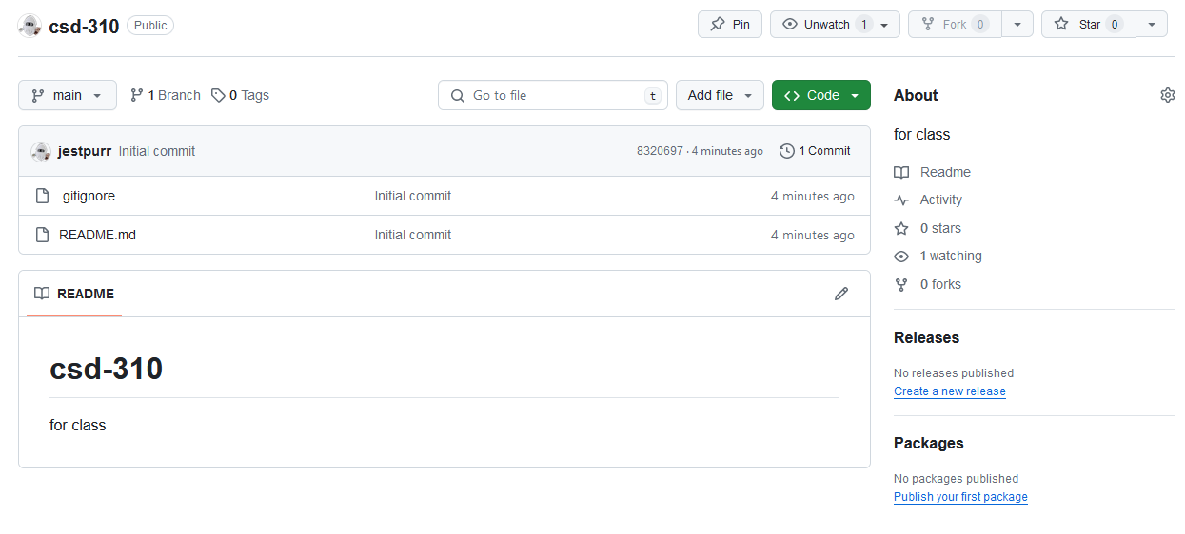

Screenshot of your local directory (properly formatted):  
  
(For the step four screenshot)