Madisyn Kovacic  
Jonathan Davis  
Deena Linehan  
Giancarlo Ruiz  
Jarred Santos  
Caleb Stark  
  
Assignment 10.1

Milestone 2:

*Revised ERD:*

*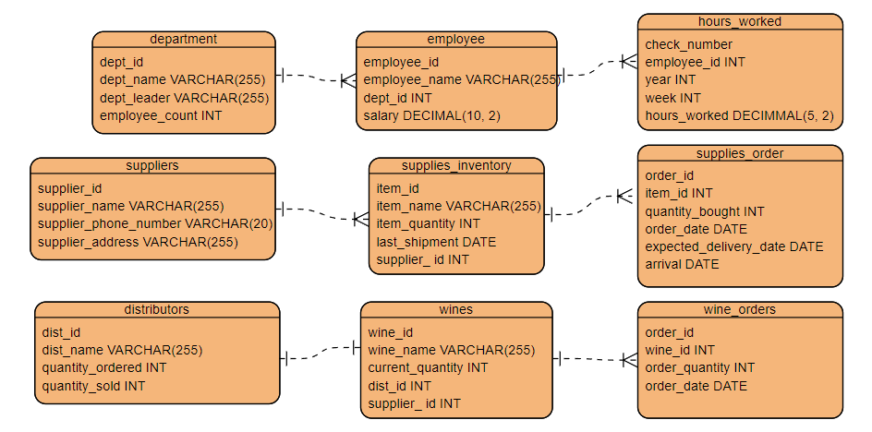*

*3NF:*

*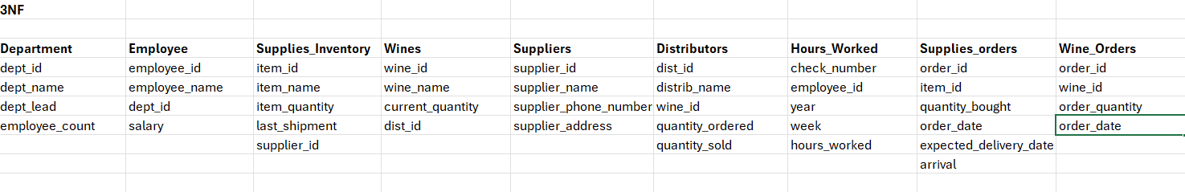*

*Script Results:*

Departments Table:

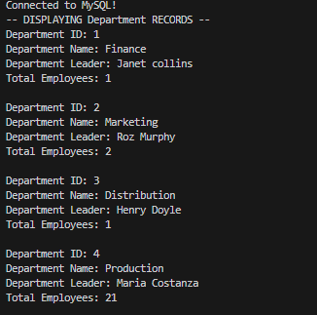

First 11 entries Employee Table:

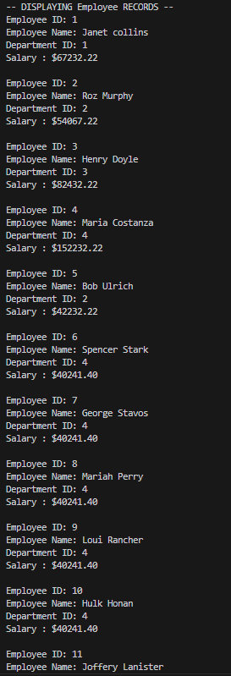

14 Checks with Hours Worked:

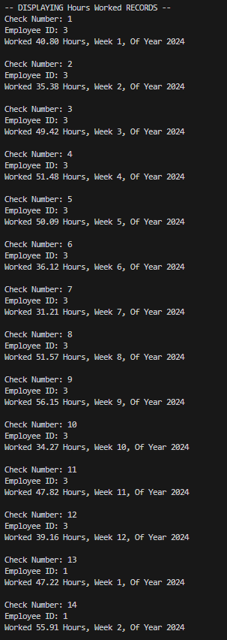

Supplier Table:

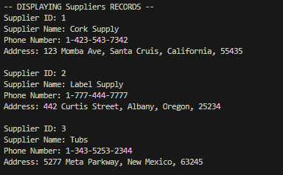

Most of Inventory Table:

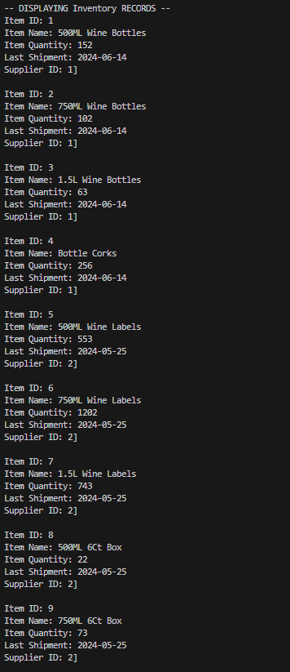

Supplies Ordered:

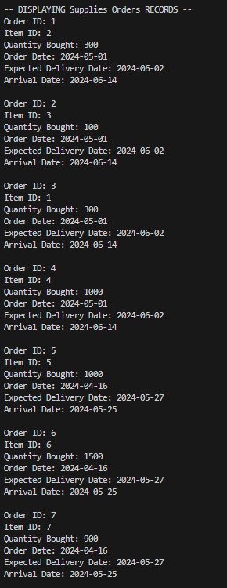

Distributors Table:

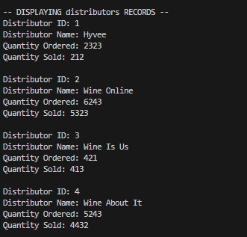

Wines Table:

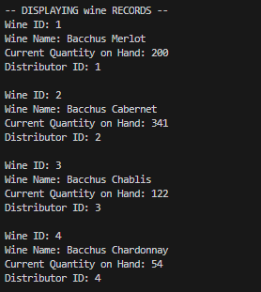

Wine Orders Table:

