Madisyn Kovacic

CSD-310

5.2

REPEAT FUNCTION

The repeat function is used to repeat a string a certain number of times, kind of like a loop. Uses I’ve seen for this function are:

* Quickly filling in data if it’s all the same, like same last names in a “Lastname” column
* Using it to generate spacers in tables
* Used to make patterns
* Used to make a progress bar, which I found the most interesting

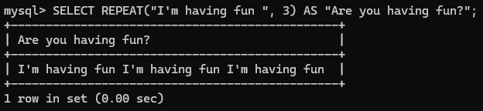  
[Source](https://www.geeksforgeeks.org/repeat-function-in-mysql/)

STRCMP FUNCTION

The STRCMP function is used to compare two strings’ length. If the value returns as 0, both strings are equal. If the value is 1, string 2 is bigger than string one. If the value is -1, string 1 is bigger than string 2. Uses I’ve seen for this function are:

* Finding data that doesn’t align. Like seeing if the data from a collum like “current_status” matched with the data in “final_status” to ensure consistency or what hasnt been done
* This is literally all I’ve seen 🙁 Other sources have just explained what it does and end it there.

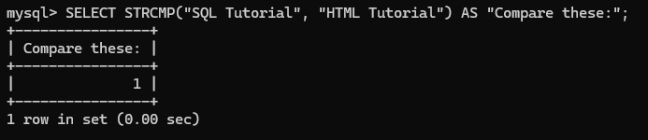  
[Source](https://www.geeksforgeeks.org/strcmp-function-in-mysql/)

POSITION FUNCTION

This function is used to find the occurrence of something within a string. Such as finding how many A’s are in the word Apple. Uses I’ve seen for this function are:

* Sorting data by how many of a certain thing it has in its strings
* Finding certain kinds of data such as substrings

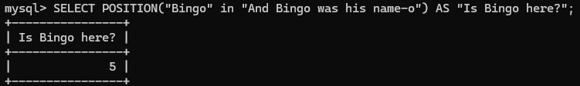

[Source](https://www.geeksforgeeks.org/position-function-in-mysql/), [Source](https://www.w3resource.com/mysql/string-functions/mysql-position-function.php)