Madisyn Kovacic  
CSD 310

Assignment 6.2

Take a screenshot of the last couple of lines you see once you've run the script:

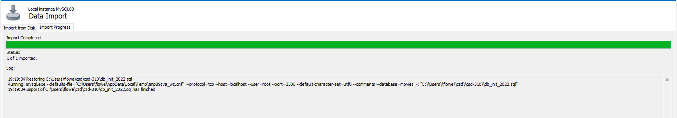  
  
Take a screenshot of the result of SHOW TABLES:  
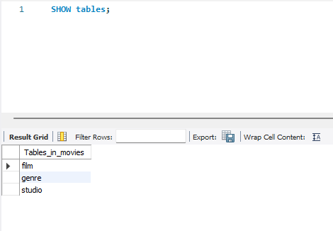  
  
Run the script and take a screenshot of the results and paste into the Word document:  
