**Figure 1:** Sample flow diagram

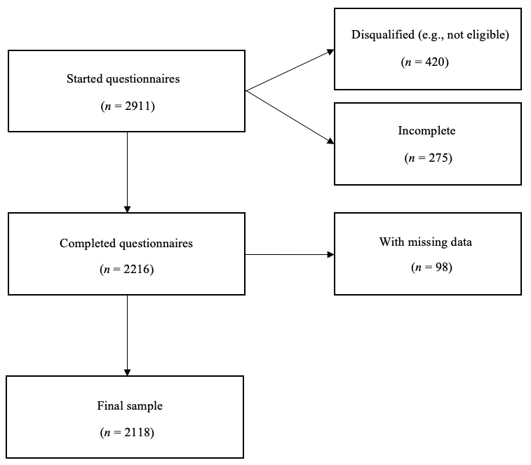

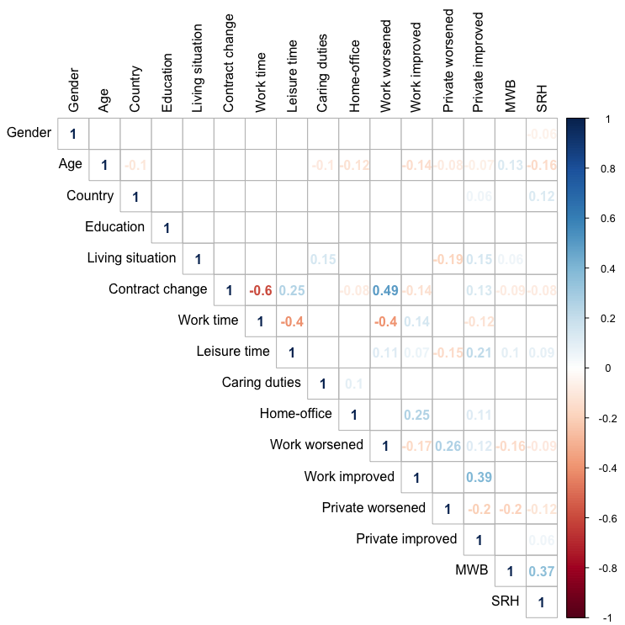**Figure 2:** Correlation matrix of the analyzed variables

Note:Only correlations with *p* < 0.01 displayed; Gender (1 = Female, 2 = Male); Country (1 = Germany, 2 = Switzerland); Education (1 = Primary, 2 = Secondary, 3 = Tertiary); Living situation (1 = Alone, 2 = With partner/family); Contract change (1 = No change, 2 = Short-time reduced, 3 = Short-time 0, 4 = Job loss); Home-office (1 = None, 2 = Experienced, 3 = New).

**Figure 3** Perceived impact on work and private life and self-reported changes in work time, leisure time, and caring duties

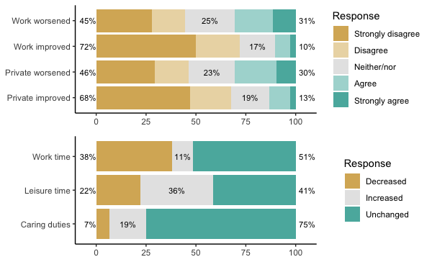

Note: Total percentage does not always equal 100% due to rounding error.

**Figure 4** Self-reported changes in home-office

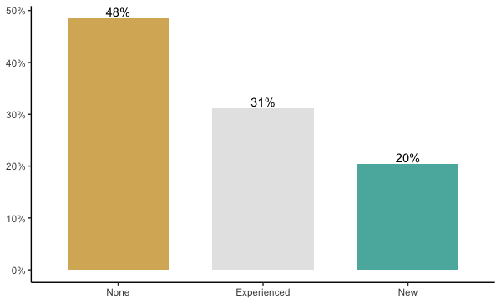

Note: None = 0% WFH before COVID-19, 0% after; Experienced = at least 10% WFH before and at least 10% after COVID-19; New = 0% WFH before and at least 10% after COVID-19

**Figure 5** Self-reported changes in contracted working hours

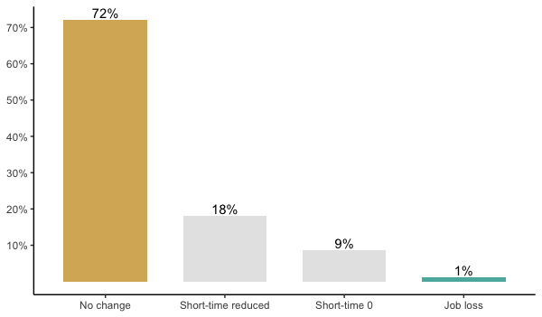

Note: Short-time reduced = work hours temporarily partly reduced by employer; Short time 0 = work hours temporarily reduced to 0 by employer