Punch Force Game Design Document (GDD)

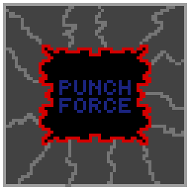

***‘Punch till you drop’*** – Jesus Alberto Marquez

This page: Table of Contents and Team Member Listing

|  |  |  |
| --- | --- | --- |
| Table of Contents  [1 Game Overview](https://n-xovwktmtjsnaxyc2mwes2xu7pohqedmdm6zjw5q-2lu-script.googleusercontent.com/userCodeAppPanel)  [2 High Concept](https://n-xovwktmtjsnaxyc2mwes2xu7pohqedmdm6zjw5q-2lu-script.googleusercontent.com/userCodeAppPanel) / Genre  [3 Unique Selling Points](https://n-xovwktmtjsnaxyc2mwes2xu7pohqedmdm6zjw5q-2lu-script.googleusercontent.com/userCodeAppPanel)  [4 Platform Minimum Requirements](https://n-xovwktmtjsnaxyc2mwes2xu7pohqedmdm6zjw5q-2lu-script.googleusercontent.com/userCodeAppPanel)  [5 Competitors / Similar Titles](https://n-xovwktmtjsnaxyc2mwes2xu7pohqedmdm6zjw5q-2lu-script.googleusercontent.com/userCodeAppPanel)  [6 Synopsis](https://n-xovwktmtjsnaxyc2mwes2xu7pohqedmdm6zjw5q-2lu-script.googleusercontent.com/userCodeAppPanel)  [7 Game Objectives](https://n-xovwktmtjsnaxyc2mwes2xu7pohqedmdm6zjw5q-2lu-script.googleusercontent.com/userCodeAppPanel)  [8 Game Rules](https://n-xovwktmtjsnaxyc2mwes2xu7pohqedmdm6zjw5q-2lu-script.googleusercontent.com/userCodeAppPanel)  [9 Game Structure](https://n-xovwktmtjsnaxyc2mwes2xu7pohqedmdm6zjw5q-2lu-script.googleusercontent.com/userCodeAppPanel)  [10 Game Play](https://n-xovwktmtjsnaxyc2mwes2xu7pohqedmdm6zjw5q-2lu-script.googleusercontent.com/userCodeAppPanel)  [10.1 Game Controls](https://n-xovwktmtjsnaxyc2mwes2xu7pohqedmdm6zjw5q-2lu-script.googleusercontent.com/userCodeAppPanel)  [10.2 Game Camera](https://n-xovwktmtjsnaxyc2mwes2xu7pohqedmdm6zjw5q-2lu-script.googleusercontent.com/userCodeAppPanel)  [10.2.1 HUD](https://n-xovwktmtjsnaxyc2mwes2xu7pohqedmdm6zjw5q-2lu-script.googleusercontent.com/userCodeAppPanel)  [10.2.2 Maps](https://n-xovwktmtjsnaxyc2mwes2xu7pohqedmdm6zjw5q-2lu-script.googleusercontent.com/userCodeAppPanel)  [11 Players](https://n-xovwktmtjsnaxyc2mwes2xu7pohqedmdm6zjw5q-2lu-script.googleusercontent.com/userCodeAppPanel)  [11.1 Characters](https://n-xovwktmtjsnaxyc2mwes2xu7pohqedmdm6zjw5q-2lu-script.googleusercontent.com/userCodeAppPanel)  [11.2 Metrics](https://n-xovwktmtjsnaxyc2mwes2xu7pohqedmdm6zjw5q-2lu-script.googleusercontent.com/userCodeAppPanel)  [11.3 States](https://n-xovwktmtjsnaxyc2mwes2xu7pohqedmdm6zjw5q-2lu-script.googleusercontent.com/userCodeAppPanel)  [11.4 Weapons](https://n-xovwktmtjsnaxyc2mwes2xu7pohqedmdm6zjw5q-2lu-script.googleusercontent.com/userCodeAppPanel)  [12 Player Line-up](https://n-xovwktmtjsnaxyc2mwes2xu7pohqedmdm6zjw5q-2lu-script.googleusercontent.com/userCodeAppPanel)  [13 NPC](https://n-xovwktmtjsnaxyc2mwes2xu7pohqedmdm6zjw5q-2lu-script.googleusercontent.com/userCodeAppPanel)  [13.1 Enemies](https://n-xovwktmtjsnaxyc2mwes2xu7pohqedmdm6zjw5q-2lu-script.googleusercontent.com/userCodeAppPanel)  [13.1.1 Enemy States](https://n-xovwktmtjsnaxyc2mwes2xu7pohqedmdm6zjw5q-2lu-script.googleusercontent.com/userCodeAppPanel)  [13.1.2 Enemy Spawn Points](https://n-xovwktmtjsnaxyc2mwes2xu7pohqedmdm6zjw5q-2lu-script.googleusercontent.com/userCodeAppPanel)  [14 Art](https://n-xovwktmtjsnaxyc2mwes2xu7pohqedmdm6zjw5q-2lu-script.googleusercontent.com/userCodeAppPanel)  [14.1 Setting](https://n-xovwktmtjsnaxyc2mwes2xu7pohqedmdm6zjw5q-2lu-script.googleusercontent.com/userCodeAppPanel)  [14.2 Level Design](https://n-xovwktmtjsnaxyc2mwes2xu7pohqedmdm6zjw5q-2lu-script.googleusercontent.com/userCodeAppPanel)  [14.3 Audio](https://n-xovwktmtjsnaxyc2mwes2xu7pohqedmdm6zjw5q-2lu-script.googleusercontent.com/userCodeAppPanel)  [15 Minimum Viable Product (MPV)](https://n-xovwktmtjsnaxyc2mwes2xu7pohqedmdm6zjw5q-2lu-script.googleusercontent.com/userCodeAppPanel)  [16 Wish List](https://n-xovwktmtjsnaxyc2mwes2xu7pohqedmdm6zjw5q-2lu-script.googleusercontent.com/userCodeAppPanel)  17 Bibliography   |  | | --- | |  | | Game Development Team Members    PRODUCER  Jesus Alberto Marquez    PRODUCTION MANAGER  Jesus Alberto Marquez    PRODUCTION COORDINATOR  Jesus Alberto Marquez  GAME DESIGNERS  Jesus Alberto Marquez  SYSTEMS/IT COORDINATOR  Jesus Alberto Marquez  PROGRAMMERS  Jesus Alberto Marquez  TECHNICAL ARTISTS  Jesus Alberto Marquez  AUDIO ENGINEERS  Jesus Alberto Marquez  UX TESTERS  Jesus Alberto Marquez |

|  |
| --- |
|  |

# 1 Game Overview

Title: Punch Force

Platform: PC Standalone

Genre: Action, Beat ‘em up

Rating: (10+) ESRB

Target: Casual gamer (aging from 12 - 30)

Serious games

Co-Op players

Release date: April 2022

Publisher: Brick Bot Productions

Description: Punch Force is a third person action beat ‘em up where the player must make his way through a level making sure he beats up every enemy he sees. For the player to pass to the next level they must knock down every enemy they see. Destroying certain pieces of the environment the player can find temporary power ups and health items.

# 2 High Concept / Genre

Punch Force sets the player in a futuristic city scape where the player is hired to beat up a criminal organization. The player can fight using their punches and weapons found thought the game. Weapons include two flashbangs that immobilize all enemies on screen temporarily (recharges every level), a brick, a pistol with just 12 shots, a laser sword that last 10 hits, and a bazooka that shots once.

# 3 Unique Selling Points

* 4 player couch co-op
* Absurd Humor

# 4 Platform Minimum Requirements

PC

OS: Windows 7 (SP1+), Windows 10 and Windows 11, 64-bit versions only.

GPU: DX10, DX11, and DX12-capable GPUs

# 5 Competitors / Similar Titles

Similar games to Punch Force is The Simpsons Arcade Game, Streat’s of Rage, and castle crashers. I want to imitate the Simpsons Arcade Game and Castle Crashers co-op mechanics.

# 6 Synopsis

A city is rampant with crimes and it’s the job of the punch force to stop it. You and your partner must go around the city and clean up the streets of crime.

# 7 Game Objectives

Knock out all enemies on screen to go to the next level. Do this till the game is over or the player dies

# 8 Game Rules

The game is a closed environment set in various city environments where the player is attacked by various thugs. The player can attack the enemy with their basic mele and different ranged weapons (see weapons). Enemy’s will spawn from different points around each level. Each time an enemy is defeated, there is a chance of a weapon dropping for the player.

# 9 Game Structure

# 10 Game Play

## 10.1 Game Controls

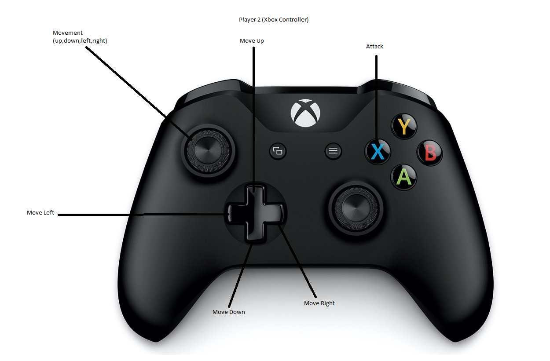

## 10.2 Game Camera

The Camera is fixed in position to show the entire level.

### 10.2.1 HUD

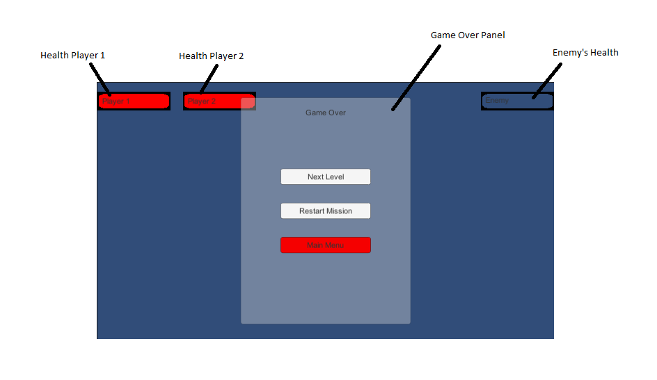

Health Player ½: Indicates each player’s health (if 1 player is selected, player 2 health is turned off)

Enemy’s Health: Displays the current enemy’s health. Changes to show whichever enemy’s health was recently attacked.

Game Over Panel: Contains basic buttons that either load the next level (if level was cleared), Restarts current level, or quits to main menu. Panel will only appear if the player’s health is depleted (both players in 2P mode) or screen is cleared.

### 10.2.2 Maps

Level 1

Level 2

# 11 Players

## 11.1 Characters

Player 1:

Blue



Green



Red



Player 2:

Blue



Green



Red



## 11.2 Metrics

Max Health: 100

Attack Damage: 1

## 11.3 States

Idle: player is not moving and is vulnerable to enemy attacks

Moving: player moves at the direction of the input and flips the image to accommodate for the direction. Animation is played during movement. Player is still vulnerable to attacks unless already attacking.

Attacking: Player is invulnerable to direct damage and deals damage to enemies.

## 11.4 Weapons

# 12 Player Line-up

# 13 NPC

## 13.1 Enemies

Enemy:



### 13.1.1 Enemy States

Idle: The enemy is only idle if the player is dead

Moving: The enemy will run towards the player, playing a movement animation until it reaches the player

Attacking: If the player is not in an attacking state, it will attack the player and play an attacking animation

### 13.1.2 Enemy Spawn Points

Each Level has a unique amount of enemy’s and spawn points. Enemy’s spawn at the beginning of a level.

Level 1:

Level 2:

# 14 Art

## 14.1 Setting

Since the game takes place in a city, the levels are designed as average city settings. A set of regular city objects block the player from moving

Level1:

Level 1 Obstacles:

Level 2:

Level 2 obstacles:

## 14.2 Level Design

Levels are made up of different city objects acting as obstacles (Ex: lamp posts).

## 14.3 Audio

|  |  |  |
| --- | --- | --- |
| 2021-08-16_-_8_Bit_Adventure_-_www.FesliyanStudios.com | Music | Starts playing after the main menu scene is selected and plays till the game is exited out |
| mixkit-boxer-punch-exhaling-2054 | FX | Plays after player begin attacking an Enemy |
| mixkit-fast-blow-2144 | FX | N/A |

# 15 Viable Product (MPV)

* One Player character
* Two controller support
* Built for PC

# 16 Wish List

Add 4 player support with each having an individual controller. Unique character for each payer. Add Xbox and Android support

## 17 Bibliography

Credits

Programmer, Art - Jesus Alberto Marquez

<https://drive.google.com/drive/folders/1qhsLDujLheyl0ZnBL4P6GRyvos-couYQ?usp=sharing>

[Jesus Alberto Marquez / CS583_S22_Marquez_JesusAlberto_Project_2A · GitLab (sdsu.edu)](https://rijeka.sdsu.edu/Jesus7134/cs583_s22_marquez_jesusalberto_project_2a)

Music by David Renda -

Royalty Free 8-Bit Background Music Downloads | FStudios. (2022). Fesliyanstudios. <https://www.fesliyanstudios.com/royalty-free-music/downloads-c/8-bit-music/6>

Punch FX in Mixkit.co

Download Free Punch Sound Effects | Mixkit. (2022). Mixkit. <https://mixkit.co/free-sound-effects/punch/>

City Tileset by Kenny -

Kenney • Roguelike Modern City. (2022). Kenney.Nl. <https://kenney.nl/assets/roguelike-modern-city>

Art made with Pixalart.com

Pixilart - Share & Create Art Online. (2022). Pixilart. <https://www.pixilart.com/>