***Final Report by Joshua Holbrook on Center for Global Change research project “Determining anisotropic thermal conductivity of snow with needle probe measurements” funded in 2010***

A new method for measuring thermal conductivity is being adapted from the method of measuring isotropic thermal conductivity in snow with needle probes as used by Sturm, Johnson and others, in order to enable the determination of anisotropic thermal conductivities. *[Sturm et al.(2002)Sturm, Perovich, and Holmgren, Sturm and Johnson(1992)]* This method has particular relevance to measuring thermal conductivity of natural snowpacks where conductivity can be strongly anisotropic due to structures that develop from vapor transport-induced metamorphism, self-compaction and other mechanisms, and where there are known discrepancies between density-conductivity relations empirically derived from guarded hot plate and needle probe methods; In fact, these discrepancies are a prime motivator for this research, as anisotropy could potentially explain them.

Both analytically-based solutions and finite element numerical solutions to the anisotropic case are used to calculate the expected effective thermal conductivity as a function of anisotropic thermal conductivity and needle orientation. The analytically-based solutions originate from modifications of

the isotropic approach as detailed by Carslaw and Jeager, and do not account for edge effects. [*Carslaw and Jaeger (1959)*] The finite element solutions are based on a 3D geometry that models edge effects; However, the mesh used for the finite element solutions is relatively coarse. The differences in trends between the models may be seen in Figure 1.

Figure 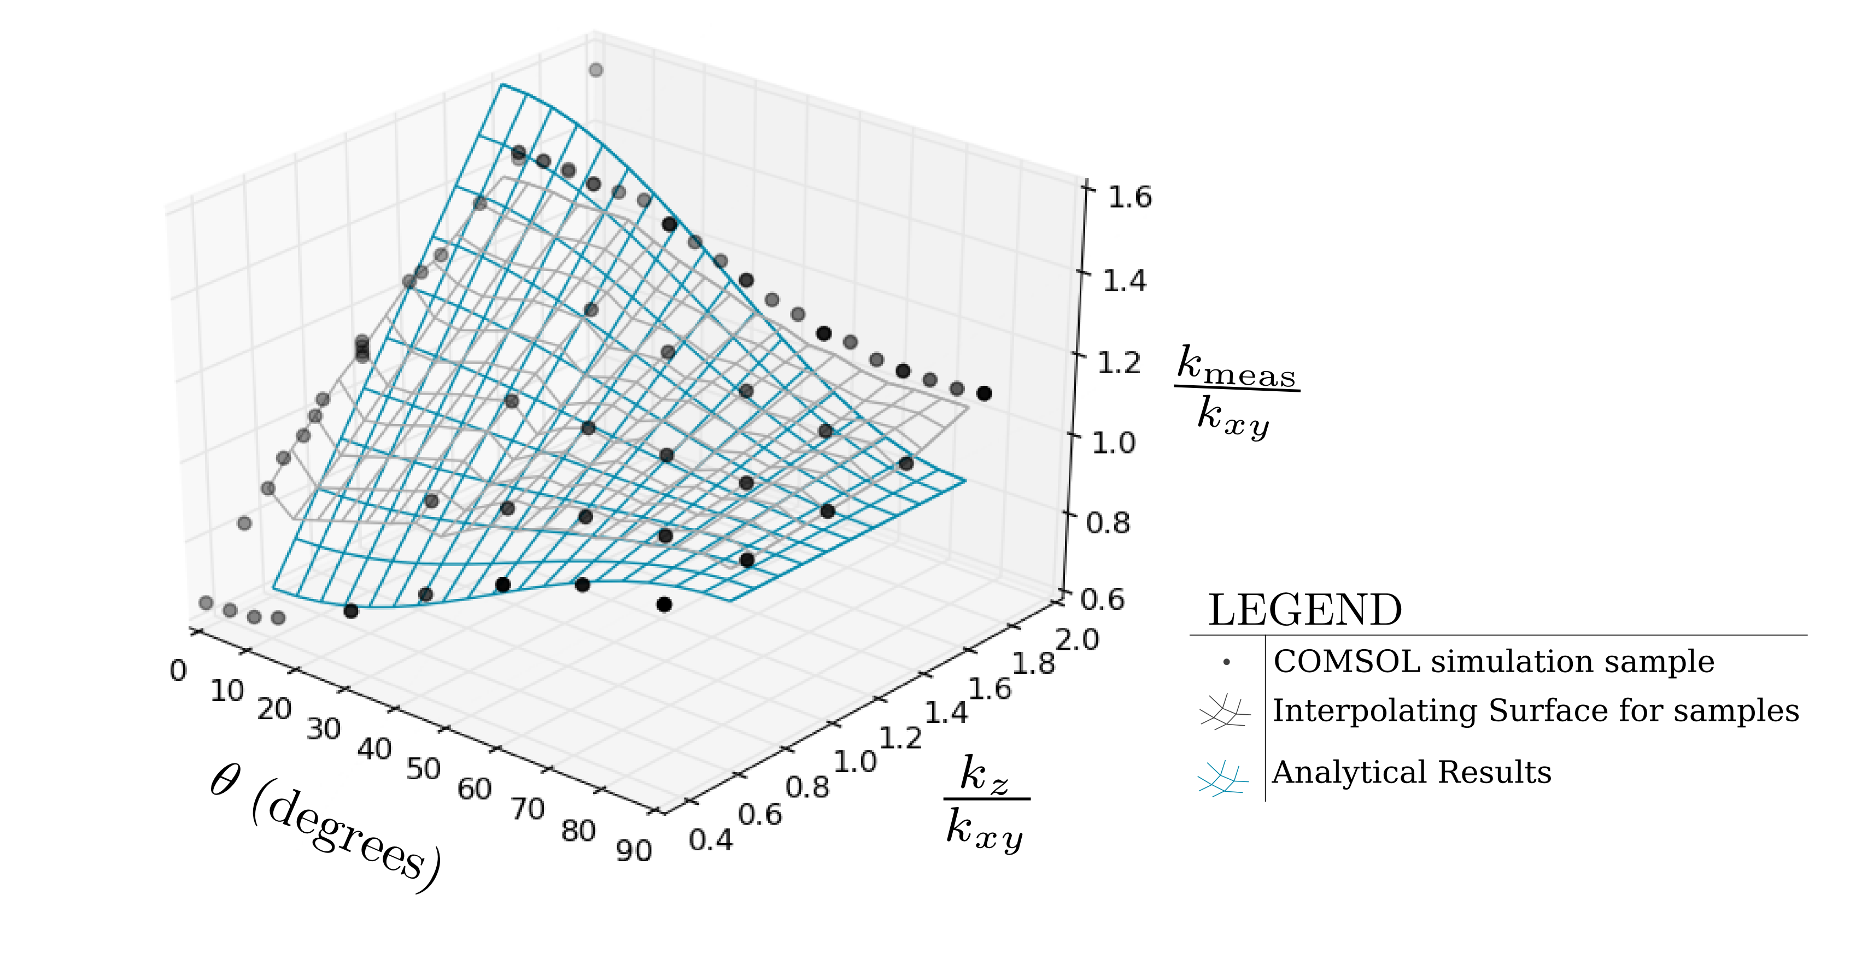1: A comparison of the numerical results and the analytical theory shows general agreement. Grey dots represent numerical simulation results, the grey surface represents an interpolating surface of the dots, and the blue surface represents the analytical model. Disagreement between the two may be due to edge effects and/or numerical model convergence issues.

Additionally, preliminary measurements of both anisotropic salt/sugar layered samples and of snow were taken. The anisotropic salt/sugar samples were layered in roughly one inch thick layers at varying orientations relative to the needle, while the snow measurements were taken with the needle at varying

orientations relative to the snowpack's horizontal plane.

Both models and measurements suggest that detecting anisotropy in such materials is possible, though made difficult by variability between measurements and the requirement of multiple measurements at various angles. Further measurements will be required in order to develop a statistically sound sample set, and further modeling will be required in order to establish a sufficiently accurate model.

These studies do suggest that anisotropy in snow may be able to explain in part the discrepancies between guarded hot plate and needle probe measurements in certain cases. In the case of alternating layers of snow, vertical conductivity is always greater than horizontal conductivity due to the geometry of the composite material, which would be expected to cause the opposite trend from what is seen in the guarded hot plate/needle probe discrepancies. [*Lunardini (1981)*] However, structural anisotropy, which may be caused by vapor transport, could be sufficient explain the differences.

**References:**

[*Carslaw and Jaeger (1959)*] Carslaw, H., and J. Jaeger (1959), *Conduction of Heat in Solids*, 2nd ed., Oxford University Press.

[*Lunardini (1981)*] Lunardini, V. J. (1981), *Heat Transfer in Cold Climates*, Van Nostrand Reinhold Company.

[*Sturm and Johnson(1992)*] Sturm, M., and J. B. Johnson (1992), *Thermal Conductivity Measurements of Depth Hoar*, Journal of Geophysical Research, 97 (B2), 2129–2139.

[*Sturm et al.(2002)Sturm, Perovich, and Holmgren*] Sturm, M., D. K. Perovich, and J. Holmgren (2002), *Thermal Conductivity and Heat Transfer Through the Snow on the Ice of the Beaufort Sea*, Journal of Geophysical Research, 107 (C21).