**Bug Report**

|  |  |
| --- | --- |
| ID number | #1 |
| Name | API – Encoded password is the response is not correct |
| Reporter | Jesús Figueroa |
| Submit Date | 12/16/2022 |
| Platform | POSTMAN |
| Operating System | N/A |
| Browser | N/A |
| Severity | Major |
| Assigned to | / |
| Priority | High |

**Description**

When encoded password is requested, wrong value is returned in the response, it does not match the known value, which means the request is pointing to a different value other than the expected one.

The value for this request URL (<http://127.0.0.1:8088/hash/1>) is “*angrymonkey*” and the encoded value is “*YW5ncnltb25rZXk=*” (refer to this site to use the encoder base64: <https://www.base64encode.org/>), but the call is returning “*NN0PAKtieayiTY8/Qd53AeMzHkbvZDdwYYiDnwtDdv/FIWvcy1sKCb7qi7Nu8Q8Cd/MqjQeyCI0pWKDGp74A1g==”* which does not match the expected result.

**Test Case ID (If applicable):** TC-5

**Precondition:**

1. App is up and running

**Steps to reproduce**

1. Open POSTMAN
2. Add a new GET request
3. Submit the following URL <http://127.0.0.1:8088/hash/1>
4. Click on Send

**Expected result**

Response returns “*YW5ncnltb25rZXk=*” value

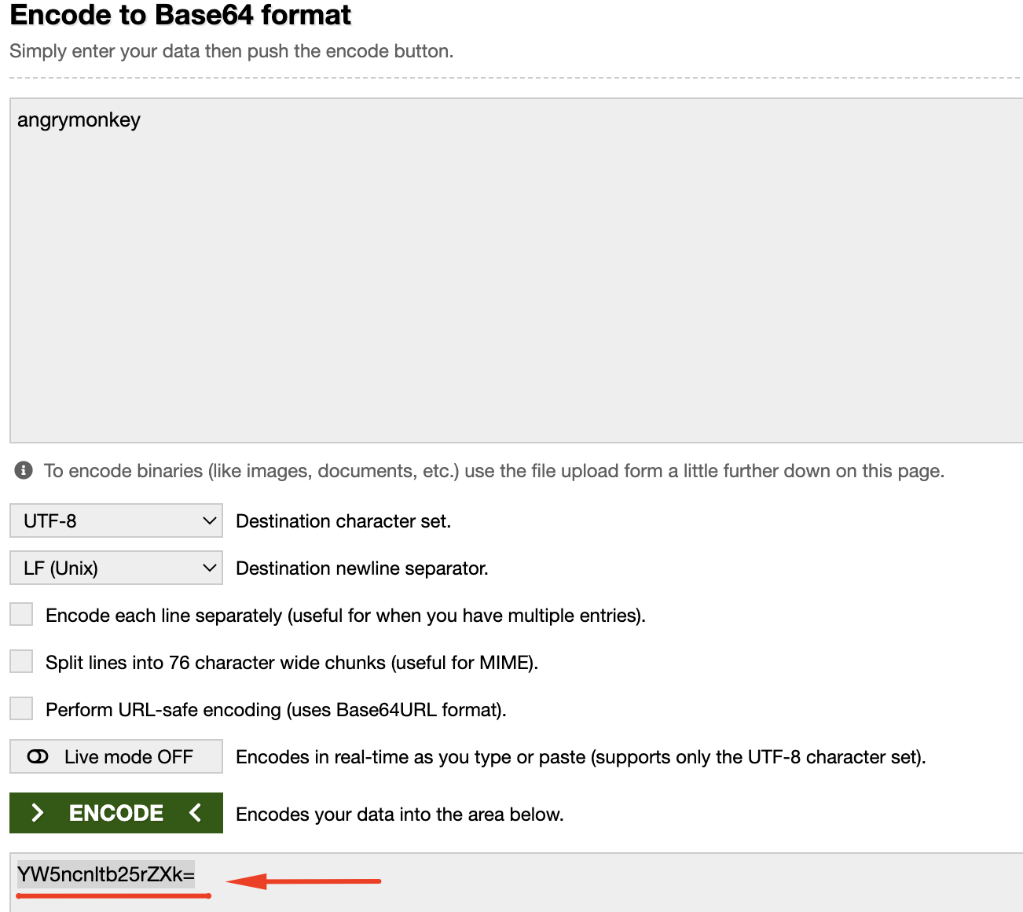

**Actual result**

Response returns “*NN0PAKtieayiTY8/Qd53AeMzHkbvZDdwYYiDnwtDdv/FIWvcy1sKCb7qi7Nu8Q8Cd/MqjQeyCI0pWKDGp74A1g==*”

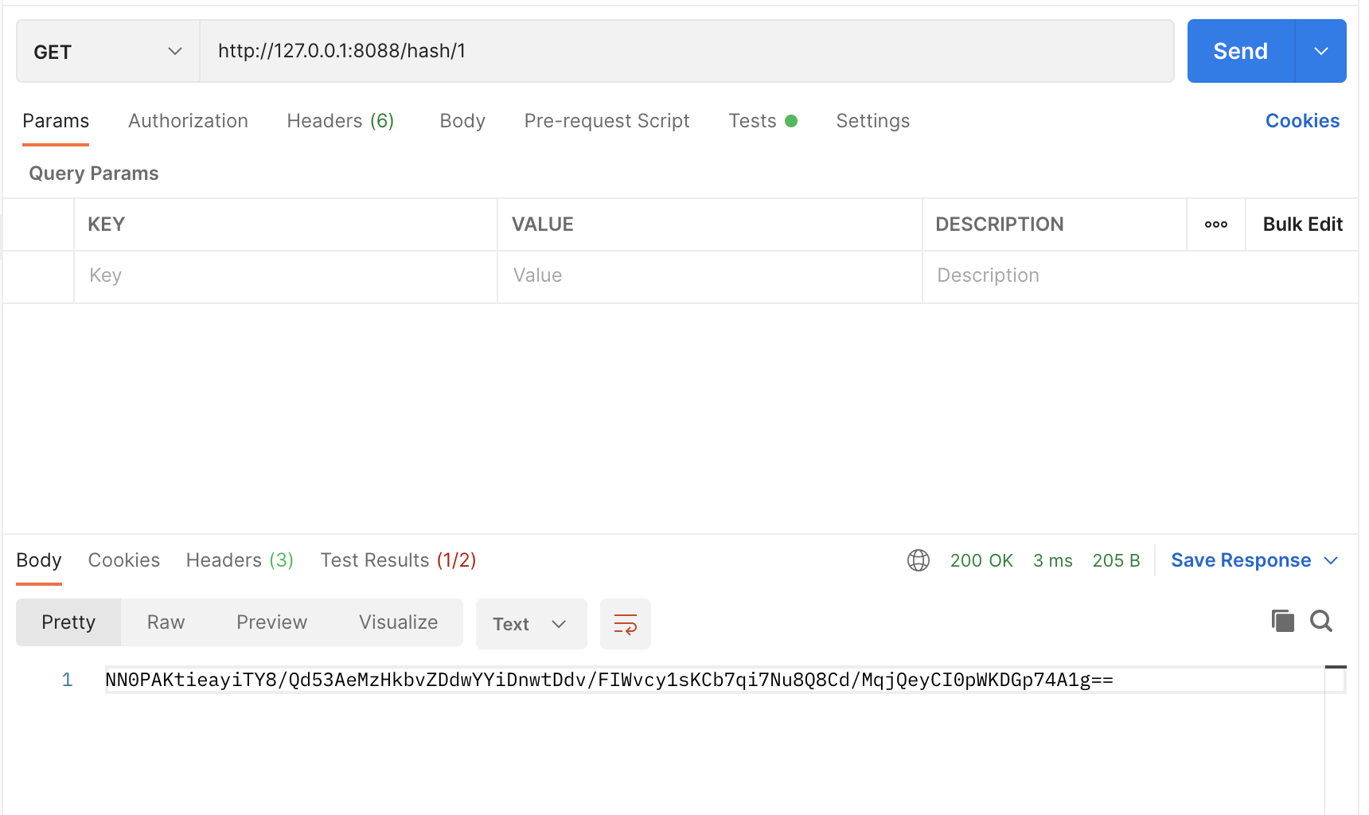

**\*Notes**