**Bug Report**

|  |  |
| --- | --- |
| ID number | #2 |
| Name | API – User can be created with empty values |
| Reporter | Jesús Figueroa |
| Submit Date | 12/16/2022 |
| Platform | POSTMAN |
| Operating System | N/A |
| Browser | N/A |
| Severity | Major |
| Assigned to | / |
| Priority | High |

**Description**

It is possible to create users with empty values (username and/or password = null), POST request is successfully sent, returns a 200 – OK HTML code and ID in the response

**Test Case ID (If applicable):** TC-8

**Precondition:**

1. App is up and running

**Steps to reproduce**

1. Open POSTMAN
2. Add a new POST request
3. Submit the following URL <http://127.0.0.1:8088/hash/1>
4. Add the following data to the body request {"username":"","password":""}
5. Click on Send

**Expected result**

Response returns code 400 and there is not ID in the response

**Actual result**

Response code is 200 – OK and id is in the response

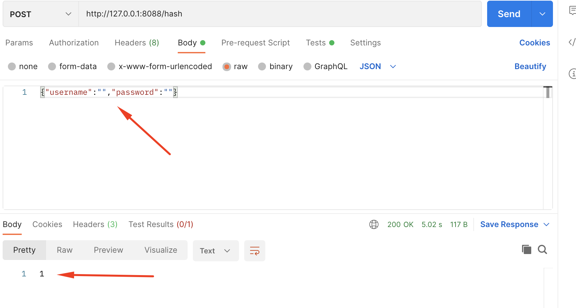

**\*Notes**