KERNEL
git clone https://github.com/roberto-sartori-gl/kernel_oneplus_msm8998

CROSS_COMPILER
git clone https://android.googlesource.com/platform/prebuilts/gcc/linux-x86/aarch64/aarch64-linux-android-4.9

AOSP’S CLANG
git clone https://android.googlesource.com/platform/prebuilts/clang/host/linux-x86

ADD TO PATH
PATH="path/cross_compiler/aarch64-linux-android-4.9/bin/:path/aosp_clang/linux-x86/clang-r416183b/bin:${PATH}"
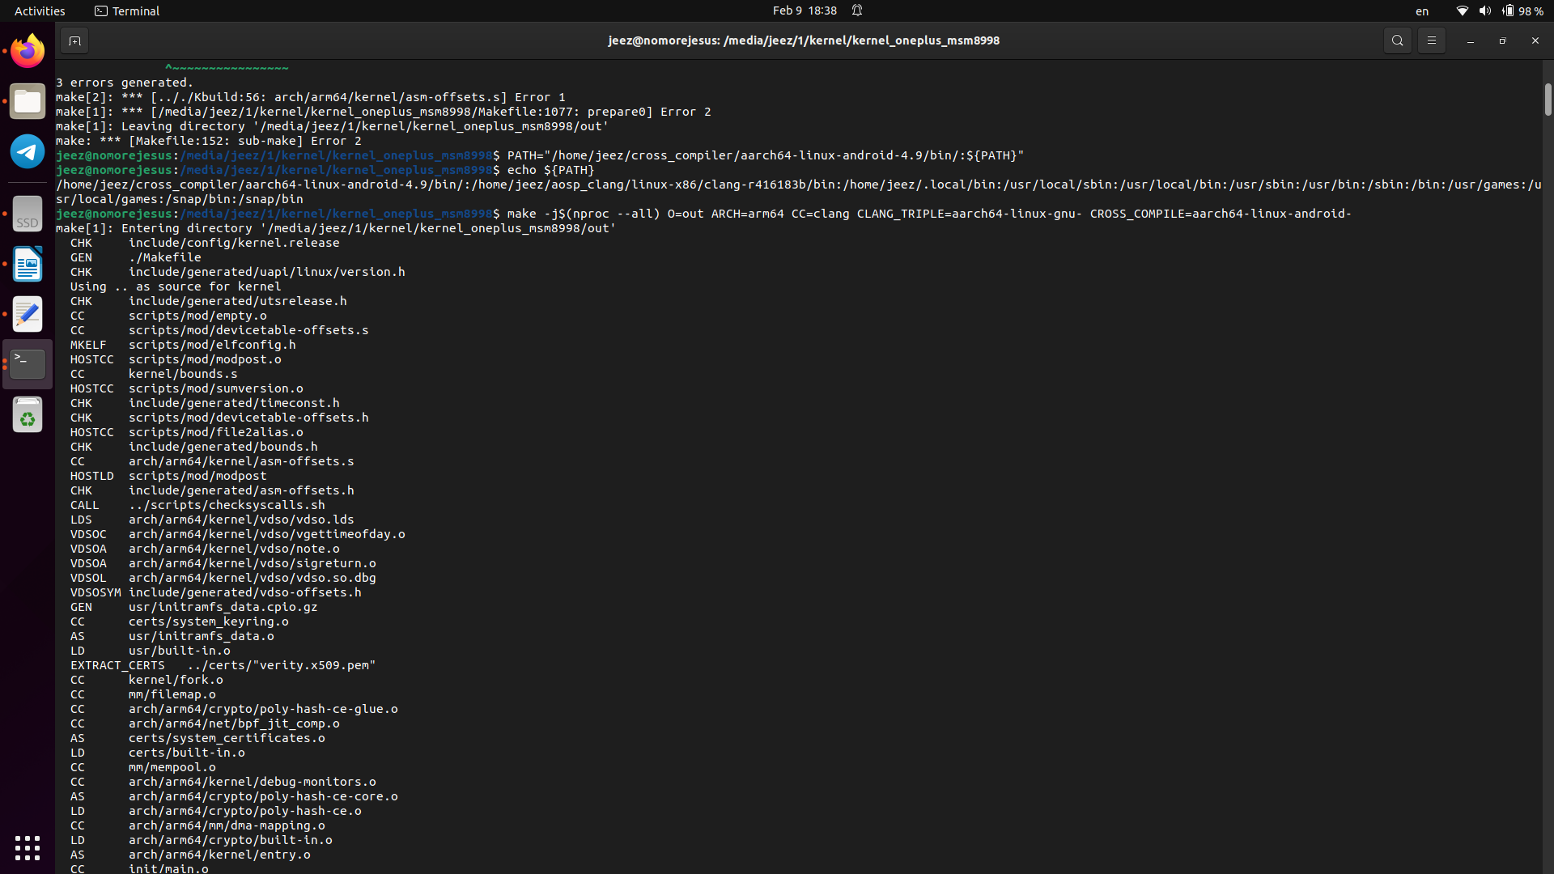
MAKE CONFIG
make O=out ARCH=arm64 lineage_oneplus5_defconfig
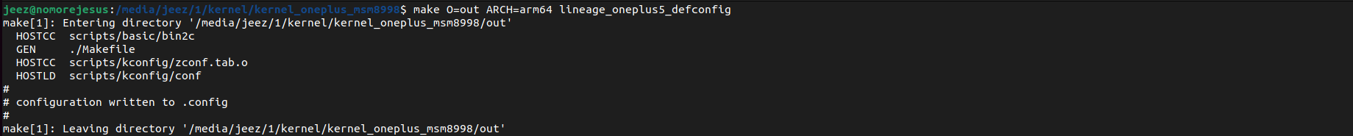
MAKE KERNEL
make -j$(nproc --all) O=out ARCH=arm64 CC=clang CLANG_TRIPLE=aarch64-linux-gnu- CROSS_COMPILE=aarch64-linux-android-

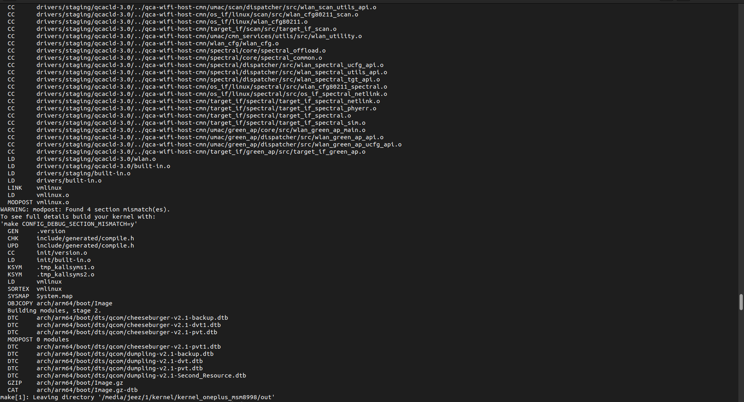

KERNEL
git clone https://github.com/LineageOS/android_kernel_oneplus_msm8998.git

ADD TO PATH
PATH="path/cross_compiler/aarch64-linux-android-4.9/bin/:path/aosp_clang/linux-x86/clang-r416183b/bin:path/android_ndk/arm-linux-androideabi-4.9/bin:${PATH}"

MAKE DEFCONFIG
make O=out ARCH=arm64 lineage_oneplus5_defconfig

MAKE KERNEL
make -j$(nproc --all) O=out ARCH=arm64 CC=clang CLANG_TRIPLE=aarch64-linux-gnu- CROSS_COMPILE=aarch64-linux-android- CROSS_COMPILE_ARM32=arm-linux-androideabi-
