Lab 2 MGS Chapter 2 exercises | Jesus Hilario Hernandez

7. Create a connection named mgs for the user named mgs. The password for the user should be “mgs”:

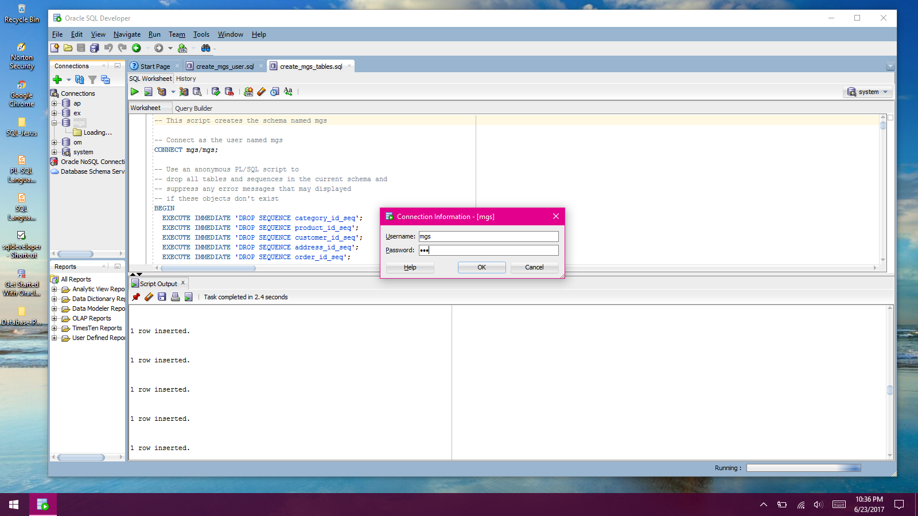

11. Open SQL Worksheet. Then, enter and run this SQL Statement:

SELECT product_name FROM products

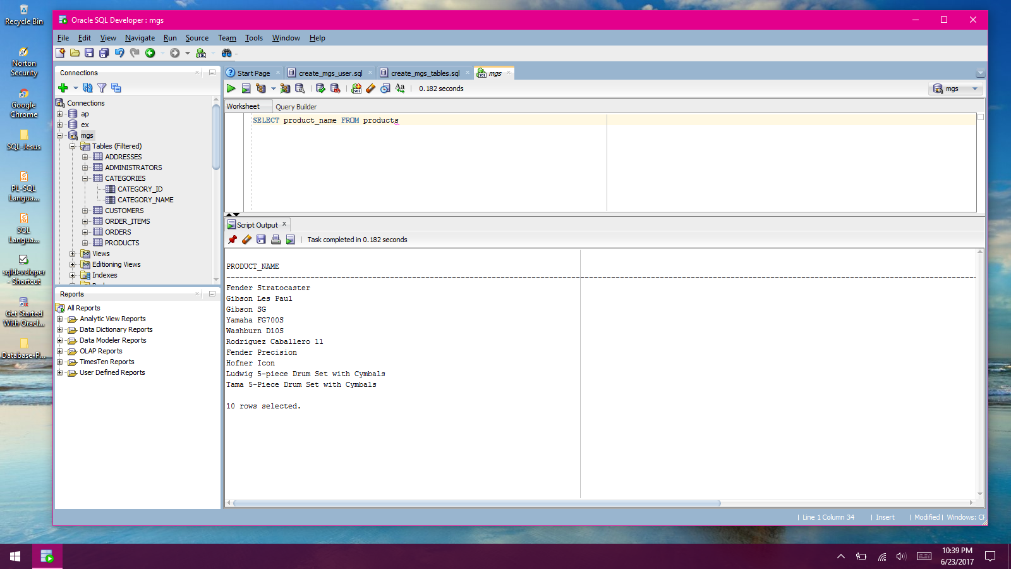

12. Delet the *e* at the end of product_name and run the statement again.

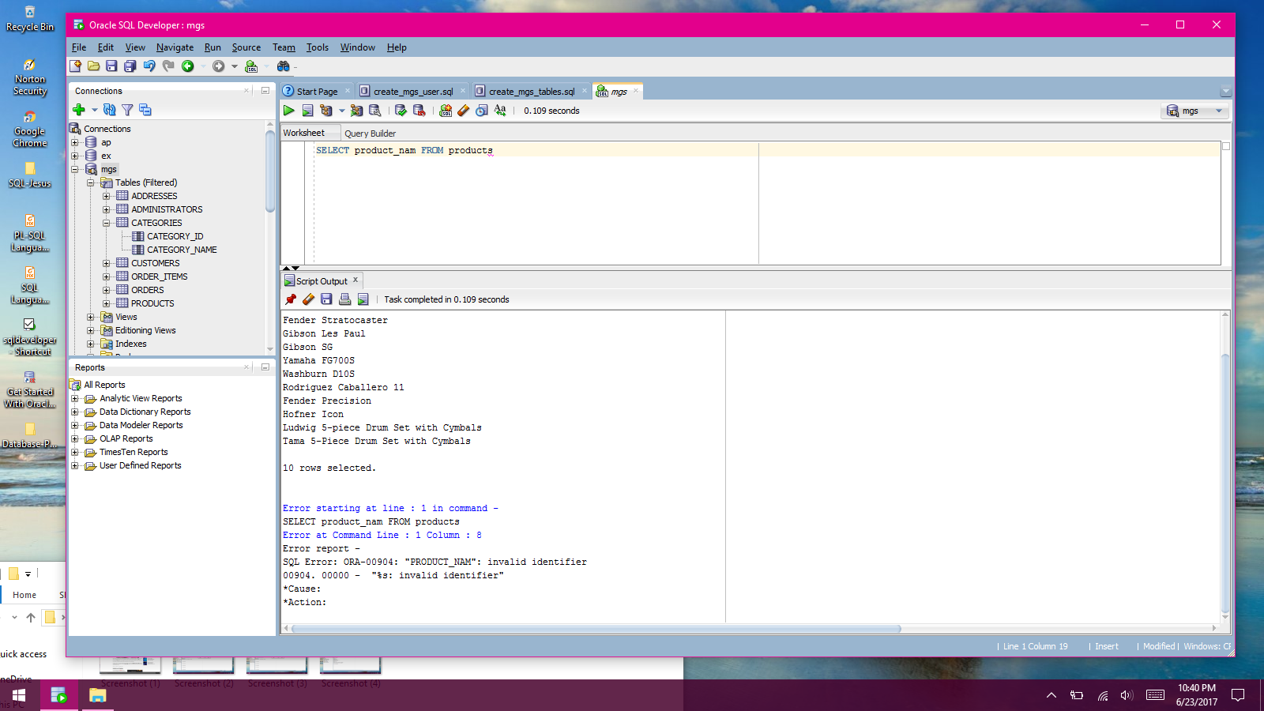

13. Open another SQL Worksheet. Then, enter and run this statement:

SELECT COUNT(*) AS number_of_products

FROM products

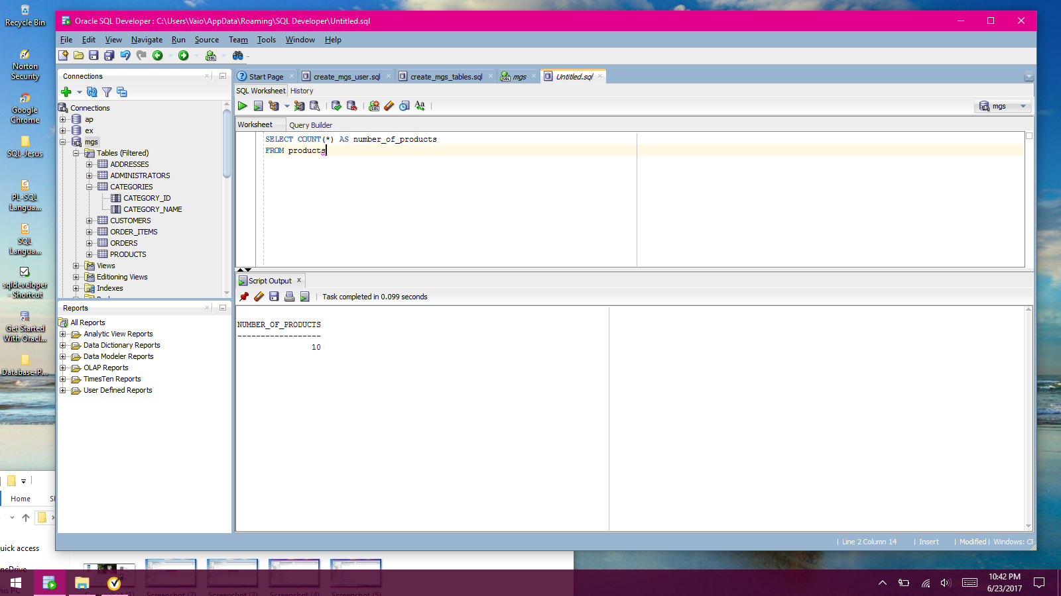

14. Open the script named product_details.sql that’s in the mgs_ex_starts directory. Note that this script contains just on SQL statement. Then, run the statement.

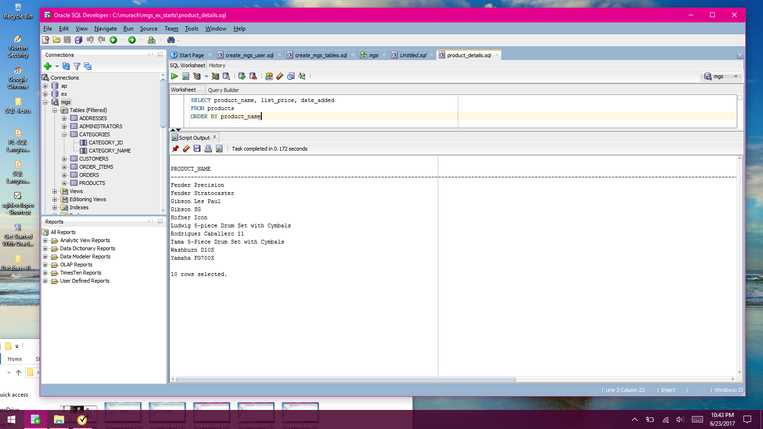

17. Press the F5 key of click the Run Script button to run both of the statements in this script. Note: you may need to scroll over to the right to see the list_price and date_added columns. Make sure to view the results of both SELECT statements.

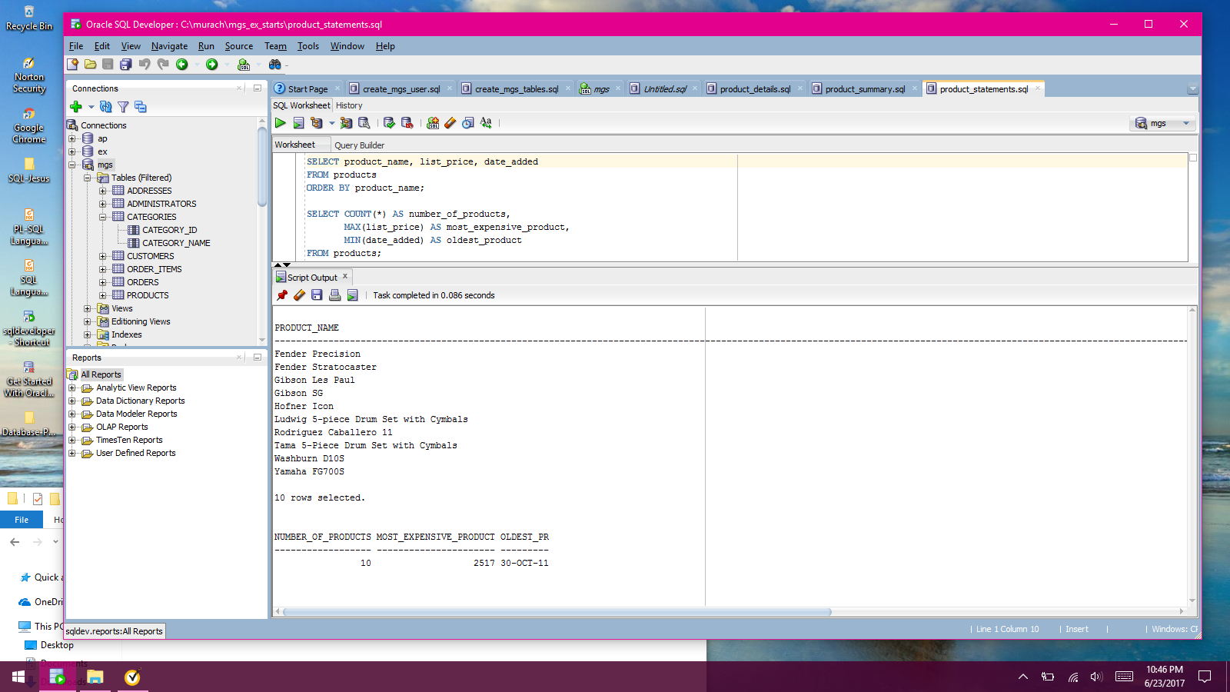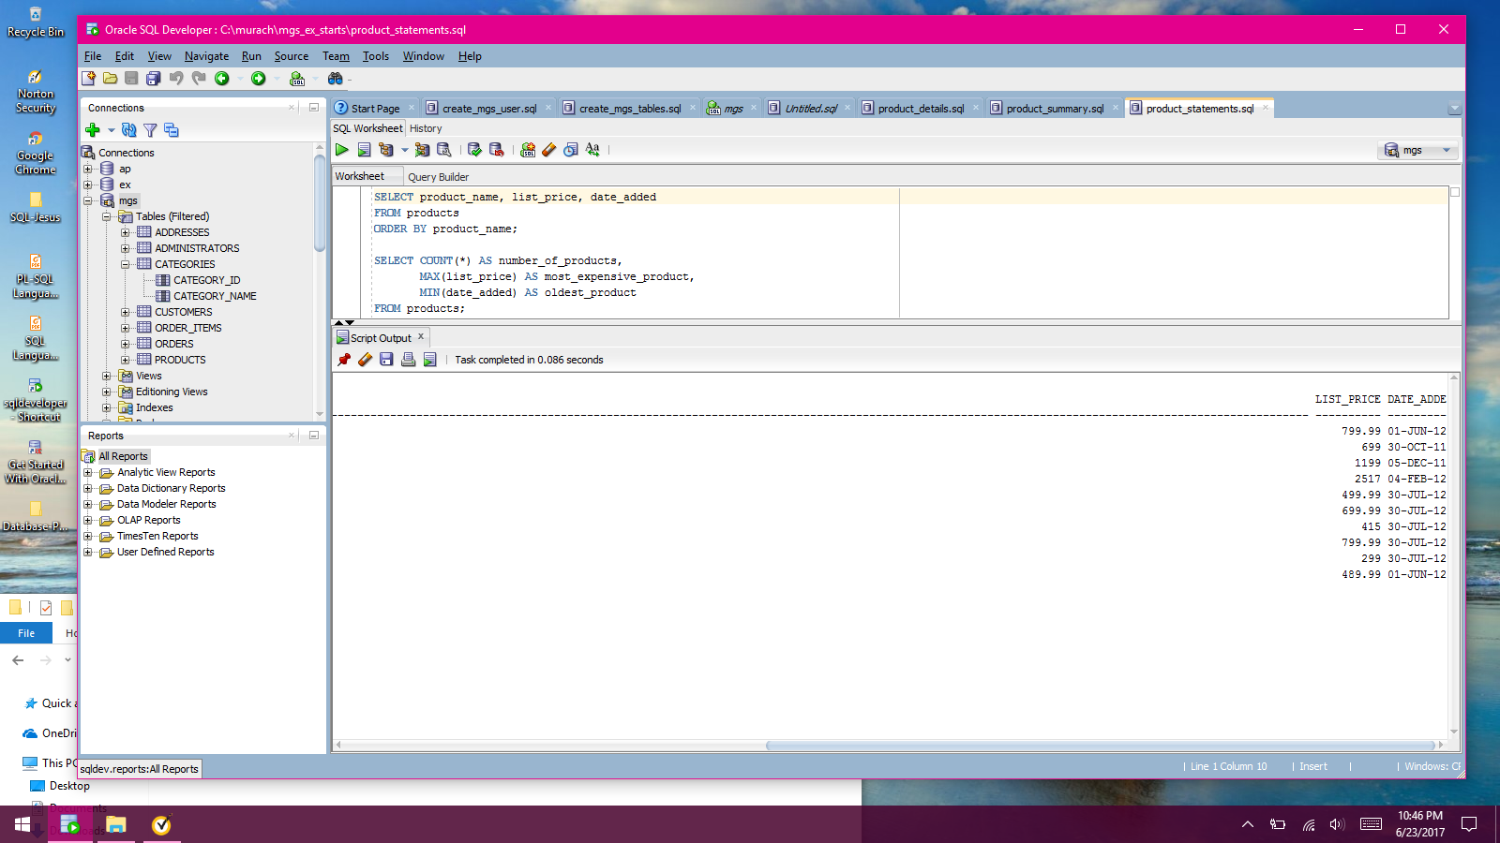

18. Move the insertion point into the first statement and press Ctrl+Enter to fun just that statement.

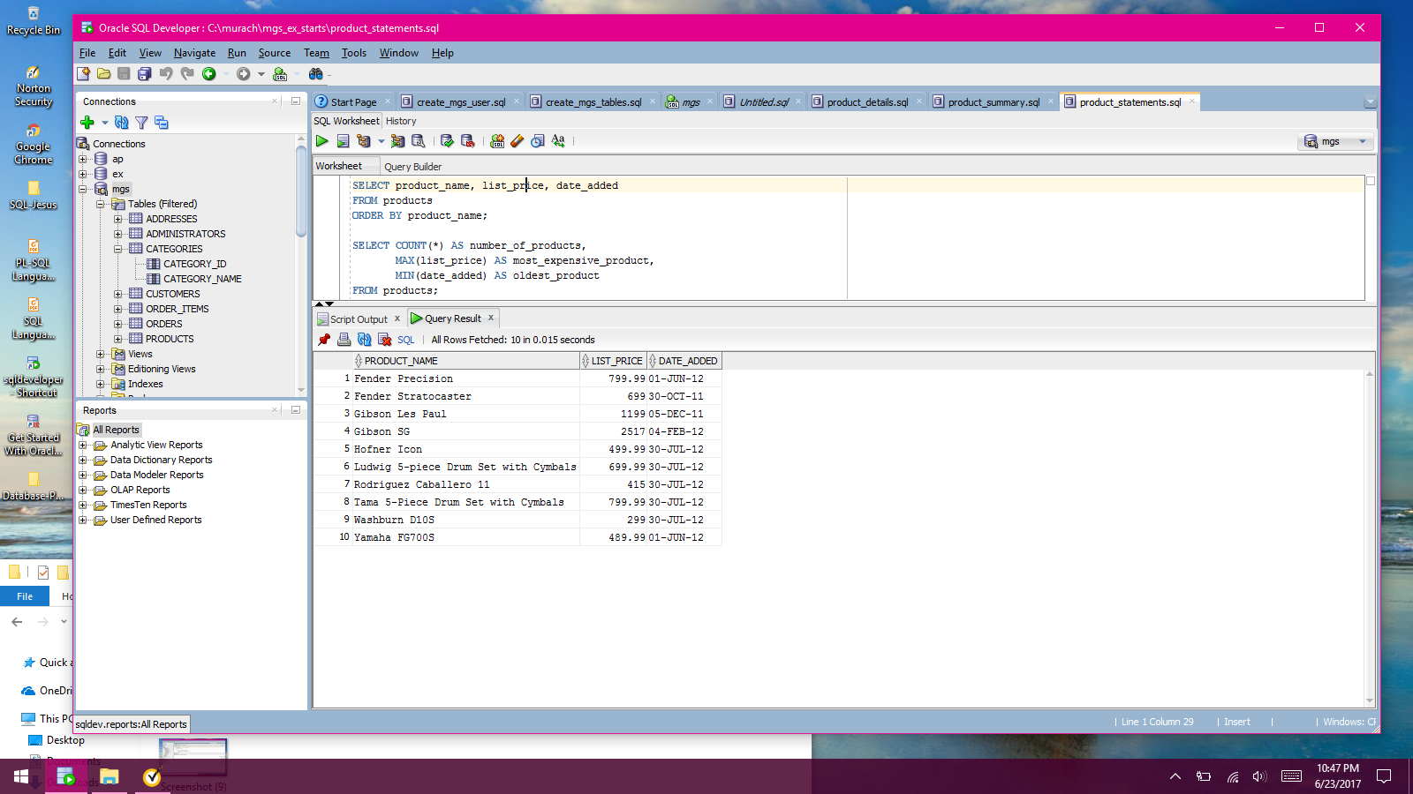

19. Move the insertion point into the second statement and press Ctrl+Enter to run just that statement.

