-- 1 write a SELECT statement that returns four columns from the Products table.

-- Add ORDER BY clause that sorts by list_price, descending

SELECT product_code, product_name, list_price, discount_percent

FROM products -- SCREEN SHOT

ORDER BY list_price DESC; -- SCREEN SHOT

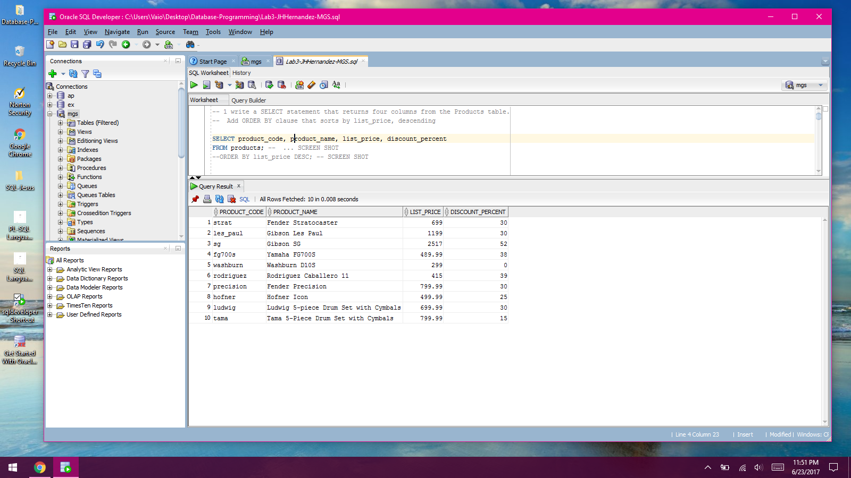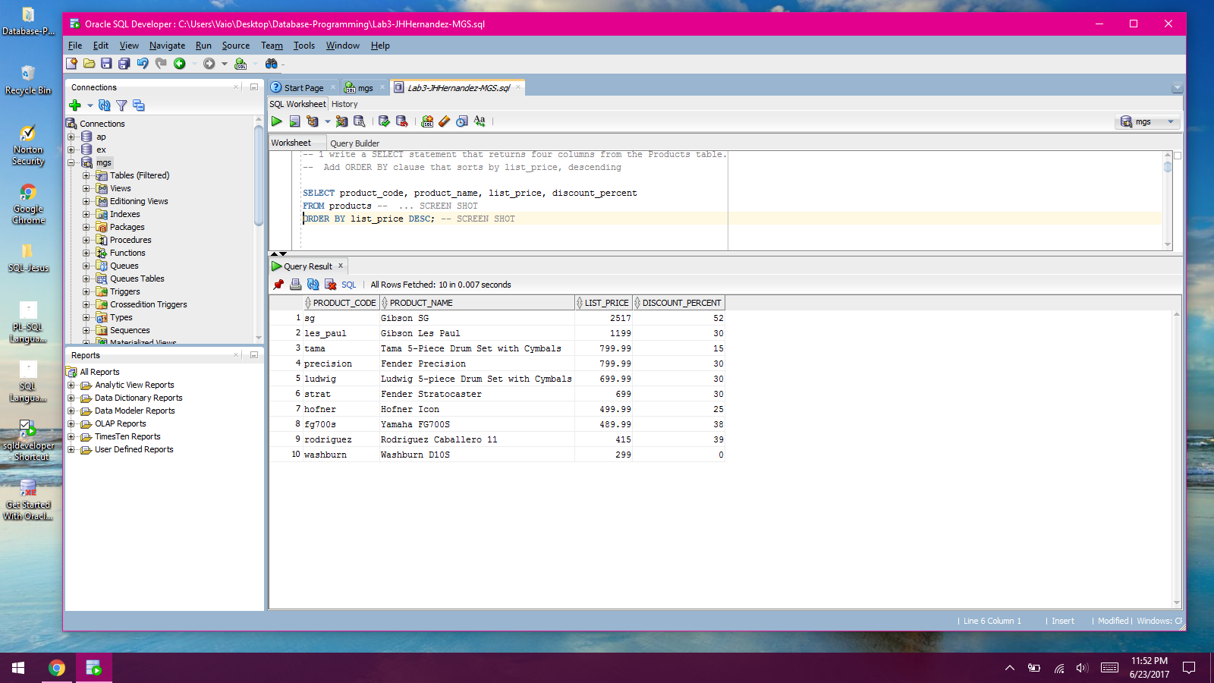

-- 2 Write a SELECT statement that returns one column from

-- Customers named full_name that joins the last_name and first_name columns.

SELECT last_name || ', ' || first_name AS full_name

FROM Customers

WHERE last_name >= 'M' AND last_name <= 'Z'

ORDER BY last_name; -- SCREEN SHOT

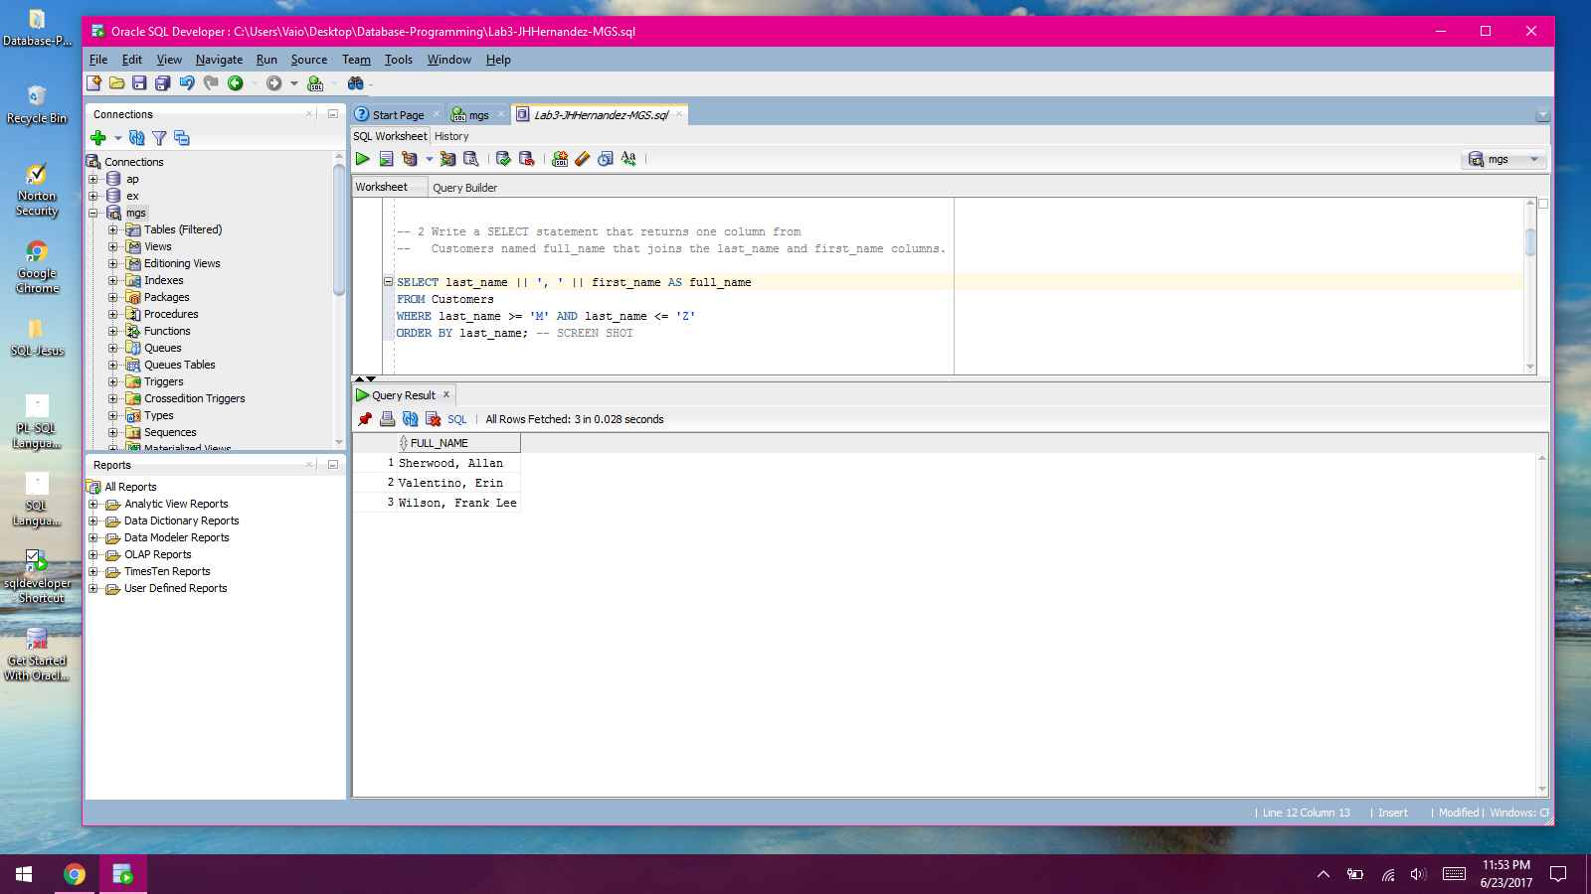

--3 Write a SELECT statment that returns columns from Products table:

-- Return only the rows with a list price that's greater than 500

-- and less than 2000.

-- Sort result in DESC order by date_added

SELECT product_name, list_price, date_added

FROM Products

WHERE list_price > 500 AND list_price < 2000

ORDER BY date_added DESC; -- SCREEN SHOT

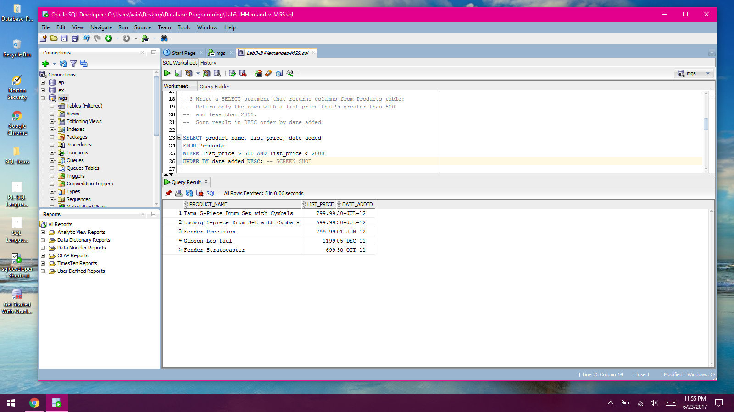

-- 4 Write a SELECT statement that returns column names from Products table:

-- Use the ROWNUM pseudo column so the result set contains only the first 5 rows.

-- Sort the result set by discount price in descending sequence.

SELECT product_name, list_price, discount_percent,

(list_price - discount_percent) AS discount_amount,

list_price - (list_price - discount_percent) AS discount_price

FROM Products

WHERE ROWNUM <= 5

ORDER BY discount_price DESC; -- SCREEN SHOT

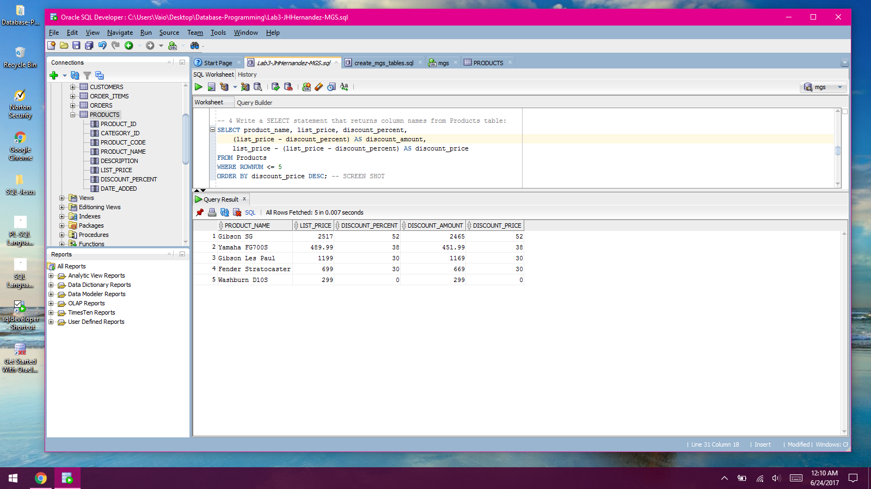

-- 5 Write a SELECT statement that returns columns from Order_Items table:

-- Only return rows where the item_total is greater than 500.

-- Sort the result set by item total in descending sequence.

SELECT item_id, item_price, discount_amount, quantity,

(item_price * quantity) AS price_total,

(discount_amount * quantity) AS discount_total,

(item_price - discount_amount) * quantity AS item_total

FROM Order_Items

WHERE ((item_price - discount_amount) * quantity) > 500

ORDER BY item_total DESC; -- SCREEN SHOT

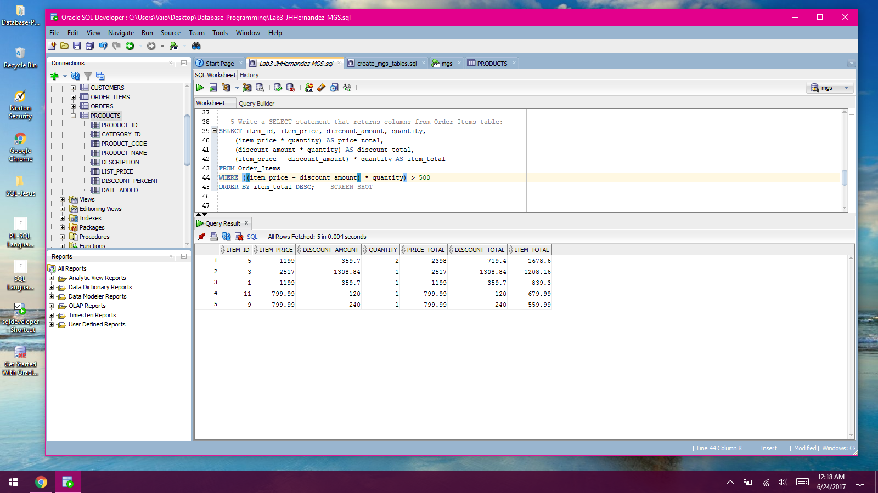

-- WORK WITH NULLS AND TEST EXPRESSIONS --

-- WORK WITH NULLS AND TEST EXPRESSIONS --

-- WORK WITH NULLS AND TEST EXPRESSIONS –

-- 6 Write a SELECT statement that returns these columns from the Orders table:

-- Return only the rows where the ship_date column contains a null value.

SELECT order_id, order_date, ship_date

FROM Orders

WHERE ship_date IS NULL; -- SCREEN SHOT

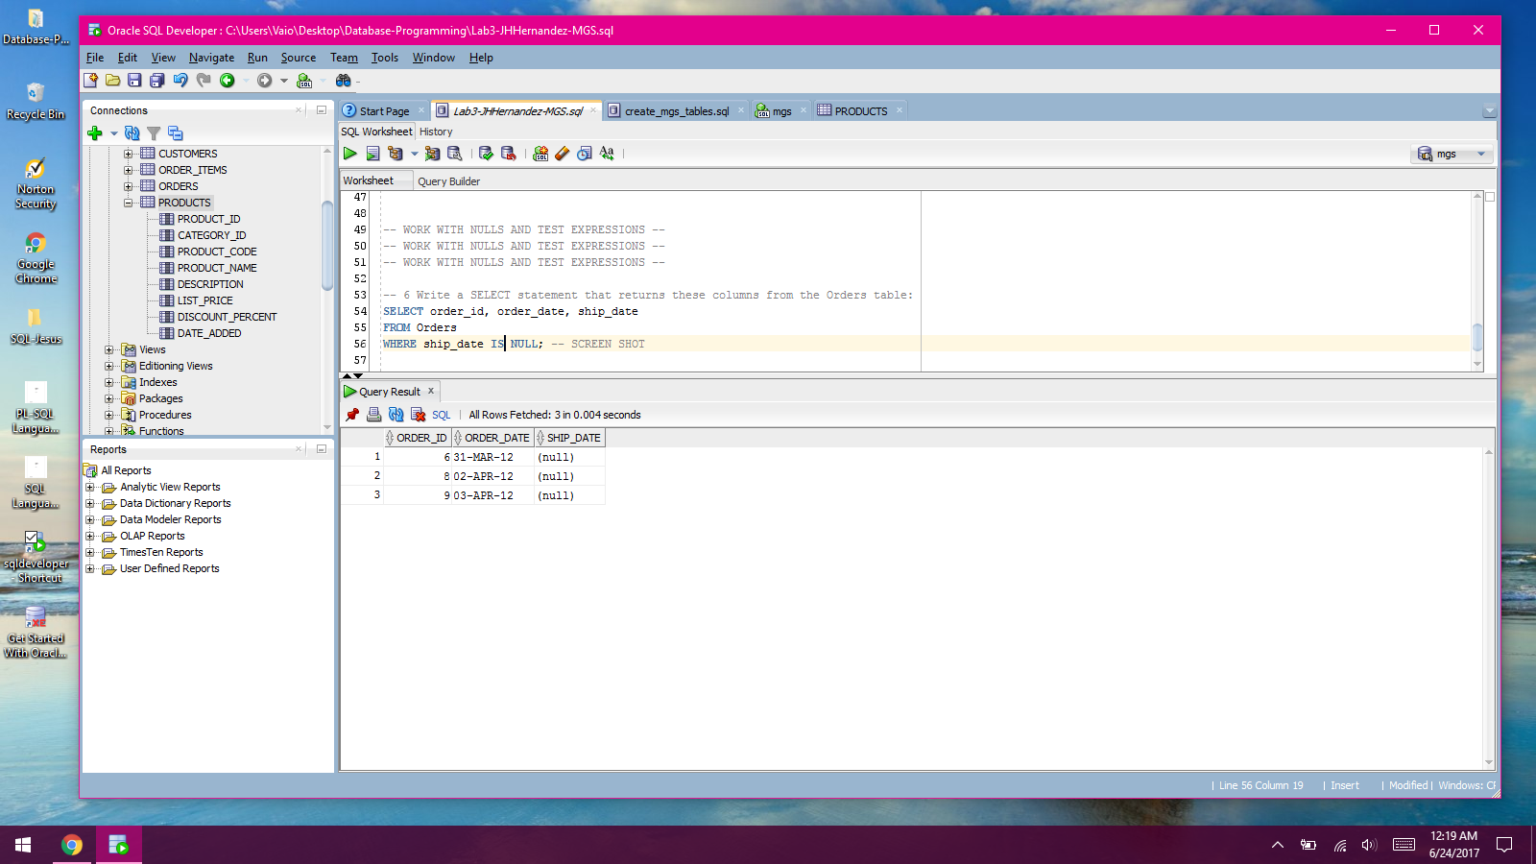

-- 7 Write a SELECT statement that uses the SYSDATE function to create a row with these columns:

-- This displays a number for the month, a number for the day, and a four-digit year.

-- Use a FROM clause that specifies the Dual table.

SELECT

SYSDATE AS today_unformatted,

TO_CHAR(SYSDATE, 'MM-DD-YYYY') AS today_formatted

FROM Dual; -- SCREEN SHOT

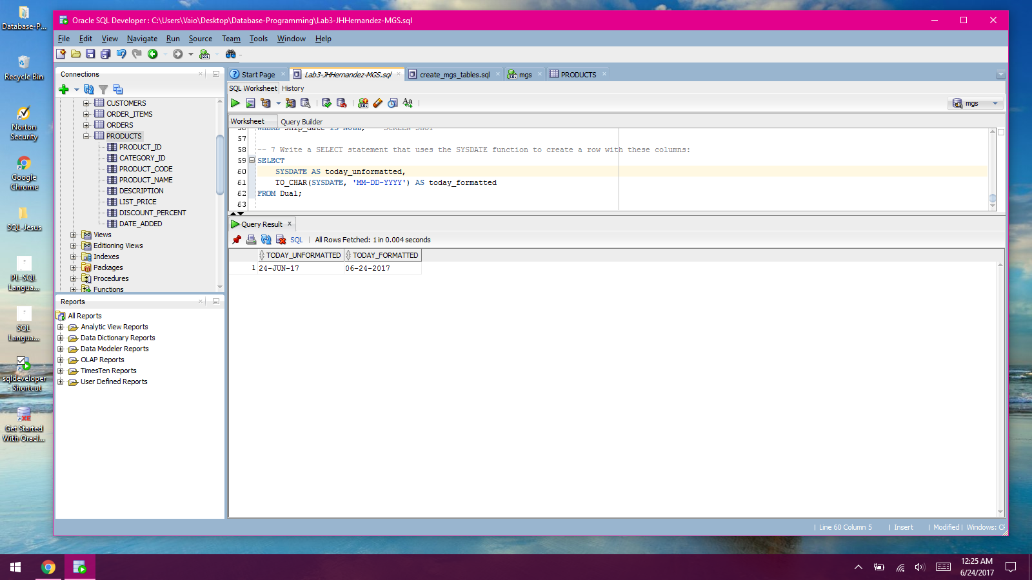

-- 8 Write a SELECT statement that creates a row with these columns;

-- To calculate the fourth column, add the expressions you used for the first and third columns.

-- Use a FROM clause that specifies the Dual table.

SELECT

100 AS price,

.07 AS tax_rate,

(100 * .07) AS tax_amount,

(100 + (100 * .07)) AS total

FROM Dual; -- SCREEN SHOT

