Your Name and Date

**HW 5 Lab Manual Ch 6**

* Be sure to paste **code and screenshots** of your executable (black) screen when asked.

**6.1 Fill in the Blank**

1. Answer: **Void**
2. Answer: **value**
3. Answer: **Actual**
4. Answer: **data type**, **names**
5. Answer: **ampersand (&) character**
6. Answer: **Procedures.**
7. Answer: **Reference**
8. Answer: **name, data type.**
9. Answer: **scope**.
10. Answer: **Formal Parameters**.

**proverb.cpp**

1. Exercise 1: Fill in the code (places in bold) so that the program will print out the proverb listed in the comments at the beginning of the program. The proverb will be printed by the function which is called by the main function.
   1. Copy of Code & Screenshot of black screen: **Note: full copy of code is included in zip file.**

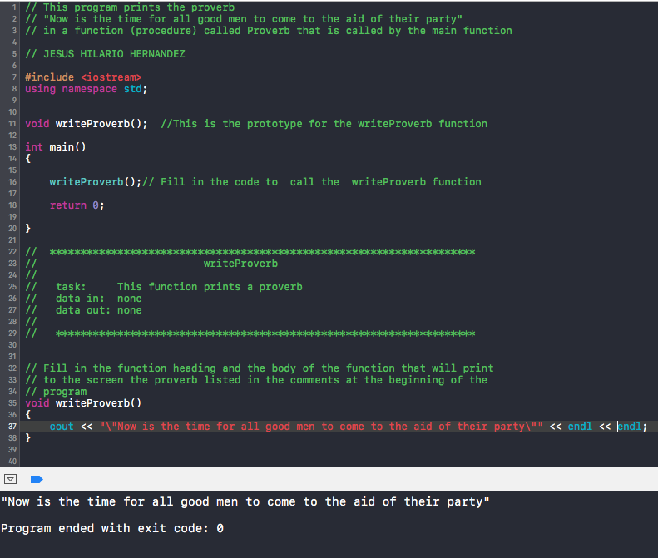

**newproverb.cpp**

1. Exercise 1: Some people know this proverb as “Now is the time for all good men to come to the aid of their country” while others heard it as “Now is the time for all good men to come to the aid of their party.” This program will allow the user to choose which way they want it printed. Fill in the blanks of the program to accomplish what is described in the program comments.
2. Copy of Code & Screenshot of black screen: **Note: full copy of code is included in zip file.**

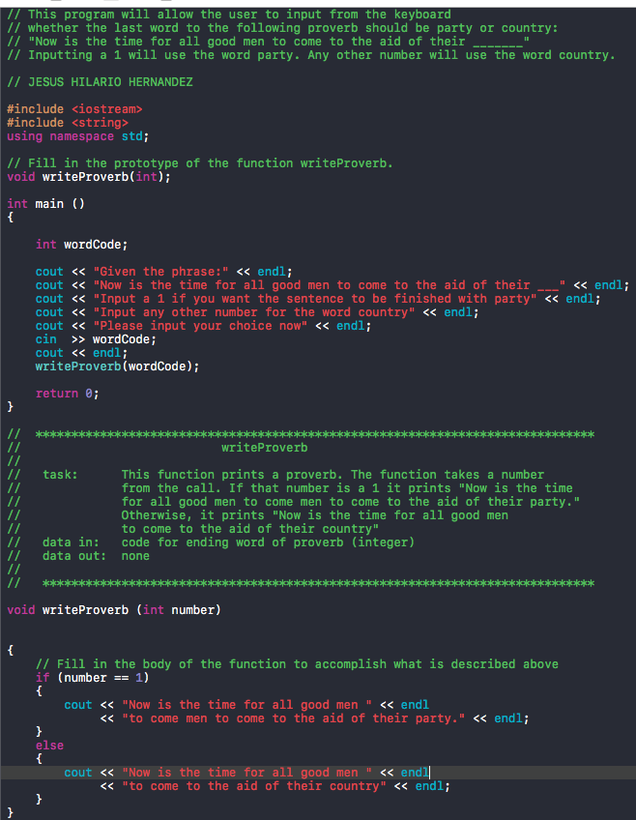

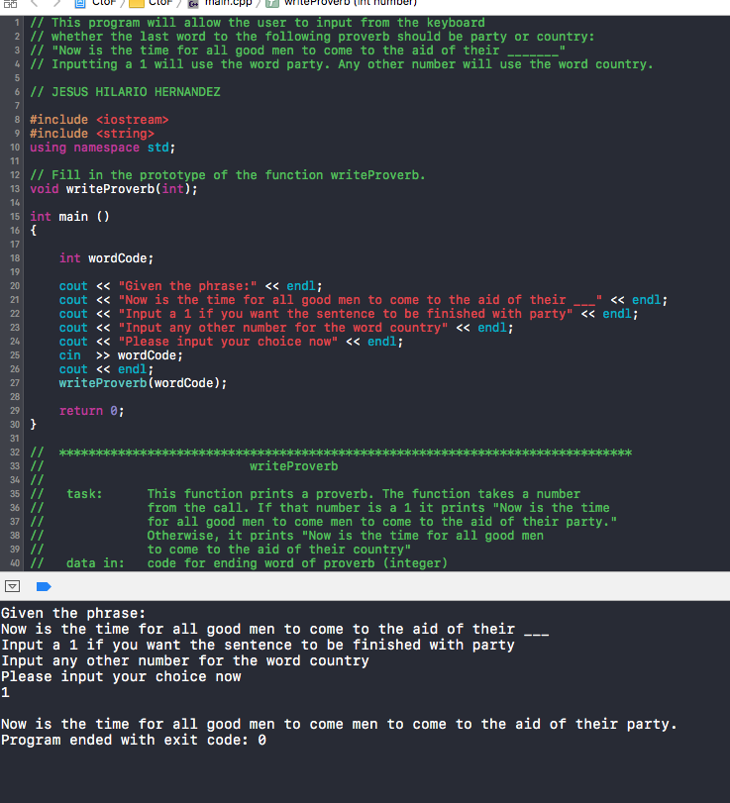

1. What happens if you inadvertently enter a float such as -3.97? **If a float is entered, the second version of the proverb will be displayed. This is made possible by the if/else statements that are provided in the writeProverb function.**
2. Exercise 2: Change the program so that an input of 1 from the user will print “party” at the end, a 2 will print “country” and any other number will be invalid so that the user will need to enter a new choice.

Given the phrase:

Now is the time for all good men to come to the aid of their Input a 1 if you want the sentence to be finished with party Input a 2 if you want the sentence to be finished with country Please input your choice now

4

I'm sorry but that is an incorrect choice; Please input a 1 or 2

2

Now is the time for all good men to come to the aid of their country

1. Copy of Code & Screenshot of black screen: **Note: full copy of code is included in zip file.**

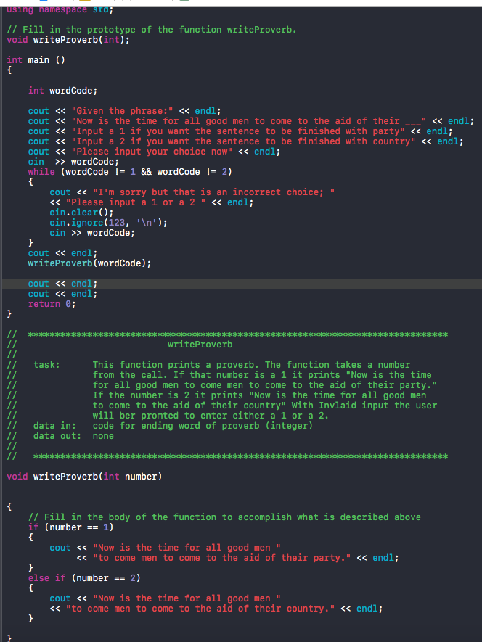

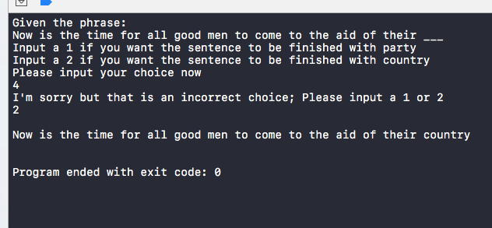

1. Exercise 3: Change the previous program so the user may input the word to end the phrase. The string holding the user’s input word will be passed to the proverb function instead of passing a number to it. Notice that this change requires you to change the proverb function heading and the prototype as well as the call to the function.

Given the phrase:

Now is the time for all good men to come to the aid of their Please input the word you would like to have finish the proverb family

Now is the time for all good men to come to the aid of their family

1. Copy of Code & Screenshot of black screen: **Note: full copy of code is included in zip file.**

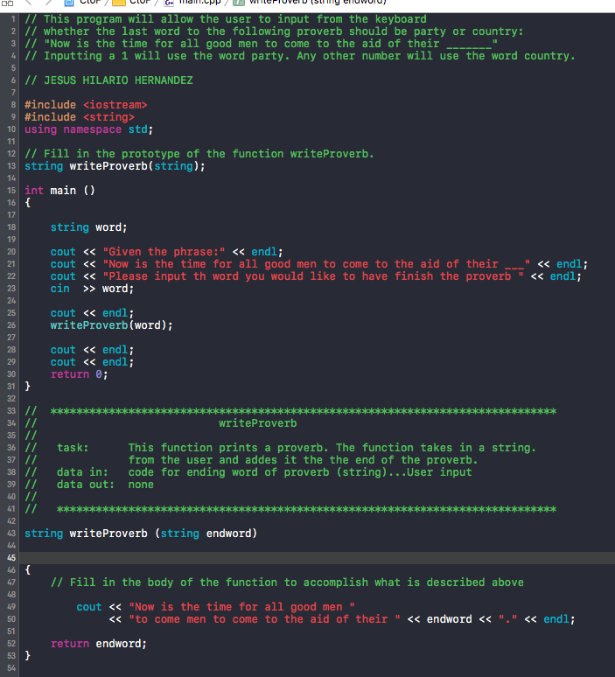

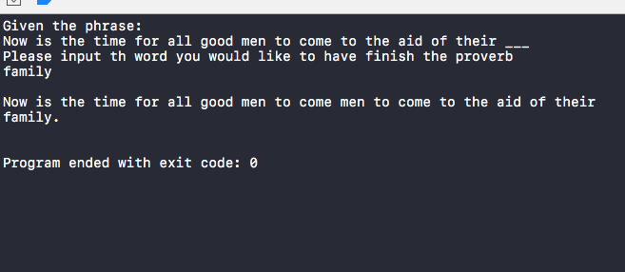

**paycheck.cpp**

1. Exercise 1: Fill in the code (places in bold) and note that the function computePaycheck determines the net pay by subtracting 15% from the gross pay. Both gross and net are returned to the main() function where those values are printed.
   1. Copy of Code: **Note: full copy of code is included in zip file.**

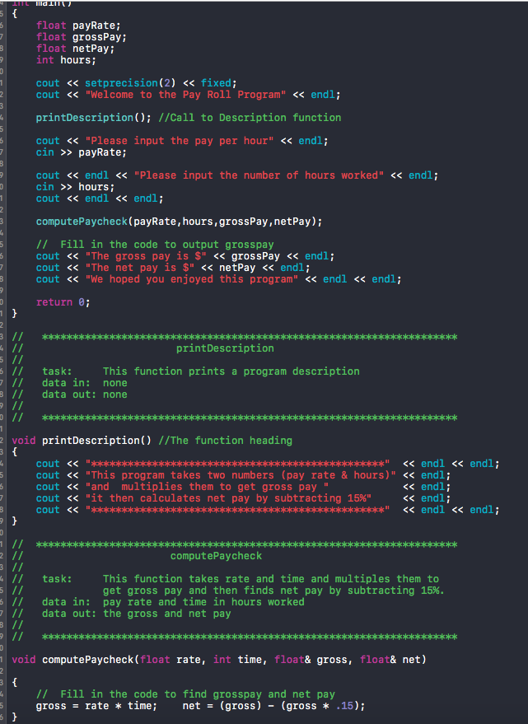

1. Exercise 2: Compile and run your program with the following data and make sure you get the output shown.

Please input the pay per hour

9.50

Please input the number of hours worked

40

The gross pay is $380

The net pay is $323

We hoped you enjoyed this program

* 1. Copy of Code & Screenshot of black screen: **Note: full copy of code is included in zip file.**

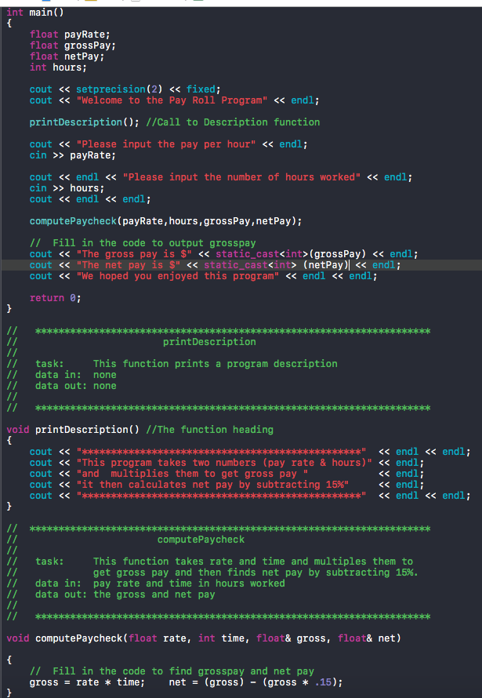

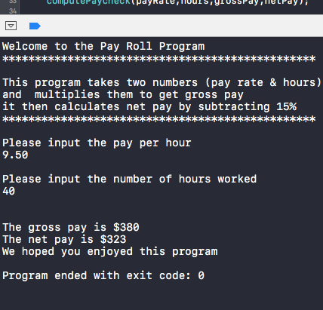

1. Exercise 3: Are the parameters gross and net, in the modified calPaycheck func- tion you created in Exercise 1 above, pass by value or pass by reference?
   1. Answer: **The parameters gross and net are pass by reference. The ampersand sign after the data type allows the gross and net parameters to be passed by reference.**
2. Exercise 4: Alter the program so that gross and net are printed in the function compute computePaycheck instead of in main(). The main() function executes the statement

cout << "We hoped you enjoyed this program" << endl;

after the return from the function calPaycheck.

* 1. Copy of Code & Screenshot of black screen: **Note: full copy of code is included in zip file.**

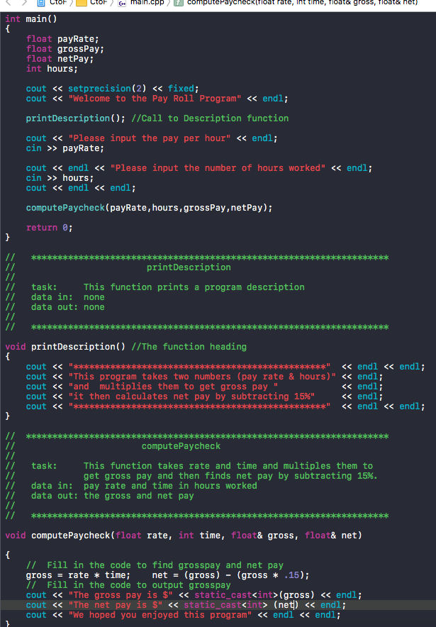

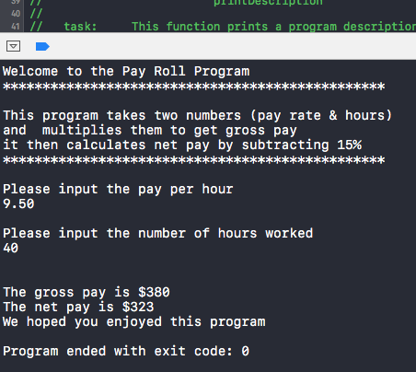

1. Exercise 5: Run the program again using the data from Exercise 2. You should get the same results. All parameters should now be passed by value.

Please input the pay per hour

9.50

Please input the number of hours worked

40

The gross pay is $380

The net pay is $323

We hoped you enjoyed this program

* 1. Screenshot of black screens for all data:

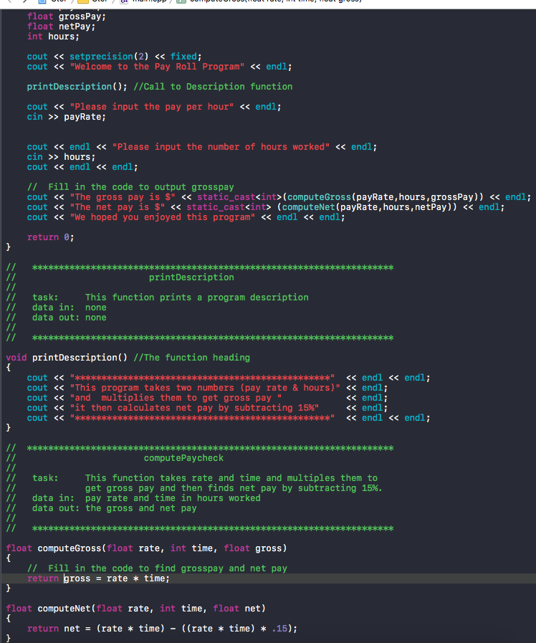

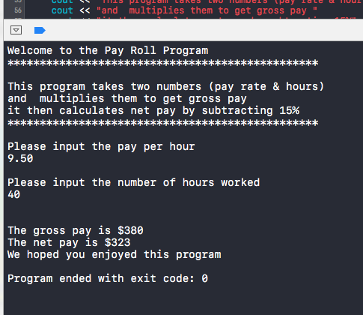

DO NOT DO SECTION 6.4 Student Generated Move on to the next pdf

**6.2 Fill in the Blank**

1. Answer: **Static**
2. Answer: **Local**
3. Answer: **Function Prototype**
4. Answer: **pass by reference**
5. Answer: **return statement**
6. Answer: **Driver**
7. Answer: **braces { }**
8. Answer: **Stub**
9. Answer: **reference**
10. Answer: **Overloaded functions**

**scope.cpp**

1. Exercise 1: Fill in the following chart by listing the identifiers (function names, variables, constants)

|  |  |  |  |  |  |
| --- | --- | --- | --- | --- | --- |
| **GLOBAL** | **Main** | **Main (inner1)** | **Main (inner2)** | **Area** | **Circumference** |
| **PI** | **radius** | **area** | **radius** | **rad** | **length** |
| **RATE** |  |  | **circumference** | **answer** | **distance** |
| **findArea()** |  |  |  |  |  |
| **findCircumference()** |  |  |  |  |  |
|  |  |  |  |  |  |
|  |  |  |  |  |  |
|  |  |  |  |  |  |
|  |  |  |  |  |  |
|  |  |  |  |  |  |
|  |  |  |  |  |  |

1. Exercise 2: For each cout instruction that reads:

cout << " LIST THE IDENTIFIERS THAT are active here" << endl;

Replace the words in all caps by a list of all identifiers active at that location. Change it to have the following form:

cout << "area, radius and PI are active here" << endl;

* 1. Copy of Code & Screenshot of black screen: **Note: full copy of code is provided in zip file.**

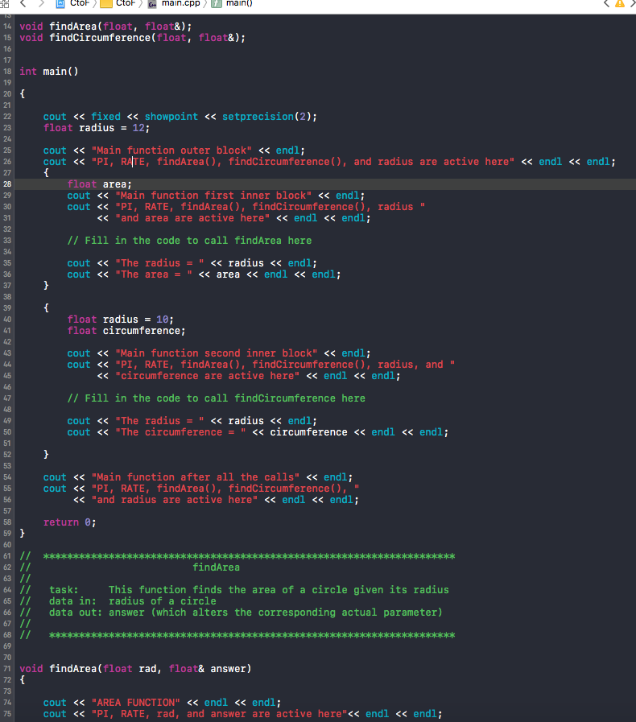

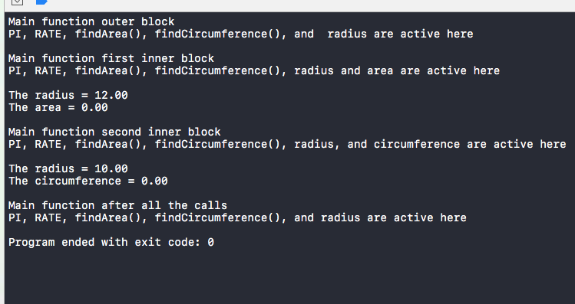

1. Exercise 3: For each comment in bold, place the proper code to do what it says.

NOTE:

area = π r2

circumference = 2πr

* 1. Copy of Code: **Note: entire cope of code included in zip file.**

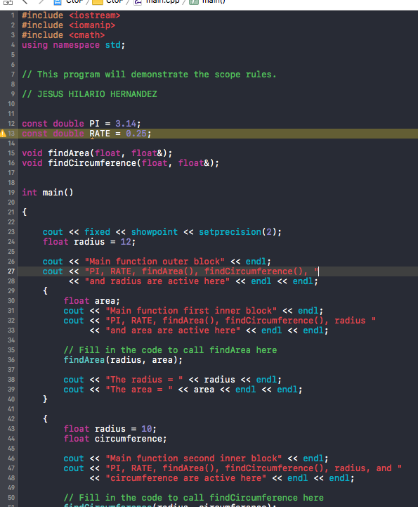

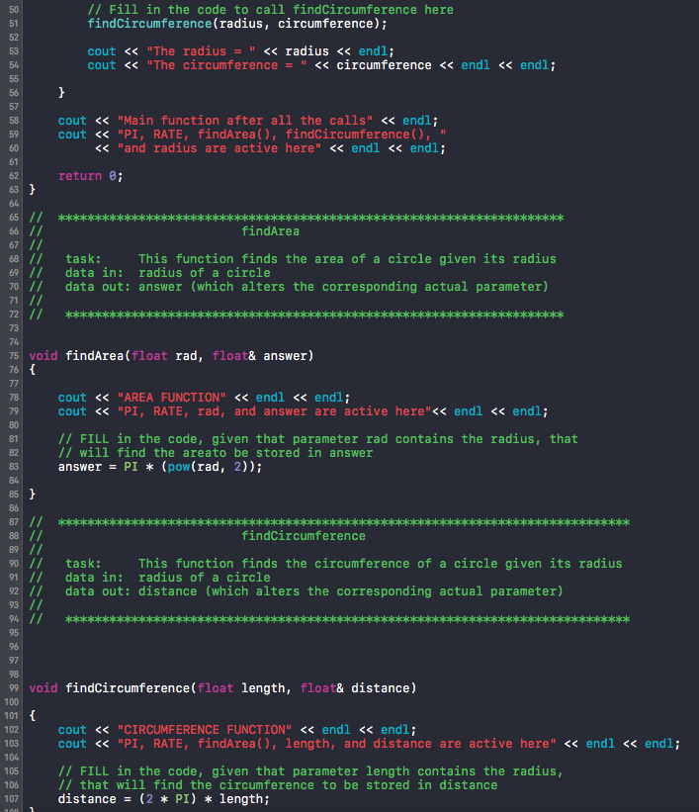

1. Exercise 4: Before compiling and running the program,
   1. Write out what you expect the output to be.
      1. Answer: **I expect the output for area to be pi x 12 x 12. The out put should be: 542.16. For Circumference I expect the answer to be 62.80.**
   2. What value for radius will be passed by main (first inner block) to the findArea function?
      1. Answer: **12**
   3. What value for radius will be passed by main function (second inner block) to the findCircumference function?
      1. Answer: **10**
2. Exercise 5: Compile and run your program. Your instructor may ask to see the program run or obtain a hard copy.
   1. Screenshot of black screen:

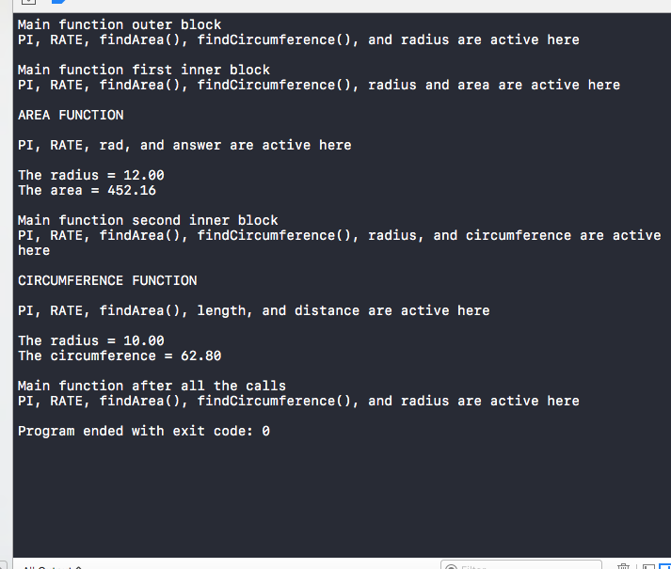

**money.cpp**

1. Exercise 1: You will notice that the function has to be completed. This function will take cents and convert it to dollars. It also keeps a running total of all the money it has processed. Assuming that the function is complete, write out what you expect the program will print.
   1. Answer: **First the program will print “We will now add 95 cents to our dollar total.” Then, the conversion from cents to dollars will be printed to screen. Afterward, the program will print another conversion after adding 193 cent to the dollar total. The default value will, then, be added and the conversion printed to screen.**
2. Exercise 2: Complete the function. Fill in the blank space to define sum and then write the code to convert cents to dollars. Example: 789 cents would convert to 7.89. Compile and run the program to get the expected results. Think about how sum should be defined.
   1. Copy of Code & Screenshot of black screen: **Note: entire cope of code included in zip file.**

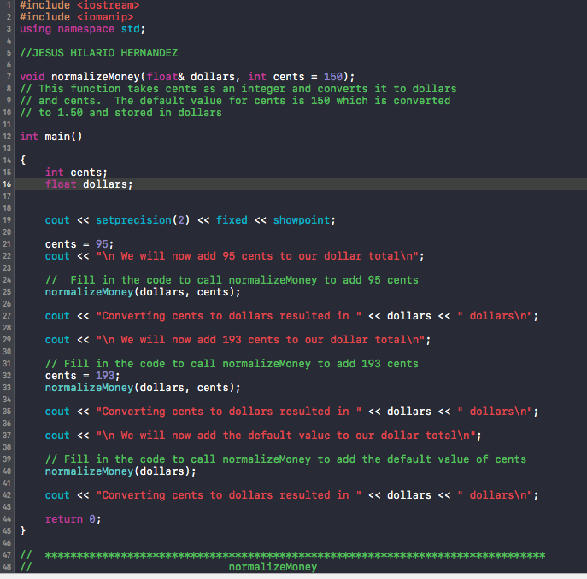

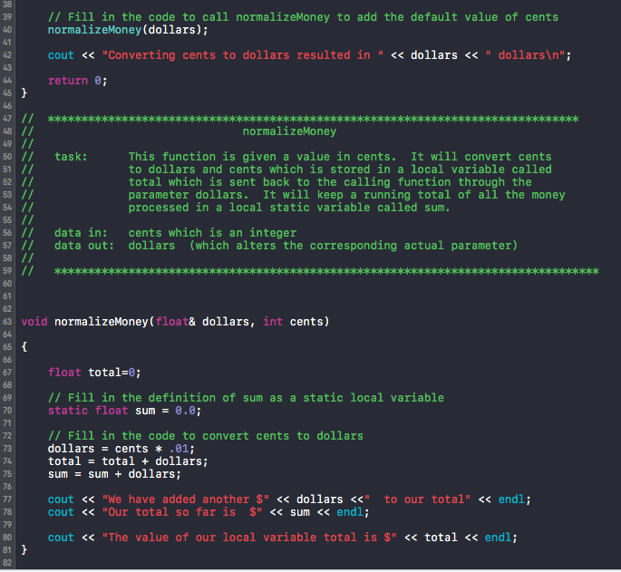

**convertmoney.cpp**

1. Exercise 1: Run this program and observe the results. You can input anything that you like for the dollars to be converted. Notice that it has stubs as well as overloaded functions. Study the stubs carefully. Notice that in this case the value returning functions always return 0.
   1. Copy of Code & Screenshot of black screen:

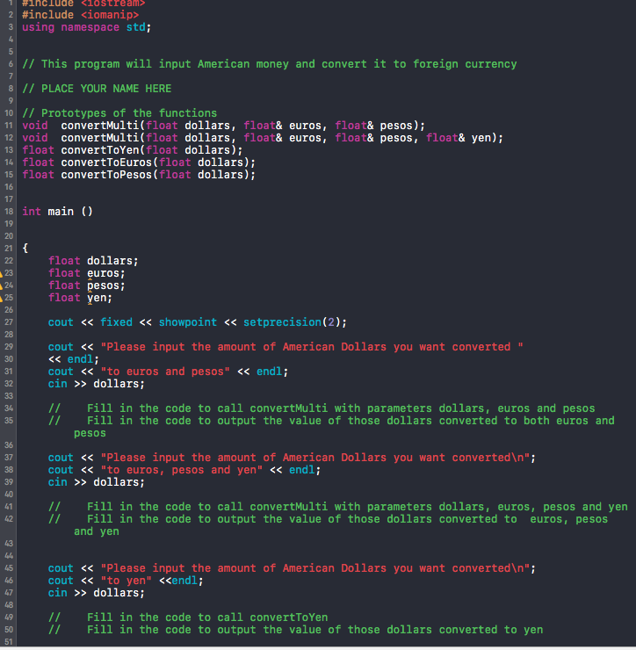

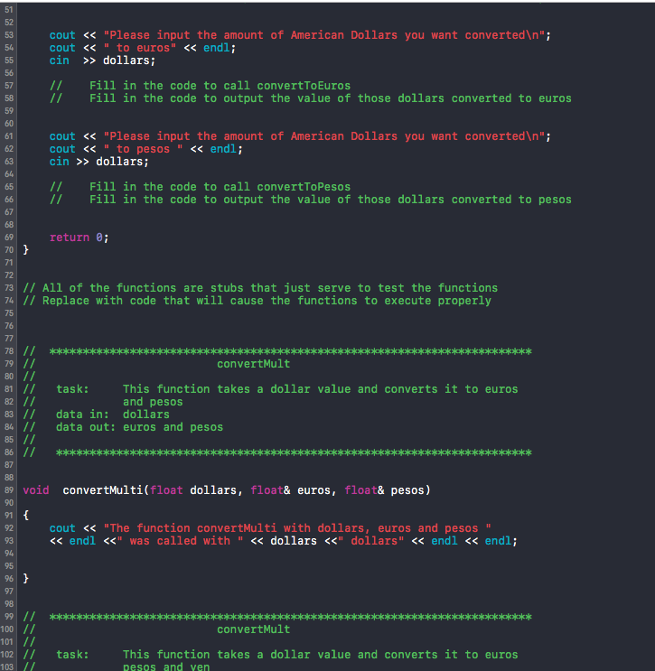

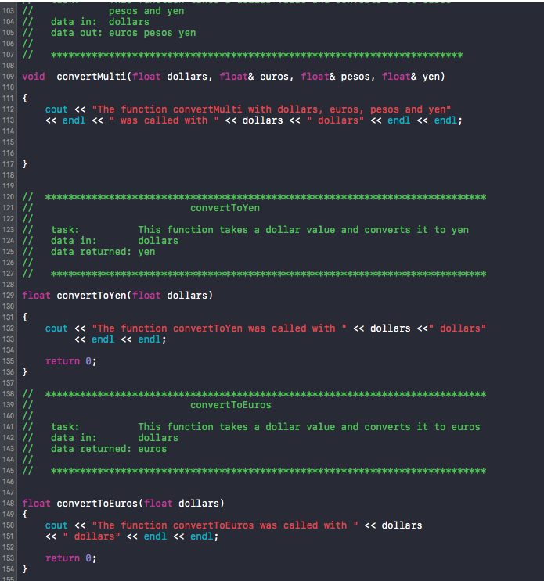

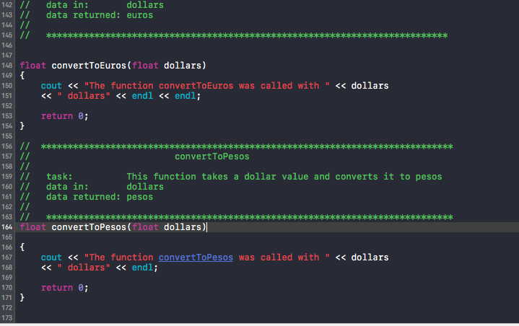

1. Exercise 2: Complete the program by turning all the stubs into workable functions. Be sure to call true functions differently than procedures. Make sure that functions return the converted dollars into the proper currency. Although the exchange rates vary from day to day, use the following conversion chart for the program. These values should be defined as constants in the global section so that any change in the exchange rate can be made there and nowhere else in the program.

One Dollar = 1.06 euros

9.73 pesos

124.35 yen

Sample Run:

Please input the amount of American Dollars you want converted to euros and pesos

9.35

$9.35 is converted to 9.91 euros and 90.98 pesos

Please input the amount of American Dollars you want converted to euros and pesos and yen

10.67

$10.67 is converted to 11.31 euros, 103.82 pesos, and 1326.81 yen

Please input the amount of American Dollars you want converted to yen

12.78

$12.78 is converted to 1589.19 yen

Please input the amount of American Dollars you want converted to euros

2.45

$2.45 is converted to 2.60 euros

Please input the amount of American Dollars you want converted to pesos

8.75

$8.75 is converted to 85.14 pesos

* 1. Copy of Code & Screenshot of black screen:

DO NOT DO 6.8 Student Generated section

Remember to submit this .doc file.