UNIVERSIDAD NACIONAL MAYOR DE SAN MARCOS

Doctoral Program in Deep Tech, Artificial
Intelligence & Emerging Technologies
Research Methods and Scientific Integrity in AI
and Advanced Technologies
MODEL CARD AND DATASET DATASHEET FOR A VERIFIABLE
CLAUSE-RECOMMENDATION ARTEFACT
DELIVERABLE No. 7
Course Instructor Dr. Loveleen Gaur
Student Eng. Jesús Vicente Inca Cárdenas

2026 - II

Table of Contents
1. Research Artefact and Evidence Status 3
2. Model Card — VeriClause-HITL v0.0 3
3. Dataset Datasheet — Fiduciary Clause Recommendation Evaluation Dataset v0.0 6
4. Documentation Scorecard — Self-Audit 8
5. Regulatory Documentation Crosswalk 8
6. Course Exercises on the Clause Proxy 9
7. Reproducibility and Pre-Collection Actions 11
8. Submission Bundle 12
References 13

MODEL CARD AND DATASET DATASHEET FOR A VERIFIABLE CLAUSE-RECOMMENDATION ARTEFACT
DELIVERABLE No. 7
Research topic: A Verifiable, Human-in-the-Loop Generative AI Model for Contractual Clause Recommendation in Regulated Fiduciary Institutions. Documented artefact: VeriClause-HITL v0.0 (research specification) and its planned evaluation dataset.
Submission scope. This report documents the planned doctoral artefact and its planned evaluation dataset with the nine-section Model Card and the seven-section Datasheet required in Session 7. It separates current evidence from future evaluation: the artefact has not been built or evaluated, and no thesis result is claimed. The course exercises were run on the public LEDGAR clause subset versioned in Deliverable No. 5, and their results are reported only as proxy demonstrations.

1. Research Artefact and Evidence Status
Research title. A Verifiable, Human-in-the-Loop Generative AI Model for Contractual Clause Recommendation in Regulated Fiduciary Institutions.
Documented artefact. VeriClause-HITL v0.0, the clause-recommendation assistant specified in Deliverable No. 3: given a clause need typed by a legal analyst, it returns two or three candidate clauses, each cited to the precedent clauses and normative provisions that support it, and withholds any candidate whose propositions are not supported by an identified source in force. The analyst accepts, edits or rejects every suggestion.
Current status. Pre-implementation Design Science Research specification. The protocol plans formative evaluation on an expert gold standard and summative comparison against three baselines (B0 no retrieval, B1 standard RAG, B3 current practice) within one SBS-supervised fiduciary institution and one clause family.
Evidence used in this deliverable. Three kinds of evidence are kept separate. (1) Specification: the protocol (Deliverable No. 3). (2) Proxy component evidence: the clause-type recogniser evaluated on public LEDGAR contracts in Deliverable No. 5. (3) Course demonstrations: the Session 7 exercises re-run on the same LEDGAR subset (Section 6). None of them is evidence about the attribution, hallucination or legal correctness of the artefact.

2. Model Card — VeriClause-HITL v0.0

2.1 Model details
Field | Content
Name / version | VeriClause-HITL v0.0 — Verifiable, human-in-the-loop clause recommendation assistant (research specification)
Owner / contact | Jesús Vicente Inca Cárdenas — UNMSM Doctoral Program in Deep Tech, AI & Emerging Technologies
Documentation date | 22 October 2026
Development status | Pre-implementation Design Science Research specification (Deliverable No. 3). Not yet built, evaluated with experts, or deployed.
Architecture | Seven planned components: (i) de-identification pipeline; (ii) knowledge base of de-identified precedent clauses and applicable norms (Law No. 26702, SBS Resolution No. 1010-99, circulars), versioned with the validity dates of each provision; (iii) query autocompletion; (iv) hybrid retrieval of precedents and norms; (v) generation with a self-hosted LLM; (vi) verifiability layer that decomposes each candidate clause into propositions, checks support by the cited span and that the cited provision is in force, and withholds unsupported candidates; (vii) human review interface (accept / edit / reject).
Generation model | Self-hosted open-weight LLM served on-premise; specific model, version and quantisation: UNKNOWN — to investigate before the formative evaluation.
License | UNKNOWN — to investigate — code licence and the licences of the selected LLM and embedding models must be checked before any release.

2.2 Intended use
Field | Content
Primary intended uses | Advisory recommendation of two or three candidate clauses, each with citations to the supporting precedent clauses and normative provisions, for one bounded clause family within one trust type, inside one SBS-supervised fiduciary institution.
Intended users | Qualified legal analysts of the host institution, who retain authority over every adopted clause; researchers evaluating the artefact under an approved protocol.
Out-of-scope / misuse | NOT for autonomous adoption of clauses; legal advice to clients or the public; jurisdictions, clause families or trust types not covered by the knowledge base; credit evaluation or any decision about individuals; regulatory reporting; use as an authoritative source of law; processing identifiable client data on external services; evaluating the performance of individual employees.

2.3 Factors
Field | Content
Relevant groups / conditions | Clause family and trust type; normative tier of the supporting source (law, regulation, circular, precedent); temporal validity of the cited provision at the reference date; query type (adaptation of a precedent vs. norm-driven drafting); Spanish legal register; analyst experience.
Evaluation factors | Results will be disaggregated by condition (B0 no retrieval, B1 standard RAG, B2 proposed artefact, B3 current practice), by hallucination type (unsupported, misattributed, contradictory), by normative tier, and by clause subtype where the sample allows.

2.4 Metrics
Field | Content
Primary 1 — Attribution quality | Citation precision and recall (Gao et al., 2023) plus span-level attributability judged by lawyers under the AIS criterion (Rashkin et al., 2023).
Primary 2 — Hallucination rate | Proportion of generated propositions that are unsupported, misattributed or contradict the governing framework, reported by type.
Primary 3 — Legal correctness (non-inferiority) | Expert severity rubric per clause aggregated by maximum severity; share of queries with at least one legally acceptable suggestion, tested against a prespecified margin Δ.
Secondary / process | Citation faithfulness probe; outdated-source rate; abstention rate; review time and edits relative to B3; accepted, edited and rejected suggestions.
Variation approach | Each query run k times per system with fixed seeds; mean ± SD across runs; mixed-effects logistic regression with item and run effects; paired bootstrap 95% CIs; Holm–Bonferroni across metric × baseline contrasts; one-sided CI for the non-inferiority margin.

2.5 Evaluation data
Field | Content
Dataset / design | NOT YET COLLECTED. Drafting queries for one clause family, evaluated under B0–B3 on a dated, frozen snapshot of the knowledge base; number of queries and k fixed by an a priori power analysis recorded in the preregistration.
Gold standard | Two to three external lawyers with at least five years in trust or financial-regulatory practice, written guideline, Krippendorff’s α ≥ 0.67 (≥ 0.80 preferred), adjudication by a senior expert; annotators blind to condition; the researcher does not annotate.
Independence rule | Queries and gold passages are created without access to the artefact’s segmentation, metadata or outputs (lesson from the Deliverable No. 6 audit).
Preprocessing | De-identification or pseudonymisation of all contract text before any processing; exact pipeline and residual re-identification test: UNKNOWN — to investigate before data collection.

2.6 Training data
Field | Content
Datasets | No fine-tuning is planned in v0.0: knowledge enters through retrieval, not training. The pre-training data of the selected LLM are those of its provider: UNKNOWN — to investigate.
Knowledge base (non-parametric) | De-identified precedent clauses from the institution’s typology-specific templates and executed contracts, and the applicable normative corpus retrieved from the SBS portal and SPIJ with recorded consultation dates.
Leakage control | Prompts, thresholds and retrieval settings are frozen before the summative evaluation; evaluation queries are never used for tuning. Any later adaptation would be versioned as a new DSR iteration.

2.7 Quantitative analyses
Field | Content
Overall results | NO THESIS RESULTS YET — no claim about attribution, hallucination or legal correctness of the artefact is made in this deliverable.
Proxy component evidence | Deliverable No. 5 evaluated a clause-type recogniser on public LEDGAR contracts (English, 20 types, 3,000 clauses): macro-F1 92.39% ± 0.11% across 7 seeds, against 0.48% for a majority baseline. This is evidence about a candidate component on a public proxy, not about the artefact.
Disaggregated results | Per-class F1 of the proxy recogniser (seed 42): from 0.98+ (Governing Laws, Severability, Counterparts) down to 0.81 (Terminations) and 0.68 (General). For the thesis, results will be reported per condition, per hallucination type and per normative tier, never as a single pooled score.

2.8 Ethical considerations
Field | Content
Risks | Disclosure of information protected by banking secrecy (Law No. 26702, art. 140) or personal data (Law No. 29733; Supreme Decree No. 016-2024-JUS); fluent but unsupported or outdated clauses; automation bias and over-reliance; attributable but legally incorrect clauses; unclear accountability for adopted text; insider bias of a researcher who leads technology in the host institution.
Mitigations | On-premise, self-hosted processing; de-identification and data minimisation; advisory-only design with the analyst’s decision required; verifiability layer with in-force check and abstention; separate legal-correctness rubric; stopping rule for leaks or highest-severity recommendations; external blind annotators; preregistration; voluntary adoption of the high-risk safeguards of Supreme Decree No. 115-2025-PCM (arts. 31.1, 31.4 and 32).
Human agency principle | Outputs are suggestions with visible sources, never decisions. No clause enters a contract without a qualified legal officer’s decision.

2.9 Caveats and recommendations
Field | Content
Caveats | Research-stage specification only. Verifiability is necessary but not sufficient for a trustworthy clause. No accuracy, safety, generalisability or external validity has been established; transfer beyond one institution is analytical, not statistical.
Recommendations | Before the summative evaluation freeze: LLM and model versions, knowledge-base snapshot, prompts, thresholds, clause family, gold-standard guideline, margin Δ, sample size, analysis plan and environment; read every parameter from one configuration file and log it with each run (Deliverable No. 5 scaffold).
Note. Individual elaboration following Mitchell et al. (2019). Fields marked UNKNOWN are deliberate: they are decisions the protocol schedules before evaluation.

3. Dataset Datasheet — Fiduciary Clause Recommendation Evaluation Dataset v0.0

3.1 Motivation
Field | Content
Purpose | Create a traceable evaluation dataset to test whether a verifiable clause-recommendation artefact improves attribution and reduces hallucination relative to B0, B1 and current practice, without loss of legal correctness.
Created by / funded by | Planned doctoral dataset led by Jesús Vicente Inca Cárdenas (UNMSM) in one SBS-supervised fiduciary institution, under written institutional authorisation. Funding: self-funded doctoral research with possible in-kind institutional support; UNKNOWN — to investigate.

3.2 Composition
Field | Content
What instances represent | One instance is a drafting query linked to its candidate clauses from each condition (B0–B3), their citations, and the gold annotations of attribution, hallucination type and legal severity.
Linked components | (A) de-identified precedent clauses; (B) normative provisions with identifiers and validity dates; (C) drafting queries; (D) system outputs and run metadata (seed, model version, snapshot); (E) gold annotations and adjudication records.
Sample vs population | One clause family within one trust type in one institution. NOT representative of all Peruvian fiduciary contracts or institutions. Number of queries: UNKNOWN — to investigate until the power analysis.
Current status / missingness | NO DATA COLLECTED YET. Field dictionary, missing-data rules and corpus size will be reported only in aggregate after de-identification.

3.3 Collection process
Field | Content
How collected | Precedent clauses extracted from the institution’s templates and executed contracts and de-identified on-premise; norms retrieved from the SBS normative portal and SPIJ with consultation dates; queries elicited with the legal area; system outputs logged by the prototype; annotations produced by external lawyers with a written guideline.
Experimental structure | Same queries under B0, B1 and B2 (same base model) with k seeded runs each, plus B3 clauses drafted by legal staff under the usual procedure.
Consent / ethics | Begins only after ethics approval at UNMSM and written institutional authorisation; informed consent and confidentiality agreements for annotators, panel members and participating analysts.
Timeframe | Months 19–24 of the doctoral plan; exact dates: UNKNOWN — to investigate.

3.4 Preprocessing / cleaning / labeling
Field | Content
Steps | De-identification before any processing; separation of identifiers under restricted access; versioning of the normative corpus with validity dates; dated snapshot frozen for evaluation; annotation of attribution spans, hallucination type and severity; agreement reported with Krippendorff’s α; documented adjudication.
Leakage control | Gold passages and queries created without access to the artefact’s segmentation or outputs; annotators blind to condition; no evaluation query used for tuning.
Raw data available | Raw contract text, client data and pre-de-identification records will NOT be released and will not leave the institution’s controlled environment.

3.5 Uses
Field | Content
Appropriate uses | Doctoral evaluation of the artefact; reproducibility audit of the comparison; analysis of attribution, hallucination and correctness failure modes; refinement of design principles.
Should NOT be used for | Training commercial or unrelated models; re-identification of clients, counterparties or trusts; legal advice; assessment or ranking of individual employees (B3 data describe practice, not people); profiling; claims about other institutions or clause families.

3.6 Distribution
Field | Content
How distributed | Shareable after review: schema, annotation guideline, synthetic examples, aggregate results and the public normative corpus with consultation dates. Contract-derived data stay access-controlled inside the institution.
License / restrictions | UNKNOWN — to investigate — to be aligned with the institutional authorisation, banking secrecy, data-protection law and consent terms.

3.7 Maintenance
Field | Content
Maintainer | Doctoral researcher under UNMSM governance and the host institution’s data-protection policies.
Versioning | Snapshots versioned with DVC and MD5 hashes, runs logged in MLflow, normative updates recorded with validity dates (scaffold of Deliverable No. 5).
Retention / deletion | Retention period, storage location, access revocation and deletion schedule: UNKNOWN — to investigate before data collection.
Note. Individual elaboration following Gebru et al. (2021).

4. Documentation Scorecard — Self-Audit
Result: 8 / 8. The scorecard evaluates documentation completeness and transparency, not model accuracy. The result is reached without inventing thesis outcomes: variation and disaggregation are specified for the artefact and reported for the proxy component, misuse is explicit for both the model and the dataset, the collection process is described, and unresolved items are flagged.
Table 1
Documentation Scorecard (Session 7, Exercise 6)
Check | Status | Where it is satisfied
Model Card has all 9 sections | PASS | Section 2
Datasheet has all 7 sections | PASS | Section 3
Intended misuse / out-of-scope stated | PASS | 2.2 Out-of-scope / misuse
Performance reported with variation (± / std / seeds) | PASS | 2.4 Variation approach; 2.7 proxy evidence (± over 7 seeds)
Metrics disaggregated (per-class / per-group) | PASS | 2.3 Evaluation factors; 2.7 per-class F1 of the proxy
Dataset “should NOT be used for” stated | PASS | 3.5 Uses
Collection process described | PASS | 3.3 Collection process
Gaps flagged honestly (“unknown”) | PASS | 2.1, 2.5, 2.6, 3.1, 3.3, 3.6, 3.7
Note. Individual elaboration; computed by score_documentation() in the executed notebook.

5. Regulatory Documentation Crosswalk
This crosswalk is an educational gap analysis, not a conformity assessment. It maps the Model Card onto the technical-documentation elements of Annex IV of the EU AI Act (Regulation (EU) 2024/1689), as in class, and adds the rules that actually apply to the thesis: Peru’s Law No. 31814 and its Regulation, Supreme Decree No. 115-2025-PCM. Under that Regulation the artefact is provisionally classified as acceptable-risk (art. 22.2), but the protocol voluntarily adopts the safeguards set for high-risk systems.
Table 2
Model Card Crosswalk to EU AI Act Annex IV and Supreme Decree No. 115-2025-PCM
Element | Maps to | Status | Needs attention
EU IV(1) General description: purpose, provider, version | Model details; Intended use | COVERED | —
EU IV(2) Development process: data, design choices, methods | Training data; Evaluation data; Metrics | PARTIAL | LLM and version, knowledge-base snapshot and evaluation data not yet fixed
EU IV(3) Monitoring, functioning and control; accuracy by group | Factors; Quantitative analyses | PARTIAL | Disaggregation planned; no artefact results yet
EU IV(4) Appropriateness of performance metrics | Metrics | COVERED | Primary, secondary and process metrics justified in the protocol
EU IV(5) Risk management: foreseeable risks and mitigations | Ethical considerations | COVERED | —
EU IV(8) Post-market monitoring / known limitations | Caveats and recommendations | PARTIAL | No deployment; monitoring plan pending
Peru art. 22.2 Risk classification | Intended use; Out-of-scope | PARTIAL | Provisional; formal consultation under art. 24.2 if uncertain
Peru art. 31.1 Record of operating principles, data sources and impacts | Model details; Training data; Datasheet | PARTIAL | Complete once components and corpus are frozen
Peru art. 31.4 Human oversight: stop, correct, override | Intended use; Human agency principle | COVERED | —
Peru art. 32 Impact assessment | Ethical considerations | GAP | Documented AI impact assessment scheduled for months 13–18
Note. Individual elaboration. Status counts: 4 COVERED, 5 PARTIAL, 1 GAP.
Every PARTIAL or GAP row is a sentence that cannot yet be written for a regulator, and each corresponds to a dated task in the protocol timeline. The single GAP, the impact assessment, is the item most likely to be requested by the host institution before any pilot.

6. Course Exercises on the Clause Proxy
The Session 7 notebook was customised so that its benchmarking exercises run on the public LEDGAR clause subset from Deliverable No. 5 (3,000 provisions, 20 clause types, MD5 bc995ef9bacb814a07d06dbecad47ad0) instead of the workshop dataset. The task is clause-type classification with TF-IDF features. The results below are demonstrations of method on a proxy; each paragraph ends with the rule it fixes for the thesis evaluation.
Table 3
Results of the Benchmarking Exercises on LEDGAR (Macro-F1)
Exercise | Result | Rule for the thesis
1. Weak-baseline illusion | Fancy 0.9199 vs untuned baseline 0.7197 (+0.2002); vs tuned baseline 0.9119 (+0.0080) | B1 standard RAG gets the same model, snapshot and retrieval budget as B2
2. One seed is not a result | 10 seeds: 0.9276 ± 0.0053; range 0.9204–0.9388 | k seeded runs per query and system; report mean ± SD
7. Significance and CIs | Paired over seeds: +0.0122, t = 7.48, p < 0.001; McNemar on one test set: 20 vs 13, p = 0.296; bootstrap 95% CI [-0.0067, +0.0232] | Query-level paired bootstrap and mixed-effects models; no pooled test over aggregates
8. Compute-matched comparison | Fancy model beats the tuned baseline (0.9154) only with ≥ 2,000 features; 1,000 features: 0.9128 | Report and match capacity and context budget across B0–B2
9. Leakage trap | Pure noise, 20 classes: leaky 0.094 vs honest 0.044 (chance 0.050) | Queries and gold passages built without access to the artefact
Note. Individual elaboration from results_summary.json of the executed notebook.
Exercise 7 gives the most useful lesson. Over ten seeds the paired t-test declares the fancy model better with p < 0.001, but on a single held-out set the exact McNemar test finds no difference (p = 0.30) and the bootstrap interval of the macro-F1 difference includes zero. The seed-level test is optimistic because overlapping training sets make the ten runs correlated (Nadeau & Bengio, 2003). A gain of about one point that looks decisive in one analysis and indistinguishable from zero in another is exactly the kind of claim the thesis must not make without a preregistered, query-level analysis.
Table 4
Ablation of the Clause-Type Pipeline (5 Seeds)
Configuration | Macro-F1 | SD | Δ vs full | Paired p
FULL model | 0.9288 | 0.0022 | +0.0000 | —
– remove bigrams | 0.9267 | 0.0028 | -0.0021 | 0.0072
– remove sublinear tf | 0.9221 | 0.0034 | -0.0067 | 0.0097
– remove IDF weighting | 0.9207 | 0.0056 | -0.0081 | 0.0128
– remove min_df filter | 0.9287 | 0.0027 | -0.0001 | 0.9485
Note. Individual elaboration. Bonferroni threshold for four comparisons: 0.0125.
Removing IDF weighting produces the largest drop (−0.81 points) yet does not pass the Bonferroni threshold (p = 0.0128 > 0.0125), while removing bigrams produces a smaller drop that does. Removing the min_df filter changes nothing, an honest negative result. The thesis applies the same logic to attribute gains to retrieval (B0 → B1) and to the verifiability layer (B1 → B2), with Holm–Bonferroni across its prespecified contrasts.
Figure 1
Ablation With Error Bars on the Clause Proxy
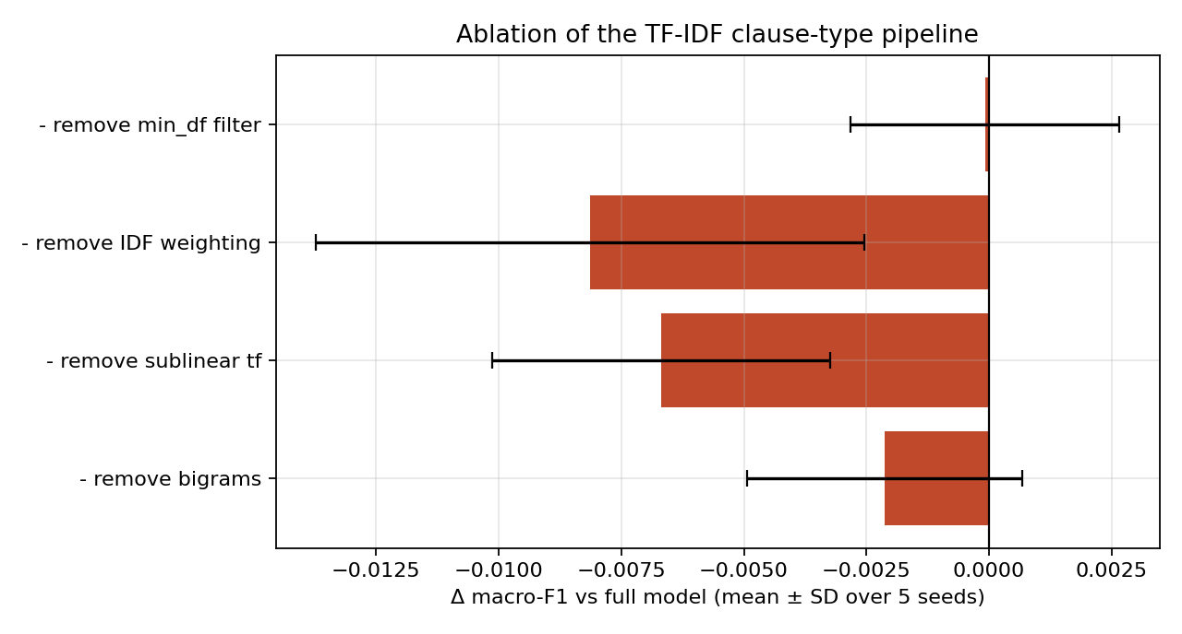
Note. Bars show the change in macro-F1 relative to the full model; error bars are the SD over five seeds. Course demonstration on public LEDGAR data, not a thesis result.
Figure 2
Compute-Matched Comparison on the Clause Proxy
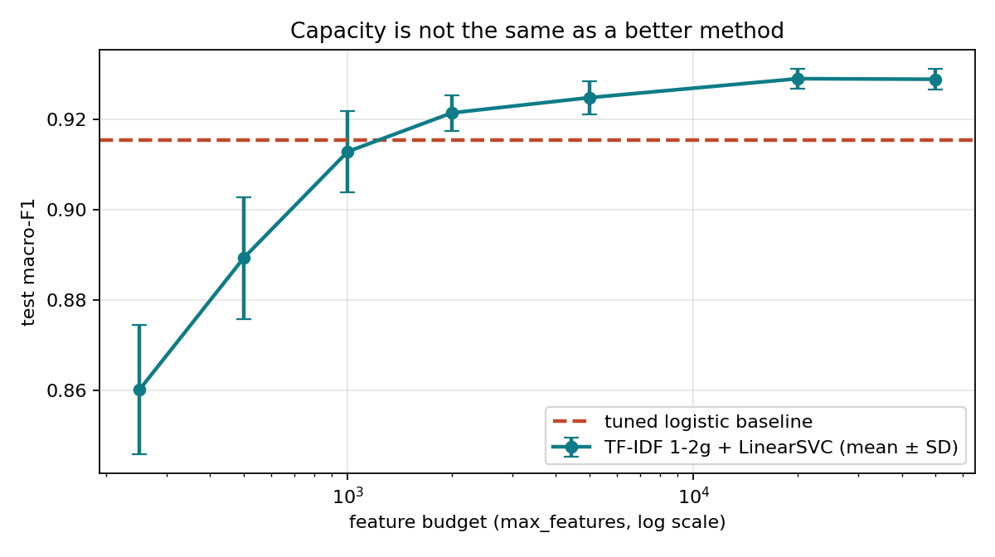
Note. Macro-F1 of the TF-IDF + linear SVM model as the feature budget grows, against the tuned logistic baseline. Course demonstration on public LEDGAR data, not a thesis result.

7. Reproducibility and Pre-Collection Actions
- Freeze the self-hosted LLM, its version and quantisation, the embedding and re-ranking models, and record their licences.
- Freeze a dated snapshot of the knowledge base with validity dates per provision, versioned with DVC as in Deliverable No. 5.
- Freeze prompts, retrieval depth, verification thresholds and abstention rules; read them from one configuration file and log them with every run in MLflow.
- Select the trust type and clause family with the legal area; elicit drafting queries without access to the artefact’s segmentation or outputs.
- Recruit external annotators, finalise the annotation guideline and the severity rubric, and run a calibration round until Krippendorff’s α ≥ 0.67.
- Fix the non-inferiority margin Δ by expert consensus, run the power analysis for queries and k, and preregister hypotheses and analysis plan.
- Complete ethics approval, institutional authorisation, the de-identification test and the documented AI impact assessment (art. 32) before any contract text is processed.
- Define retention, deletion and access rules; never release contract-derived data outside the institution.

8. Submission Bundle
Table 5
Files in the Deliverable No. 7 Folder
File | Purpose
model_card.md | Nine-section Model Card for VeriClause-HITL v0.0
datasheet.md | Seven-section Datasheet for the planned evaluation dataset
documentation_scorecard.md | 8/8 self-audit (Exercise 6)
regulatory_crosswalk.md | EU AI Act Annex IV and Supreme Decree No. 115-2025-PCM gap analysis
REPRODUCIBILITY_REPORT.md | Environment, evidence status and integrity boundary
results_summary.json | Numerical results of the proxy exercises
fig_seed_variance.png, fig_compute_matched.png, fig_ablation_errorbars.png | Proxy demonstration figures
Notebook_HandsOn_Inca.ipynb and Notebook_HandsOn_Executed_Inca.ipynb | Customised Session 7 notebook, clean and executed
D7_Model_Card_Datasheet_Jesus_Inca.pdf | This report

References
Congreso de la República del Perú. (2023). Ley N.º 31814, Ley que promueve el uso de la inteligencia artificial en favor del desarrollo económico y social del país.
Gao, T., Yen, H., Yu, J., & Chen, D. (2023). Enabling large language models to generate text with citations. In Proceedings of the 2023 Conference on Empirical Methods in Natural Language Processing (pp. 6465–6488). Association for Computational Linguistics.
Gebru, T., Morgenstern, J., Vecchione, B., Vaughan, J. W., Wallach, H., Daumé III, H., & Crawford, K. (2021). Datasheets for datasets. Communications of the ACM, 64(12), 86–92. https://doi.org/10.1145/3458723
Mitchell, M., Wu, S., Zaldivar, A., Barnes, P., Vasserman, L., Hutchinson, B., Spitzer, E., Raji, I. D., & Gebru, T. (2019). Model cards for model reporting. In Proceedings of the Conference on Fairness, Accountability, and Transparency (pp. 220–229). ACM. https://doi.org/10.1145/3287560.3287596
Nadeau, C., & Bengio, Y. (2003). Inference for the generalization error. Machine Learning, 52(3), 239–281. https://doi.org/10.1023/A:1024068626366
Presidencia del Consejo de Ministros. (2025). Decreto Supremo N.º 115-2025-PCM, que aprueba el Reglamento de la Ley N.º 31814. Diario Oficial El Peruano.
Rashkin, H., Nikolaev, V., Lamm, M., Aroyo, L., Collins, M., Das, D., Petrov, S., Tomar, G. S., Turc, I., & Reitter, D. (2023). Measuring attribution in natural language generation models. Computational Linguistics, 49(4), 777–840.
Regulation (EU) 2024/1689 of the European Parliament and of the Council of 13 June 2024 laying down harmonised rules on artificial intelligence (Artificial Intelligence Act). (2024). Official Journal of the European Union.
Tuggener, D., von Däniken, P., Peetz, T., & Cieliebak, M. (2020). LEDGAR: A large-scale multi-label corpus for text classification of legal provisions in contracts. In Proceedings of the 12th Language Resources and Evaluation Conference (pp. 1235–1241). European Language Resources Association.

