**Provisioning Report**

**ASAP 7.0.2 – JAMU66**

**&**

**ASAP7.0.2 – WASS1133**

**Month: June**

**July 01st, 2018**

**Content**

1. Summary Transaction Information from JAMU66 3

2. Summary Transaction Information from WASS1133 6

3. Tickets 9

4. Platforms refusing connectivity 11

5. RFC support 13

# Summary Transaction Information from JAMU66

|  |  |  |  |
| --- | --- | --- | --- |
| ***JAMU66*** | | |  |
| ***Transactions*** | |  | 100% |
| ***Start Date*** | | 01-May-2018 00:00:00 AM | |
| ***End Date*** | | 31-May-2018 23:59:59 PM | |
| ***Order Status*** | **Description** | **Values** | |
| ***COMPLETED*** | The order was completed with successful response from the Network Element |  |  |
| ***FAILED*** | The order was completed with error response from the Network Element |  |  |
| ***IN_PROG*** | Orders in Progress |  |  |
| ***TIMEOUT*** | Orders that exceeded the execution time |  |  |
| ***TRANSL_FAIL*** | Orders that were not executed |  |  |

|  |  |  |  |  |  |  |  |  |  |  |  |
| --- | --- | --- | --- | --- | --- | --- | --- | --- | --- | --- | --- |
| **Day** | **Total** | **Transactions  Complete** | **% Complete** | **Transactions  Failed** | **%  Failed** | **Transactions  In_Prog** | **% In_Prog** | **Transactions  Timeout** | **% Timeout** | **Transactions Trans Fail** | **%  Trans Fail** |
|  |  |  |  |  |  |  |  |  |  |  |  |
|  |  |  |  |  |  |  |  |  |  |  |  |
|  |  |  |  |  |  |  |  |  |  |  |  |
|  |  |  |  |  |  |  |  |  |  |  |  |
|  |  |  |  |  |  |  |  |  |  |  |  |
|  |  |  |  |  |  |  |  |  |  |  |  |
|  |  |  |  |  |  |  |  |  |  |  |  |
|  |  |  |  |  |  |  |  |  |  |  |  |
|  |  |  |  |  |  |  |  |  |  |  |  |
|  |  |  |  |  |  |  |  |  |  |  |  |
|  |  |  |  |  |  |  |  |  |  |  |  |
|  |  |  |  |  |  |  |  |  |  |  |  |
|  |  |  |  |  |  |  |  |  |  |  |  |
|  |  |  |  |  |  |  |  |  |  |  |  |
|  |  |  |  |  |  |  |  |  |  |  |  |
|  |  |  |  |  |  |  |  |  |  |  |  |
|  |  |  |  |  |  |  |  |  |  |  |  |
|  |  |  |  |  |  |  |  |  |  |  |  |
|  |  |  |  |  |  |  |  |  |  |  |  |
|  |  |  |  |  |  |  |  |  |  |  |  |
|  |  |  |  |  |  |  |  |  |  |  |  |
|  |  |  |  |  |  |  |  |  |  |  |  |
|  |  |  |  |  |  |  |  |  |  |  |  |
|  |  |  |  |  |  |  |  |  |  |  |  |
|  |  |  |  |  |  |  |  |  |  |  |  |
|  |  |  |  |  |  |  |  |  |  |  |  |
|  |  |  |  |  |  |  |  |  |  |  |  |
|  |  |  |  |  |  |  |  |  |  |  |  |
|  |  |  |  |  |  |  |  |  |  |  |  |
|  |  |  |  |  |  |  |  |  |  |  |  |
| **SUMMARY AVERAGE** | **274,645** | **240,507** | **89.57%** | **21,573** | **5.99%** | **0** | **0.00%** | **12,565** | **4.44%** | **0** | **0.00%** |

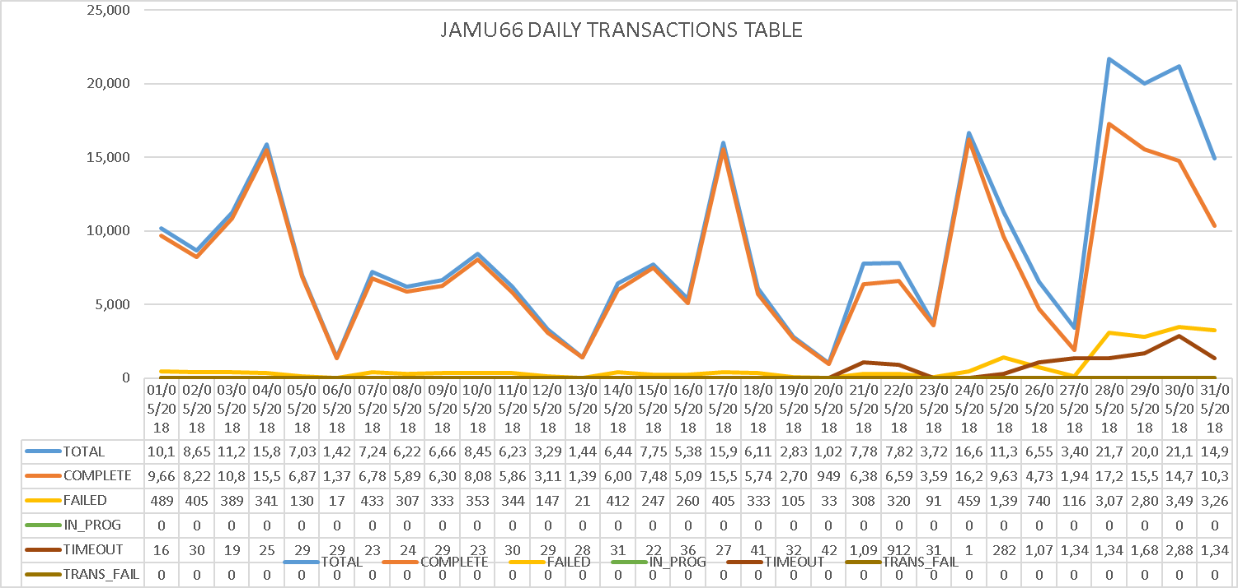

# Summary Transaction Information from WASS1133

|  |  |  |  |
| --- | --- | --- | --- |
| ***WASS1133*** | | | ***%*** |
| ***Transactions*** | |  | 100% |
| ***Start Date*** | | 01-May-2018 00:00:00 AM | |
| ***End Date*** | | 31-May-2018 23:59:59 PM | |
| ***Order Status*** | **Description** | **Values** | |
| ***COMPLETED*** | The order was completed with successful response from the Network Element |  |  |
| ***FAILED*** | The order was completed with error response from the Network Element |  |  |
| ***IN_PROG*** | Orders in Progress |  |  |
| ***TIMEOUT*** | Orders that exceeded the execution time |  |  |
| ***TRANSL_FAIL*** | Orders that were not executed |  |  |

|  |  |  |  |  |  |  |  |  |  |  |  |
| --- | --- | --- | --- | --- | --- | --- | --- | --- | --- | --- | --- |
| **Day** | **Total** | **Transactions  Complete** | **% Complete** | **Transactions  Failed** | **%  Failed** | **Transactions  In_Prog** | **% In_Prog** | **Transactions  Timeout** | **% Timeout** | **Transactions Trans Fail** | **%  Trans Fail** |
|  |  |  |  |  |  |  |  |  |  |  |  |
|  |  |  |  |  |  |  |  |  |  |  |  |
|  |  |  |  |  |  |  |  |  |  |  |  |
|  |  |  |  |  |  |  |  |  |  |  |  |
|  |  |  |  |  |  |  |  |  |  |  |  |
|  |  |  |  |  |  |  |  |  |  |  |  |
|  |  |  |  |  |  |  |  |  |  |  |  |
|  |  |  |  |  |  |  |  |  |  |  |  |
|  |  |  |  |  |  |  |  |  |  |  |  |
|  |  |  |  |  |  |  |  |  |  |  |  |
|  |  |  |  |  |  |  |  |  |  |  |  |
|  |  |  |  |  |  |  |  |  |  |  |  |
|  |  |  |  |  |  |  |  |  |  |  |  |
|  |  |  |  |  |  |  |  |  |  |  |  |
|  |  |  |  |  |  |  |  |  |  |  |  |
|  |  |  |  |  |  |  |  |  |  |  |  |
|  |  |  |  |  |  |  |  |  |  |  |  |
|  |  |  |  |  |  |  |  |  |  |  |  |
|  |  |  |  |  |  |  |  |  |  |  |  |
|  |  |  |  |  |  |  |  |  |  |  |  |
|  |  |  |  |  |  |  |  |  |  |  |  |
|  |  |  |  |  |  |  |  |  |  |  |  |
|  |  |  |  |  |  |  |  |  |  |  |  |
|  |  |  |  |  |  |  |  |  |  |  |  |
|  |  |  |  |  |  |  |  |  |  |  |  |
|  |  |  |  |  |  |  |  |  |  |  |  |
|  |  |  |  |  |  |  |  |  |  |  |  |
|  |  |  |  |  |  |  |  |  |  |  |  |
|  |  |  |  |  |  |  |  |  |  |  |  |
|  |  |  |  |  |  |  |  |  |  |  |  |
| **SUMMARY AVERAGE** | **87,395** | **71,165** | **77.38%** | **11,174** | **13.70%** | **2** | **0.00%** | **5,053** | **8.92%** | **0** | **0.00%** |

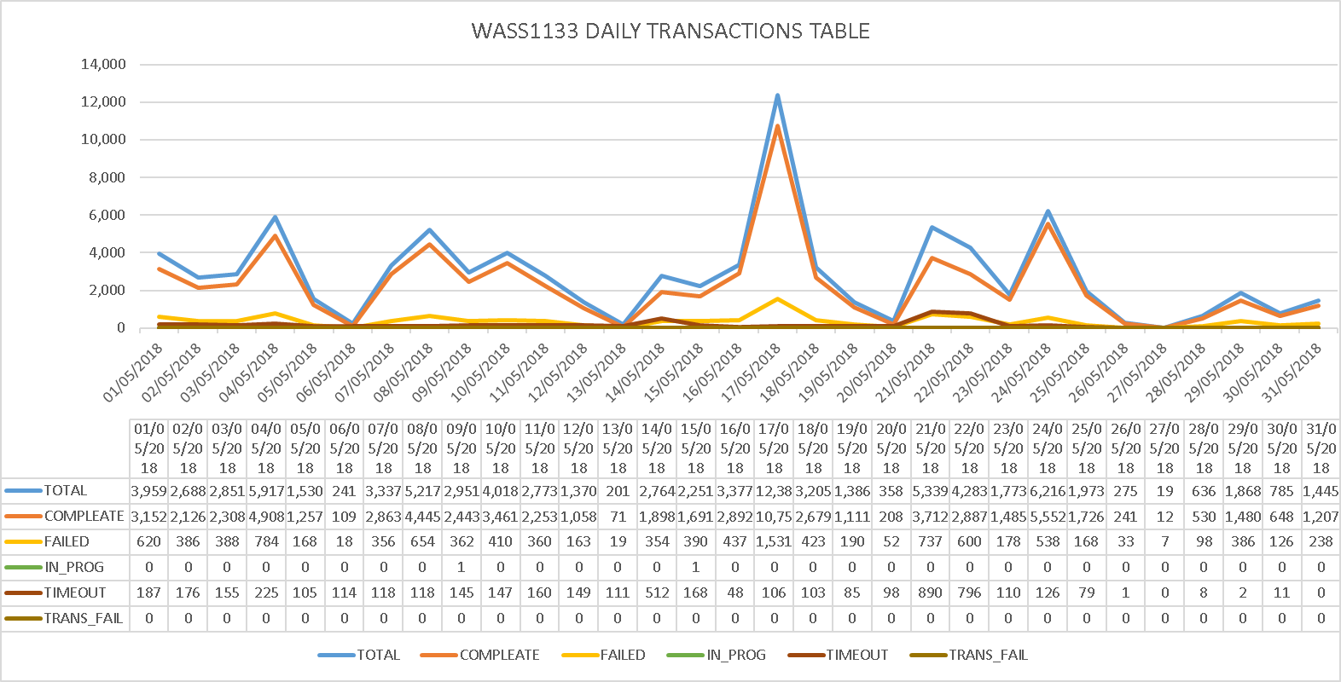

# Tickets

|  |  |
| --- | --- |
| **May Statistics** | |
| Tickets | 27 |
| **Severity** | |
| LOW | 12 |
| MEDIUM | 12 |
| HIGH | 3 |
| **Origin** | |
| Harish, Prakash | 2 |
| Joy | 3 |
| Juan Pablo | 1 |
| Kishore | 3 |
| Mounika | 1 |
| Neilsa | 6 |
| Prakash | 7 |
| Praneetha | 2 |
| Connection Refused | 3 |

|  |  |
| --- | --- |
| **Accumulative** | |
| Tickets | 148 |
| **Severity** | |
| LOW | 74 |
| MEDIUM | 38 |
| HIGH | 36 |
| **Origin** | |
| Barbara | 2 |
| Chinnasani | 5 |
| FLOW IT AUTOMATED PROVISIONING | 1 |
| Harish, Prakash | 2 |
| IGATE LIBERATE TIER 2 SUPPORT | 1 |
| Jason | 1 |
| Joy | 14 |
| Juan Pablo | 1 |
| Kishore | 11 |
| León | 1 |
| Madhusudhan | 1 |
| Mark | 2 |
| Mora | 1 |
| Mounika | 1 |
| Neilsa | 32 |
| Nola | 2 |
| Prakash | 13 |
| Praneetha | 8 |
| Rhonda | 2 |
| Samantha | 2 |
| Shalana | 1 |
| Suresh | 4 |
| Terry | 1 |
| Uday | 2 |
| Wendy | 1 |
| Connection Refused | 35 |

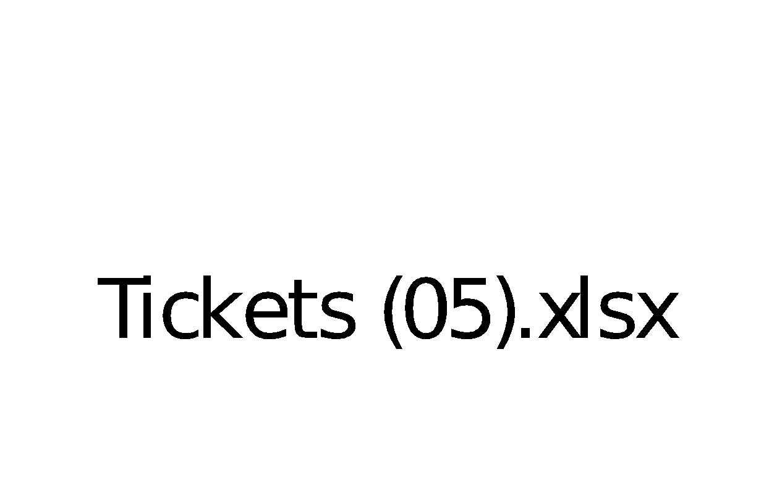

# Platforms refusing connectivity

|  |  |  |
| --- | --- | --- |
| **CONNECTION REFUSE E-MAIL TITLE** | **DATE** | **STATUS** |
| **ASAP monitor; connection refused SLU_UVF** | 24/1/18 | CLOSED |
| **ASAP monitor; connection refused EST_GSAT & EST_GSAT1** | 25/1/18 | OPEN |
| **ASAP monitor; connection refused SLU_UVF** | 30/1/18 | CLOSED |
| **ASAP monitor; connection refused SLU_UVF** | 2/2/18 | CLOSED |
| **ASAP monitor; connection refused SLU_UVF** | 5/2/18 | CLOSED |
| **ASAP monitor; connection refused SLU_UVF** | 6/2/18 | CLOSED |
| **ASAP monitor; connection refused SLU_CEN** | 5/2/18 | CLOSED |
| **ASAP monitor; connection refused SLU_UVF** | 9/2/18 | CLOSED |
| **ASAP monitor; connection refused JAM_CALIX** | 13/2/18 | OPEN |
| **ASAP monitor; connection refused SLU_UVF** | 16/2/18 | CLOSED |
| **ASAP-WASS133-ASAP There is no connection to Database -No Listener** | 18/2/18 | CLOSED |
| **ASAP JAMU66 shutdown** | 22/2/18 | CLOSED |
| **ASAP monitor; connection refused SLU_UVF** | 22/2/18 | CLOSED |
| **ASAP monitor; connection refused CAY_GNBND with WASS1133** | 22/2/18 | OPEN |
| **ASAP monitor; connection refused SLU_UVF** | 22/2/18 | CLOSED |
| **ASAP monitor; connection refused SLU_UVF** | 28/2/18 | CLOSED |
| **WASS1133-ASAP provisioning asappro1 user fails to login** | 28/2/18 | CLOSED |
| **ASAP monitor; connection refused SLU_CEN** | 5/3/18 | CLOSED |
| **JAM_MOBY connection failure** | 9/3/18 | CLOSED |
| **ASAP-FLOW-monitor, Unable to connect to remote host: Connection refused to SLU_UVF** | 13/3/18 | CLOSED |
| **ASAP monitor; connection refused SLU_UVF** | 14/3/18 | CLOSED |
| **ASAP monitor; connection refused SLU_UVF** | 28/3/18 | CLOSED |
| **ASAP monitor; connection refused SLU_UVF** | 2/4/18 | CLOSED |
| **ASAP monitor; connection refused SLU_UVF** | 3/4/18 | CLOSED |
| **ASAP monitor; connection refused JAM_EAST** | 3/4/18 | CLOSED |
| **ASAP monitor; connection refused SLU_UVF** | 5/4/18 | CLOSED |
| **ASAP monitor; connection refused SLU_UVF** | 9/4/18 | CLOSED |
| **ASAP connection refused SONUS** | 11/4/18 | CLOSED |
| **ASAP connection refused SONUS** | 16/4/18 | CLOSED |
| **ASAP monitor; connection refused SLU_UVF** | 16/4/18 | CLOSED |
| **ASAP monitor; connection refused SLU_UVF** | 26/4/18 | CLOSED |
| **ASAP monitor; connection refused SLU_CEN** | 26/4/18 | CLOSED |
| **ASAP monitor; connection refused SLU_UVF** | 30/4/18 | OPEN |
| **ASAP monitor; connection refused SLU_UVF** | 2/5/18 | CLOSED |
| **LIME-ASAP-jamu66-Connection Fail to SONUS platform** | 28/5/18 | OPEN |

# RFC support

|  |  |
| --- | --- |
| **CONCEPT** | **DATE** |
| RFC 4080434 - Barbados HLR CP Upgrade from R12B to R15A | **25/01/2018** |
| |RFC6786| SCHEDULED RFC NOTIFICATION Cleandata Routine Maintenance on JAMU66 | **22/02/2018** |
| RFC6955-Reroute provisioning on Barbados HLR to Jamaica HLR - MW3 | **7/03/2018** |
| |RFC7430| SCHEDULED RFC NOTIFICATION Routine Maintenance: ASAP Cleandata on JAMU66 server | **11/04/2018** |
| |RFC8041| SCHEDULED RFC NOTIFICATION ASAP Cleandata Maintenance Activity - JAMU66 | **24/05/2018** |