An Investigation of the Diastereoselectivity of Aldol Couplings between β-Alkoxy Methyl and Ethyl Ketones and Achiral Aldehydes

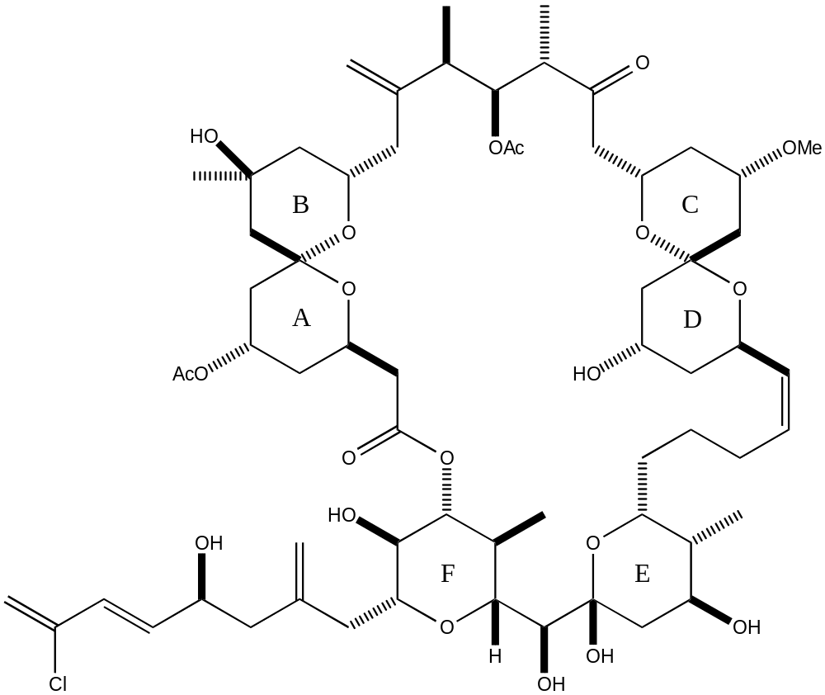

Spongistatin 1

Retrosynthesis

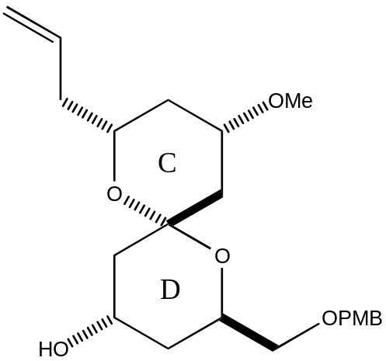

CD Spiroacetal Fragment

Need chemdraw bits of the steps back to my aldol.

The Boron Mediated Aldol Reaction

- Enolisation with dicyclohexylboron chloride and triethylamine gives high (>99:1) regioselectivity as shown below:

DIAGRAM OF CIS-ENOLATE ON ME SIDE

Explanation

- Sterics Favour Co-ordination cis to the Methyl Group

- Anomeric Effect between n_{O} → σ*_{B-X} leads to activation of cis alkyl group to enolisation

DIAGRAM OF SOMETHING HERE!

1,5-anti Diastereoselectivity

- Very high levels of 1,5-anti stereocontrol observed in reactions of β-oxygenated chiral methyl ketones.

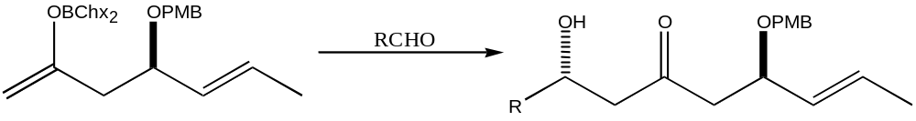
- β Protecting Group Key to Remote Stereocontrol

Same as above but with other group - racemic

Explanation

- Proposed Boat Shaped Transition State

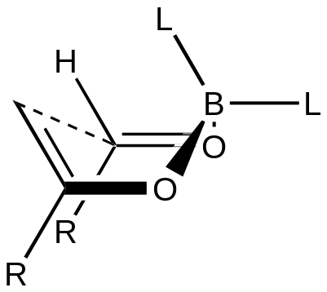

Synthesis of Optically Active Methyl and Ethyl Ketones

- Synthesis from (3R)-polyhydroxybutyrate

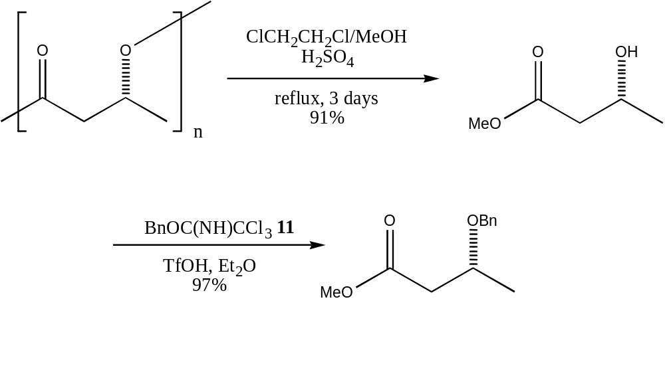

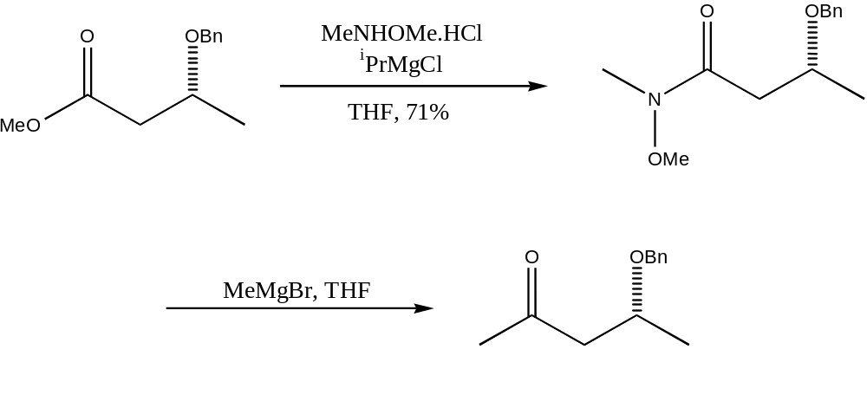

Trial Aldol Couplings (Lithium Mediated)

- Isobutyraldehyde

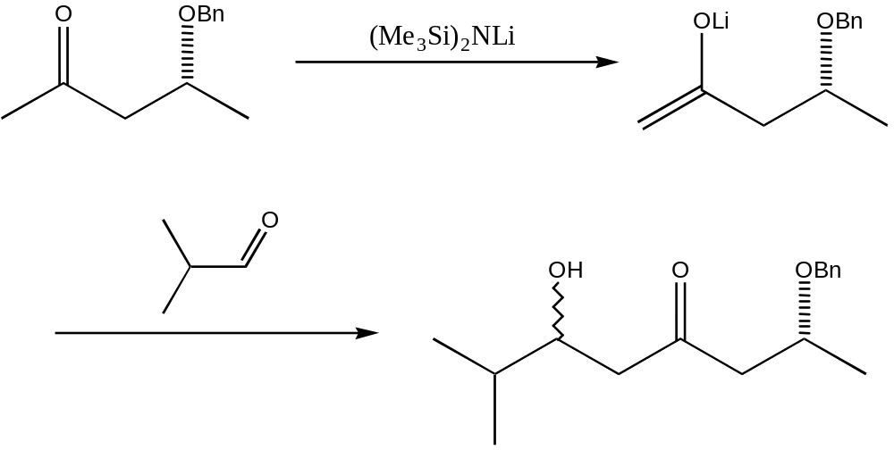

- Crotonaldehyde

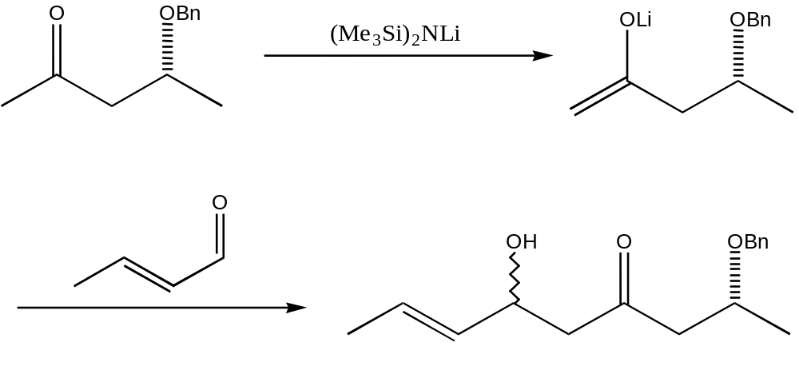

CD Precursor Aldol Couplings

- Lithium Mediated Coupling

- Boron Mediated Couplings

- Chx₂BCl
- (+)-ipc₂BCl
- (-)-ipc₂BCl

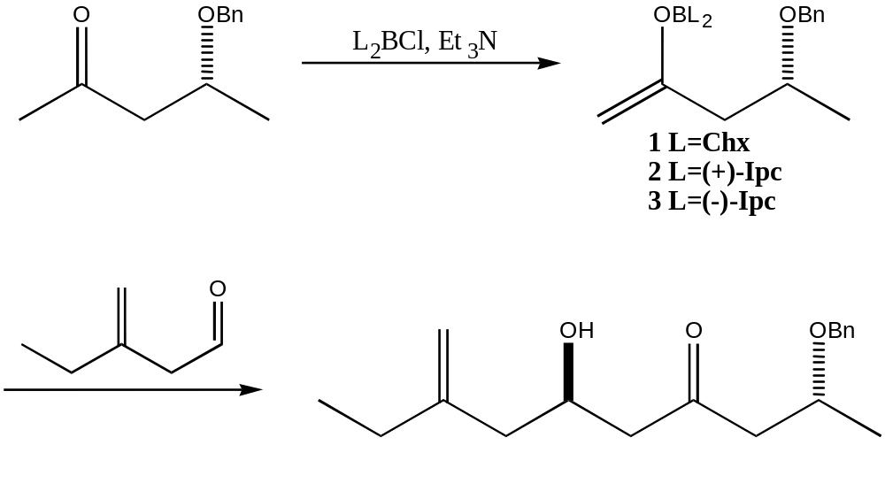

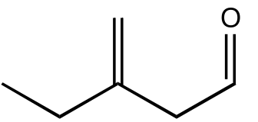
synthesised in two steps from 3-butyn-1-ol

Results for Methyl Ketones

Enolisation Conditions  (all at –78°C) | Diastereoselectivity  (anti:syn)
Chx₂BCl, Et₃N | 87:13
(+)-Ipc₂BCl, Et₃N | 91:09
(-)-Ipc₂BCl, Et₃N | 74:26
Li-N^{i}Pr₂ | 52:48

- No Stereoselectivity with Lithium Aldol
- High 1,5-anti stereoselectivity with Cyclohexyl aldol
- Matched Ipc aldol shows extremely high selectivity
- Mismatched Ipc aldol shows significant anti stereoselectivity

Calculation of Results

- Formation of Mosher’s Esters

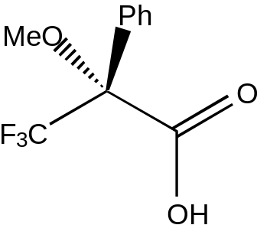
(R)-α-methoxy-α-(trifluoromethyl)phenylacetic acid

- Comparison of Proton Integrals in High-Field NMR spectra

Include a bit of a spectrum ?? Plot expansion from one of the well-spread ones?

Method and Results for Ethyl Ketones

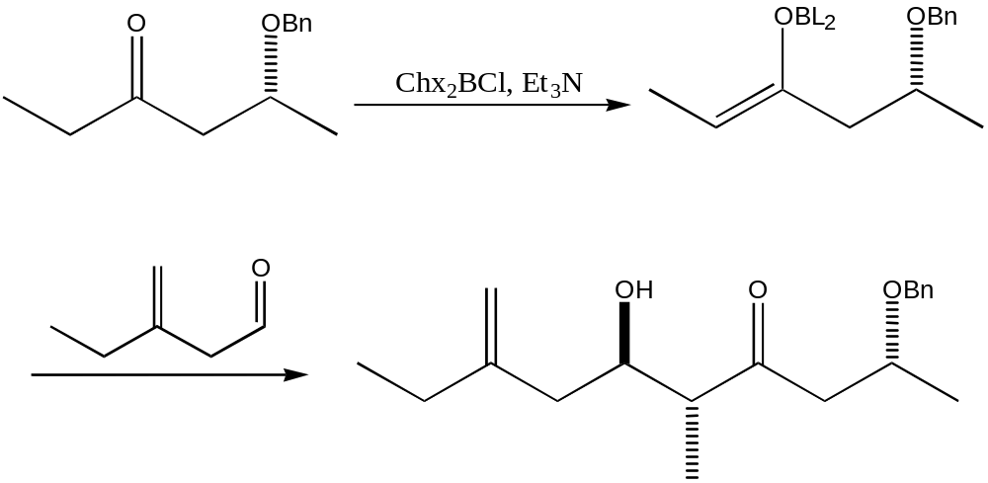

Enolisation Conditions  Chx₂BCl, Et₃N, -78°C | Diastereoselectivity  (anti:syn)
Methyl Ketone 14 | 87:13
Ethyl Ketone 15 | 92:8

- Ethyl Ketone shows extremely high stereoselectivity

- Necessary to Determine Fully the Absolute Stereochemistry of Ethyl Adduct

Mosher’s Method (Modified)

- Form Mosher Esters using both (R) and (S)-MTPA acids

- Take High Resolution NMR Spectra of Both Samples

- Compare δ values of equivalent protons in each structure

- Values of “Δδ” give absolute stereochemistry at Hyrdoxyl centre

Explanation of Mosher’s Method

- Preferred Conformation of Ester

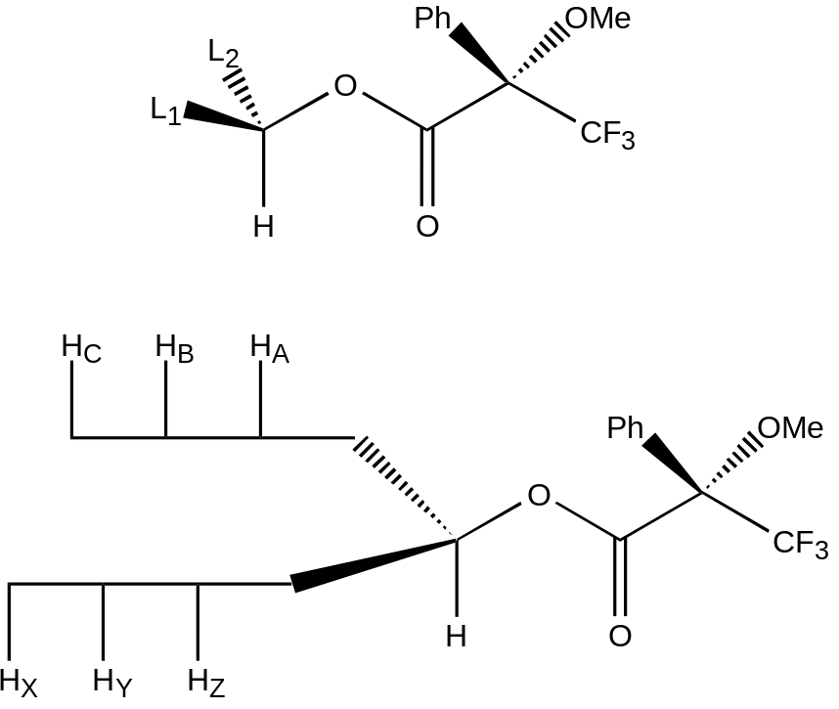

- Diamagnetic Influence of Phenyl Group

- Determination of Absolute Configuration

Relative Stereochemistry of OH and Me Groups

- Pseudo 6-Membered Ring Formation

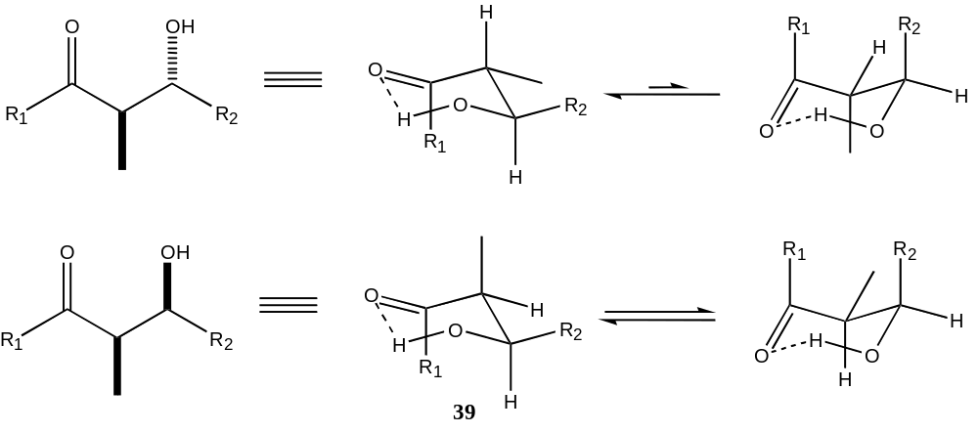

- ³J Proton Coupling

Further Work

- Use of Alternative Protecting Groups
- Ethyl Ketone Couplings with Ipc Boron Halides
- Improvement to Synthetic Steps
- Molecular Modelling of Ethyl Adduct Transition State

