MeshCAD
User Manual and Practical Tutorials
2D block-structured mesh generator with integrated CAD
Application version 1.0 | Updated 29 October 2026

Contents
Starting the Application
Interface Overview
Undo and Redo
Canvas Navigation
Typical Workflow
1. Draw Geometry
Import an Ordered Point Sequence
2. Edit Geometry
3. Detect a Closed Loop
4. Create a Structured Block
5. Configure Edge Distributions
6. Validate Blocks
7. Generate the Mesh
Mesh Improvement Controls
Orthogonality
Elliptic Smoothing
Complete Tutorials
Tutorial 1: Rectangular Block from Drawing to Mesh
Tutorial 2: Two Conformal Blocks and a Shared Interface
Tutorial 3: Biasing a Boundary and Improving the Mesh
Tutorial 4: Boundary Patches and Mesh Export
Tutorial 5: Split a Shared Edge and Rebalance the Mesh
Saving Projects
Exporting VTK
Mesh Patches and Block Interfaces
Troubleshooting
No loop is detected
A block reports MISMATCH
An edge cannot be deleted
No mesh appears
Geometry is outside the visible area
The arc center is not exactly at the requested point
The mesh is strongly distorted
VTK export is unavailable
Mouse and Keyboard Reference
Final Checklist

Starting the Application
From the project root, run:
python -m meshcad

Interface Overview
The main window contains:
• File menu: New, Open, Import Point Sequence, Save, Save As, Export Mesh (VTK), Export Mesh (JSON), and Exit.
• Edit menu: Undo and Redo (Ctrl+Z / Ctrl+Y).
• Toolbar: Select, Line, Arc, Spline, Insert Point, Generate Mesh, Clear Mesh, Show Grid, Reset Zoom, and live mesh-improvement controls.
• Central canvas: drawing, selection, geometry editing, zoom, pan, and mesh visualization.
• Loops panel: closed-loop detection and block creation.
• Distributions panel: edge selection, node counts, and distribution settings.
• Blocks panel: block dimensions and compatibility status.
• Mesh Patches panel: groups exterior block edges into named boundary patches.
• Status bar: operation messages and current cursor coordinates.
Hold the pointer over a toolbar icon or parameter control to display its tooltip. The active drawing tool (Select, Line, Arc, or Spline) stays highlighted in the toolbar. Vertex and spline/arc grip markers keep a constant on-screen size as you zoom.

Undo and Redo
Choose Edit > Undo (Ctrl+Z) or Edit > Redo (Ctrl+Y) to reverse or restore document edits. Geometry drawing, vertex drags and merges, edge splits, block edits, mesh distributions, boundary patches, and mesh options are recorded as actions. A drag is recorded as one action. Opening or creating a project clears the undo history.

Canvas Navigation
• Rotate the mouse wheel to zoom around the pointer.
• Hold the middle mouse button and drag to pan.
• Click Reset Zoom to fit the complete model in the viewport.
• Press Esc to cancel the active drawing tool.
• Read the current scene coordinates in the status bar.

Typical Workflow

1. Draw Geometry
Choose one of the CAD tools:
• Line: click the start point and the end point.
• Arc: click the center, the start point, and the end point. The arc is traversed counterclockwise.
• Spline: add control points with left-click and finish with right-click.
• Insert Point: enter exact X and Y coordinates for an isolated vertex.
A dashed preview shows the candidate geometry while the pointer moves. Existing vertices appear as light red circles. New points snap to nearby vertices so that contours can be closed accurately. The coordinate readout in the status bar helps place geometry against the visible grid. The selected drawing tool remains highlighted until another tool is selected; press Esc to cancel it and return to Select.

Import an Ordered Point Sequence
Choose File > Import Point Sequence and select a CSV or TXT file containing two comma-separated coordinates per row:
X,Y
0.0,0.0
1.0,0.5
2.0,0.0
The optional header is X,Y (case-insensitive). Blank rows are ignored, but each data row must contain exactly two finite numbers. The points are used in file order; they are never sorted. At least two points are required, and consecutive duplicates are rejected.
MeshCAD previews the interpolated curve, marks its start in green and end in red, and reports the number of input points. Confirm with Import to add the sequence as one spline edge. The first and last points are its topological endpoints; intermediate points are editable spline grips. If an endpoint lies within the topology tolerance of an existing vertex, it is connected to that vertex. No closure, smoothing, or point reduction is applied automatically. The imported curve can participate in a block loop when its endpoints connect to other geometry.
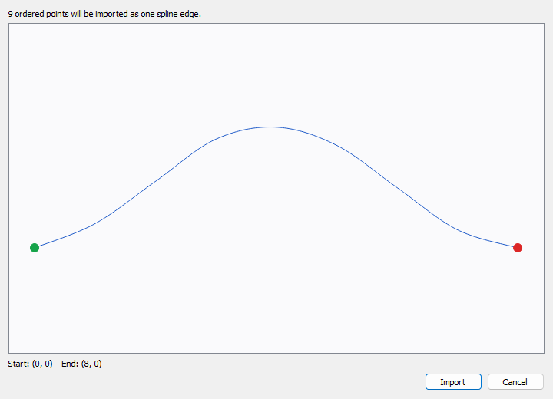
MeshCAD point-sequence import preview with the curve start marked in green and its end in red.

2. Edit Geometry
Switch to Select before editing.
• Drag a red vertex to move every connected edge. Drag it near another unconnected vertex and release to merge the endpoints; the target highlights in green while dragging. A merge that would collapse an existing edge is prevented.
• Drag a blue grip to move an arc center or an internal spline control point.
• Double-click a vertex or grip to enter exact coordinates.
• When an arc center is edited, its endpoints remain fixed and the center is constrained to the chord perpendicular bisector.
• Existing block meshes are regenerated automatically after relevant geometry changes.

3. Detect a Closed Loop
In the Loops panel, click Detect Loops. Closed contours are listed. Selecting a loop highlights it in green on the canvas.
If no loop is detected:
1. zoom into every connection;
2. check for gaps or duplicate endpoints;
3. drag one endpoint near the other and release to merge them, or use double-click coordinate editing to make their coordinates coincide;
4. run Detect Loops again.

4. Create a Structured Block
Select a loop and click Create Block from Loop. Click four distinct loop vertices to define the four logical corners. The portions of the loop between consecutive corners become the four block sides. A loop may contain more than four edges: all intervening edges are grouped into the corresponding side.
A block side may contain one or several CAD edges. The block itself always has four logical sides.

5. Configure Edge Distributions
In the Distributions panel:
1. click Refresh Edges if necessary;
2. select one or more edges;
3. set the total number of nodes, including both endpoints;
4. choose Uniform or Biased distribution;
5. set Bias when a biased distribution is selected;
6. click Apply to Selected.
You can also select an edge by clicking it on the canvas. Hold Ctrl while clicking to add or remove individual edges from the selection. A regular click selects only that edge, and clicking empty canvas clears the selection.
A shared edge has one distribution specification, so adjacent blocks automatically use the same interface nodes. Changing its node count updates the opposite sides of every block that uses that edge. When an opposite side contains multiple edges, the required intervals are distributed across them in proportion to their lengths. Requested values in a multi-edge update are kept fixed; if they conflict with a block side total, MeshCAD reports the conflict and leaves existing settings unchanged.

Split an Edge
Select exactly one edge in the Distributions panel. Choose Split Edge on the toolbar or Split Selected Edge by Clicking in the panel, then click within the selected edge. Alternatively, choose Split Selected Edge at Coordinates and enter a point on the edge. Points at or too near an endpoint are rejected.
The split creates two consecutive edges and preserves the original curve shape. Block sides using the edge are updated, including shared interfaces traversed in opposite directions, and exterior patch membership is preserved on both child edges. The existing intervals are apportioned according to the child lengths; the split adds a node. Opposite block sides are adjusted to preserve compatible node totals.

Distribution Types
• Uniform: equal spacing in the edge parameter.
• Biased, Bias = 1: equivalent to uniform spacing.
• Biased, Bias > 1: smaller intervals near the edge start and progressively larger intervals toward the end.

6. Validate Blocks
The Blocks panel reports whether opposite sides have compatible node totals.
Typical states are:
• OK (nodes N x M)
• MISMATCH sides 0/2: A vs B
• MISMATCH sides 1/3: A vs B
For a valid structured block:
• side 0 must have the same total number of nodes as side 2;
• side 1 must have the same total number of nodes as side 3.

7. Generate the Mesh
Click Generate Mesh. The structured grid appears over each valid block, and the status bar reports the number of blocks and cells.
Click Clear Mesh to hide generated meshes without deleting geometry, blocks, or distribution settings.

Mesh Improvement Controls
The toolbar includes live controls for mesh improvement.

Orthogonality
Enable Orthogonal to push the first interior layers toward the local boundary-normal direction.
• Layers: number of interior layers affected.
• Strength: correction fraction from 0 to 1.
Useful initial values are 2 to 4 layers and a strength from 0.70 to 0.90.

Elliptic Smoothing
• Smoothing: number of interior smoothing iterations.
• Relaxation: update fraction per iteration.
Useful initial values are 20 to 60 iterations and a relaxation factor from 0.30 to 0.50. Boundary nodes remain fixed.

Complete Tutorials
The tutorials below start from a blank project and use the controls in the current application. Drawing clicks are approximate; use the status-bar coordinates and grid as a guide. The important requirements are shared snapped vertices, closed loops, and matching node counts on opposite sides.

Tutorial 1: Rectangular Block from Drawing to Mesh
Goal: Build one rectangular block with 9 nodes horizontally and 6 vertically (40 cells).
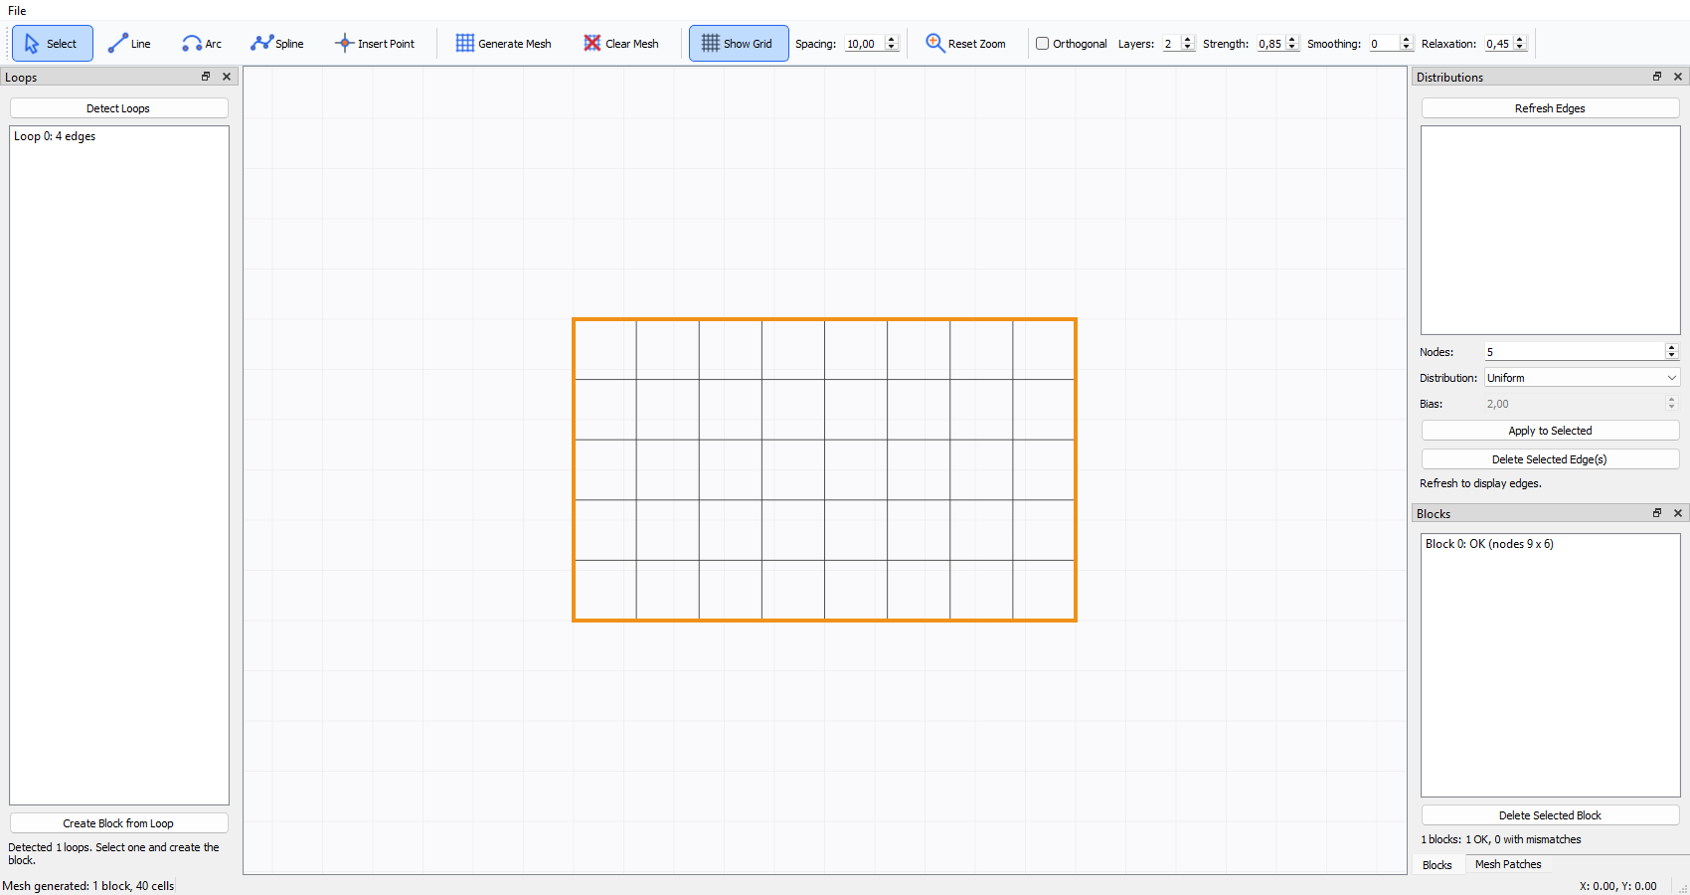
MeshCAD showing a generated rectangular block with a 9 by 6 node grid and a valid block status.
1. Start MeshCAD and choose File > New if a project is already open.
2. Leave Show Grid enabled. Adjust Spacing if a finer or coarser drawing reference is useful.
3. Click Line. Draw the four rectangle sides by clicking the lower-left, lower-right, upper-right, upper-left, and lower-left points in sequence. Snap the last click to the first vertex so the contour closes. The Line button remains highlighted while drawing.
4. Click Select to leave line-drawing mode. In the Loops panel, click Detect Loops. Select the detected four-edge loop; it is highlighted green on the canvas.
5. Click Create Block from Loop, then click the four rectangle vertices. They can be selected in any order, but all four must be distinct. The Blocks panel should show one block.
6. In Distributions, click Refresh Edges if needed. Select the lower and upper edges (use Ctrl-click for multiple edges). Set Nodes to 9, Distribution to Uniform, then click Apply to Selected.
7. Select the left and right edges. Set Nodes to 6, keep Uniform, and click Apply to Selected.
8. Confirm the block status is OK (nodes 9 x 6). If it reports a mismatch, inspect the listed opposite sides and apply matching totals.
9. Click Generate Mesh. The canvas should show a structured grid with (9 - 1) x (6 - 1) = 40 cells.
10. Choose File > Save As and save the project as a .json file.

Tutorial 2: Two Conformal Blocks and a Shared Interface
Goal: Create two side-by-side rectangular blocks that share one edge and have matching interface nodes.
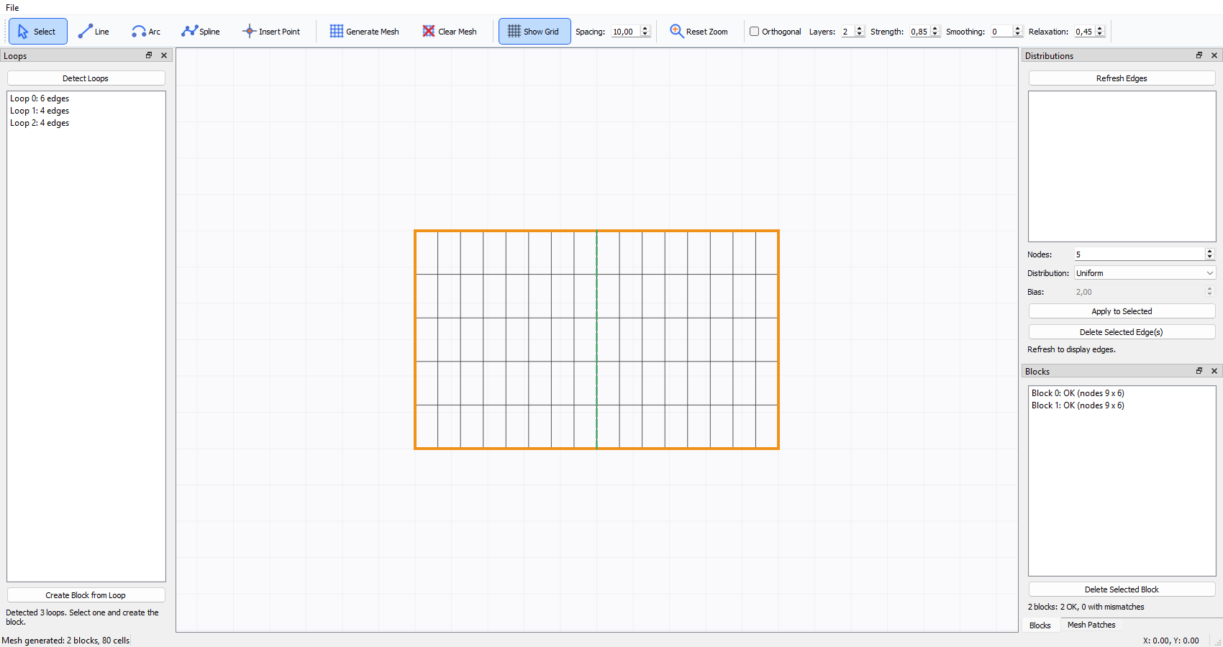
MeshCAD showing two structured blocks joined at a conformal shared interface.
1. Start a blank project and select Line.
2. Draw the lower outer boundary as two segments: lower-left to the center point, then center to lower-right. The center must be a real vertex where the interface meets the boundary.
3. Draw the right outer vertical side, the upper boundary as two segments (upper-right to upper-center, then upper-center to upper-left), and the left outer vertical side. Snap endpoints to existing vertices as you close the outline.
4. Draw the internal vertical interface from the lower-center vertex to the upper-center vertex, snapping to both. The result is a pair of adjacent closed loops. Do not draw a second overlapping copy of this interface.
5. Select Select, then click Detect Loops. Select each loop in turn to confirm that it highlights one rectangle.
6. Select the first loop and click Create Block from Loop. Click its four corner vertices. Repeat for the second loop.
7. In Distributions, set all horizontal edges to 9 uniform nodes and all vertical edges—including the shared interface—to 6 uniform nodes. The shared edge has one specification, used by both blocks.
8. Check the Blocks panel. Both blocks should report OK (nodes 9 x 6). Resolve any mismatch before generating.
9. Click Generate Mesh. Verify that both grids meet continuously at the shared edge and have the same number of interface nodes.
10. Select Select and drag an exterior vertex to adjust the geometry. Generated meshes update when the geometry changes; regenerate if needed after changing mesh settings.
11. Save the project with File > Save As.

Tutorial 3: Biasing a Boundary and Improving the Mesh
Goal: Compare a uniform mesh against a graded mesh with boundary orthogonalization and smoothing.
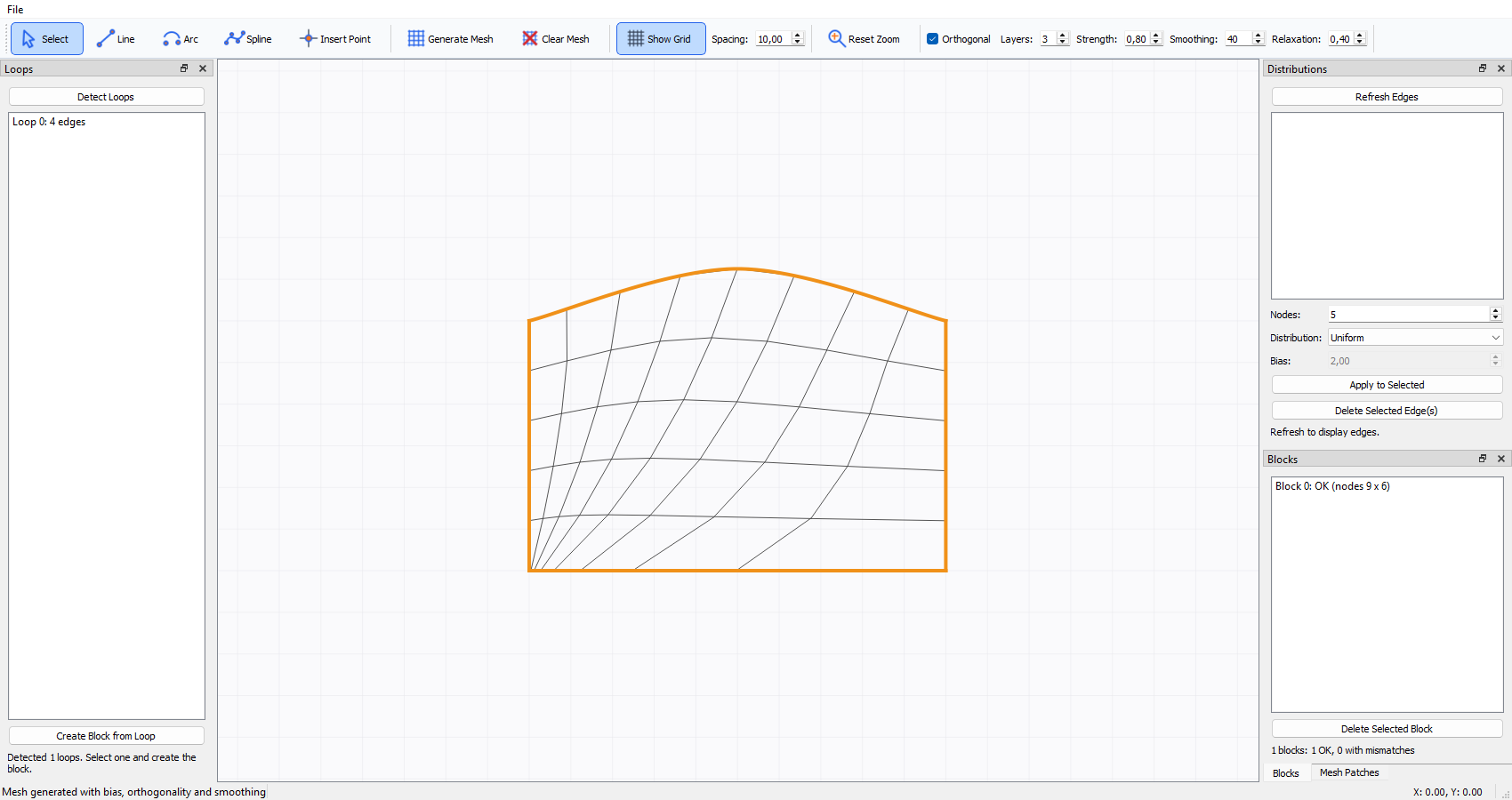
MeshCAD showing a curved block mesh with biased spacing, orthogonalization, and smoothing enabled.
1. Open the project from Tutorial 1 or 2, or create a block and generate its uniform baseline mesh.
2. In Distributions, select one exterior edge. The selected edge is highlighted on the canvas. Set Distribution to Biased, set Bias to 2.0, and click Apply to Selected.
3. The bias direction follows the edge's start-to-end direction: a bias greater than 1 concentrates nodes near the start. The direction in which an edge was drawn therefore determines which endpoint receives finer spacing.
4. Keep opposite sides' node totals compatible. Generate the mesh and compare cell spacing with the uniform baseline.
5. Enable Orthogonal. Set Layers to 3 and Strength to 0.80. Mesh improvement controls update the generated mesh live when blocks exist.
6. Set Smoothing to 40 iterations and Relaxation to 0.40. Observe how interior lines change while boundary nodes remain fixed.
7. Compare with orthogonality disabled and smoothing set to 0. Change one setting at a time so its effect is clear.
8. Inspect for crossed/inverted cells, abrupt size jumps, irregular interior lines, poor angles near boundaries, and discontinuities across block interfaces. Reduce bias, strength, iterations, or relaxation if the grid becomes distorted.
9. Save the project after choosing acceptable settings.

Tutorial 4: Boundary Patches and Mesh Export
Goal: Assign exterior edges to a named boundary, save the project, and export the mesh for visualization or CFD.
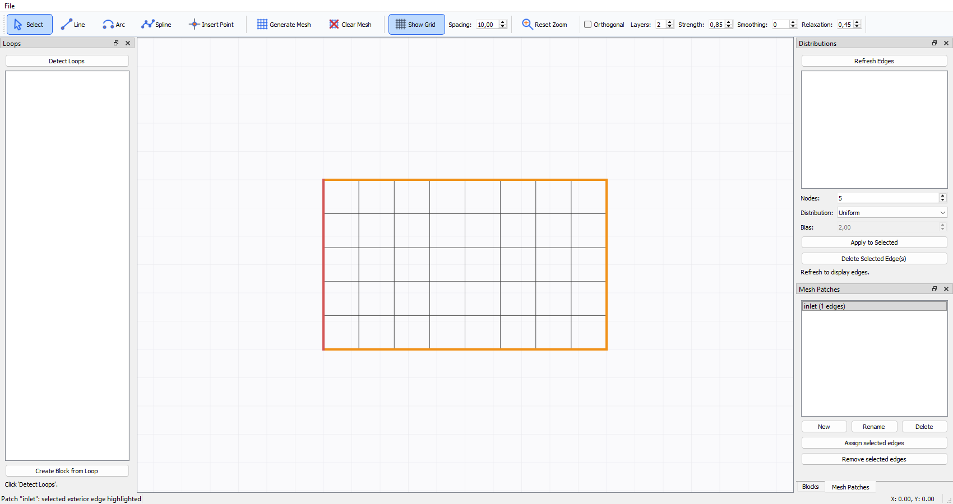
MeshCAD showing the inlet patch selected and its exterior edge highlighted on the mesh.
1. Open a project with at least one valid block, configure compatible edge distributions, and click Generate Mesh.
2. In Mesh Patches, click New, enter a name such as inlet, and confirm. Create additional patches for other boundary groups as required.
3. Select the desired patch. Its assigned edges are automatically selected and highlighted in the model. Selecting another patch replaces the selection; selecting an empty patch clears it.
4. In Distributions, select one or more exterior edges. Use Ctrl-click in the list or Ctrl-click edges on the canvas to add/remove edges from the selection.
5. Return to Mesh Patches and click Assign selected edges. Only exterior block edges are accepted. Shared edges between blocks are internal interfaces and cannot be assigned.
6. Repeat for other patches. An edge can belong to only one patch and cannot be assigned twice. A conflicting assignment is rejected; remove an edge from its current patch before assigning it elsewhere.
7. Choose File > Save to preserve the geometry, mesh settings, blocks, and patches in the project JSON.
8. For visualization, click File > Export Mesh (VTK) and save the .pvd file. Open it in ParaView. Keep the .pvd file together with the generated <name>_blocks folder and its .vts files.
9. For a CFD boundary mesh, click File > Export Mesh (JSON) and save a .json file. The export contains named boundary patches; shared block interfaces are represented as internal faces with owner and neighbour, not as boundary patches.
10. If an export is unavailable, confirm that a valid block and generated mesh exist, correct all block mismatches, and try again.

Tutorial 5: Split a Shared Edge and Rebalance the Mesh
Goal: Split the interface shared by two blocks, then change one of its segments and verify that both blocks remain compatible.
1. Complete Tutorial 2 and confirm that both blocks show OK (nodes 9 x 6). Save a copy of the project before experimenting.
2. In Distributions, select the shared vertical interface. Confirm that the cyan highlight covers the internal edge between the blocks.
3. Click Split Edge on the toolbar, then click near the middle of the highlighted interface. Alternatively, use Split Selected Edge at Coordinates and enter a point on the interface.
4. The interface becomes two consecutive edges. Both blocks continue to use the same pair of edges, in opposite traversal directions, and their mesh status should remain OK. The split point adds a node; intervals are apportioned between the segments according to their lengths.
5. In Distributions, select one of the two new interface segments. Set Nodes to 5 and click Apply to Selected.
6. Check the Blocks panel. Both blocks should still report OK: the shared edge is used by both blocks, and the opposite side of each block is adjusted to match. If an opposite side contains several edges, intervals are distributed among them in proportion to their lengths.
7. Click Generate Mesh. Confirm that both grids appear and meet along the split interface without a node-count mismatch.
8. Choose File > Save As and save the split-interface project under a new name, preserving the original baseline project.

Saving Projects
Use File > Save or File > Save As. The JSON project stores topology, geometry, edge distributions, blocks, and mesh-improvement parameters.
Use incremental project names before large geometry changes.

Exporting VTK
1. Generate the mesh.
2. Choose File > Export Mesh (VTK).
3. Select a .pvd filename.
4. MeshCAD creates the PVD file and a <name>_blocks folder containing one .vts file per block.
5. Open the .pvd file in ParaView to load all blocks together.
Keep the PVD file and its _blocks folder together because the collection uses relative paths.

Mesh Patches and Block Interfaces
Only exterior block edges can be assigned to mesh patches. An edge shared by two blocks is an internal interface and cannot belong to a patch.
Selecting a mesh patch highlights its edges in the model. An edge can belong to only one patch and cannot be repeated within a patch; conflicting assignments are rejected.
The CFD JSON export keeps shared-interface faces as internal faces with an owner and neighbour; they are not assigned to boundary patches. VTK export writes one structured grid per block, so the shared interface remains part of each block grid rather than being exported as a boundary patch.

Troubleshooting

No loop is detected
The contour is open or two endpoints do not coincide. Inspect connections and edit the affected coordinates.

A block reports MISMATCH
Opposite sides have different total node counts. Apply compatible distribution settings to the relevant edges.

An edge cannot be deleted
The edge belongs to a block. Delete the associated block first.

No mesh appears
Check that at least one valid block exists and that the Blocks panel reports compatible opposite sides.

Geometry is outside the visible area
Click Reset Zoom.

The arc center is not exactly at the requested point
A circular arc with fixed endpoints requires the center to remain on the chord perpendicular bisector. MeshCAD projects the requested center onto that line.

The mesh is strongly distorted
Reduce bias, orthogonality strength, smoothing iterations, or relaxation. Increase parameters gradually and inspect each result.

VTK export is unavailable
Generate the mesh before exporting.

Mouse and Keyboard Reference
• Left-click: place points, select an item, or begin dragging.
• Double left-click: edit vertex or grip coordinates.
• Right-click: finish a spline.
• Middle-button drag: pan the view.
• Mouse wheel: zoom around the pointer.
• Esc: cancel the active tool.
• File > Import Point Sequence: preview and import an ordered CSV/TXT curve.

Final Checklist
Before exporting a finished project, verify that:
• all intended contours are closed;
• every block reports OK;
• shared interfaces are conformal;
• no cells are crossed or inverted;
• grading transitions are acceptable;
• the project has been saved;
• the PVD/VTS export opens correctly.

