Load RTF Objects in Fusion Instance for Increment Carts
- Click on the main icon
- Go to Compensation task

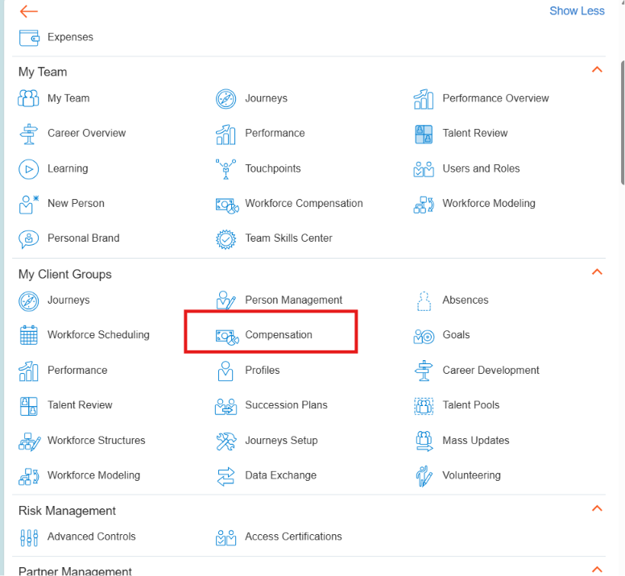

- Within Compensation task search Workforce Compensation Plans
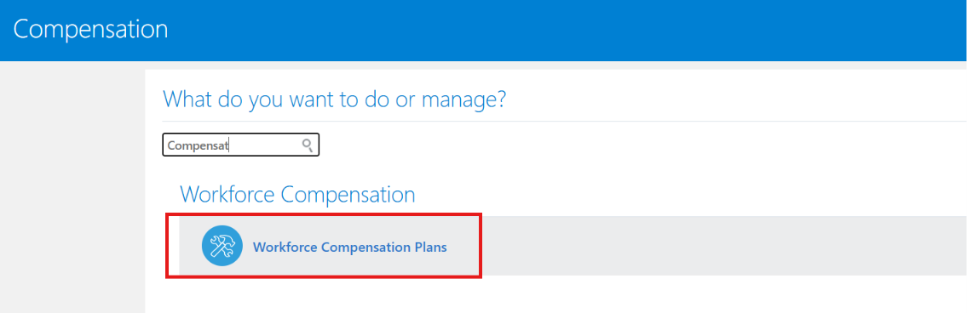
- Then select the actual Plan
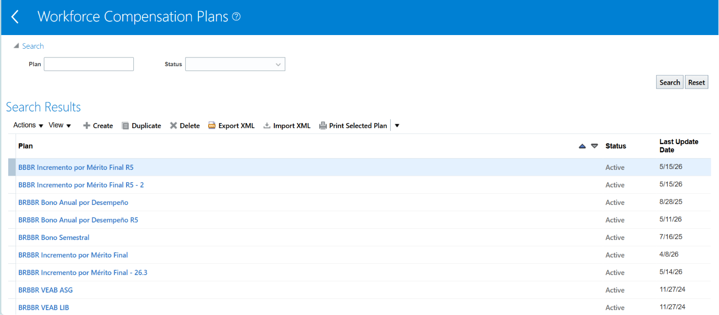

- Select the Compensation Change Statements option
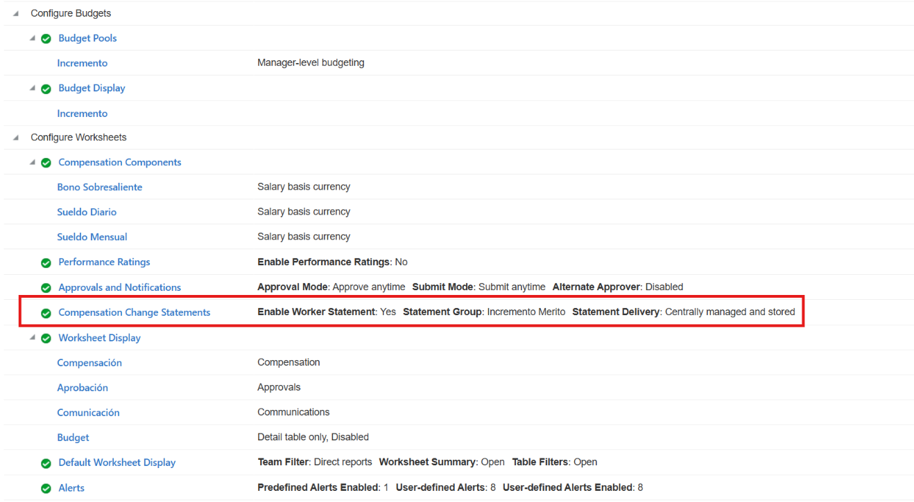
- Click on Manage Statement Groups button
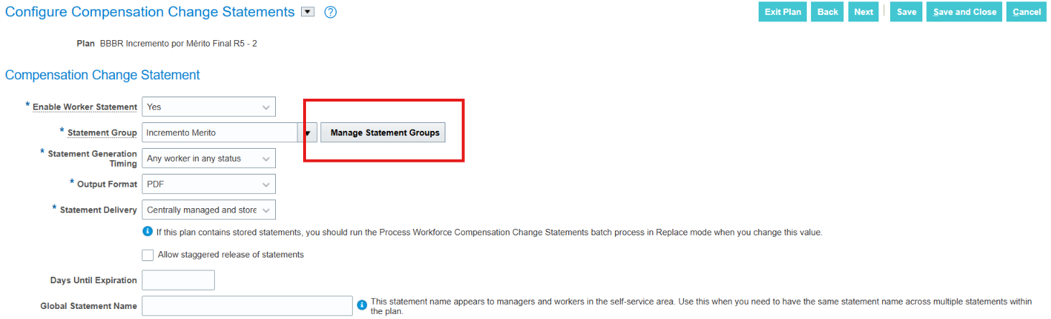
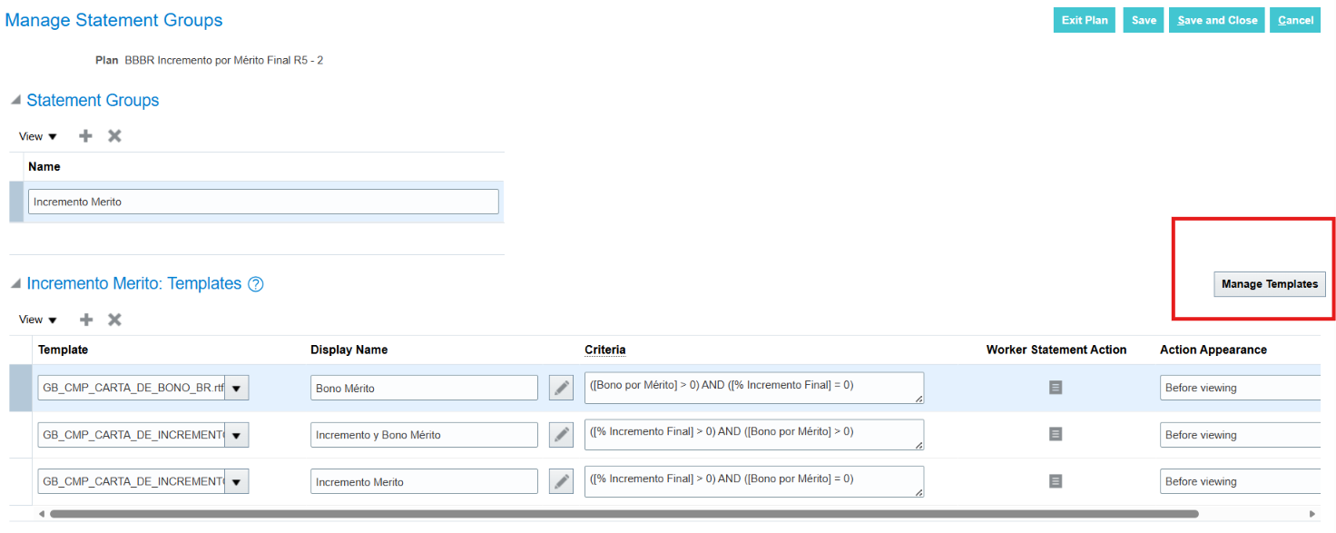
- Go to GitHub repository and download the 3 RTF Layouts
https://github.com/jesusrgz-tech/statements-layout-compensation.git
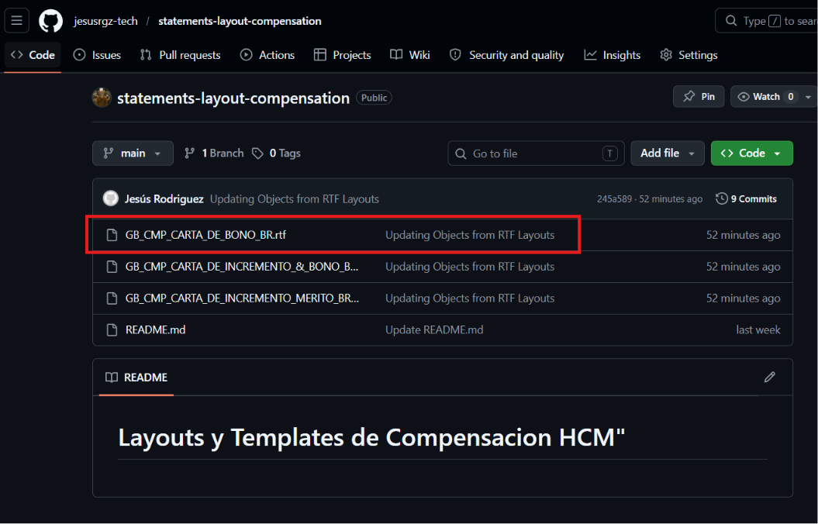
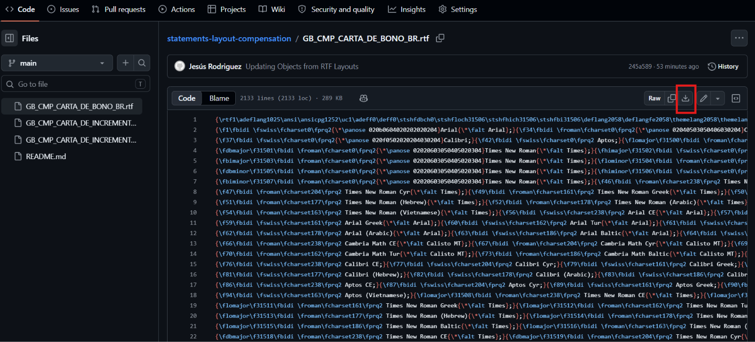
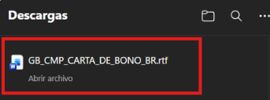
- Once you get the 3 Layouts in your system upload the 3 statements in Template Section
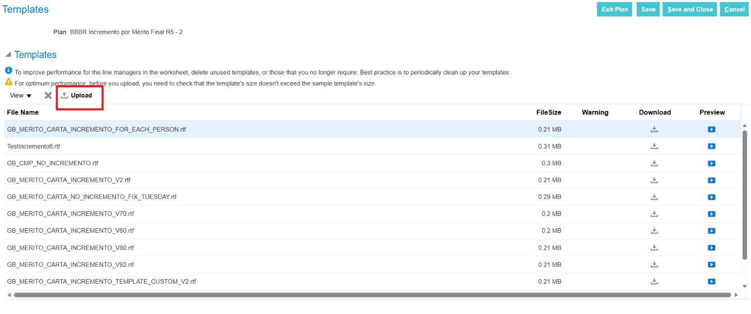
- Select every template that is in the repository link
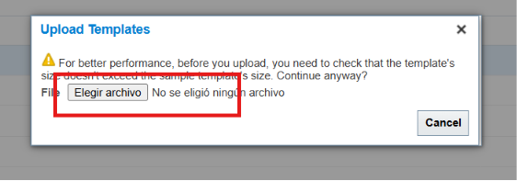

- Select template from your system
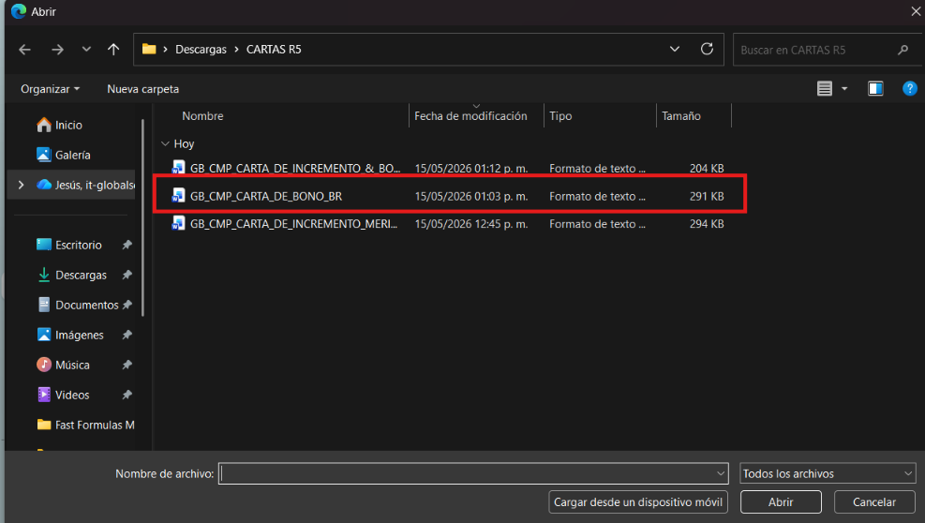
- Save and Close
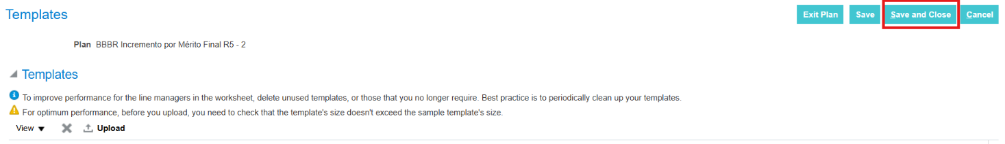
- Created or select the Statement group
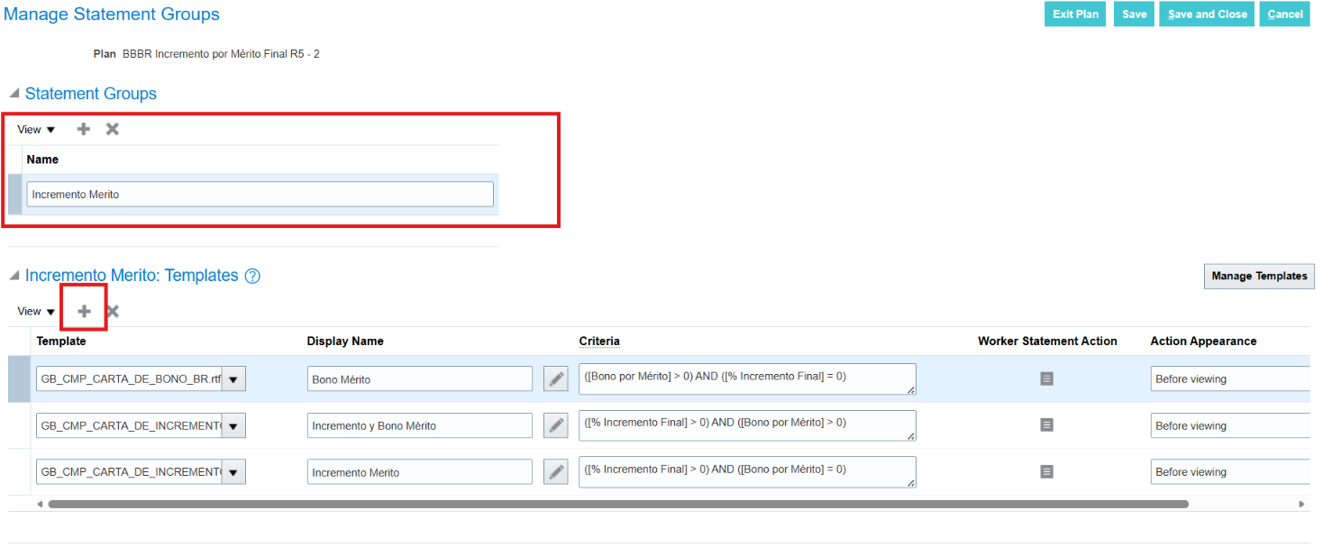

- Add or replace the 3 statements and save and close
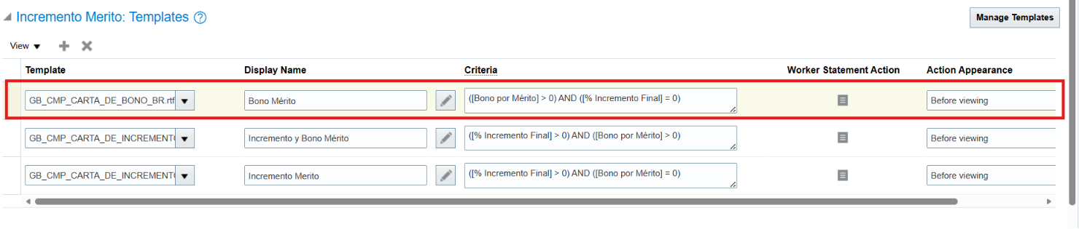
- The save and close all the changes
