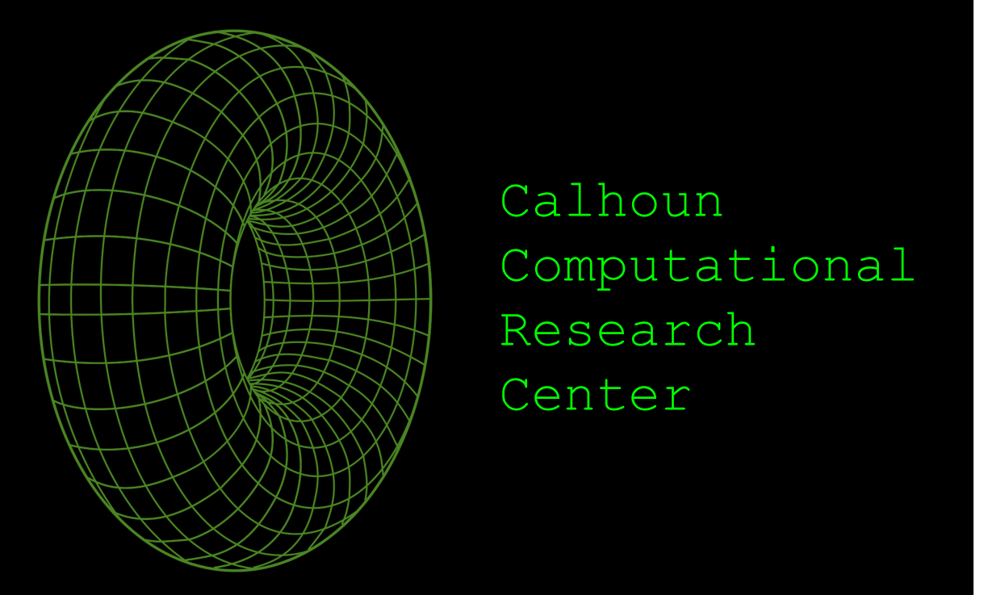***Calhoun Computational Research Center:***

***Overview***

***Contents***

1. **HISTORY 3**
2. **PRODUCTS AND SERVICES 4**
3. **STAFF 5**
4. **CONTACT INFORMATION 6**
5. **OUR INFORMATION SYSTEMS 7**

***History***

**The Calhoun Computational Research Center was established on January 22, 2017, on Calhoun County, Georgia. The Calhoun Computational Research Center was founded as a collaborative effort between scientists, mathematicians, engineers, and computer scientists in Georgia to address several problems in these fields. Most of our current projects focus primarily on machine learning, high performance scientific computing for large** **scale numerical problems found in engineering and science, and advanced** **graphics simulation and visualization for scientific concepts. Moreover, the Calhoun Computational Research Center currently collaborates with several colleges in Georgia, such as Mercer University and the University of Georgia.**

***Products and Services***

**The Calhoun Computational Research Center currently offers the following products/services:**

1. ***Delta3D* (2018):**
   1. **Delta3D is a desktop computing program used to model three-dimensional shapes and to solve Calculus operations (i.e. integration and derivation). and differential equations found in natural sciences and engineering. Buying a subscription for this program allows the user to download and use this program in up to two devices at the same time.**
      1. **Price: 100$/month or 850$/year.**
2. ***MyCloud* (2018):**
   1. **MyCloud is an affordable cloud storage and backup service. In order to protect the users’ files, the software encrypts the files that are sent and stored in our servers. Likewise, the software uses two-factor authentication to better regulate access to the files.**
      1. **Price: 15$/month or 70$/year.**
3. ***F-Epsilon* (2017):**
   1. ***F-Epsilon* is an integrated development environment (IDE) that primarily works with modern implementations of Fortran, a high performance-oriented language. Fortran is a programming language that is generally used for numeric computation and high scientific computing.**
      1. **Price: 35$/month or 200$/year.**

***Staff***

* **Dr. Thomas B. Kirby** 
  + **Executive Director**.
  + **B.S.E., Cornell University (1974); M.S.E., Ph.D., University of Georgia (1974, 1978).**
* **Dr. John S. Ware**
  + **Senior Director of Engineering and Computing Programs.**
  + **B.S.E., M.S.E., University of Pittsburgh (1981, 1985); Ph.D., Georgia Institute of Technology (1996).**
* **Dr. Kathryn Connell**
  + **Chief Engineer: Mathematical Software.**
  + **B.S.E, DeVry University (1991); M.S.E., Ph.D., University of Florida (1997, 2005).**
* **Dr. Jeanene Willet**
  + **Chief Engineer: Scientific Programs.**
  + **B.S.E., Purdue University (1995); M.S.E., University of South Florida (2005); Ph.D., University of Mississippi (2010).**
* **Dr. Lewis McCoy**
  + **Chief Engineer: Engineering Programs.**
  + **B.S.E., Mercer University (1990); M.S.E, Howard University (2003).**

***Contact Information***

* **For general information.:**
  + **E-mail:** [**info@calhoun.org**](mailto:info@calhoun.org)
  + **Telephone: (470) 470-7010**
* **For business inquiries:**
  + **E-mail:** [**business@calhoun.org**](mailto:business@calhoun.org)
  + **Telephone: (470) 950-7678 (ext. 471).**
* **Points of contact:**
  + **Dr. Thomas B. Kirby** 
    - **E-mail:** [**kirby.th@calhoun.org**](mailto:kirby.th@calhoun.org)
    - **Telephone: (470) 950-7678 (ext. 150).**
  + **Dr. John S. Ware**
    - **E-mail:** [**ware.jo@calhoun.org**](mailto:ware.jo@calhoun.org)
    - **Telephone: (470) 950-7678 (ext. 160).**
  + **Dr. Kathryn Connell**
    - **E-mail:** [**connell.ka@calhoun.org**](mailto:connell.ka@calhoun.org)
    - **Telephone: (470) 950-7678 (ext. 170).**
  + **Dr. Jeanene Willet**
    - **E-mail:** [**willet.je@calhoun.org**](mailto:willet.je@calhoun.org)
    - **Telephone: (470) 950-7678 (ext. 180).**
  + **Dr. Lewis McCoy**
    - **E-mail:** [**mccoy.le@calhoun.org**](mailto:mccoy.le@calhoun.org)
    - **Telephone: (470) 950-7678 (ext. 190).**

***Our Information Systems***

* **The “Eclipse” computing cluster.**
  + **The “Eclipse” computing cluster, which was created in May 2018, contains many high-end servers that are used both for multi-node parallel program development and shared memory and threaded parallel program development.**
* **The web search engine “Neo-Mosaic.”**
  + **The Calhoun Computational Research Center developed a special search engine called “Neo-Mosaic” that implements machine learning in order to provide optimal search results.**
* **MySQL.**
  + **MySQL is a Data Base Management System (DBMS) used to store and analyze the information gathered from all our computing processes.**
* **Our website:** [**https://researchcenter.calhoun.org**](https://researchcenter.calhoun.org)
  + **Within our website, we store information related to our ongoing projects and archives on past projects.**
* **Microsoft Project**
  + **We use this program to track the progress of our projects.**
* **ZOOM**
  + **We use ZOOM in order to host video communication among the company’s staff and outer collaborators.**