PANADERO Baking System
Database Design and SQL Queries
PANADERO Project Group • Editable Word Document • 12 October 2026

1. Database Overview
Database name: panadero_bakery. Engine: MySQL/MariaDB with InnoDB and utf8mb4. Canonical import file: database/panadero.sql. Runtime compatibility migrations in server.js ensure older local databases can start safely.

2. Entity and Relationship Summary
Entity | Purpose | Key relationships
users | Customer, Staff, and Admin accounts. | One user has many orders, reservations, and logs.
categories | Product groupings such as breads, cakes, doughnuts, and pies. | One category has many bread_products.
bread_products | Product name, category, price, and current stock. | Appears in order_items, reservations, and inventory_batches.
orders | Order header, customer, total, delivery, payment selection, and status. | One order has many order_items.
order_items | Products and quantities belonging to an order. | References orders and bread_products.
reservations | Scheduled product reservations and their status. | References users and bread_products.
inventory_batches | Fresh baked batches and expiration tracking. | References bread_products.
system_logs | Audit/action records. | Optionally references users.
customer_notifications | Per-customer completion notifications. | References users and a request reference.
app_settings | Application settings and startup seed markers. | Key-value configuration table.

3. Key Integrity Rules
- Primary keys identify each record uniquely.
- Foreign keys prevent orphaned business records.
- orders → order_items uses ON DELETE CASCADE.
- Product, category, and user relationships generally use ON DELETE RESTRICT.
- system_logs.user_id uses ON DELETE SET NULL.
- Money uses DECIMAL(10,2) rather than FLOAT.
- Order and reservation stock changes occur inside transactions.

4. Text ERD
USERS 1───∞ ORDERS 1───∞ ORDER_ITEMS ∞───1 BREAD_PRODUCTS ∞───1 CATEGORIES
USERS 1───∞ RESERVATIONS ∞───1 BREAD_PRODUCTS 1───∞ INVENTORY_BATCHES
USERS 1───∞ SYSTEM_LOGS and USERS 1───∞ CUSTOMER_NOTIFICATIONS

5. Core SQL Queries

Create/use database
CREATE DATABASE IF NOT EXISTS panadero_bakery;
USE panadero_bakery;

Catalog with category
SELECT p.product_id, p.product_name, p.price, p.stock_quantity, c.category_name
FROM bread_products p
JOIN categories c ON c.category_id = p.category_id
ORDER BY c.category_name, p.product_name;

Customer order history
SELECT order_id, total_amount, order_status, order_date
FROM orders
WHERE user_id = ?
ORDER BY order_date DESC;

Order line items
SELECT oi.order_id, p.product_name, oi.quantity, oi.unit_price
FROM order_items oi
JOIN bread_products p ON p.product_id = oi.product_id
WHERE oi.order_id = ?;

Available inventory
SELECT product_id, product_name, stock_quantity
FROM bread_products
WHERE stock_quantity > 0
ORDER BY product_name;

Inventory batches
SELECT b.batch_id, p.product_name, b.quantity, b.baked_date, b.expiration_date
FROM inventory_batches b
JOIN bread_products p ON p.product_id = b.product_id
ORDER BY b.expiration_date;

Pending requests
SELECT order_id AS request_id, user_id, total_amount, order_status, order_date
FROM orders
WHERE order_status IN ('Pending', 'Processing', 'Ready')
ORDER BY order_date;

Low stock report
SELECT product_id, product_name, stock_quantity
FROM bread_products
WHERE stock_quantity <= 5
ORDER BY stock_quantity, product_name;

6. Canonical SQL File Contents
The accompanying panadero.sql file creates the database and all canonical tables with CREATE TABLE IF NOT EXISTS statements. It is non-destructive and does not drop existing records. The application seeds categories, products, and demo Staff/Admin accounts through server.js when appropriate.

7. Import Instructions
- Back up the existing panadero_bakery database before importing.
- Open MySQL/MariaDB through XAMPP.
- Run mysql -u root -p < database/panadero.sql, or import the file through MySQL Workbench/phpMyAdmin.
- Set DB_HOST, DB_PORT, DB_USER, DB_PASSWORD, and DB_NAME in .env.
- Start the Node.js server and verify /api/health.
- For an existing database, allow server.js to apply only its non-destructive compatibility migrations.

8. SQL Source-of-Truth Notes
- Use database/panadero.sql for the canonical schema import.
- Use the timestamped database backup only as a backup/reference copy, not as the primary schema source.
- Do not upload .env because it contains local database credentials.
- Do not upload node_modules because dependencies are restored by npm install.

9. Database and Integration Screenshots
The ER diagram and interface screenshots below visually connect the relational database design to the application modules that read and update it.
Screenshot note: These are illustrative interface screenshots from the PANADERO project documentation. They show the application screens and planned feature presentation; they are not proof of a live MySQL connection. Capture and add live database screenshots when the system is running for final submission.

Database ER Diagram
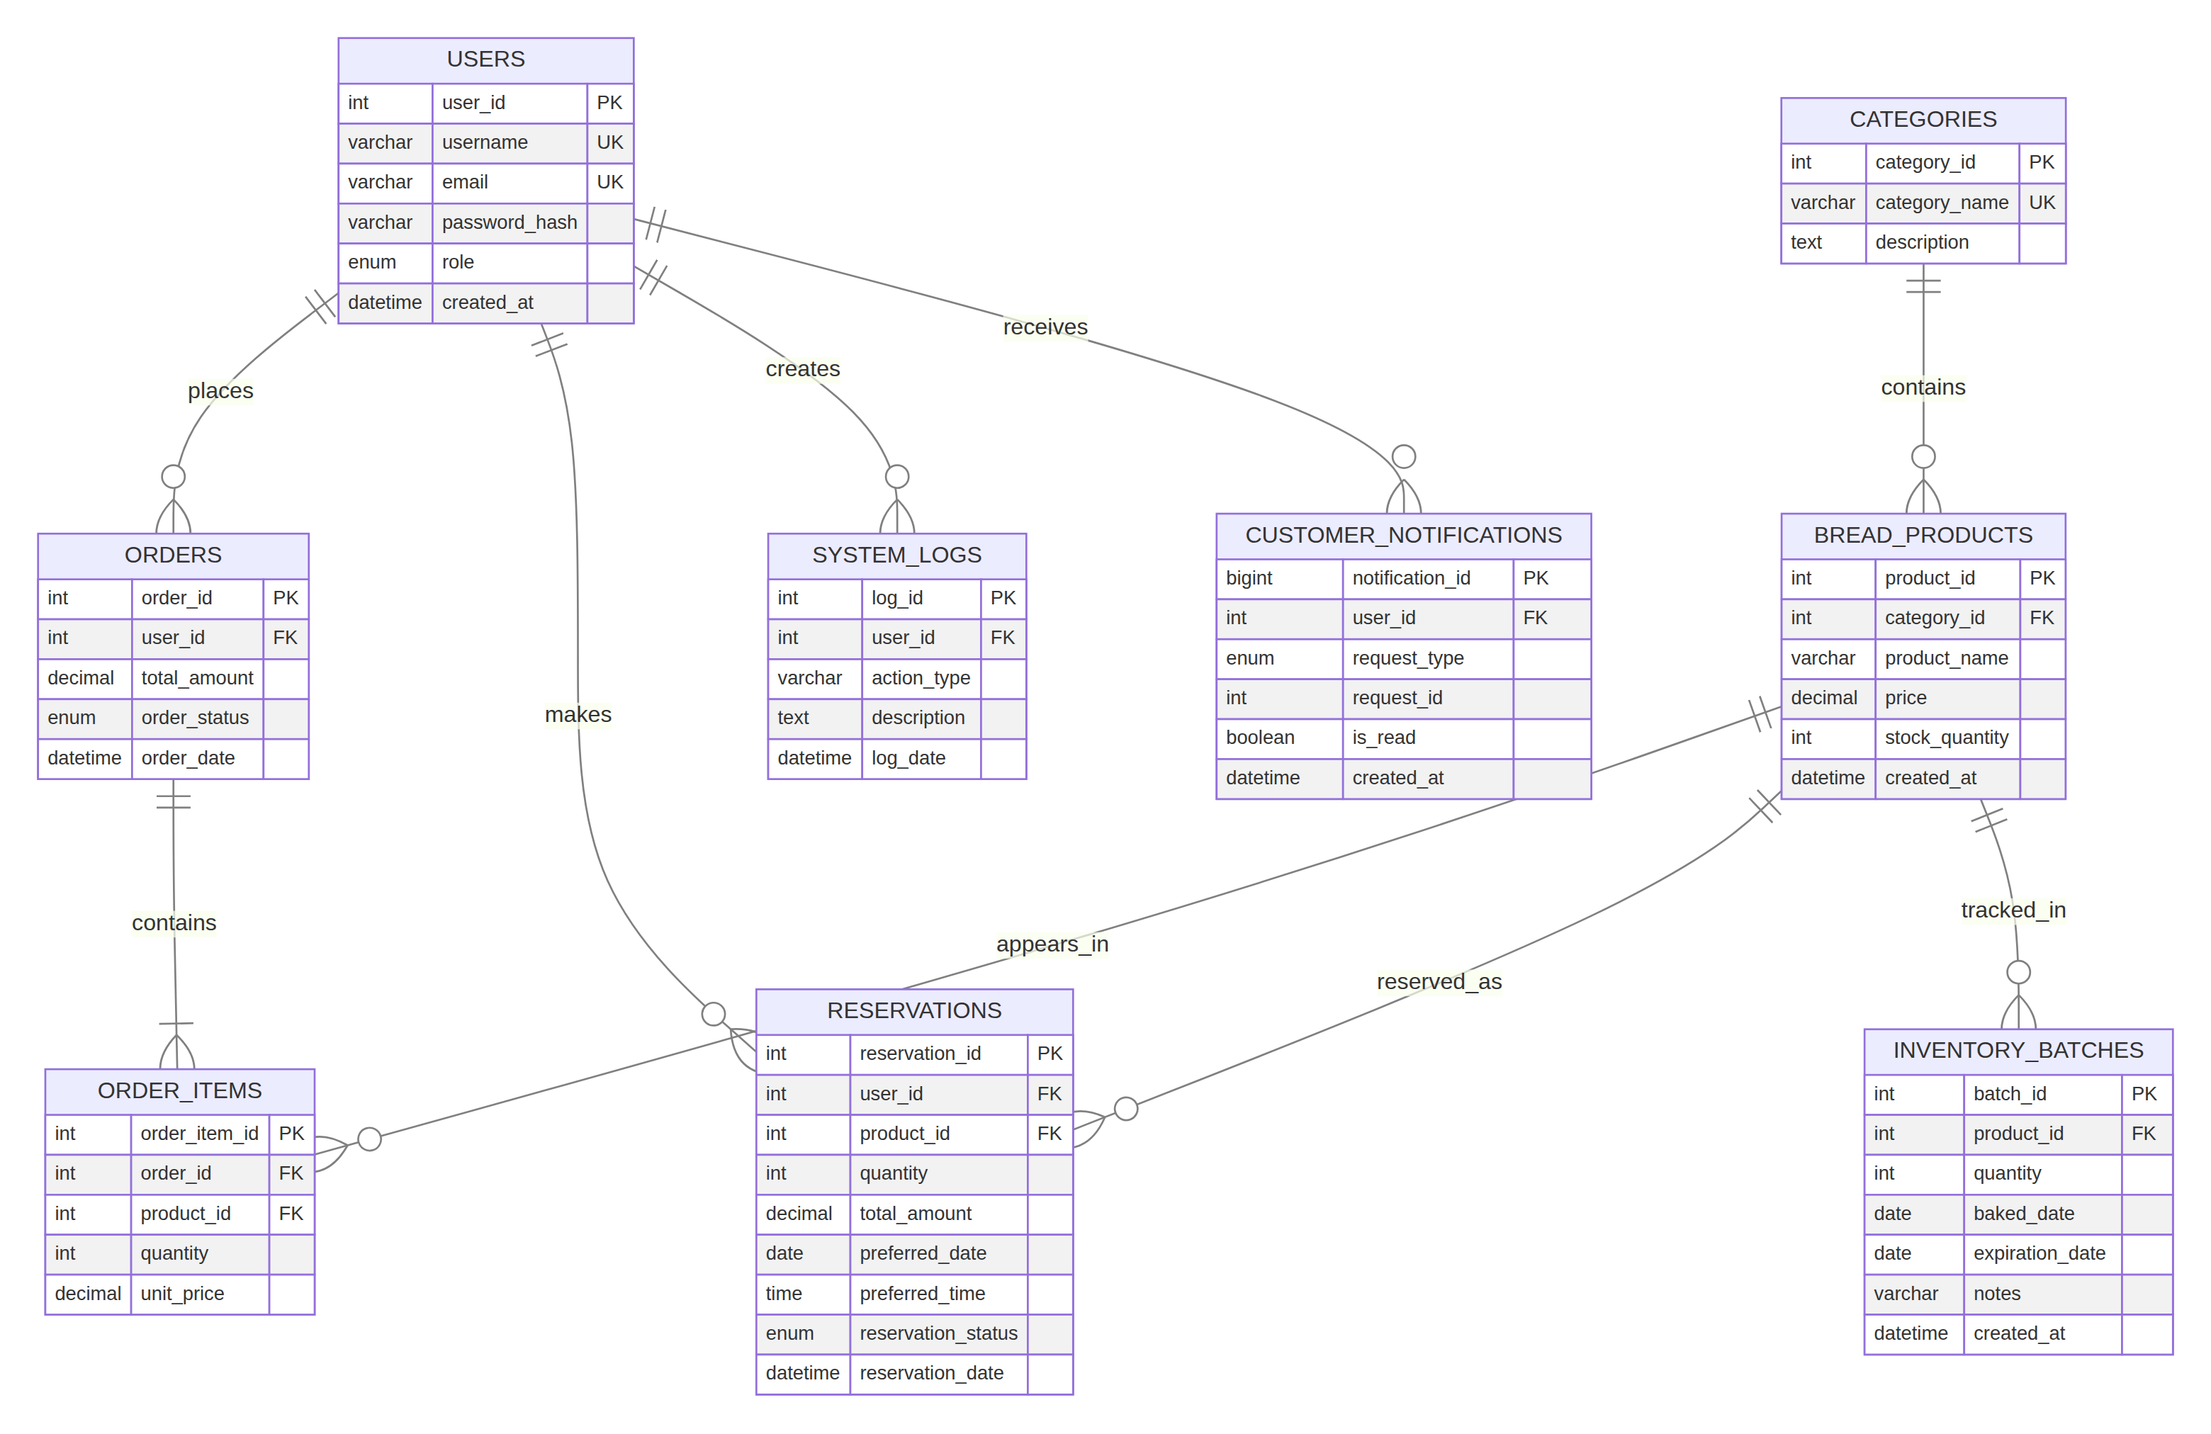
PANADERO entity-relationship diagram showing tables, keys, and relationships.

Staff Inventory
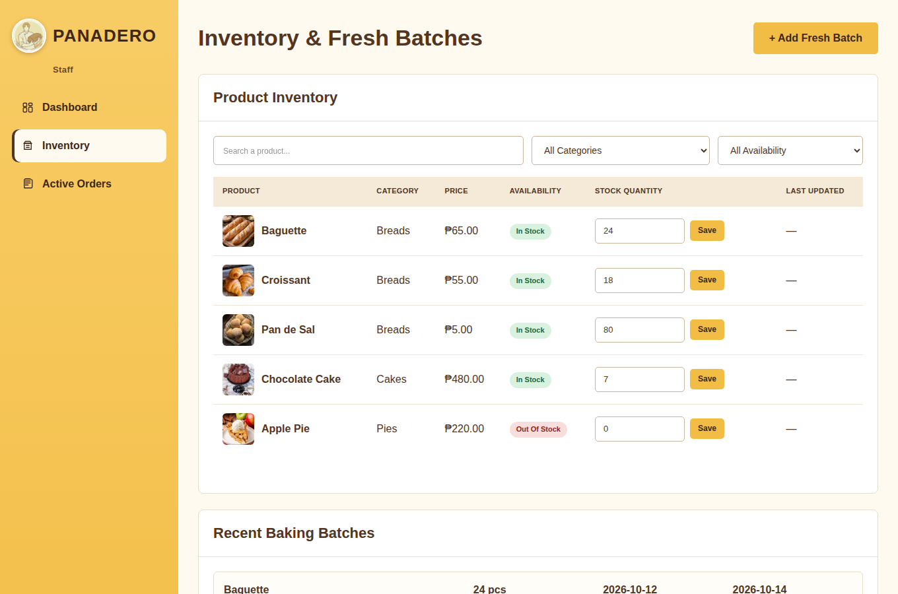
Application screen that reads and updates products, stock, and inventory batches.

Staff Orders
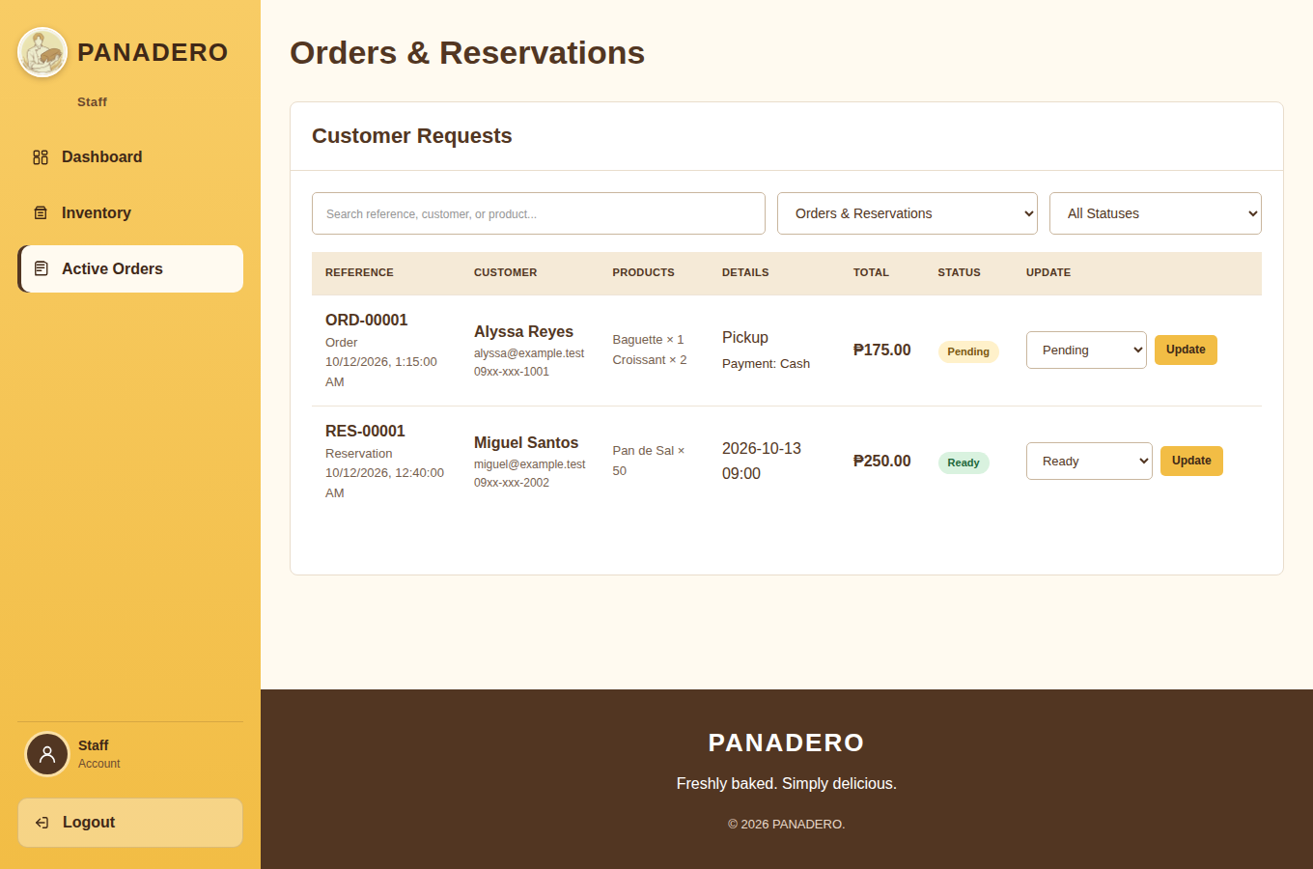
Application screen that reads orders/reservations and updates their statuses.

