PANADERO Bakeshop Production and Pre-Order System
3–5 Minute Video Script and Visual Storyboard
CCS110 Information Management 1 • Replace bracketed group details before recording
IMPORTANT: The screenshots in this guide are illustrative/non-live previews. They help plan the video, but the submitted video should ideally show the application connected to MySQL/MariaDB.

1. Group Information to Add
- Group number: [GROUP NUMBER]
- Section: [SECTION]
- Members: [MEMBER 1], [MEMBER 2], [MEMBER 3], [MEMBER 4], [MEMBER 5]
- Filename: CCS110_Group#_PANADERO.mp4

2. Video Timeline
Time | What to show | What to say
0:00–0:20 | Title card and group details | Introduce PANADERO, group, section, and members.
0:20–0:45 | Login page and problem/solution | Explain the bakery record-management problem and solution.
0:45–1:10 | Customer, Staff, Admin previews | Briefly tour the main modules.
1:10–1:25 | Database before state | Show that temporary SQL Demo Loaf does not exist.
1:25–2:05 | Admin Add → Save → Display | Create and show a temporary product.
2:05–2:35 | Admin Edit | Change the temporary product price and save.
2:35–2:55 | Admin Delete | Delete the temporary product.
2:55–3:25 | Database after state | Refresh/search the table and show the record is gone.
3:25–3:50 | Run a SELECT query | Show a JOIN + WHERE + ORDER BY query and results.
3:50–4:10 | Conclusion | Summarize the UI → API → MySQL flow.

3. Screenshot Storyboard
Use these screenshots to plan the order of the video. The images are from the project documentation and are not proof of a live database connection.
Customer home / interface tour
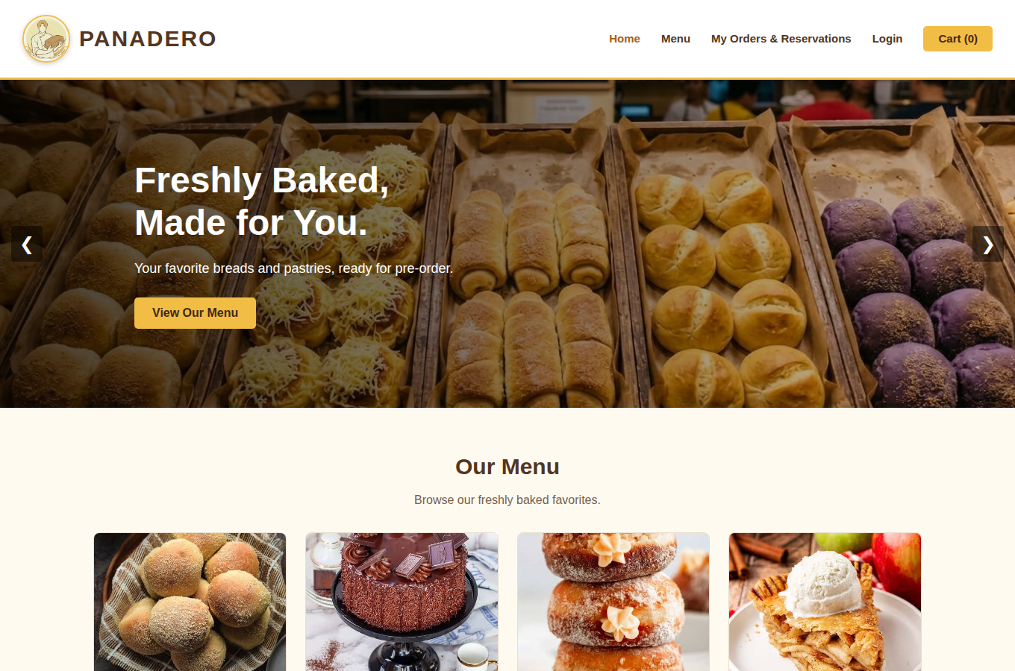
Illustrative preview screenshot — not a live database proof. Replace or supplement with a live recording screenshot when possible.

Narration: “Customers can browse products, use a cart, place orders or reservations, and track their requests.”
Customer menu / catalog
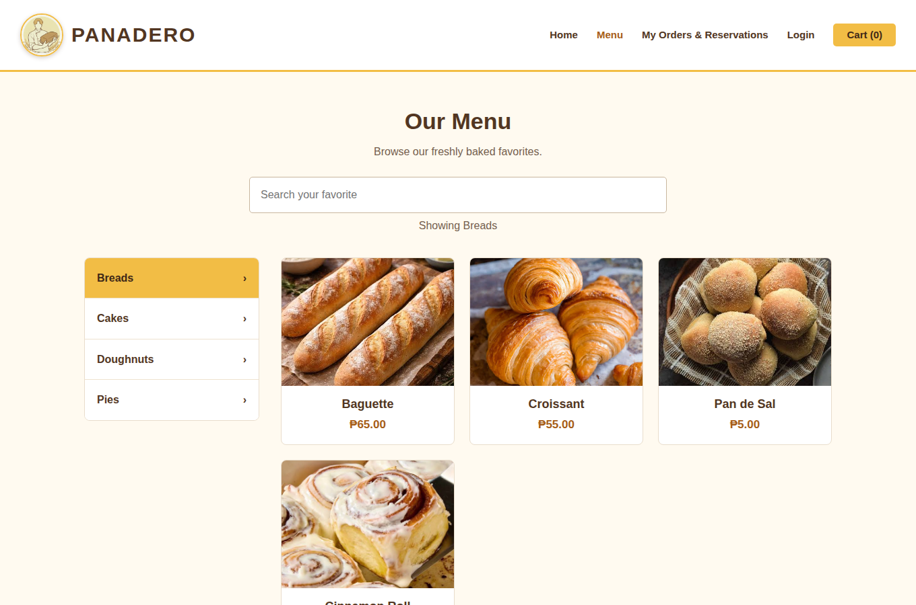
Illustrative preview screenshot — not a live database proof. Replace or supplement with a live recording screenshot when possible.

Narration: “The catalog displays products and categories that are supplied by the system.”
Staff dashboard
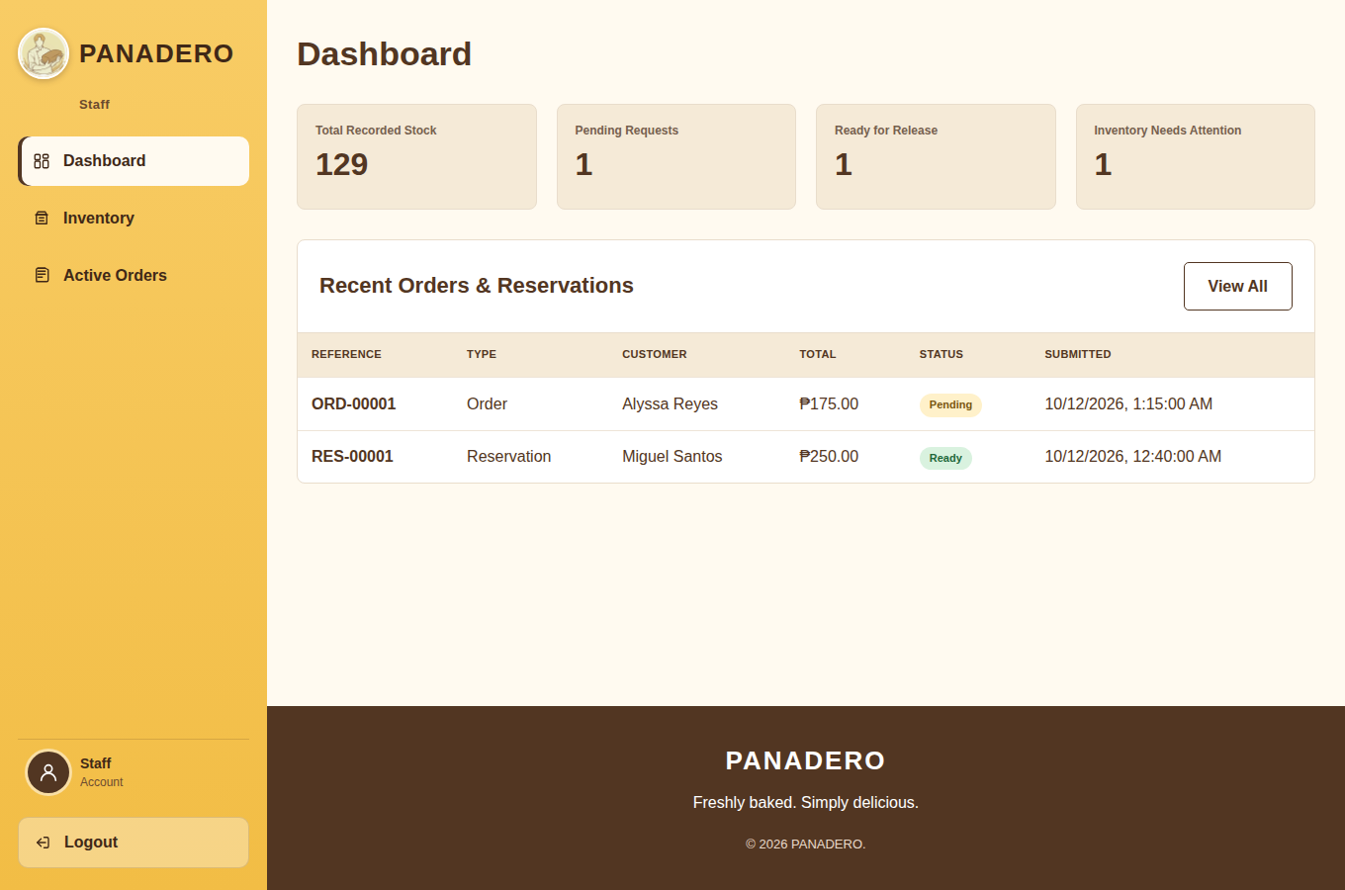
Illustrative preview screenshot — not a live database proof. Replace or supplement with a live recording screenshot when possible.

Narration: “Staff process inventory and customer requests.”
Staff inventory
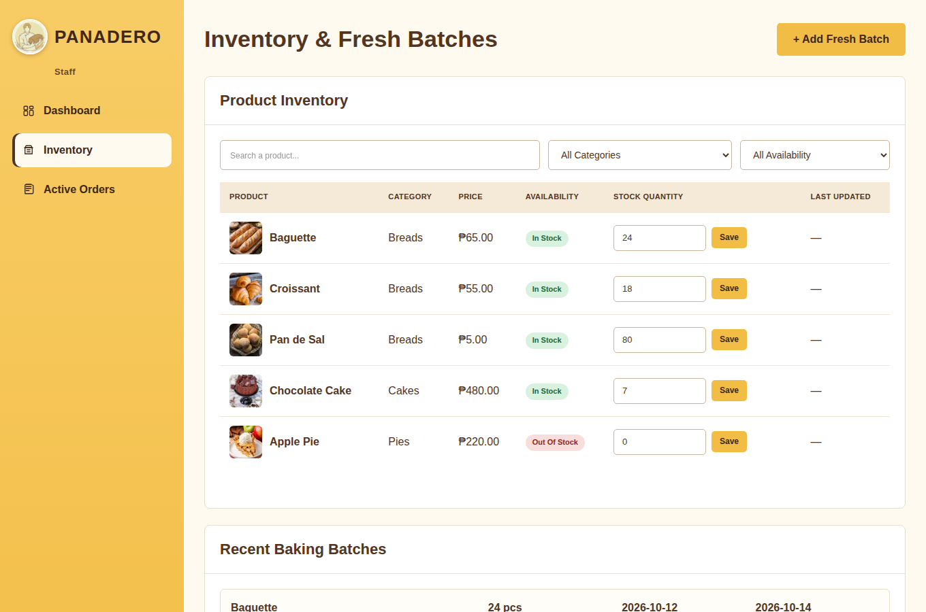
Illustrative preview screenshot — not a live database proof. Replace or supplement with a live recording screenshot when possible.

Narration: “Staff can add baking batches and update product stock.”
Staff orders
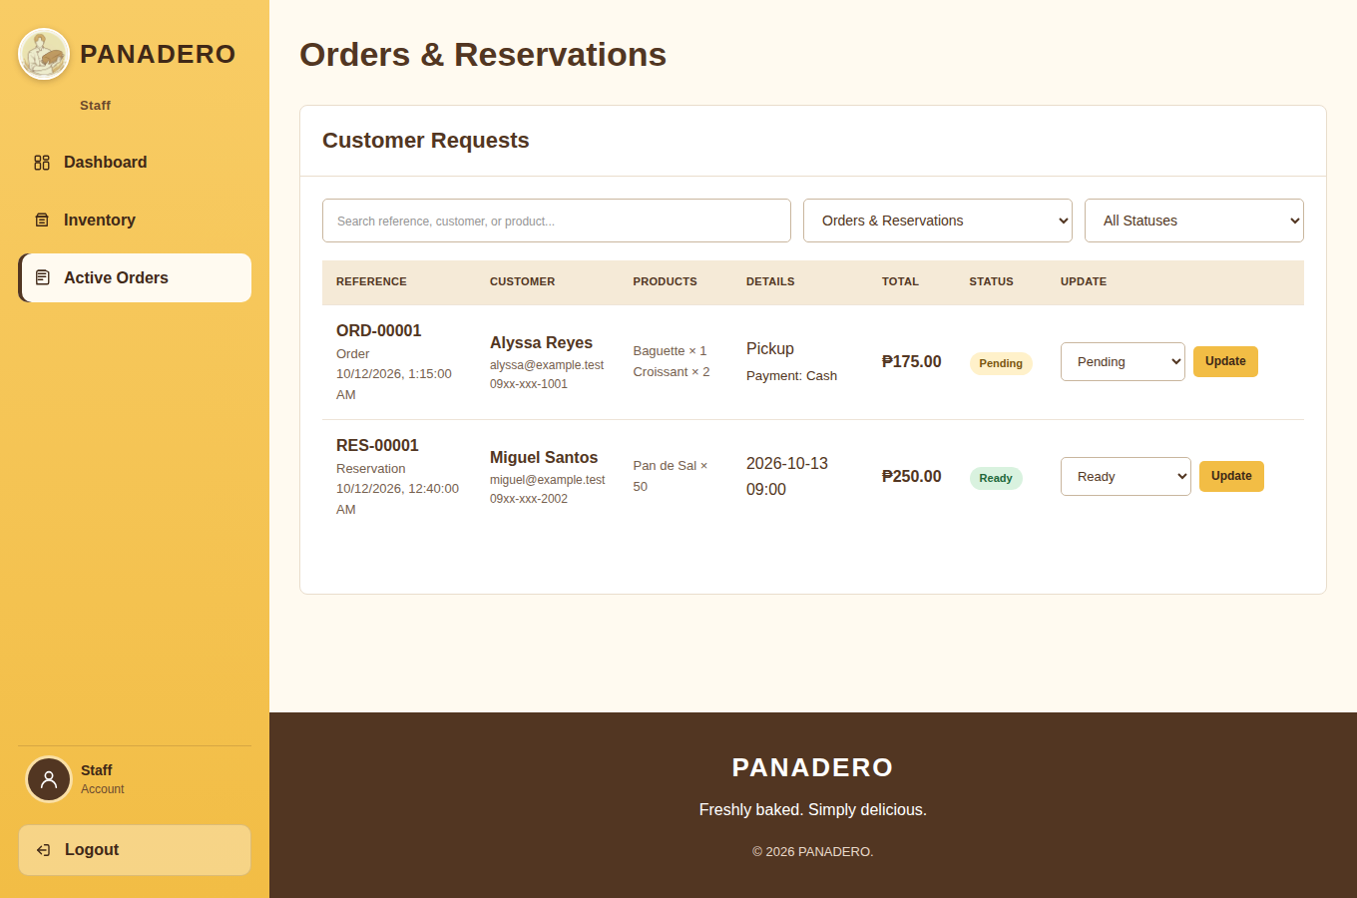
Illustrative preview screenshot — not a live database proof. Replace or supplement with a live recording screenshot when possible.

Narration: “Staff can update order and reservation statuses.”
Admin module
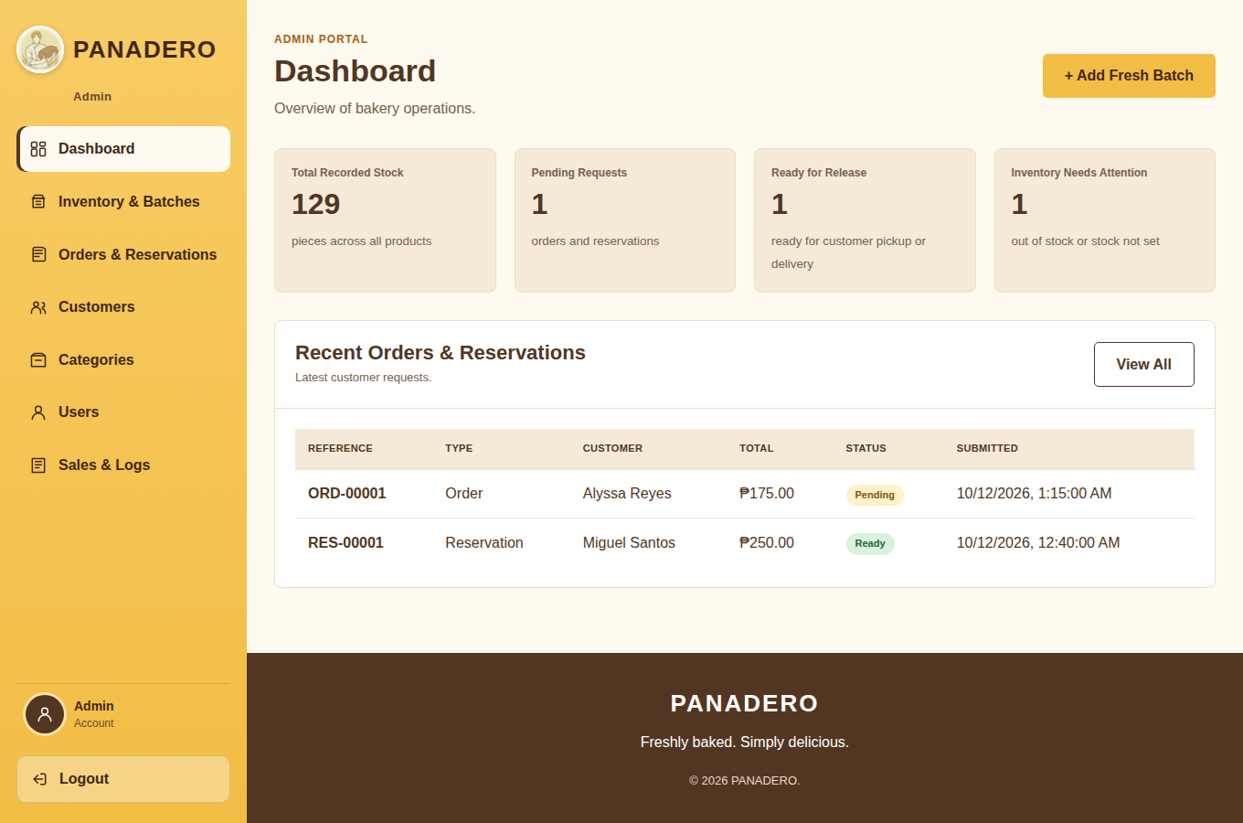
Illustrative preview screenshot — not a live database proof. Replace or supplement with a live recording screenshot when possible.

Narration: “Administrators manage the catalog, users, stock, and requests. This is where the temporary CRUD demonstration will be performed.”
Database relationship reference
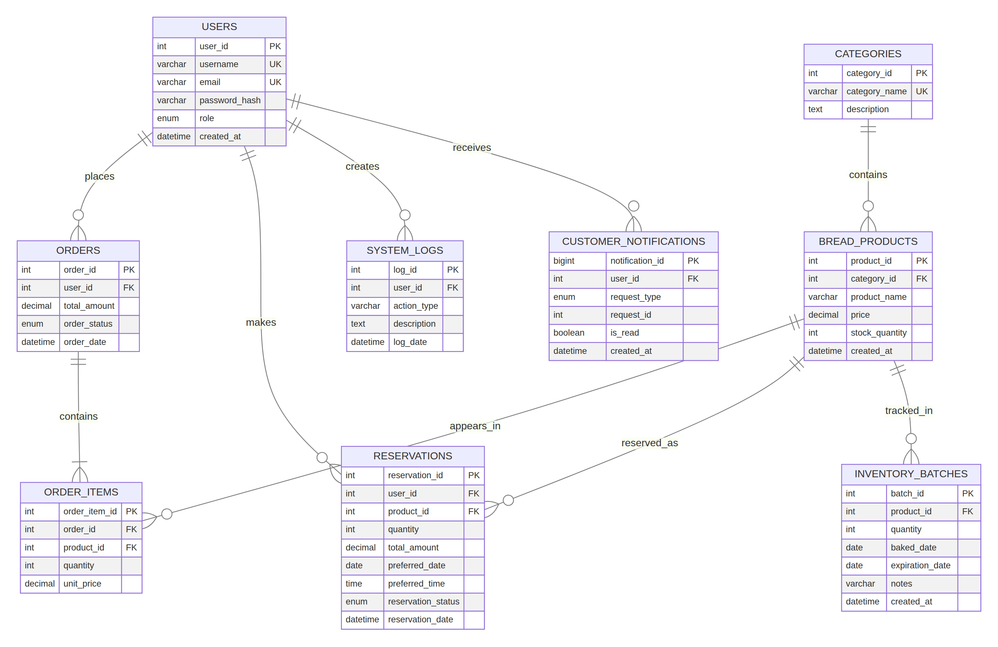
Illustrative preview screenshot — not a live database proof. Replace or supplement with a live recording screenshot when possible.

Narration: “The database uses related tables for users, categories, products, orders, order items, reservations, inventory batches, notifications, settings, and logs.”

4. Ready-to-Read Script

Scene 1 — Introduction
On screen: PANADERO Bakeshop Production and Pre-Order System; CCS110 Information Management 1; Group [NUMBER]; Section [SECTION]; member names.
Say: “Good day. We are Group [NUMBER] from Section [SECTION]. This is PANADERO, our bakeshop production and pre-order system for CCS110 Information Management 1. Our members are [read names]. This video demonstrates the running system, its database integration, and one complete CRUD workflow.”

Scene 2 — Problem and solution
Say: “A bakeshop needs to manage products, stock, customer orders, reservations, and production batches. Manual records can cause incorrect stock quantities and inconsistent request updates. PANADERO solves this by connecting Customer, Staff, and Admin portals to a Node.js and Express API with a MySQL database.”

Scene 3 — Interface tour
Say: “Customers can browse products, use a cart, place orders or reservations, and track requests. Staff can manage inventory batches and request statuses. Administrators can manage products, categories, users, stock, and requests. I will now demonstrate an Admin product CRUD workflow.”

Scene 4 — Database before state
Show MySQL/phpMyAdmin and search the bread_products table for SQL Demo Loaf. Say: “Before adding the test record, I checked the bread_products table. There is no SQL Demo Loaf record. This is the database state before the transaction.”

Scene 5 — Add, save, display
In Admin, add SQL Demo Loaf under Breads, price ₱99.00, stock 5, click Save, then show it in the product list. Say: “The Admin form sends the product to the Express API. The API validates the input and inserts it into MySQL. The product now appears in the catalog, demonstrating Add, Save, and Display.”

Scene 6 — Edit
Change the price from ₱99.00 to ₱109.00, save, and show the updated list. Say: “The API updates the matching product row using its product ID. The changed price is now displayed, proving the edit was persisted.”

Scene 7 — Delete
Delete SQL Demo Loaf and confirm. Say: “I am deleting the temporary test product. The product disappears from the Admin list, completing Add, Save, Display, Edit, and Delete.”

Scene 8 — After state
Refresh/search the database table. Say: “After the workflow, SQL Demo Loaf is no longer in bread_products. This confirms the delete operation was saved in MySQL.”

Scene 9 — SQL query
Run this query on screen:
SELECT c.category_name, p.product_name, p.price, p.stock_quantity
FROM categories AS c
JOIN bread_products AS p ON p.category_id = c.category_id
WHERE p.stock_quantity > 0
ORDER BY c.category_name, p.product_name;
Say: “This SELECT query joins categories and bread_products, filters products with stock greater than zero, and orders the results by category and product name.”

Scene 10 — Conclusion
Say: “PANADERO provides role-based bakery management with a connected frontend, backend, and relational database. We demonstrated the problem and solution, the main modules, a complete CRUD workflow, database changes before and after the transaction, and a working SQL query. Thank you.”

5. Recording Checklist
- Use an actual screen recording of the running application.
- Keep the final MP4 between 3 and 5 minutes.
- Show title, group number, section, and members.
- Show problem and solution.
- Show login and the Customer, Staff, and Admin modules.
- Show Add → Save → Display → Edit → Delete.
- Show the database before and after.
- Execute at least one SQL query on screen.
- Use voice-over and captions.
- Do not show .env, passwords, password hashes, or private customer information.
- Test the Drive/YouTube link in a private browser window.
Final reminder: These screenshots are useful for the storyboard and written documentation, but the strongest video evidence is a recording made while the app is connected to your actual MySQL/MariaDB database.

