PANADERO Baking System
System Features Documentation
PANADERO Project Group • Editable Word Document • 12 October 2026

1. Customer Features
Feature | Description
Catalog browsing | Loads categories, product names, prices, images, and current stock from the API.
Registration and login | Creates accounts and uses bcrypt-hashed passwords with a temporary session token.
Shopping cart | Keeps selected products in browser storage until checkout.
Checkout | Submits product IDs and quantities; the server reloads prices, validates stock, creates the order, and deducts stock.
Reservations | Creates a scheduled reservation with product, quantity, date, time, total, and status.
Order tracking | Displays the signed-in customer’s own orders and reservations with references and statuses.
Cancellation | Allows the owner to cancel an eligible pending order and return stock transactionally.

2. Staff Features
- Inventory dashboard showing products, categories, stock, and inventory batches.
- Stock adjustment for current product quantities.
- Batch recording with quantity, baked date, expiration date, and notes.
- Request table for orders and reservations.
- Status workflow: Pending → Processing/Preparing → Ready → Completed.
- Re-fetching actual server state after successful writes.

3. Admin Features
- Dashboard metrics for users, products, orders, reservations, and inventory.
- Catalog and category create/edit operations.
- User and role management with initial password for new Staff/Admin accounts.
- Stock and batch management.
- Order and reservation status management with validation.
- Database-backed synchronization rather than silent browser-only edits.
- System log and customer notification support.

4. API Feature Groups
Area | Representative endpoints
Health and catalog | GET /api/health, GET /api/catalog
Authentication | POST /api/auth/register, POST /api/auth/login, POST /api/auth/logout
Customer requests | POST /api/orders, GET /api/orders, PATCH /api/orders/:id/status, POST /api/reservations
Staff operations | GET /api/inventory, POST /api/inventory/batches, PATCH /api/inventory/products/:id/stock, GET /api/staff/requests
Admin operations | GET /api/admin/state, POST /api/admin/sync and validated catalog/user/request operations

5. Order Workflow
- Customer selects products and quantities in the browser.
- Checkout sends only product IDs and quantities plus delivery/payment selections.
- API authenticates the customer and reloads prices from MySQL.
- API validates product IDs, quantities, stock, delivery details, and payment selection.
- A database transaction creates the order and order items, deducts stock, and commits together.
- Customer receives a reference such as ORD-00001 and can track the status.

6. Reservation Workflow
- Customer selects a product, quantity, preferred date, and preferred time.
- API validates the customer, product, date/time, and available stock.
- API calculates the total from the database price.
- A transaction creates the reservation and deducts stock.
- Staff/Admin process the reservation and the customer sees the status.

7. Data and Security Rules
- Never trust browser-provided prices or totals.
- Never expose .env or database passwords in a repository or browser.
- Use parameterized SQL queries.
- Use foreign keys to preserve relationships.
- Use transactions for order, reservation, cancellation, and stock-changing workflows.
- Do not describe a selected Cash/Card/GCash method as a completed payment.

8. Testing Checklist
- Start a clean database and confirm the canonical SQL imports.
- Create a customer, log in, browse catalog, and place an order.
- Confirm stock decreases exactly once and order items preserve the checkout price.
- Add an inventory batch and confirm product stock increases.
- Move a request from Pending through Ready to Completed.
- Cancel a pending order and confirm stock returns exactly once.
- Test Admin catalog and user changes after page refresh.
- Test responsive layouts and invalid input/error messages.

9. Feature Screenshots
The following screenshots correspond to the major user-facing modules and should be replaced or supplemented with live captures during the final demonstration.
Screenshot note: These are illustrative interface screenshots from the PANADERO project documentation. They show the application screens and planned feature presentation; they are not proof of a live MySQL connection. Capture and add live database screenshots when the system is running for final submission.

Customer Home
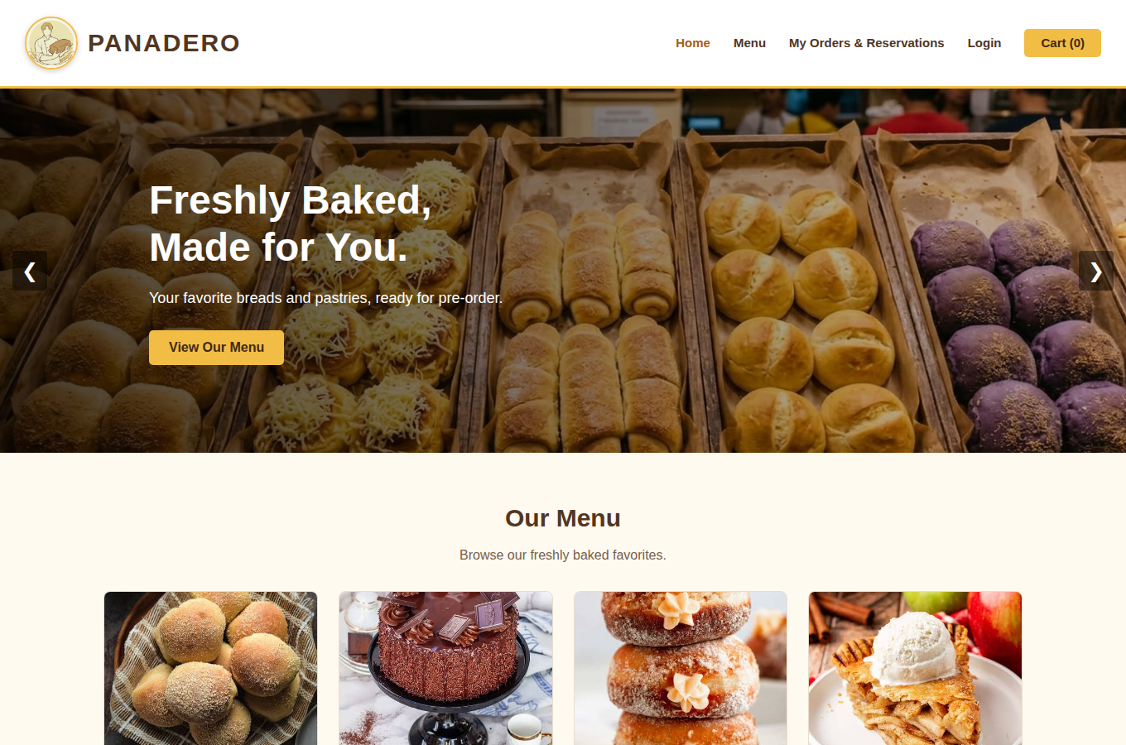
Customer home screen and entry point.

Customer Menu / Catalog
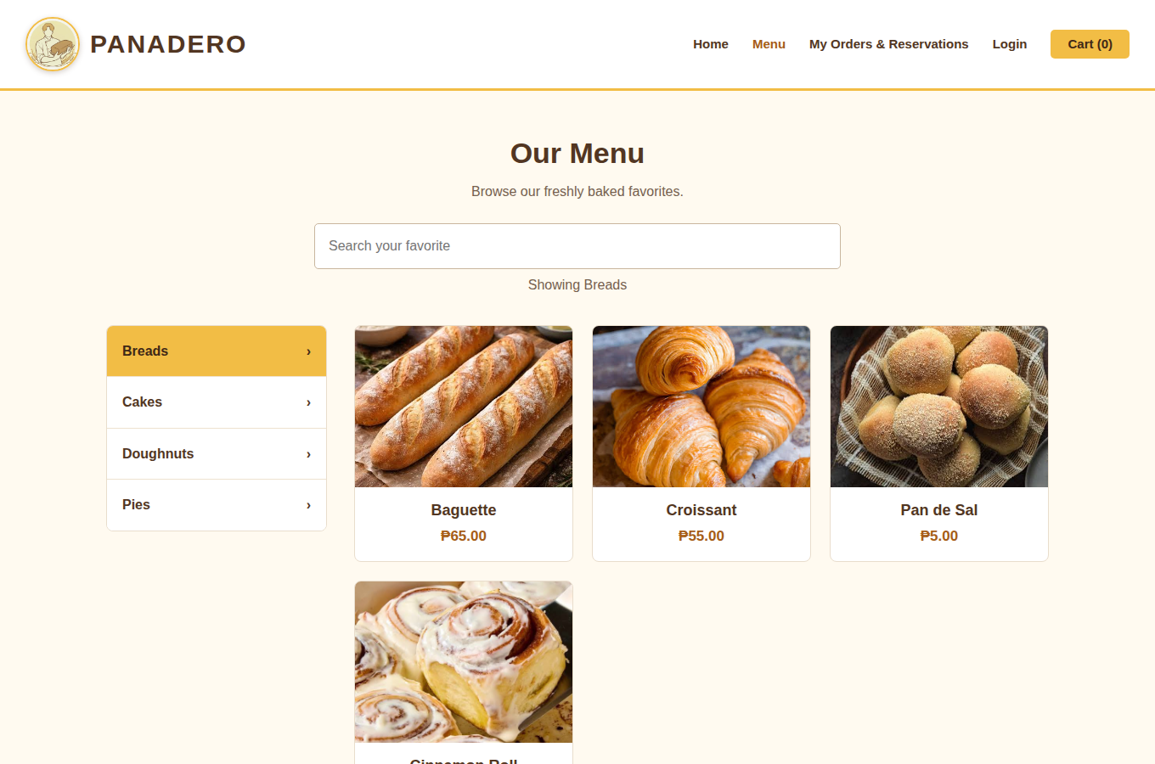
Customer catalog/menu screen showing bakery products and categories.

Staff Dashboard
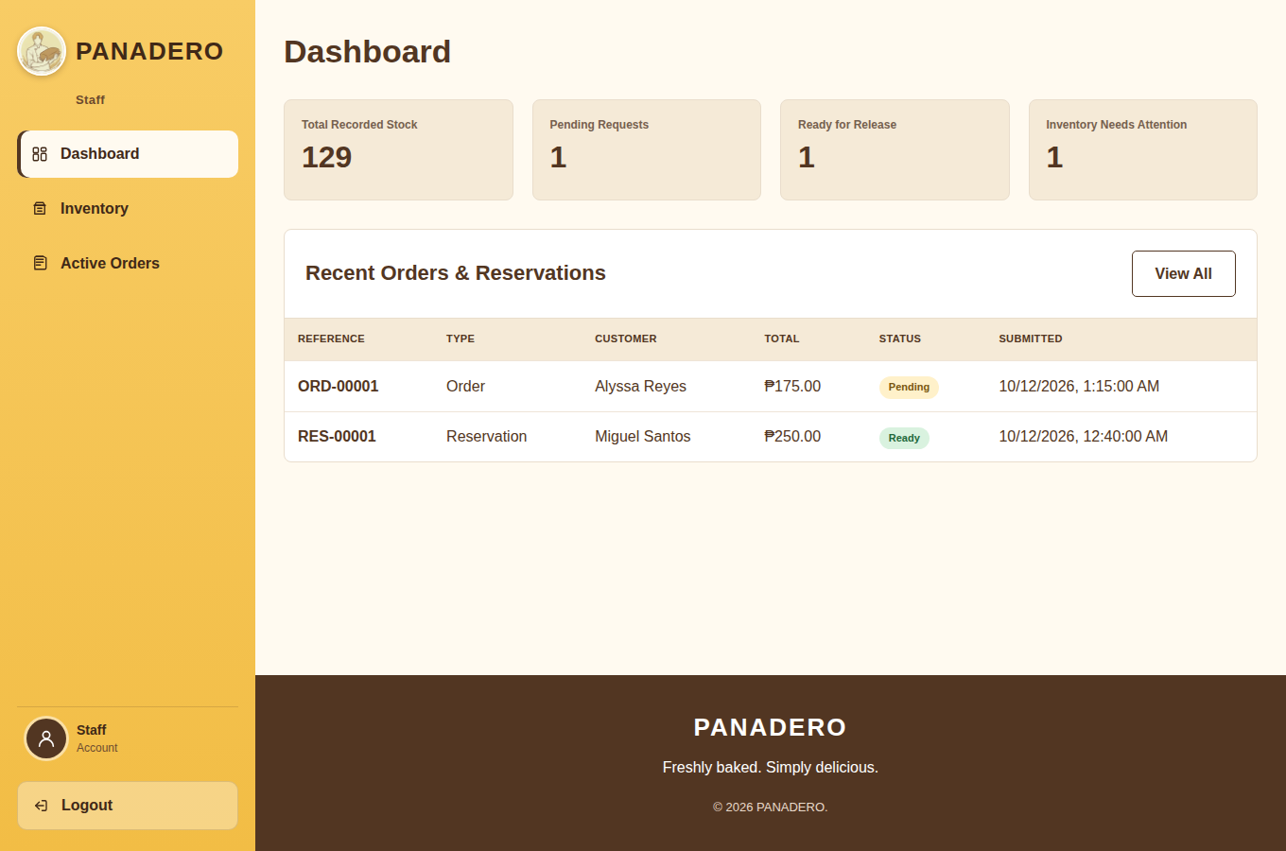
Staff dashboard and operational overview.

Staff Inventory
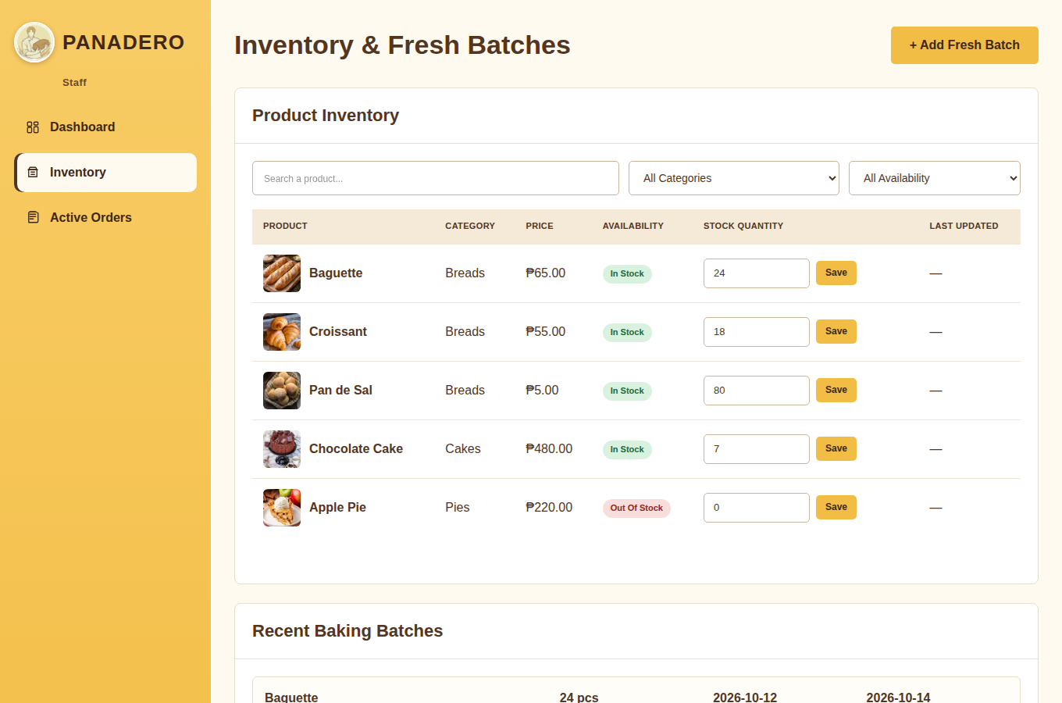
Inventory and baking-batch management screen.

Staff Orders
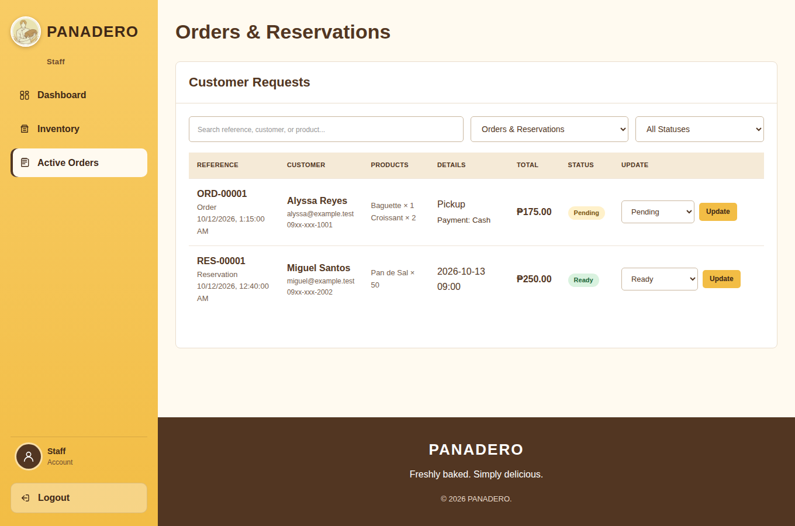
Staff order and reservation processing screen.

Admin Module
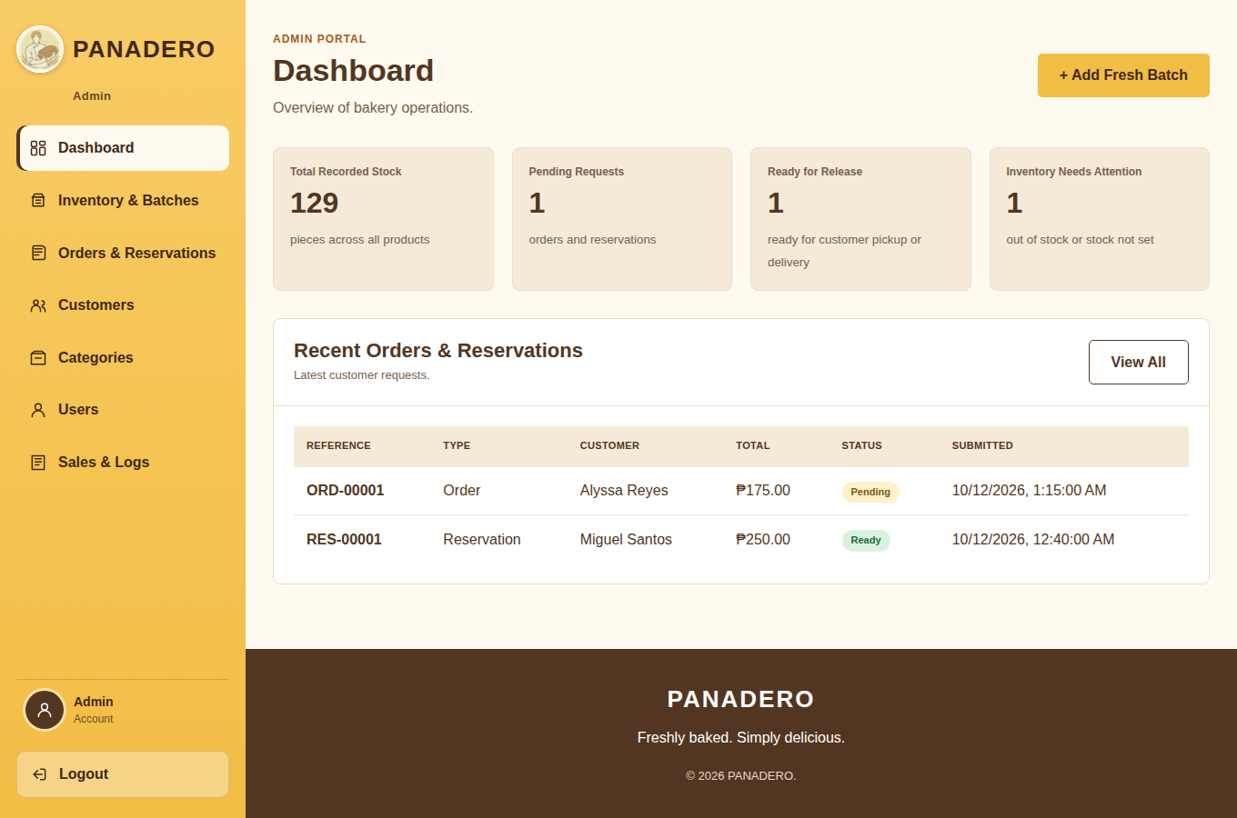
Admin management screen for catalog, users, stock, and requests.

