PANADERO Baking System
System Overview and Requirements
PANADERO Project Group • Editable Word Document • 12 October 2026

1. Executive Summary
PANADERO is a local-laptop bakery management system for customer ordering, reservations, inventory operations, staff request processing, and administrative catalog management. It uses role-based web portals backed by a Node.js/Express API and a MySQL database.

2. Problem and Objectives
The system provides one controlled workflow for managing bakery products and customer requests instead of relying on disconnected browser-only data or manual stock tracking.
- Display a live bakery catalog with current prices and stock.
- Allow customers to register, log in, place orders, reserve products, and track request status.
- Allow staff to record baking batches, update inventory, and process orders and reservations.
- Allow administrators to manage products, categories, users, stock, requests, and system records.
- Keep business rules, price calculations, stock checks, and database credentials on the server.

3. Scope and Users
Role | Main capabilities
Customer | Browse products, maintain a cart, check out, make reservations, view history, cancel eligible pending orders.
Staff | View inventory, add batches, update stock, and move requests through processing statuses.
Admin | Manage catalog, categories, users, stock, requests, and synchronized administrative state.

4. System Architecture
Customer, Staff, and Admin HTML/CSS/JavaScript frontends communicate over HTTP/JSON with the Node.js and Express API. The API is the only layer that connects to MySQL. The browser never connects directly to the database.
Layer | Technology | Responsibility
Presentation | HTML, CSS, JavaScript | Role-based screens, forms, tables, cart, and responsive layouts.
Application/API | Node.js + Express | Validation, authentication, business workflows, transactions, and static-file serving.
Data | MySQL/MariaDB | Users, catalog, stock, orders, reservations, batches, notifications, settings, and logs.

5. Functional Requirements
- The system shall support Customer, Staff, and Admin roles.
- The system shall authenticate users and redirect each role to its portal.
- The system shall load catalog products and stock from MySQL.
- The system shall calculate order totals using server-side prices.
- The system shall validate stock before creating an order or reservation and deduct stock transactionally.
- The system shall store order and reservation status history in MySQL.
- The system shall allow staff to record inventory batches and update product stock.
- The system shall allow administrators to manage the catalog and user records.
- The system shall keep local database credentials in .env and exclude them from version control.

6. Non-Functional Requirements
- Local deployment: Node.js, XAMPP/MariaDB, and a modern browser.
- Security: bcrypt password hashing, Bearer-token protected customer requests, parameterized SQL, and server-side authorization checks.
- Data integrity: foreign keys, restrictive deletes for related business records, and transaction rollback on failure.
- Usability: responsive customer, staff, and admin interfaces with clear request statuses.
- Maintainability: separate frontend portals, API services, canonical SQL schema, and documentation.

7. Known Limitations
- Staff/Admin authentication should be strengthened before any public deployment.
- Payment selection is not live payment processing; no card or GCash charge is performed.
- Forgot-password currently records a request message rather than sending an email.
- Sessions are held in the running Node.js process and are intended for local use.
- Saved address presets and convenience preferences remain browser-local.

8. Local Startup
- Start MySQL/MariaDB through XAMPP.
- Import database/panadero.sql.
- Copy .env.example to .env and set local database credentials.
- Run npm install, then npm start.
- Open http://localhost:3000/login.html.

9. Interface Screenshots
The following screenshots provide a visual reference for the system users and portal structure described in this document.
Screenshot note: These are illustrative interface screenshots from the PANADERO project documentation. They show the application screens and planned feature presentation; they are not proof of a live MySQL connection. Capture and add live database screenshots when the system is running for final submission.

Customer Home
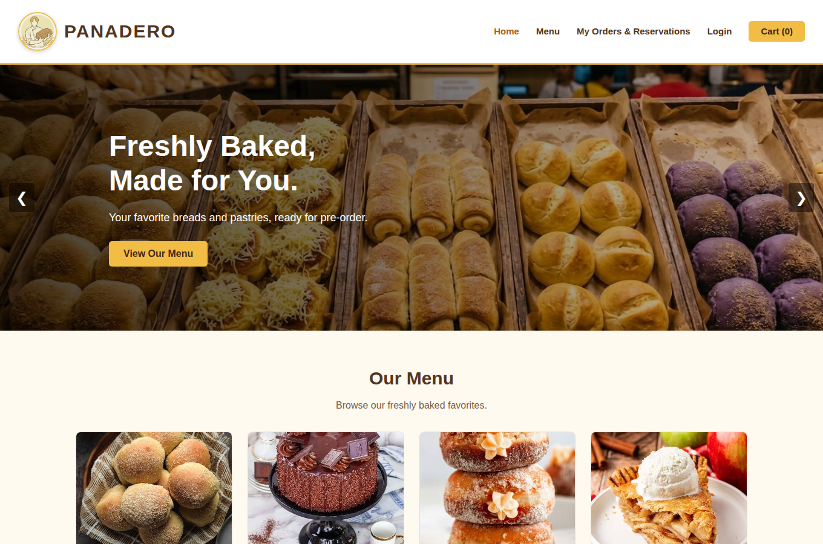
Customer landing/home interface used for browsing the bakery system.

Staff Dashboard
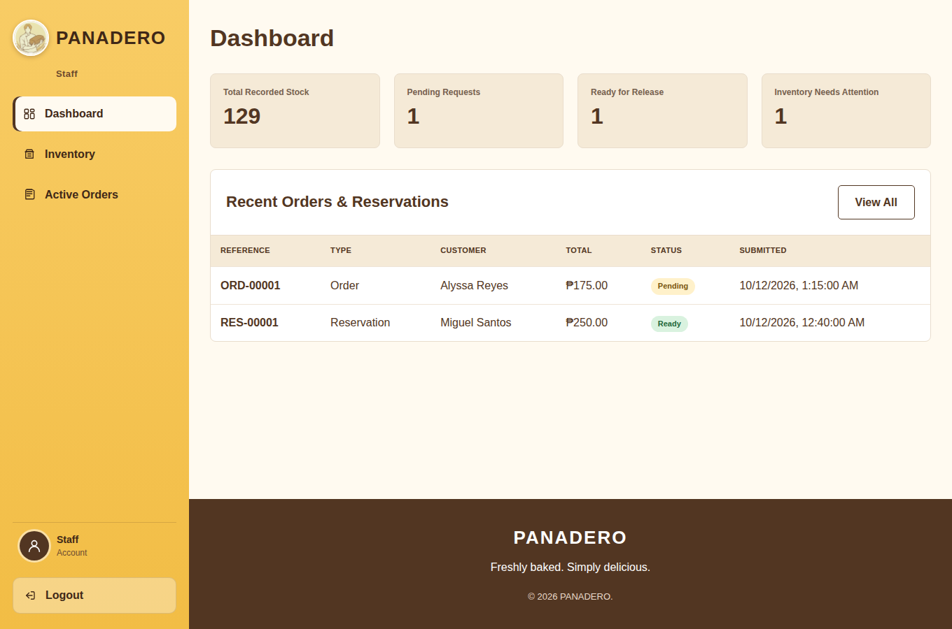
Staff portal dashboard used for operational request and inventory work.

Admin Module
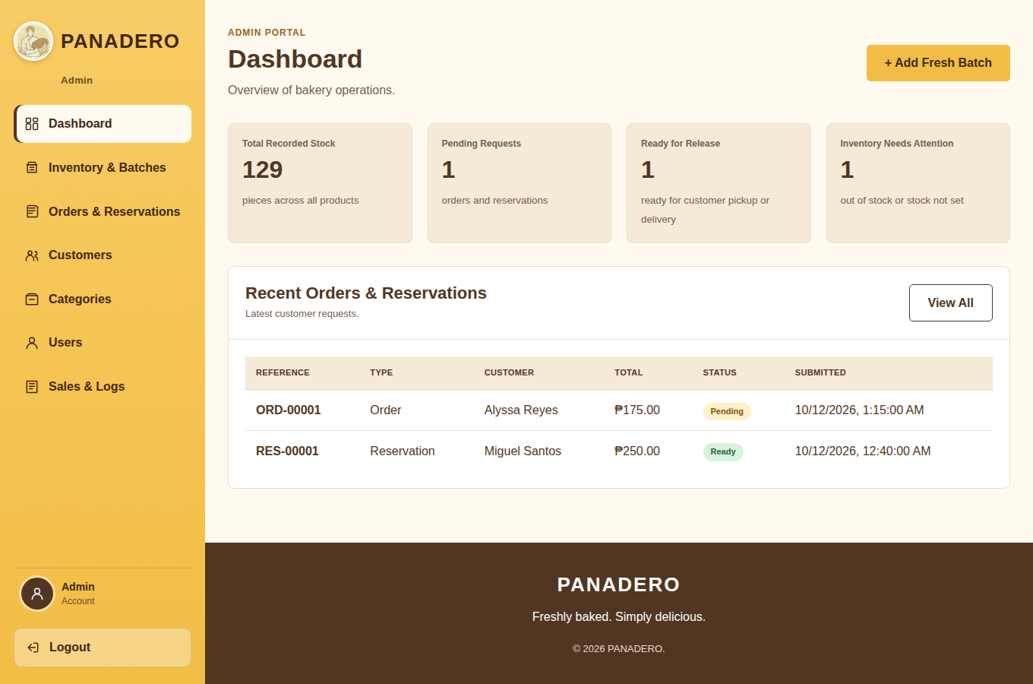
Admin portal used for catalog, user, stock, and request management.

