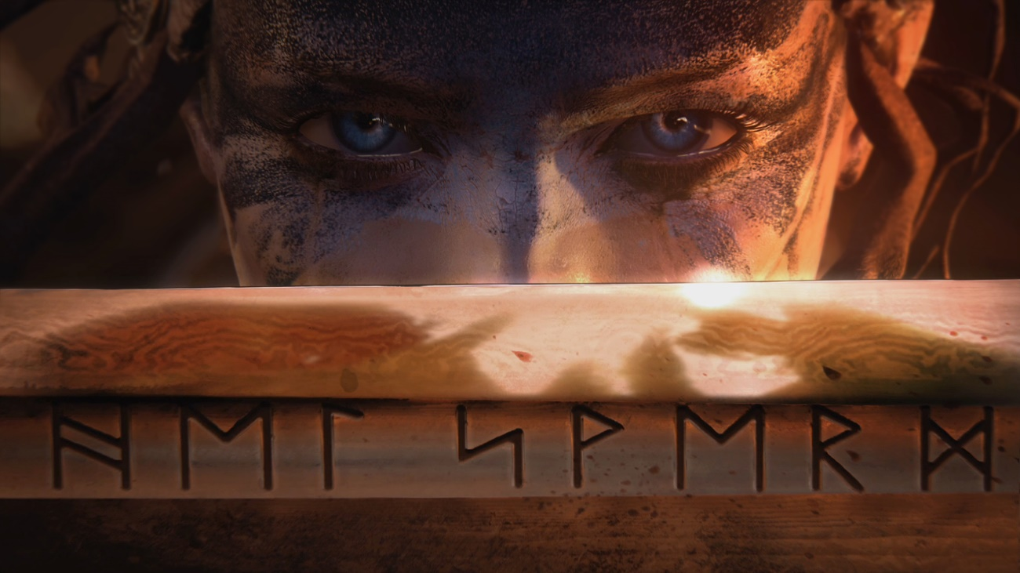

22 SEP DESIGN: CHOOSING A CAMERA SYSTEM
Posted at 13:52h in Design, R21 by Dom 16 Comments
11Likes

Share

Tameem Antoniades
Hello, I am currently preparing for my first ever appearance at DICE Europe. It’s basically a conference for grown-up big-wigs in the games industry so I’m quite nervous about doing it. They originally invited Nina Kristensen, our Chief Development Ninja and co-founder, but she put me forward for it, despite my pleadings and protestations.
Anyway, despite that, I wanted to put something out there for you as Monday’s are becoming a regular thing in terms of releasing some info. Melina is away on holiday so we don’t have a juicy video for you this time. Instead, I’ve put together a little design blog about choosing a camera system for Hellblade. I think it’s worth reading if you are interested in nuts and bolts game design. Otherwise, I’m afraid you may find it rather dry.
Choosing a camera view is one of the first and most important decisions to be made on a game. It’s right up there with controls and character actions. Is the game going to be 2D, isometric, first person or 3rd person? Any system chosen will have massive ramifications on how you build the game, how you control it and how it will feel. It may seem like the dog wagging the tail, but I feel it is smarter to design the game around your camera choice and not the other way around.
When I was working at Sony Europe about 15 years ago I had to design a 3rd person camera system for a game I was working on. I analysed over 40 games, documented what worked and what didn’t. It is much cheaper to learn from other games, both good and bad than to endlessly prototype what you think is right.
People may reasonably suppose that one of the most important skills of a designer is coming up with good ideas. Personally I would put that way down the list of important skills. Ideas are cheap, everyone has them, but few can articulate them, break them down, implement them and make them feel good. So one skill I would put very near the top is “analysis”.
I reverse engineered and tested every camera attribute from the angles, the field of view, transitions, zoom behaviours, interaction with environment, controls and so on. I then proposed several options before going deeper into analysis and choosing one proposal that I thought might work. It took over a week and resulted in a 40-page tome but I learnt enough about cameras to last me a lifetime. I still have that knowedge fresh in my mind when considering camera systems for Hellblade.
So based on what I knew already, I wrote a (thankfully) more brief analysis on our internal wiki. It wasn’t written for anyone in particular, more to help my own thought process. It’s sort of a hang-over from my computer science days when we were forced to do systems analysis.
I went into it this assuming that we would have a regular 3rd person camera like in DmC but the process of analysis lead me to a place I wasn’t expecting. Here it is:
Camera System Analysis
Objective
I cannot stress this enough: the gameplay style and levels we create are wholly dependent on the camera system we decide upon.
The camera system should support clear combat awareness and a feeling of immersion. There are broadly speaking two camera systems to choose from: a 3rd person chase camera and a fixed-rail camera system plus many hybrid systems in-between.
On all our projects other than KFC, cameras were a full-time job for a programmer plus considerable work for design. As we do not have a spare programmer and only one designer for Hellblade, the camera solution we employ must be one that does not require a dedicated programmer or onerous designer time to implement.
Another consideration is that once a camera system was implemented on our previous projects, I had to take directorial control over the camera placement, framing and editing throughout the game. This took an enormous amount of time and focus away from other areas of the game and I would like to avoid this going forward.
Chase Camera System
A single chase camera system that intelligently deals with enemies and environment. Examples include DMC, RE4, Last of Us, Batman etc
PROS
- Only one camera is built for the entire game.
- Player has a high level of control over the camera.
- Framing of the character can vary but is relatively close, helping you connect with the character.
- Exploration of level is freely attainable with this kind of camera
- Supports varied gameplay modes from fighting to exploration to stealth to shooting

CONS
- Development can take a very long time to manage every eventuality
- The player is typically required to control the camera system to play effectively (not an issue for hardcore players)
- Vista shots that show off the environment cannot be done with this system
- Staging of level is difficult as we don’t know where the camera is looking at any point in time
- Camera can get very messy during combat

Examples

https://www.youtube-nocookie.com/embed/P4YyGnGPFUc
https://www.youtube-nocookie.com/embed/BVD44uXuhls
https://www.youtube-nocookie.com/embed/V2rBzQTrpkU
Fixed Rail Camera System
Fixed camera are preset in maya or unreal to give a fixed and directed view of the action. ICO, God of War, Kung Fu Chaos, Heavenly Sword.
PROS
- Very specific control over what is framed in the scene giving a very cinematic feel
- User never has to worry about the camera controls
- Action can be directed very precisely to the camera

CONS
- Every part of every level has to be designed for the camera to make sure camera doesn’t swing, gimble-lock, get obscured etc
- Exploration, stealth and so on is severely limited
- Transitions from camera to camera or branching paths can be tricky to make feel right.
- A huge amount of camera tweaking throughout development is needed on a scene by scene basis
- Creating intimate camera shots can be a big challenge.
- Suits very linear level design as backtracking involves running into the camera

Examples

https://www.youtube-nocookie.com/embed/a2-5_adukXI
https://www.youtube-nocookie.com/embed/oNbN-mh7Ero
https://www.youtube-nocookie.com/embed/ZeI9Zc71ChA
Hybrid Fixed/Chase Camera Systems
A combination of fixed and chase cameras. Usually split to be chase for combat and fixed for traversal. Examples include DMC4, Enslaved.
PROS /CONS
- The best of both worlds or the worst of both worlds depending on your implementation
- Requires the implementation of two camera systems and seamless blending between

Examples

https://web.archive.org/web/20201028145018if_/https://www.youtube-nocookie.com/embed/_lxtqYq5JT8
https://web.archive.org/web/20201028145018if_/https://www.youtube-nocookie.com/embed/EYov8AL4TGU
Directed Chase Camera
This is a chase camera that points at the framing that you decide as a player but that can be overridden at any point using camera controls. Examples: I think uncharted 2 used this, and Mario 64 in places.
PROS /CONS
- The best of both worlds or the worst of both worlds depending on your implementation
- Requires the implementation of two camera systems and seamless blending between

Examples

https://www.youtube.com/embed/saF3BMAoBGA?feature=oembed
Vector Field Camera
This is more of an idea I’ve had for a while rather than a proven solution. I imagine a 3D vector field covering all playable areas of a level that contain position, direction, character offset and fov parameters. The actual camera would interpolate between these vectors. You could set the vectors by flying the free cam and positioning the hero in-game until you have enough vectors to describe the whole space.
UE4 supports vector fields so I don’t know if that is something that may be repurposed to control cameras. Perhaps it’s worth investigating.
PROS /CONS
- Would support larger explorable areas unconstrained by spline paths.
- Would require lots of prototyping and implementation

Over-the-Shoulder Camera
This is an over the shoulder view with controls more in common with first person shooters than traditional third person views. It requires that controls are mapped to support this mode and suits shoulder buttons for man actions as you would have to release the right stick to press a button. Examples include Dead Space and RE4.

Examples

https://www.youtube-nocookie.com/embed/WWki99kvrWk

PROS
- Very immersive. you feel close to your character
- Fewer collision issues as the closeness limits obstruction
- Simpler implementation as it doesn’t require as much “assistance” as chase cameras nor the arduous set up of fixed cameras.
- Supports very cinematic transitions (like Enslaved’s dutching and Dead Space’s moments)
CONS
- Turning to face enemies is clunky as controls must be character-relative rather than screen-relative.
- Visibility of surrounding enemies is restricted so gameplay should limit these to a few.
- Face buttons are less accessible which could present serious problems for combat.

Additional Notes:
A shoulder camera will have a radical effect on controls, level design and enemy make-up, AI and combat and will take us into largely uncharted ground.
1st Person Camera
There are few examples of this in melee games. There are simply too many problems with the narrow visibility and not being able to read the character attacks and reactions on screen clearly. Though it simplifies some aspects of development, namely the fact that you don’t need to see/animate your character fully, there are far too many risks without clear tangible benefits to the player for this to be a serious consideration.
Investigate
- There is a default chase camera in UE4. We should put this to the test in a test map to see its potential and limitations.
- Can we re-use camera systems from any previous projects?
- What about a shoulder camera? We should protoype and explore this?
- Can vector fields or SHL systems be hooked up to the camera in UE4? Can this be done without code support to test the idea? What tools are available in UE4?
- The DmC chase camera was very fully featured but i imagine it was massively over developed and unusable in a new UE4 code base? Confirm
- Kung Fu Chaos had a maya-exported camera. This was fully controlled by the artists in maya. For this to work, the levels have to be extremely linear. Discount because workflow should remain in UE4 and limitations are too onerous.

Considerations
- Hardcore players don’t mind manual camera control but this comes with caveats that suggests lots of camera development:
  - The camera must follow the action invisibly. e.g. when fighting an enemy/enemies, it should track them
  - The camera must zoom in and out intelligently depending on number of surrounding enemies
  - The camera must never swing rapidly or otherwise cause sickness
  - The camera must deal with obstruction effectively
  - Wide open spaces, corridors, slopes should have different framing and positioning
- Our code resource is severely limited so the only obvious way we could implement an intelligent chase camera is to port it from one of our other games (DmC, Enslaved). Based on initial investigations, this is not feasible without a lot of code refactoring.
- Examples of fixed-camera games are few and far between. It seems to have fallen out of favour in the name of giving players the freedom to explore. God of War is probably the last example of such a camera system. It is risky to bet on it.
- Shoulder cameras are used for exploration/shooting games and I can’t think of good examples of melee games that use this viewpoint other than God Hand which great combat controls but had clunky movement controls. Doing a melee game with this viewpoint is a risk but could perhaps present an opportunity to innovate.

Conclusion
- We should pursue and prototype the shoulder camera as the first port of call.
- The shoulder cam has a far reaching consequences (effectively, you’re making a very different game from DmC) but presents several opportunities:
  - The viewpoint is unusual for melee games. All existing examples are from PC games/mods from devs that are traditionally 1st person devs.
  - Translating the depth of combat of DmC and fighting games into this viewpoint will be innovative and could present a progressive direction for melee.
  - The sense of immersion is directly comparable with the shift from RE1 to RE4 in both gameplay and cinematic moments.
  - Traversal in this viewpoint can be more scripted and canned like in RE4 rather than platform based like in DmC/GoW.
- There are several limitations to bear in mind:
  - Large open arenas are more suited to 3rd person camera views like in DmC whereas shoulder view suits more corridor based environments
  - Shoulder-based FOV limits surroundings so having lots of enemies surround you is out. Better to focus on fewer tougher enemies that approach from in front.
  - Enemy AI would have to respect the players’ limited viewpoint.
  - Controls are may have to be dictated by shoulder buttons as face buttons are difficult to reach (this may kill the idea of a shoulder cam – needs to be prototyped)
  - Animation pace and realism will matter more as you are closer to the character.
So summing up, we simply don’t have the resources to implemented most of our usual options. An over-the-shoulder camera is a more reasonable option from a resource point of view but leaves many questions unanswered when it comes to combat. This became the top item to prototype.
At the time this analysis was written, we didn’t have any available code time on the project. Luckily Alexander Litinov had just joined the team as THE designer and comes from a programming background. He prototyped the camera system in Unreal using its Blueprint system. He had done enough for us to play around and experiment with different control options with different numbers of enemies. I was delighted that it seemed perfectly natural to use face buttons in this camera view. It meant we could create a hardcore fighting set-up within an unusually intimate camera view. In a sense it felt a little more like a one-on-one fighter than a 3rd person one-on-many masher which is no bad thing.
So unless something unforeseen derails us, an over-the-shoulder style camera system it is.
We will be probably be covering our prototype phase in the next video diary so there should be more details then. Stay tuned.

