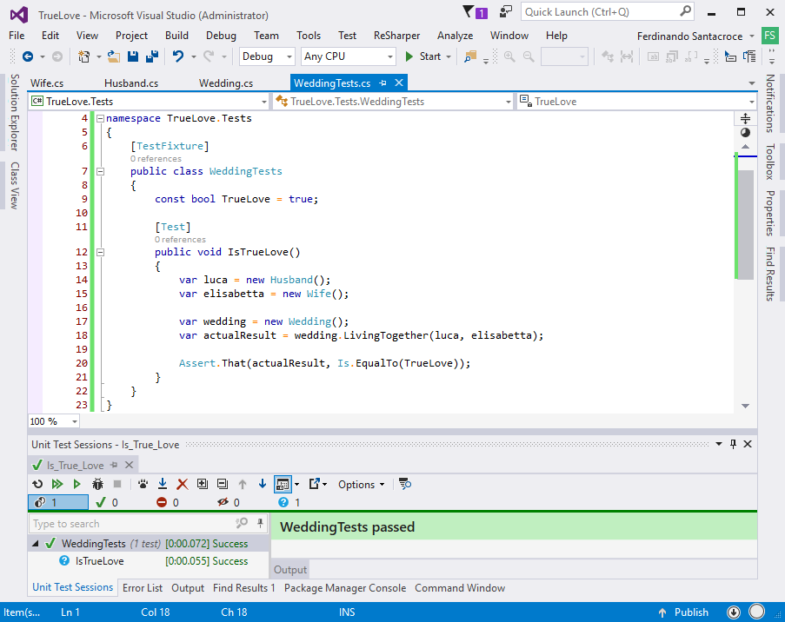

Source code available at: https://github.com/jesuswasrasta/TrueLove.git :)

