AI CAREER COMPANION: AN INTELLIGENT CAREER RECOMMENDATION AND SKILL-GAP ANALYSIS PLATFORM
A project report submitted in partial fulfilment of the requirements for the award of the degree of
[DEGREE NAME, e.g. BACHELOR OF TECHNOLOGY]
in
[DEPARTMENT]
Submitted by
Jeswin Jarald
[REGISTER NUMBER]
Internship organisation: Infosys (internship project)
Internship supervisor: [INTERNSHIP SUPERVISOR NAME]
Project guide: [PROJECT GUIDE NAME]
[COLLEGE / UNIVERSITY NAME]
[COLLEGE / UNIVERSITY ADDRESS]
[ACADEMIC YEAR]

CERTIFICATE
Template — to be issued and signed by the institution. This page is not a certificate until it is completed and signed by the authorised signatories.
This is to certify that the project report entitled "AI Career Companion: An Intelligent Career Recommendation and Skill-Gap Analysis Platform" is a record of the work carried out by Jeswin Jarald ([REGISTER NUMBER]) in partial fulfilment of the requirements for the award of the degree of [DEGREE NAME] in [DEPARTMENT] of [COLLEGE / UNIVERSITY NAME], during the academic year [ACADEMIC YEAR], under my supervision.
__________________________  [PROJECT GUIDE NAME]  Project Guide | __________________________  [HEAD OF DEPARTMENT NAME]  Head of the Department

Submitted for the project viva-voce examination held on [VIVA DATE].
__________________________  Internal Examiner | __________________________  External Examiner

DECLARATION
Editable draft — the student must read, verify and amend this declaration before signing it.
I, Jeswin Jarald ([REGISTER NUMBER]), hereby declare that the project report entitled "AI Career Companion: An Intelligent Career Recommendation and Skill-Gap Analysis Platform", submitted to [COLLEGE / UNIVERSITY NAME] in partial fulfilment of the requirements for the award of the degree of [DEGREE NAME] in [DEPARTMENT], is a record of original work carried out by me as an Infosys internship project under the guidance of [PROJECT GUIDE NAME] and the supervision of [INTERNSHIP SUPERVISOR NAME].
I further declare that this report has not been submitted, in full or in part, to any other university or institution for the award of any degree or diploma, and that all sources of information used in it have been acknowledged.
Place: [PLACE]
Date: [SUBMISSION DATE]
__________________________
Jeswin Jarald
Signature of the student

ACKNOWLEDGEMENT
Editable draft — replace the placeholders and adjust the wording before submission.
I express my sincere gratitude to [COLLEGE / UNIVERSITY NAME] and to the [DEPARTMENT] for the opportunity to undertake this project as part of my programme of study.
I thank Infosys for the internship opportunity within which AI Career Companion was designed, built and evaluated, and [INTERNSHIP SUPERVISOR NAME] for supervising the internship work.
I am grateful to my project guide, [PROJECT GUIDE NAME], for guidance throughout the project, and to [HEAD OF DEPARTMENT NAME], Head of the Department, for support and encouragement.
I also acknowledge the authors and maintainers of the open-source software on which this project depends, including FastAPI, SQLAlchemy, React, Sentence-Transformers and FAISS.
Finally, I thank my family and friends for their constant support.
Jeswin Jarald

ABSTRACT
Students and early-career job seekers often struggle to judge which openings genuinely fit their current skills, which requirements they are missing for a particular role, and how to present their real experience without overstating it. General-purpose generative assistants can help with wording, but their output is not tied to the candidate's resume or to a fixed set of opportunities and can introduce qualifications the candidate does not have.
This report describes AI Career Companion, a web application developed as an Infosys internship project that turns a student's resume into grounded, explainable career guidance. A deterministic pipeline parses an uploaded PDF or DOCX resume into a structured candidate context. The context drives semantic retrieval over a curated knowledge base of 320 early-career opportunities in 15 technology domains, using all-MiniLM-L6-v2 sentence embeddings (384 dimensions) and an exact FAISS index over 960 posting chunks, and a transparent, weighted, deterministic function ranks the results. The system adds evidence-based skill-gap analysis, a tailored resume summary and cover letter checked by a grounding validator, interview preparation, a conversational assistant that reuses these services, and an application tracker. All workflows run without a language model; a configured OpenAI-compatible model may only rewrite already-grounded text, under validation and with a deterministic fallback.
In an offline evaluation on 26 labelled retrieval queries, the final configuration achieved Hit@1 = 1.000, MRR@10 = 1.000, Precision@5 = 0.662, Recall@5 = 0.883 and nDCG@5 = 0.969; grounding checks found 0 violations, 10 of 10 injected faults were detected, 15 of 16 scripted conversation turns and 3 of 3 discovery probes behaved as intended. The backend test suite passed with 464 tests (and 1 expected failure) at the Milestone 4.4 release audit and with 555 tests on the current checkout. These results describe small, synthetic fixtures, not real-world effectiveness. Limitations include deterministic handling of general career questions, matching margins below target, a heuristic confidence flag, no live-LLM evaluation and an unimplemented learning roadmap.
Keywords: career recommendation, resume parsing, semantic search, sentence embeddings, FAISS, skill-gap analysis, grounded generation, FastAPI, React.

TABLE OF CONTENTS
CERTIFICATE i
DECLARATION ii
ACKNOWLEDGEMENT iii
ABSTRACT iv
TABLE OF CONTENTS v
LIST OF FIGURES x
LIST OF TABLES xi
LIST OF ABBREVIATIONS xiii
Chapter 1: Introduction 1
1.1 Background and Motivation 1
1.2 Challenges Faced by Students and Job Seekers 1
1.3 Need for Resume-Based Recommendation and Skill-Gap Analysis 2
1.4 Problem Statement 2
1.5 Objectives 2
1.6 Scope of the Project 3
1.7 Intended Users 3
1.8 Expected Benefits 3
1.9 Organisation of the Report 3
Chapter 2: Existing System and Proposed System 5
2.1 Conventional Career Discovery and Resume Review 5
2.2 Limitations of the Existing Approach 5
2.3 Proposed System: AI Career Companion 5
2.4 Major Functional Capabilities 6
2.5 Comparison of Existing and Proposed Approaches 6
2.6 Functional Requirements 7
2.7 Non-Functional Requirements 7
2.8 Assumptions and Constraints 8
Chapter 3: Feasibility Study and Requirements Analysis 9
3.1 Technical Feasibility 9
3.2 Operational Feasibility 9
3.3 Economic Feasibility 9
3.4 Functional Requirements Analysis 10
3.5 Quality Requirements 10
3.6 Hardware and Software Requirements 11
3.7 User Roles and Access Restrictions 11
3.8 Use Cases and Acceptance Criteria 12
Chapter 4: System Analysis and Design 13
4.1 Overall Architecture 13
4.2 Component Responsibilities 14
4.3 Data Flow 15
4.4 Database Design 17
4.5 Principal Workflow: Resume Upload and Analysis 19
4.6 Optional LLM Path 20
4.7 Authentication and Session Flow 21
4.8 Key Design Decisions and Rationale 22
Chapter 5: Methodology and Algorithms 24
5.1 Resume Upload and Validation 24
5.2 Text Extraction and Normalisation 24
5.3 Section Detection and Structuring 24
5.4 Candidate Context 25
5.5 Sentence Embeddings and Opportunity Representation 25
5.6 FAISS Indexing and Similarity Retrieval 25
5.6.1 Query-Confidence Flag 26
5.7 Deterministic Matching and Ranking 26
5.8 Skill Extraction and Skill-Gap Generation 28
5.9 Grounding and Evidence Validation 29
5.10 Semantic Similarity, Deterministic Scoring and LLM Wording 30
5.11 Optional LLM-Assisted Rewriting and Fallback 31
5.12 Conversational Assistant 31
5.13 Data Persistence and Retrieval 31
5.14 Error Handling and Validation 32
Chapter 6: Implementation 33
6.1 Frontend Architecture and Major Screens 33
6.2 Backend Structure and API Design 34
6.3 Authentication and Session Handling 34
6.4 Resume Upload and Analysis 35
6.5 Career and Opportunity Recommendations 35
6.6 Skill-Gap Analysis 35
6.7 Resume Customization and Cover Letter 36
6.8 Interview Preparation 36
6.9 Application Tracking and Persistence 36
6.10 Career Assistant and Opportunity Discovery 37
6.11 Database Models and Relationships 37
6.12 Configuration and Optional LLM Integration 37
6.13 Error Handling, Validation and Security-Related Choices 38
Chapter 7: Testing and Evaluation 39
7.1 Testing Methodology 39
7.2 Test Environment and Configuration 39
7.3 Unit, Integration, API and Regression Tests 39
7.4 Representative Test Cases 40
7.5 Test Results 42
7.6 Retrieval-Quality Evaluation 42
7.7 Optimisation Experiments and Performance Measurements 43
7.8 Grounding and Failure-Handling Evidence 45
7.9 Results Summary 46
7.10 Test Success Versus Real-World Effectiveness 46
7.11 Limitations of the Evaluation 46
7.12 Work Beyond the Canonical Baseline 47
Chapter 8: Results and Discussion 48
8.1 What the System Demonstrates 48
8.2 Fulfilment of the Objectives 48
8.3 Interpretation of Retrieval and Performance Results 48
8.4 Practical Benefits and Usability Observations 49
8.5 Trade-offs of the Deterministic-plus-Optional-LLM Design 49
8.6 Threats to Validity and Generalisability 49
Chapter 9: Security, Privacy and Reliability 51
9.1 Password Hashing 51
9.2 Session-Token Generation and Storage 51
9.3 Authentication, Authorisation and API Access Control 51
9.4 User-Data Ownership and Cross-User Isolation 51
9.5 Input and File Validation 52
9.6 Error Handling and Fallback Behaviour 52
9.7 Data Handling and Privacy Assumptions 52
9.8 Remaining Security Limitations 52
Chapter 10: Limitations and Future Enhancements 53
10.1 Current Limitations 53
10.2 Future Enhancements 54
Chapter 11: Conclusion 55
References 56
Appendix A: API Endpoint Summary 57
Appendix B: Dataset Provenance and Evaluation Fixtures 58
Appendix C: Selected Configuration and Reproduction Commands 59
Appendix D: Glossary 60

LIST OF FIGURES
Figure 4.1: Logical architecture of AI Career Companion 14
Figure 4.2: Use-case diagram 16
Figure 4.3: Level-1 data-flow diagram with trust boundaries 17
Figure 4.4: Entity-relationship diagram derived from the SQLAlchemy models 18
Figure 4.5: Sequence diagram of resume upload and analysis 20
Figure 4.6: Optional LLM path with validation and deterministic fallback 21
Figure 4.7: Authentication and session sequence 22
Figure 5.1: Retrieval and deterministic matching pipeline 28
Figure 5.2: Grounding validation of generated content 30
Figure 6.1: Screen and navigation map of the frontend 33
Figure 7.1: Retrieval metrics, M4.2 baseline versus M4.3 final 43

LIST OF TABLES
Table 2.1: Major functional capabilities of the proposed system 6
Table 2.2: Comparison of the conventional approach and the proposed system 6
Table 2.3: Functional requirements 7
Table 2.4: Non-functional requirements 7
Table 3.1: Mapping of functional requirements to implementation 10
Table 3.2: Performance, usability, maintainability, reliability and security requirements 10
Table 3.3: Software requirements (verified from the repository) 11
Table 3.4: Recommended hardware (recommendations, not benchmarked minimums) 11
Table 3.5: Principal use cases and acceptance criteria 12
Table 4.1: Component responsibilities 14
Table 4.2: Principal tables and their purpose 18
Table 4.3: Key design decisions 22
Table 5.1: Matching components and weights (MATCH_WEIGHTS in job_matching.py) 26
Table 6.1: Major screens 33
Table 6.2: Principal configuration settings (backend/app/core/config.py) 37
Table 7.1: Backend test coverage by area (backend/tests) 39
Table 7.2: Representative test cases 40
Table 7.3: Automated tests implementing the test cases 41
Table 7.4: Backend test-suite results over the project history 42
Table 7.5: Retrieval metrics on 26 labelled queries 43
Table 7.6: Summary of M4.3 controlled experiments 44
Table 7.7: Performance before and after M4.3 (medians of repeated warm calls on the single development machine; deterministic pipeline; no LLM) 44
Table 7.8: Grounding, consistency, conversation and discovery results 45
Table 7.9: Summary of verified results 46
Table 8.1: Objectives and how they were addressed 48
Table A.1: API operations (47) 57
Table B.1: Opportunity dataset 58
Table B.2: Evaluation fixture sizes (backend/data/evaluation/m4/cases) 58
Table D.1: Glossary 60

LIST OF ABBREVIATIONS
Abbreviation | Expansion
API | Application Programming Interface
CORS | Cross-Origin Resource Sharing
CRUD | Create, Read, Update, Delete
CSRF | Cross-Site Request Forgery
CSV | Comma-Separated Values
DFD | Data-Flow Diagram
DOCX | Office Open XML word-processing document
ERD | Entity-Relationship Diagram
FAISS | Facebook AI Similarity Search (library)
HTTP(S) | Hypertext Transfer Protocol (Secure)
JSON | JavaScript Object Notation
LLM | Large Language Model
MiB | Mebibyte (1,048,576 bytes)
MRR | Mean Reciprocal Rank
nDCG | Normalised Discounted Cumulative Gain
OCR | Optical Character Recognition
ORM | Object-Relational Mapper
PDF | Portable Document Format
RAG | Retrieval-Augmented Generation
REST | Representational State Transfer
SHA | Secure Hash Algorithm
SPA | Single-Page Application
SQL | Structured Query Language
UI / UX | User Interface / User Experience
UTC | Coordinated Universal Time

Chapter 1: Introduction

1.1 Background and Motivation
The transition from education to employment requires a student to make a series of linked decisions: which opportunities to pursue, how well their present skills match each one, what to learn next, how to tailor a resume and cover letter, how to prepare for interviews and how to keep track of applications. Each decision depends on the same underlying information — the student's actual skills, education, projects and experience, and the stated requirements of each opportunity — yet these steps are commonly carried out separately and by hand.
Generative AI assistants have made it easy to produce fluent career documents. Their output, however, is not inherently tied to the candidate's evidence. A system that writes "five years of experience leading a team" for a student who has neither is worse than unhelpful, because the student may submit the fabricated claim. This project was motivated by the view that career guidance software should be grounded: every recommendation, score and generated sentence should be traceable to something the student actually wrote, or to a requirement the opportunity actually states.

1.2 Challenges Faced by Students and Job Seekers
In the general context of early-career job searching, students frequently:
- do not know which openings genuinely fit their current skills, and rely on keyword searches that miss relevant roles described in different words;
- cannot see precisely which requirements of a specific role they are missing, or whether a missing item is a hard requirement or a preferred one;
- write one generic resume and cover letter for every application, or, when using generative tools, risk including skills and experience they do not possess;
- prepare for interviews without connecting likely questions to their own projects and to their gaps for the role;
- lose track of where they applied, which deadlines apply and when interviews are scheduled.
These statements describe the problem context that motivated the project. They are not findings of this project: no user study was conducted, and this report makes no claim about how common these difficulties are in any particular population.

1.3 Need for Resume-Based Recommendation and Skill-Gap Analysis
A resume is the most complete structured description of a candidate that a student already has. If it is parsed reliably, it can serve as a single source of truth for every later step: retrieving opportunities that are semantically related to the candidate's background, scoring fit transparently, listing each requirement as met, partially met or missing with quoted evidence, and constraining generated text to claims the resume supports. Skill-gap analysis is the bridge between recommendation and action: it converts "this role is a 52% match" into "these two required skills are missing, and this related skill gives partial support for a preferred one".

1.4 Problem Statement
To design, implement and evaluate a web application that accepts a student's resume and career profile and, using only verifiable evidence, (i) retrieves relevant early-career opportunities from a curated knowledge base, (ii) ranks them with an explainable, deterministic score, (iii) analyses the student's gaps against a chosen opportunity, (iv) generates tailored application materials and interview preparation that never claim unsupported qualifications, (v) answers follow-up questions conversationally by reusing these services, and (vi) tracks the student's applications — while keeping each user's data private to that user, and while remaining fully functional without a large language model.

1.5 Objectives
1. Extract structured, inspectable candidate context from PDF and DOCX resumes without OCR and without requiring an LLM.
2. Retrieve relevant opportunities semantically from a curated, validated knowledge base.
3. Score candidate–opportunity fit with transparent, deterministic, weighted logic and plain-language explanations.
4. Make every generated statement traceable to candidate evidence and never claim a skill the candidate has not shown.
5. Keep an optional LLM strictly subordinate: grounded input, validated JSON output and a deterministic fallback.
6. Persist each user's data under strict ownership and prevent cross-user access.
7. Measure the complete workflow against a frozen baseline, improve it through controlled experiments, and report the results and limitations honestly.

1.6 Scope of the Project
In scope. User registration and session-based authentication; a career profile; resume upload, validation, text extraction, section detection, structuring and candidate-context generation; semantic search over a 320-record curated opportunity catalogue; deterministic job matching; skill-gap analysis; resume and cover-letter customization with PDF/DOCX export; interview preparation with mock-answer feedback; a conversational career assistant; an application tracker with reminders; an offline evaluation framework; and automated backend tests.
Out of scope or not implemented. Live job-board integration, real application links and real deadlines (the catalogue contains none); OCR for scanned resumes; learning-roadmap generation and roadmap progress (the corresponding pages state that the feature is unavailable); deployment to a production host; and a formal user study. The project is a local development and evaluation implementation and is not deployed.

1.7 Intended Users
The primary users are students and recent graduates seeking internships, entry-level jobs, graduate programmes, trainee roles and apprenticeships in technology fields. Secondary readers of the system's output include project evaluators and mentors who wish to understand how a recommendation or a generated sentence was derived.

1.8 Expected Benefits
If used as designed, the system is expected to give a student: a ranked shortlist of related opportunities with reasons; a requirement-by-requirement view of their readiness for a chosen role; tailored application materials that stay within the evidence of their resume; interview preparation linked to their own projects; and one place to track applications. These are design intentions. Their real-world effect on students' decisions or outcomes was not measured in this project (see Chapters 7 and 8).

1.9 Organisation of the Report
Chapter 2 contrasts conventional approaches with the proposed system and lists its requirements. Chapter 3 presents the feasibility study and requirements analysis. Chapter 4 describes the architecture and design, with diagrams. Chapter 5 explains the methodology and algorithms. Chapter 6 describes the implementation. Chapter 7 presents testing and evaluation, and Chapter 8 discusses the results. Chapter 9 covers security, privacy and reliability. Chapter 10 lists limitations and future enhancements, and Chapter 11 concludes. The appendices summarise the API, the dataset and evaluation fixtures, reproduction commands and a glossary.

Chapter 2: Existing System and Proposed System

2.1 Conventional Career Discovery and Resume Review
Conventional career discovery typically combines keyword search on job portals, advice from mentors or placement offices, and manual comparison of a resume against each posting. Resume review is usually performed by a person, or by a generic checklist, and tailoring a resume or cover letter for each application is done by hand or with a general-purpose text generator. Application status, deadlines and interview dates are often kept in personal notes or spreadsheets.

2.2 Limitations of the Existing Approach
The limitations relevant to this project are:
- Lexical search misses related roles. A query for "machine learning" may not surface a posting phrased as "predictive modelling with scikit-learn".
- Fit is opaque. A student rarely sees a requirement-by-requirement explanation of why a role does or does not fit.
- Generated text may be ungrounded. A general-purpose generator is not constrained by the candidate's evidence and may introduce invented metrics, leadership claims, technologies or years of experience.
- Steps are disconnected. Search, gap analysis, document tailoring, interview preparation and tracking use different tools, so the same information is re-entered and the link between them is lost.
No specific commercial product is evaluated or compared in this report.

2.3 Proposed System: AI Career Companion
AI Career Companion integrates the whole workflow in one application built around a single structured candidate context. Its distinguishing design choices are:
- Deterministic core. Parsing, retrieval, scoring, gap analysis, keyword alignment and tracking are deterministic code, so the same input always yields the same, inspectable result.
- Semantic retrieval only for selection. Embeddings decide which canonical opportunity records are considered; all downstream reasoning runs on the structured records, not on retrieved free text.
- Grounded generation. Generated sentences are validated against the candidate's evidence, and unsupported sentences are removed.
- Optional, subordinate LLM. A configured OpenAI-compatible model may rewrite grounded content; its output is validated and discarded on any failure.
- Per-user ownership. Every user-data query is filtered by the authenticated user.

2.4 Major Functional Capabilities
Table 2.1: Major functional capabilities of the proposed system
Capability | What the system does
Accounts | Register, sign in and sign out with an HttpOnly session cookie
Career profile | Store education, degree, specialisation, experience level, interests, target roles, skills and goals
Resume analysis | Validate, extract text, detect sections, build a structured resume and a candidate context
Opportunity search | Semantic search over 320 curated opportunities with a query-confidence flag
Job matching | Rank retrieved opportunities with a weighted six-component score and reasoning
Skill-gap analysis | Requirement-level classification with evidence, severity, recommendations and readiness
Customization | Keyword alignment, tailored summary, skill and project ordering, cover letter, PDF/DOCX export
Interview preparation | Questions in six categories, revision priorities and mock-answer feedback
Career assistant | Intent-routed conversation that reuses the services above; conversations persisted
Application tracker | Ten statuses, user-entered dates, notes, linked materials, summary and reminders

2.5 Comparison of Existing and Proposed Approaches
Table 2.2: Comparison of the conventional approach and the proposed system
Aspect | Conventional approach | AI Career Companion
Opportunity discovery | Keyword search | Sentence-embedding retrieval over a curated catalogue
Fit assessment | Informal judgement | Deterministic weighted score with matched and missing skills
Gap analysis | Manual comparison | Requirement-by-requirement classification with quoted evidence
Document tailoring | Manual or ungrounded generation | Evidence-linked drafts checked by a grounding validator
Interview preparation | Generic question lists | Questions tied to the candidate's projects, the job and the gaps
Tracking | Personal notes or spreadsheets | Persisted tracker with statuses, dates and reminders
Dependence on an LLM | Often total, for generative tools | None; an LLM is optional and only rewrites grounded text

2.6 Functional Requirements
Table 2.3: Functional requirements
ID | Requirement
FR-01 | The system shall allow a user to register, sign in, view the current user and sign out.
FR-02 | The system shall create one career profile per user at registration and allow it to be updated.
FR-03 | The system shall accept PDF and DOCX resumes up to 10 MiB and reject other or malformed files.
FR-04 | The system shall extract text, detect sections and build a structured resume deterministically.
FR-05 | The system shall combine the profile and structured resume into a persisted candidate context.
FR-06 | The system shall provide semantic search over the opportunity catalogue (1–20 results).
FR-07 | The system shall rank opportunities for a resume with an explainable match score.
FR-08 | The system shall analyse the skill gap between a resume and a selected opportunity.
FR-09 | The system shall generate, edit, version and export a tailored resume summary and cover letter.
FR-10 | The system shall generate interview preparation and give structured feedback on a practice answer.
FR-11 | The system shall provide a conversational assistant whose answers reuse the services above.
FR-12 | The system shall track applications with statuses, user-entered dates, notes and linked materials, and list reminders.

2.7 Non-Functional Requirements
Table 2.4: Non-functional requirements
ID | Category | Requirement
NFR-01 | Grounding | Generated content shall not claim skills, metrics, leadership, employers, degrees or experience absent from the evidence.
NFR-02 | Explainability | Scores shall be accompanied by the matched and missing items that produced them.
NFR-03 | Privacy | A user shall never be able to read or modify another user's data.
NFR-04 | Determinism | With LLM_PROVIDER=none, identical inputs shall give identical outputs.
NFR-05 | Resilience | Any LLM failure shall fall back to the deterministic result.
NFR-06 | Honesty of display | No placeholder, random or fabricated values shall be shown; unavailable features shall say so.
NFR-07 | Maintainability | Business logic shall be separated into service modules with automated tests.
NFR-08 | Responsiveness | Interactive deterministic operations should complete in well under a second on a development machine.

2.8 Assumptions and Constraints
- The opportunity catalogue is a curated, project-authored dataset; company names are not real employers and the records are not live vacancies.
- Resumes are text-based PDF or DOCX files; image-only PDFs cannot be processed.
- The system runs locally on a single machine with SQLite; it is not designed or tested for multi-process deployment.
- The default configuration uses no LLM. When an LLM is configured, its availability, cost and latency depend on the external provider.
- The embedding model is downloaded once and then loaded from the local cache.

Chapter 3: Feasibility Study and Requirements Analysis

3.1 Technical Feasibility
All components rely on mature, open-source technology that runs on an ordinary development computer: FastAPI and Uvicorn for the API, SQLAlchemy with SQLite for persistence, pypdf and python-docx for parsing, Sentence-Transformers with the compact all-MiniLM-L6-v2 model for embeddings, and FAISS for vector search, with React 19, TypeScript and Vite 6 for the frontend. The knowledge base is small (320 records, 960 vectors), so an exact flat index is sufficient and no approximate-search tuning is needed. Feasibility is demonstrated by the implementation itself: the full workflow runs end to end on a Windows 11 development machine (Chapter 7).

3.2 Operational Feasibility
The user workflow follows the order in which a student naturally works: profile, resume, recommendations, gap analysis, application materials, interview preparation and tracking. Each step's output is visible and editable, and empty states state plainly when no data exists (for example, a new account shows "No resume analyzed yet. No skills extracted yet. No job matches yet."). The deterministic mode needs no API key, which removes a common operational barrier. Operating the system does, however, require running a local backend and frontend, which is suitable for a project or demonstration setting rather than for unassisted public use.

3.3 Economic Feasibility
No project cost data or savings were measured, so this assessment is qualitative and rests on the following transparent assumptions:
- All runtime dependencies listed in backend/requirements.txt and package.json are open-source and free to use.
- The default configuration makes no paid API calls; the embedding model runs locally.
- Development and evaluation used an existing personal computer; no server or cloud resources were provisioned.
- If an LLM provider is configured, its usage is billed by that provider. Token usage is recorded when the provider reports it, but LLM cost was not measured in this project.
Under these assumptions, the direct software cost of the deterministic configuration is zero, and the main cost is development effort.

3.4 Functional Requirements Analysis
The functional requirements of Table 2.3 map onto backend routers and frontend views as summarised below; every endpoint is listed in Appendix A.
Table 3.1: Mapping of functional requirements to implementation
Requirement | Backend router (backend/app/api) | Frontend view
FR-01 | auth.py | Sign in / Sign up
FR-02 | profile.py | Career Profile
FR-03 – FR-05 | resume.py, context.py | Resume Analyzer, Resume Results
FR-06 | jobs.py | Career Recommendations
FR-07 | resume.py (/job-matches) | Career Recommendations, Job Details
FR-08 | skill_gap.py | Skill Gap Analysis
FR-09 | customization.py | Customize Application
FR-10 | interview_prep.py | Interview Preparation
FR-11 | assistant.py | AI Career Assistant
FR-12 | applications.py | Application Tracker, Application Details, Dashboard

3.5 Quality Requirements
Table 3.2: Performance, usability, maintainability, reliability and security requirements
Quality | Requirement | How it is addressed
Performance | Deterministic operations should respond quickly on a development machine. | In-process caching of the validated dataset and index (Section 7.7).
Usability | Each page shows real data or a clear empty state; long operations show real progress. | Empty states, elapsed-time status for generation, URL-preserved job selection.
Maintainability | Logic is modular and tested; API types stay consistent with the frontend. | Service modules, 50+ test modules, generated API types and a contract check.
Reliability | Failures are reported clearly and never corrupt stored data. | Validation before persistence, JSON error handler, retry on version conflicts.
Security | Passwords and session tokens are never stored in plain text; data is per-user. | Argon2id hashing, SHA-256 token hashes, ownership checks (Chapter 9).

3.6 Hardware and Software Requirements
Table 3.3: Software requirements (verified from the repository)
Item | Version or detail
Operating system used for development | Windows 11
Python | 3.12 (virtual environment .venv; 3.12.3 used in verification)
Backend libraries | FastAPI, Uvicorn, Pydantic v2 and pydantic-settings, SQLAlchemy 2.x, pypdf, python-docx, faiss-cpu, sentence-transformers, pwdlib[argon2], reportlab, httpx
Database | SQLite (file backend/data/ai_career_companion.db by default)
Embedding model | sentence-transformers/all-MiniLM-L6-v2 (local Hugging Face cache)
Node.js / npm | Node 18.19 / npm 10.2 (Node 18 is end-of-life; an upgrade to Node 20+ is recommended)
Frontend | React 19, TypeScript ~5.8, Vite 6, ESLint 9
Browser | A current desktop browser with cookies enabled
Optional | An OpenAI-compatible chat-completions endpoint and API key

Table 3.4: Recommended hardware (recommendations, not benchmarked minimums)
Component | Recommendation
Processor | A modern 64-bit multi-core CPU (no GPU is required; FAISS and the embedding model run on the CPU)
Memory | 8 GB RAM or more, to hold the embedding model, the index and the development servers comfortably
Storage | About 2 GB free for the virtual environment, node_modules, the model cache and data
Network | Needed once to download the embedding model and dependencies; optional afterwards (and for an LLM provider)

The hardware figures in Table 3.4 are practical recommendations. They were not established by formal benchmarking.

3.7 User Roles and Access Restrictions
The system has one authenticated role, the student (registered user). There is no administrator role in the application. An unauthenticated visitor can only register, sign in, call the health check, and use the read-only opportunity endpoints (/api/jobs/*); in the user interface, visitors see the sign-in and sign-up pages. All other endpoints require a valid session, act only on the caller's own data, return HTTP 401 without a session and HTTP 404 for an object owned by another user. The optional LLM provider is an external system actor, not a user.

3.8 Use Cases and Acceptance Criteria
Table 3.5: Principal use cases and acceptance criteria
ID | Use case | Acceptance criteria
UC-01 | Register and sign in | A valid registration creates one user and one profile; login sets an HttpOnly cookie; /api/auth/me returns 401 without it.
UC-02 | Process a resume | A valid PDF/DOCX passes through upload, extraction, sections, structuring and context; an invalid file is rejected with a readable message and nothing is stored.
UC-03 | View job matches | Results are ordered by match score and show matched and missing required skills and reasoning.
UC-04 | Search opportunities | A query returns 1–20 results; an off-topic query is labelled unsupported_area but results are still shown.
UC-05 | Analyse skill gap | Each requirement is matched, partial or missing with evidence; readiness is reported separately from the match score.
UC-06 | Customize an application | Every generated sentence is supported by evidence or removed; the result states whether the grounding check passed and can be exported.
UC-07 | Prepare for interview | Questions reference the candidate's projects and the job; a practice answer receives structured feedback.
UC-08 | Converse with the assistant | Requests are routed to the matching service; the active job and resume are kept across turns.
UC-09 | Track an application | A dataset opportunity can be tracked once per user (duplicate → 409); dates and notes persist; reminders follow the documented rules.
UC-10 | Isolation | A second user receives 404 for every object owned by the first user.

Chapter 4: System Analysis and Design

4.1 Overall Architecture
AI Career Companion is a three-tier web application with an optional external dependency (Figure 4.1). The client tier is a React single-page application. The API tier is a FastAPI application with 11 routers, credentialed CORS, a session-based authentication dependency and a JSON error handler. The service tier holds the deterministic business logic. The data tier consists of a SQLite database, a private resume file store, the read-only opportunity dataset, the FAISS vector store and the locally cached embedding model. An OpenAI-compatible LLM endpoint is contacted only when explicitly configured.
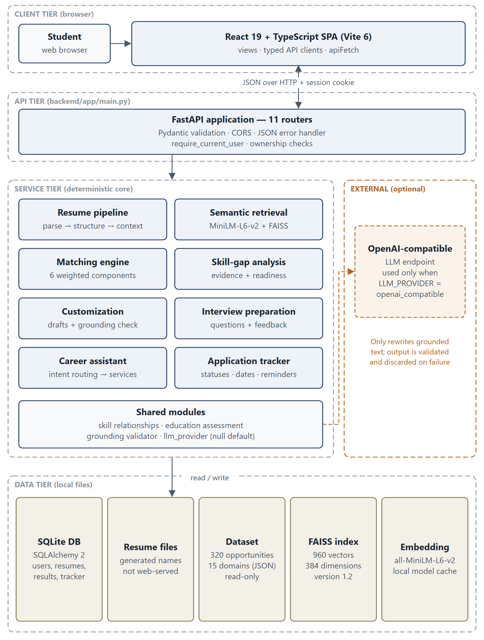
Figure 4.1: Logical architecture of AI Career Companion

4.2 Component Responsibilities
Table 4.1: Component responsibilities
Component | Responsibility | Key modules
React SPA | Views, navigation (History API), typed API clients, empty states | src/App.tsx, src/services/*.ts, src/config/api.ts
FastAPI app | Routing, validation (Pydantic), CORS, authentication dependency, error handling | backend/app/main.py, backend/app/api/*.py
Resume pipeline | Upload validation, PDF/DOCX extraction, normalisation, sections, structuring | resume_validation.py, pdf_extraction.py, docx_extraction.py, text_utils.py, section_detection.py, structured_resume.py, candidate_context.py
Retrieval | Chunking, embeddings, FAISS index, search, query confidence | job_chunking.py, embedding_service.py, job_vector_store.py, job_search_service.py, retrieval_confidence.py
Matching | Profile normalisation, six component scores, explanation | job_matching.py, skill_relationships.py, education_assessment.py
Skill gap | Evidence units, requirement classification, readiness | skill_gap_service.py, skill_gap_evidence.py
Customization | Evidence, keyword alignment, drafts, validator, LLM layer, export | resume_customization_service.py, customization_*.py, cover_letter_service.py
Interview preparation | Questions, revision topics, mock-answer feedback, LLM layer | interview_prep_service.py, interview_question_service.py, interview_mock_service.py, interview_llm.py
Assistant | Intent classification, context resolution, handlers, optional synthesis | assistant_intent.py, assistant_context.py, assistant_handlers.py, assistant_service.py, assistant_llm.py
Tracker | Applications, summary, reminders, artifact linking | application_service.py
Persistence | ORM models and session management | backend/app/models/*.py, backend/app/core/database.py

4.3 Data Flow
Figure 4.2 shows the use cases and actors, and Figure 4.3 shows the level-1 data flow with three trust boundaries: the user's device (TB1), the backend process with its local storage (TB2) and the optional external LLM provider (TB3). All requests crossing TB1 → TB2 carry the HttpOnly session cookie. Data crosses TB2 → TB3 only when an LLM provider is configured, and then consists of grounded evidence items and a strict JSON output contract; the response is validated before use or discarded.
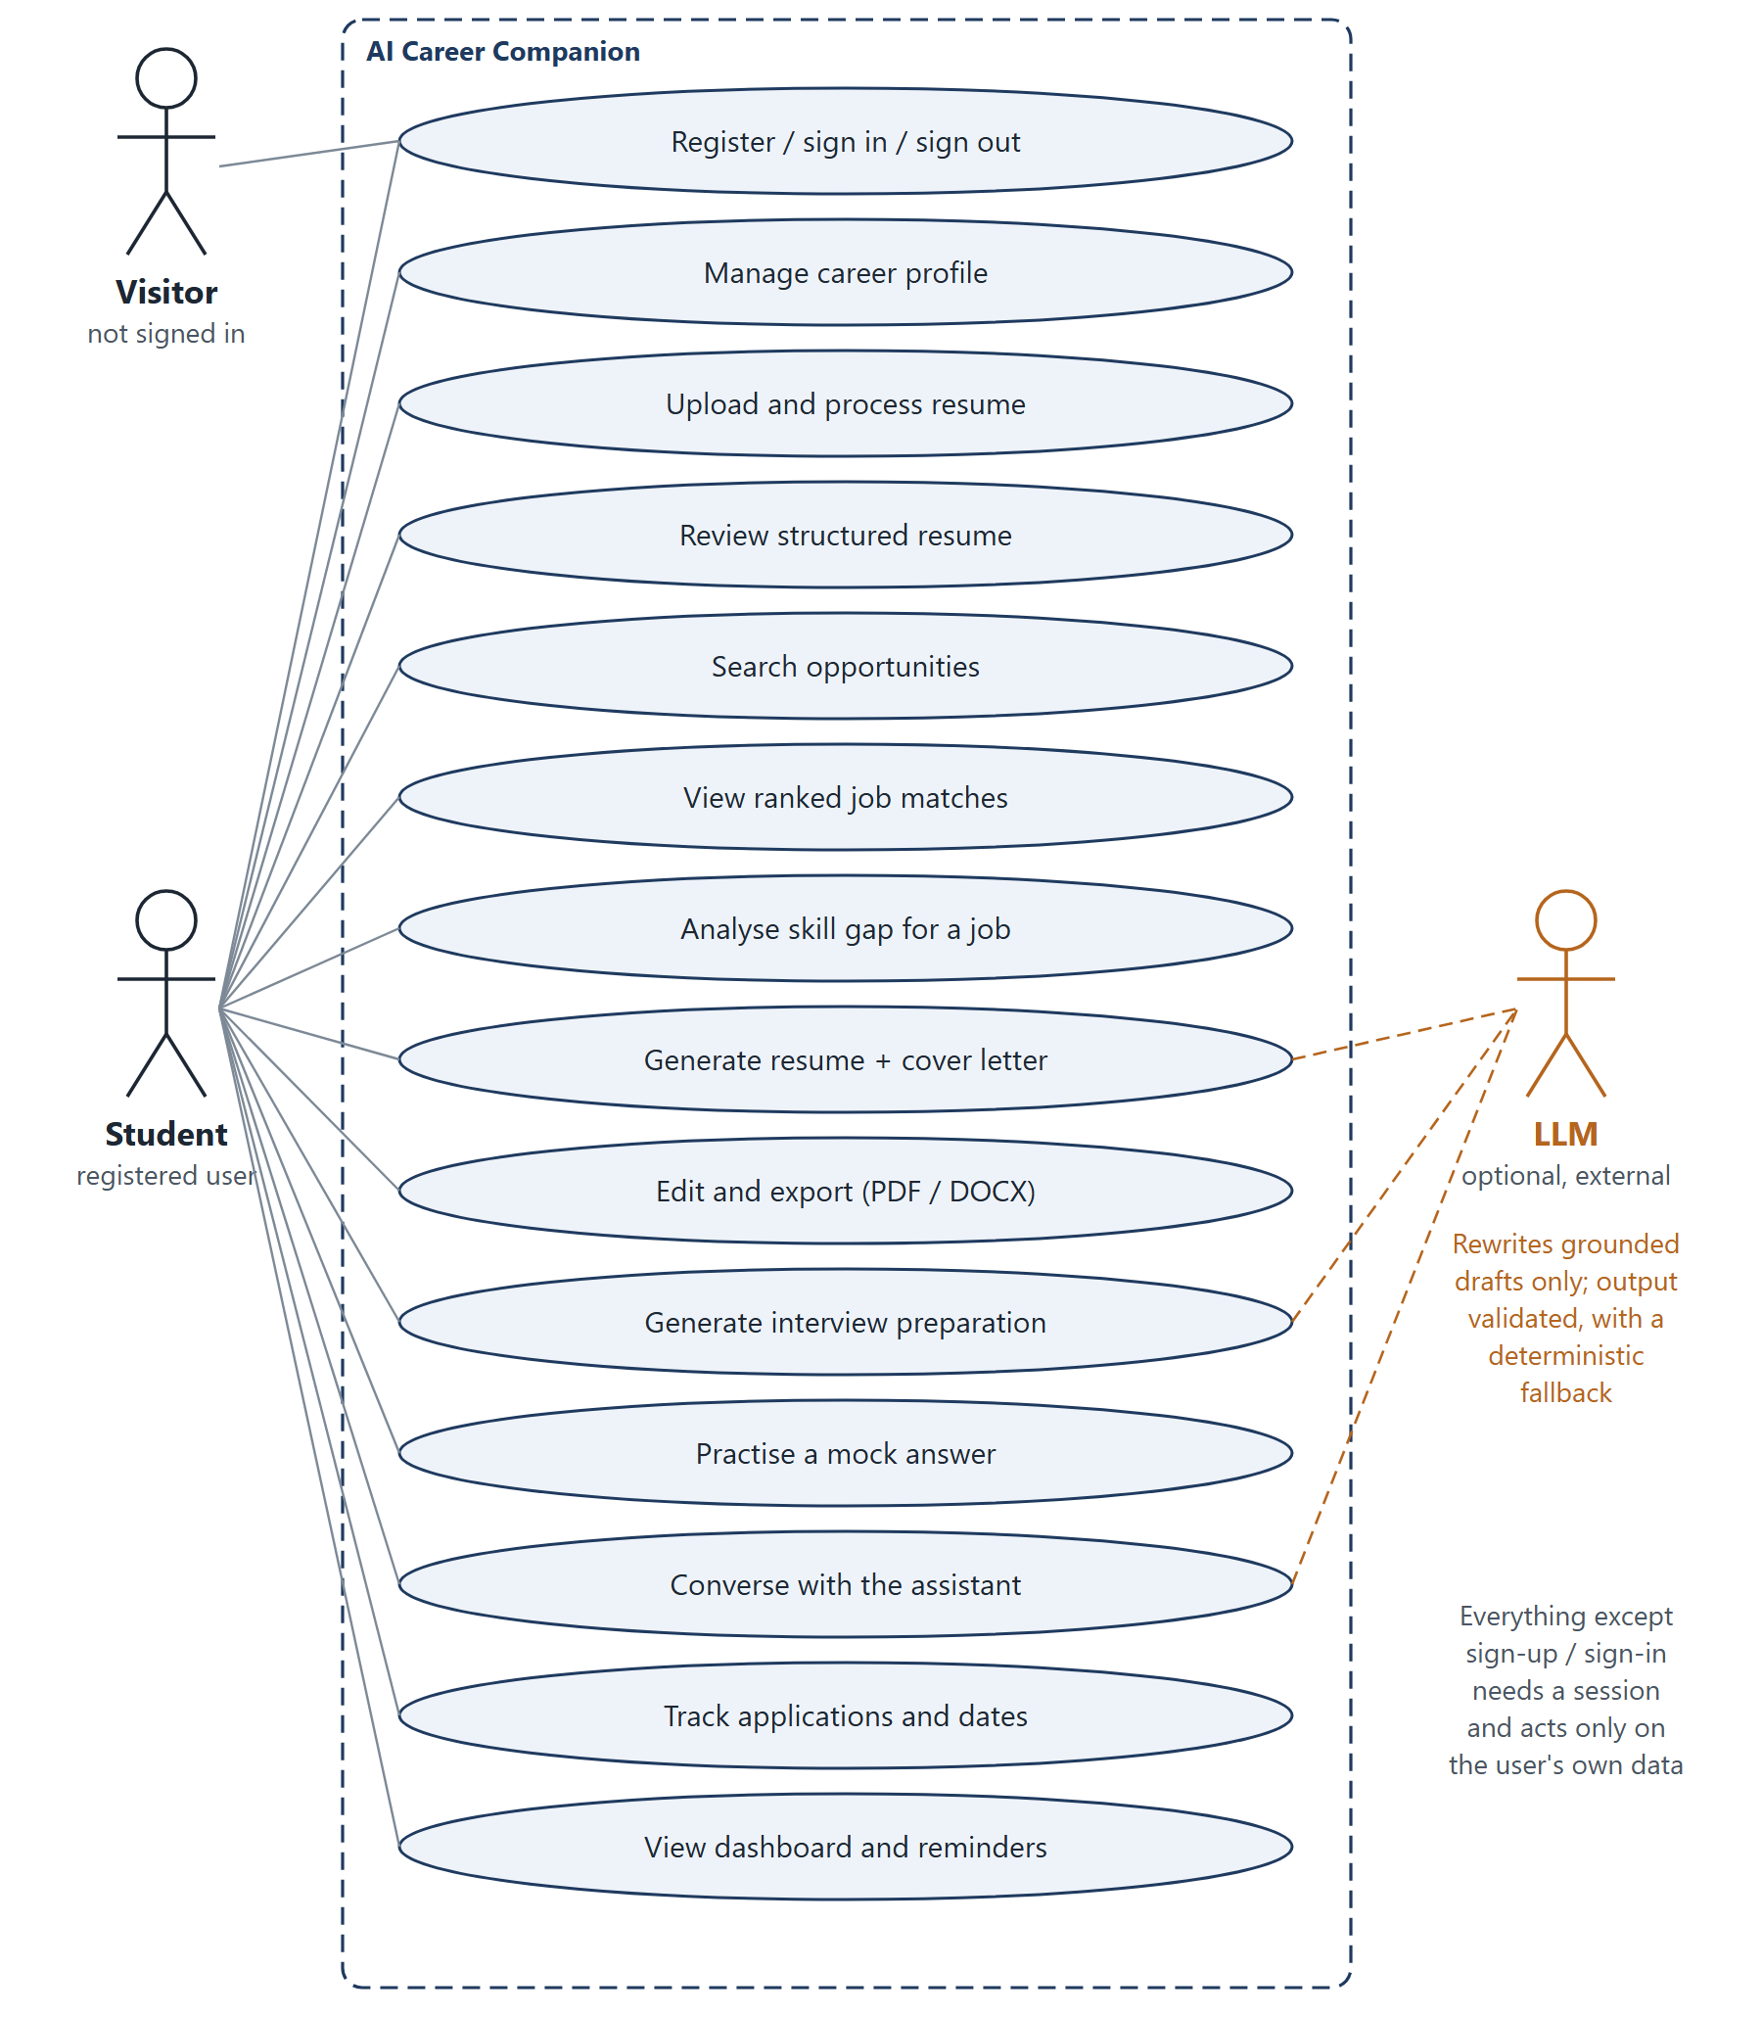
Figure 4.2: Use-case diagram
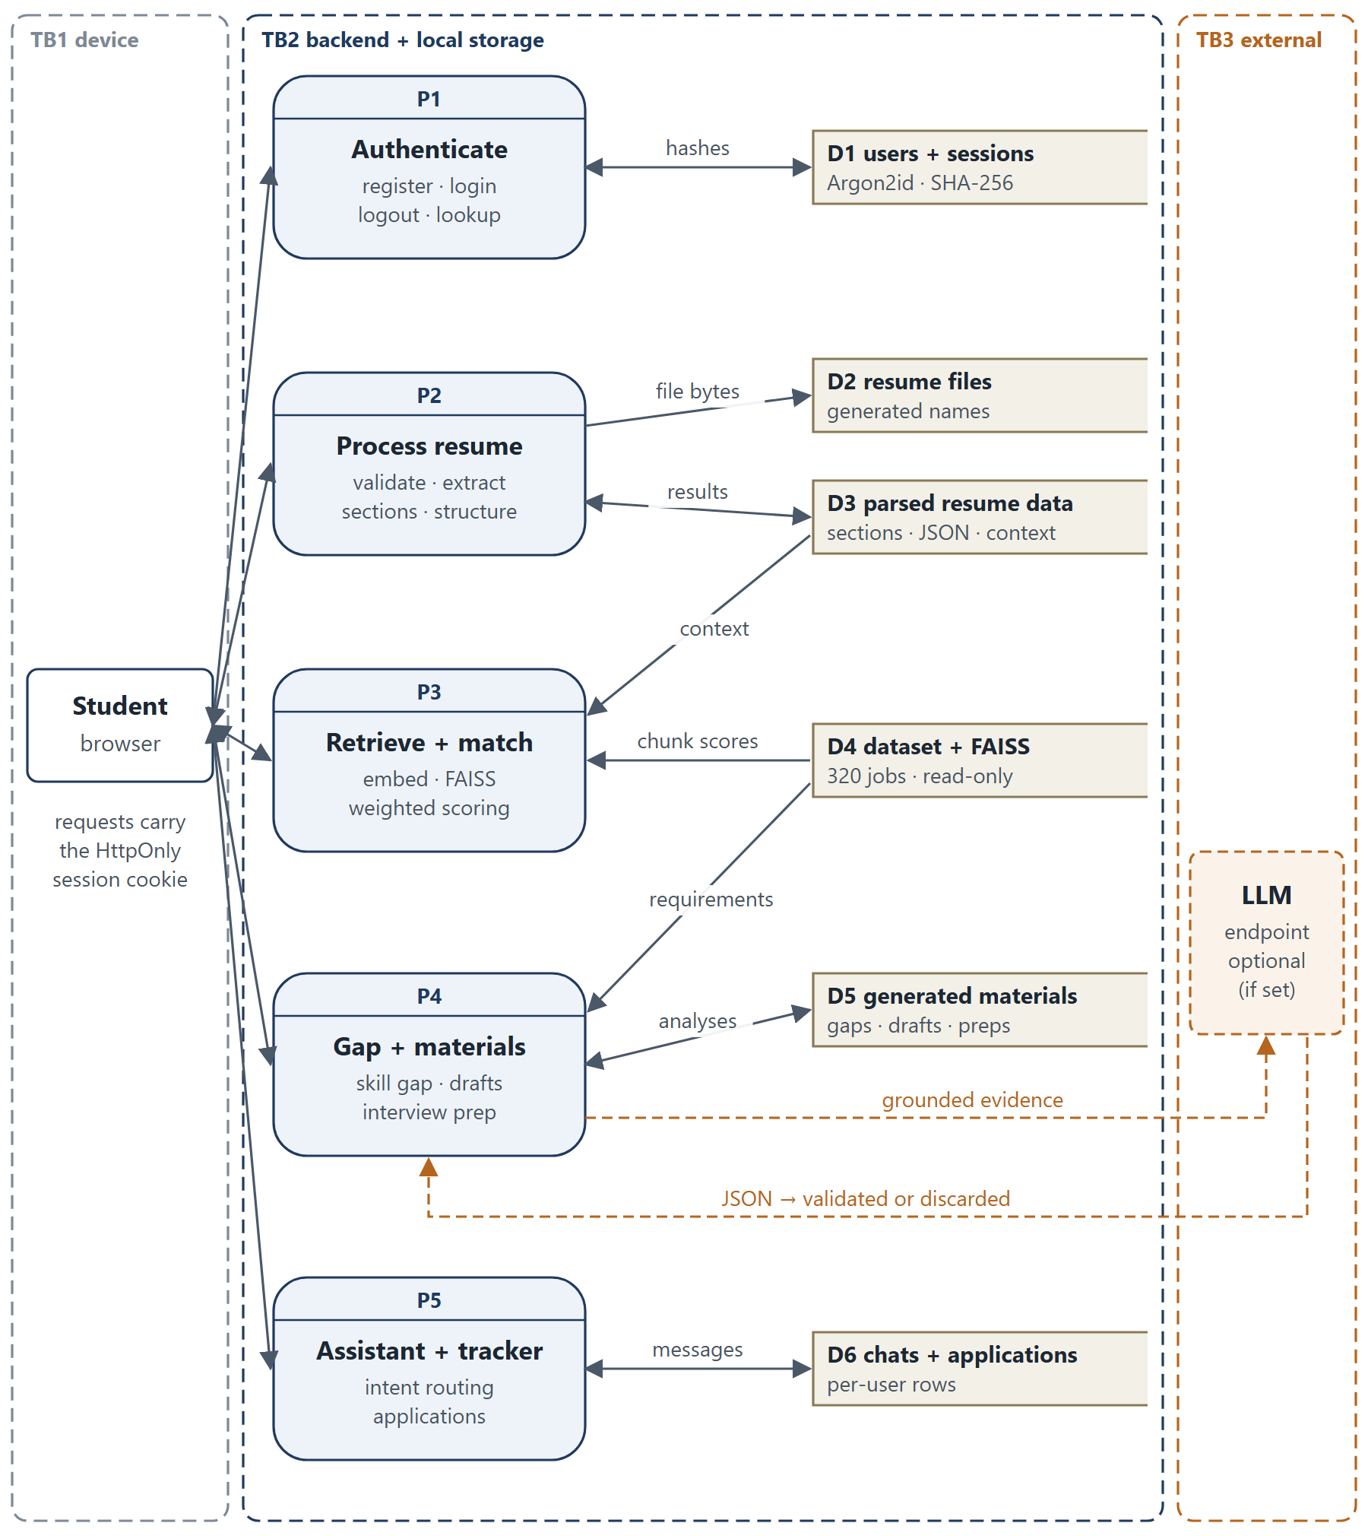
Figure 4.3: Level-1 data-flow diagram with trust boundaries

4.4 Database Design
The database is defined by SQLAlchemy 2 models in backend/app/models and created with Base.metadata.create_all. Figure 4.4, placed on its own page in landscape orientation, shows the entities and relationships. Opportunity data is not stored in the database: it is read from the validated JSON dataset and referenced by job_id. Four legacy tables (selected_jobs, learning_roadmaps, roadmap_items, progress_events) exist in the schema but are not used by any active feature.
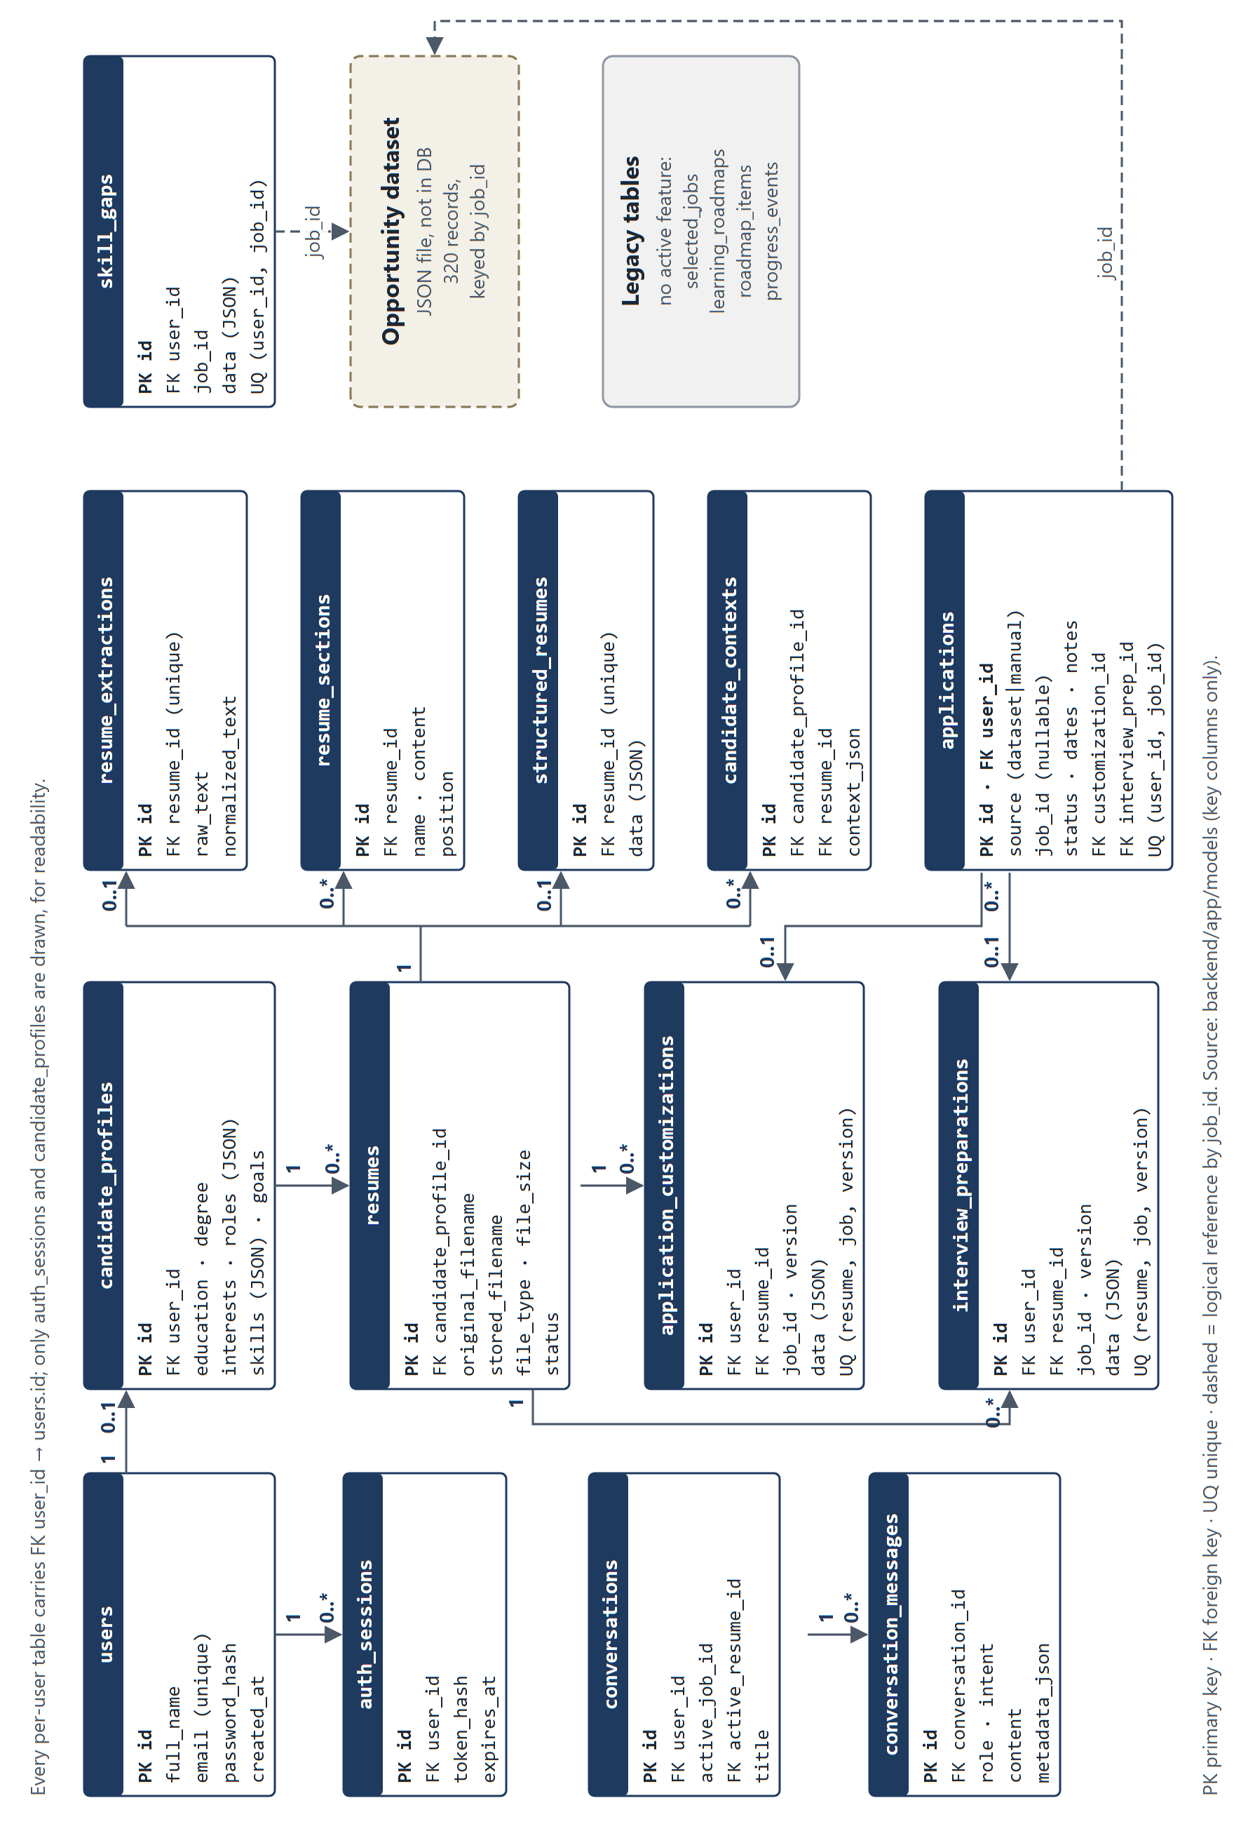
Figure 4.4: Entity-relationship diagram derived from the SQLAlchemy models
Table 4.2: Principal tables and their purpose
Table | Purpose | Notable constraints
users | Accounts | unique e-mail; Argon2id password_hash
auth_sessions | Server-side sessions | SHA-256 token_hash, expires_at
candidate_profiles | One career profile per user | created at registration
resumes | Uploaded file metadata | generated stored_filename
resume_extractions, resume_sections, structured_resumes | Pipeline results | one extraction and one structured result per resume
candidate_contexts | Profile + structured resume | linked to profile and resume
skill_gaps | Persisted analyses | unique (user_id, job_id)
application_customizations, interview_preparations | Versioned generated materials | unique (resume_id, job_id, version)
conversations, conversation_messages | Assistant history | optional active resume
applications | Tracker entries | unique (user_id, job_id); optional links to materials

4.5 Principal Workflow: Resume Upload and Analysis
Figure 4.5 shows the principal workflow. When the user clicks Process resume, the SPA calls five endpoints in sequence — upload, extract text, detect sections, structure and candidate context — and stops at the first failure. Each request is authenticated, and each resume or profile is loaded through an ownership-checking helper. The resulting candidate context feeds the job-matching request.
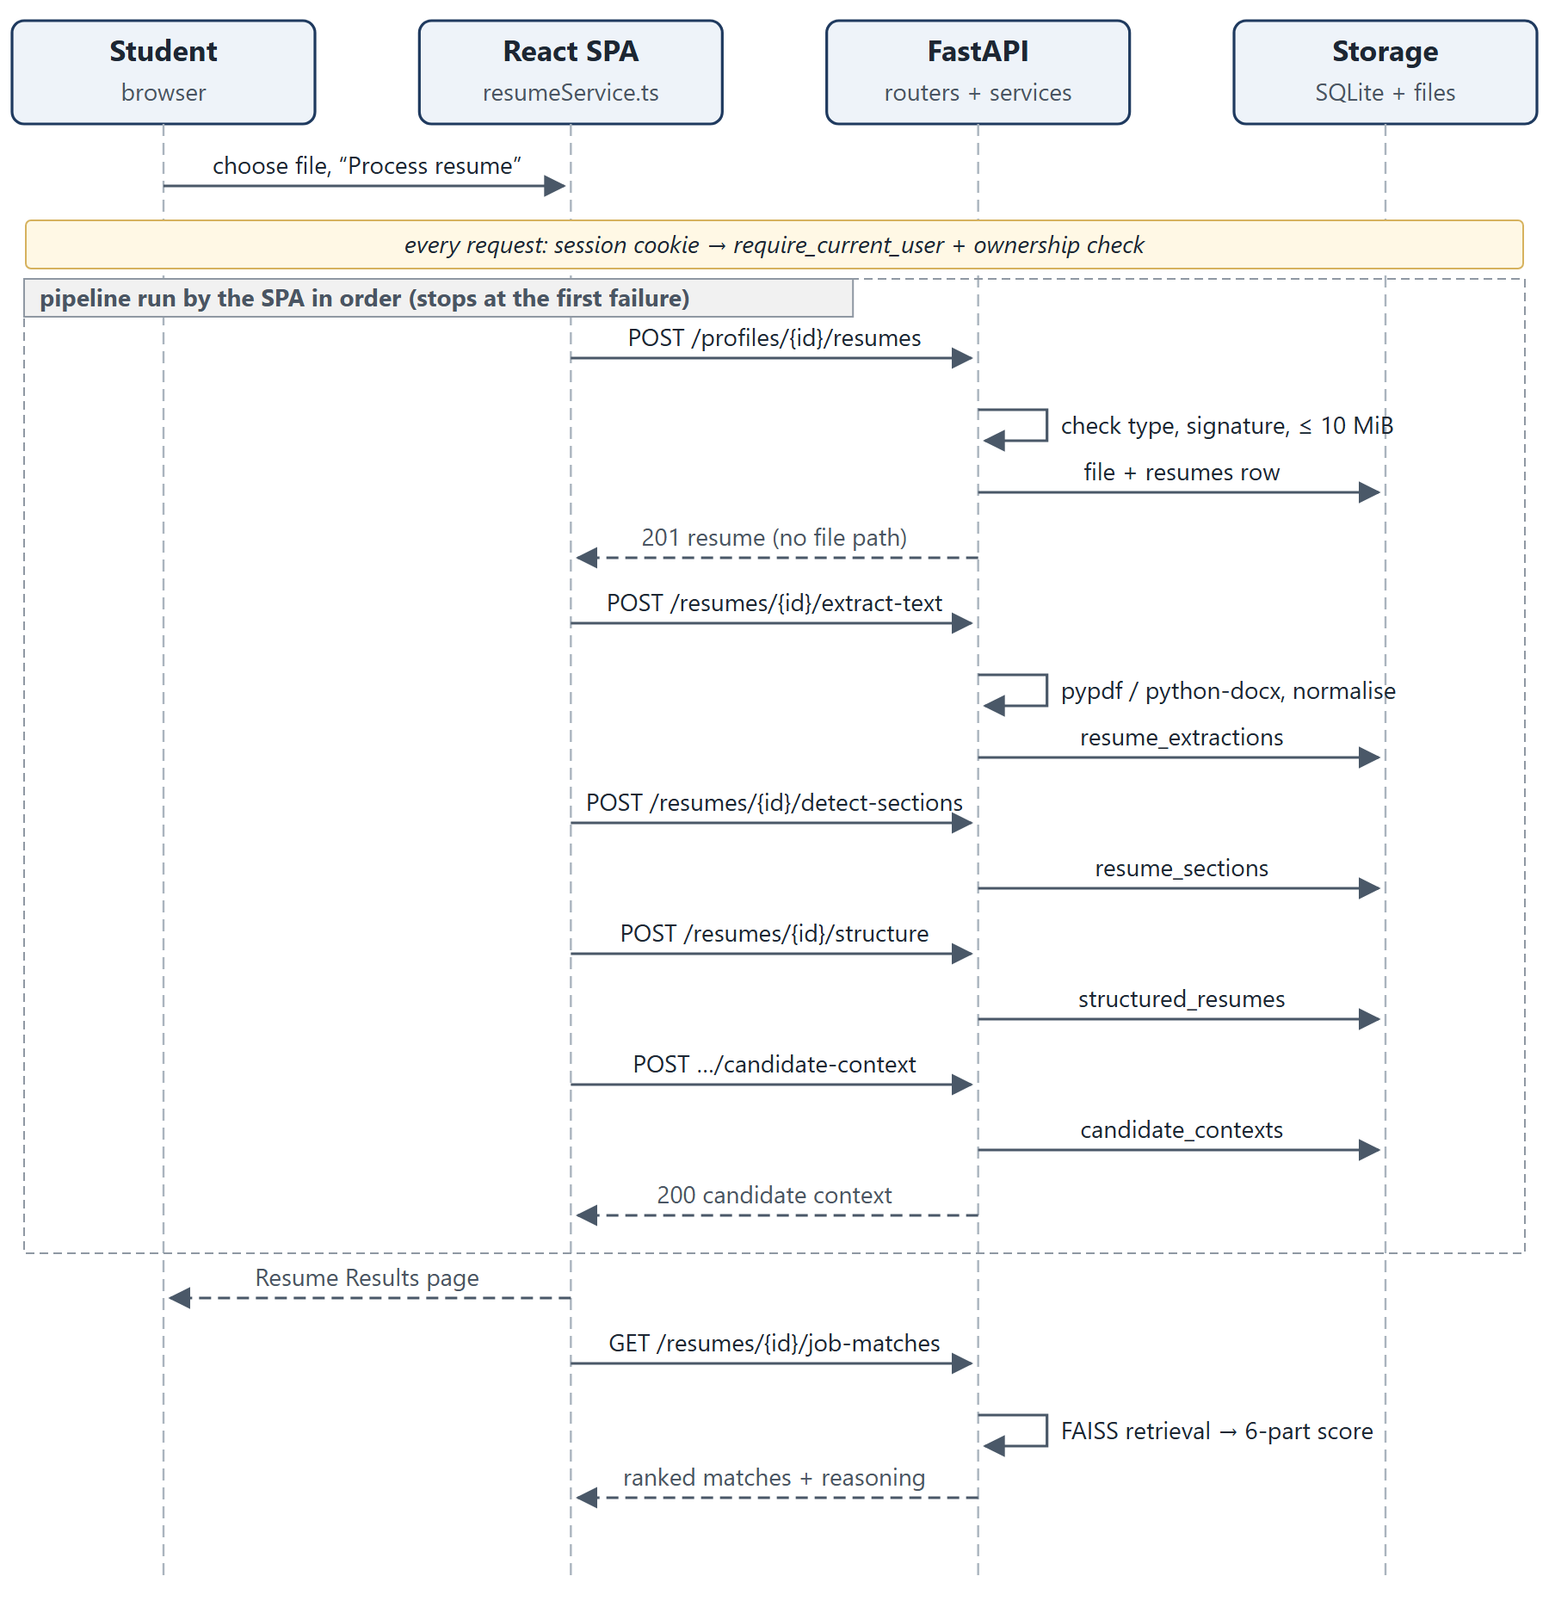
Figure 4.5: Sequence diagram of resume upload and analysis

4.6 Optional LLM Path
The LLM path is deliberately separate from the core workflow (Figure 4.6). It begins from a deterministic result that is already grounded. If LLM_PROVIDER is none (the default), that result is shown with a "Grounded Fallback" label. If it is openai_compatible, the service builds a grounded input (evidence items with identifiers, allowed claims, unsupported terms and a JSON output contract), calls the provider's /chat/completions endpoint with response_format = json_object, and validates the reply against a Pydantic schema and against evidence-ID, unsupported-keyword and fabrication checks. One repair call is allowed; any remaining failure, timeout or HTTP error falls back to the deterministic result with a recorded fallback_reason.
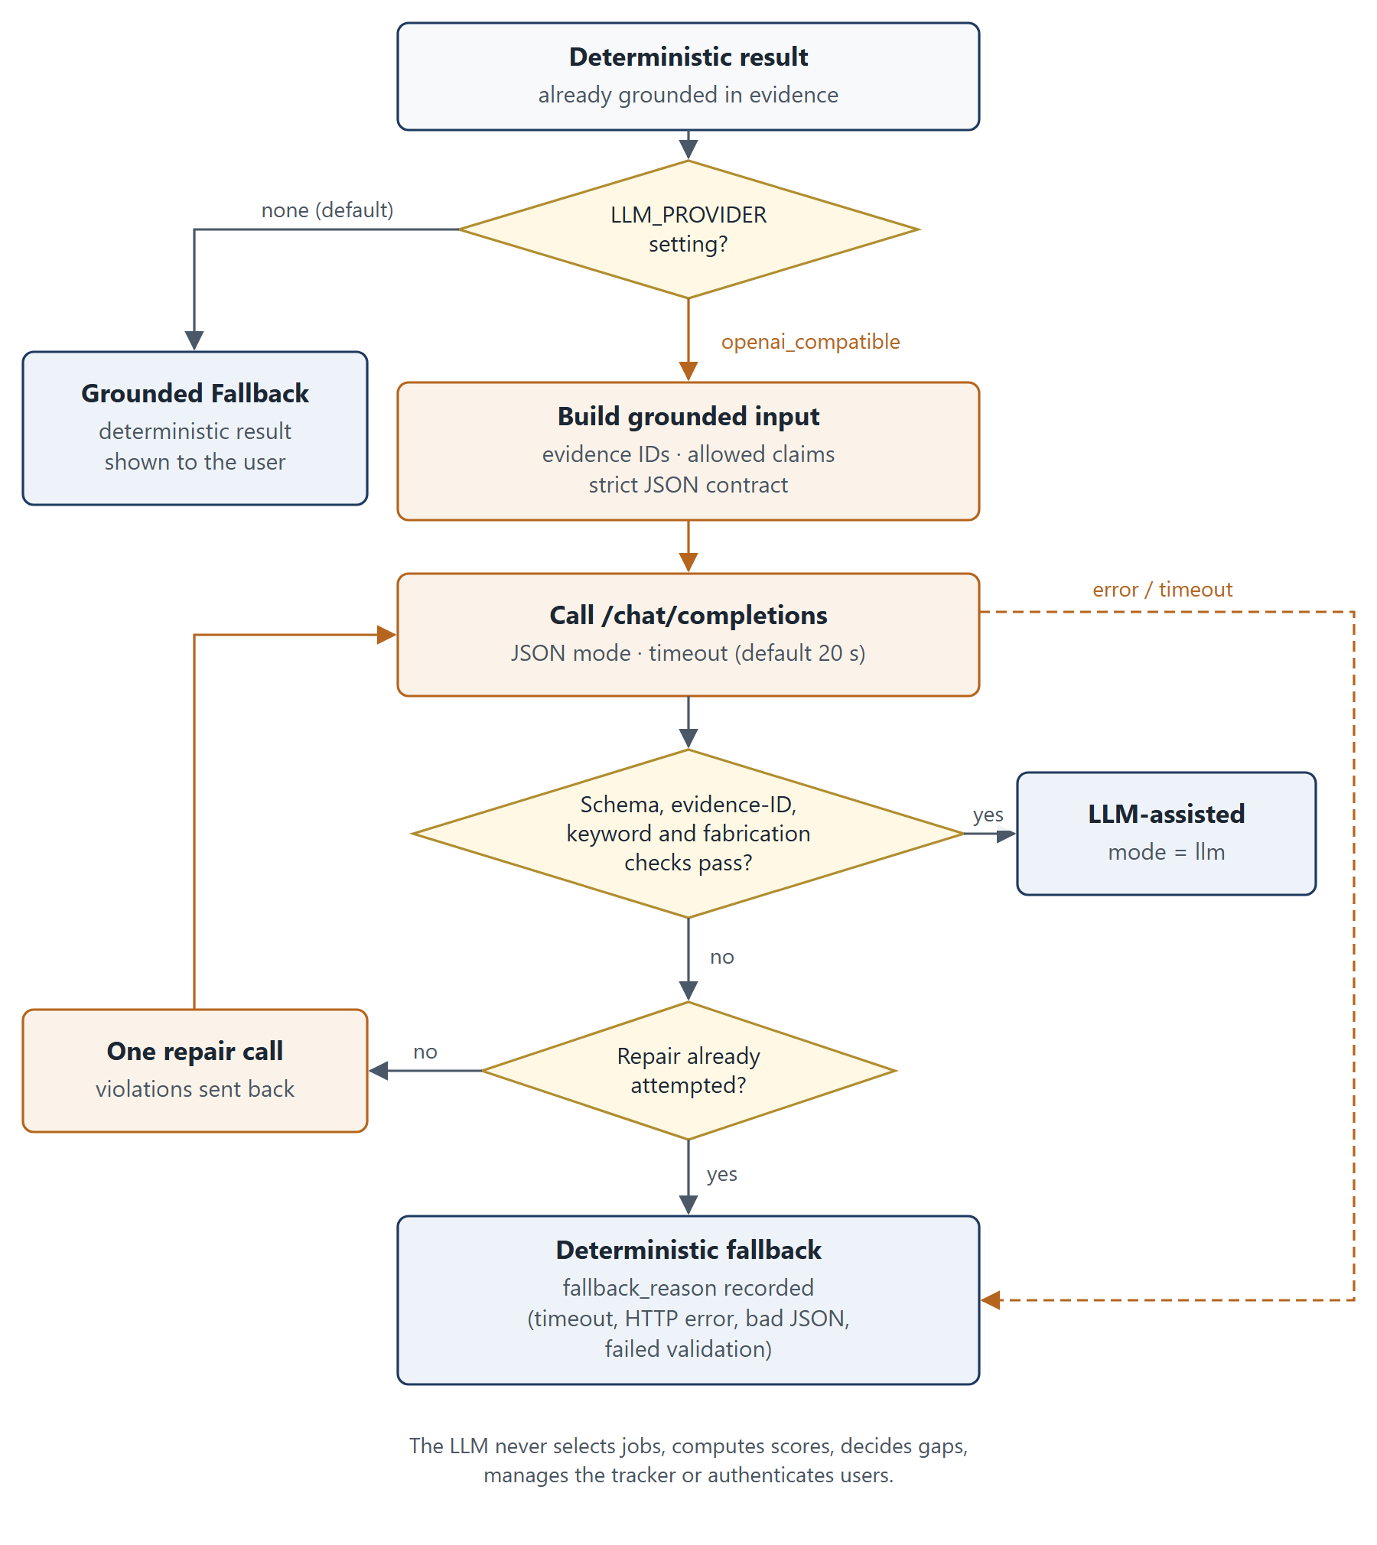
Figure 4.6: Optional LLM path with validation and deterministic fallback

4.7 Authentication and Session Flow
Figure 4.7 shows registration, login, an authenticated request and logout. Passwords are hashed with the pwdlib recommended hasher (Argon2id). At login a random token is generated with secrets.token_urlsafe(48); only its SHA-256 hash is stored, with a 14-day expiry, and the raw token is sent once as the ai_career_session cookie with HttpOnly and SameSite=Lax. The cookie is marked Secure whenever APP_ENV is not development. Every protected route depends on require_current_user, which hashes the cookie value, looks up the session and checks its expiry. On the client, any HTTP 401 dispatches a session-expired event that returns the user to the sign-in page.
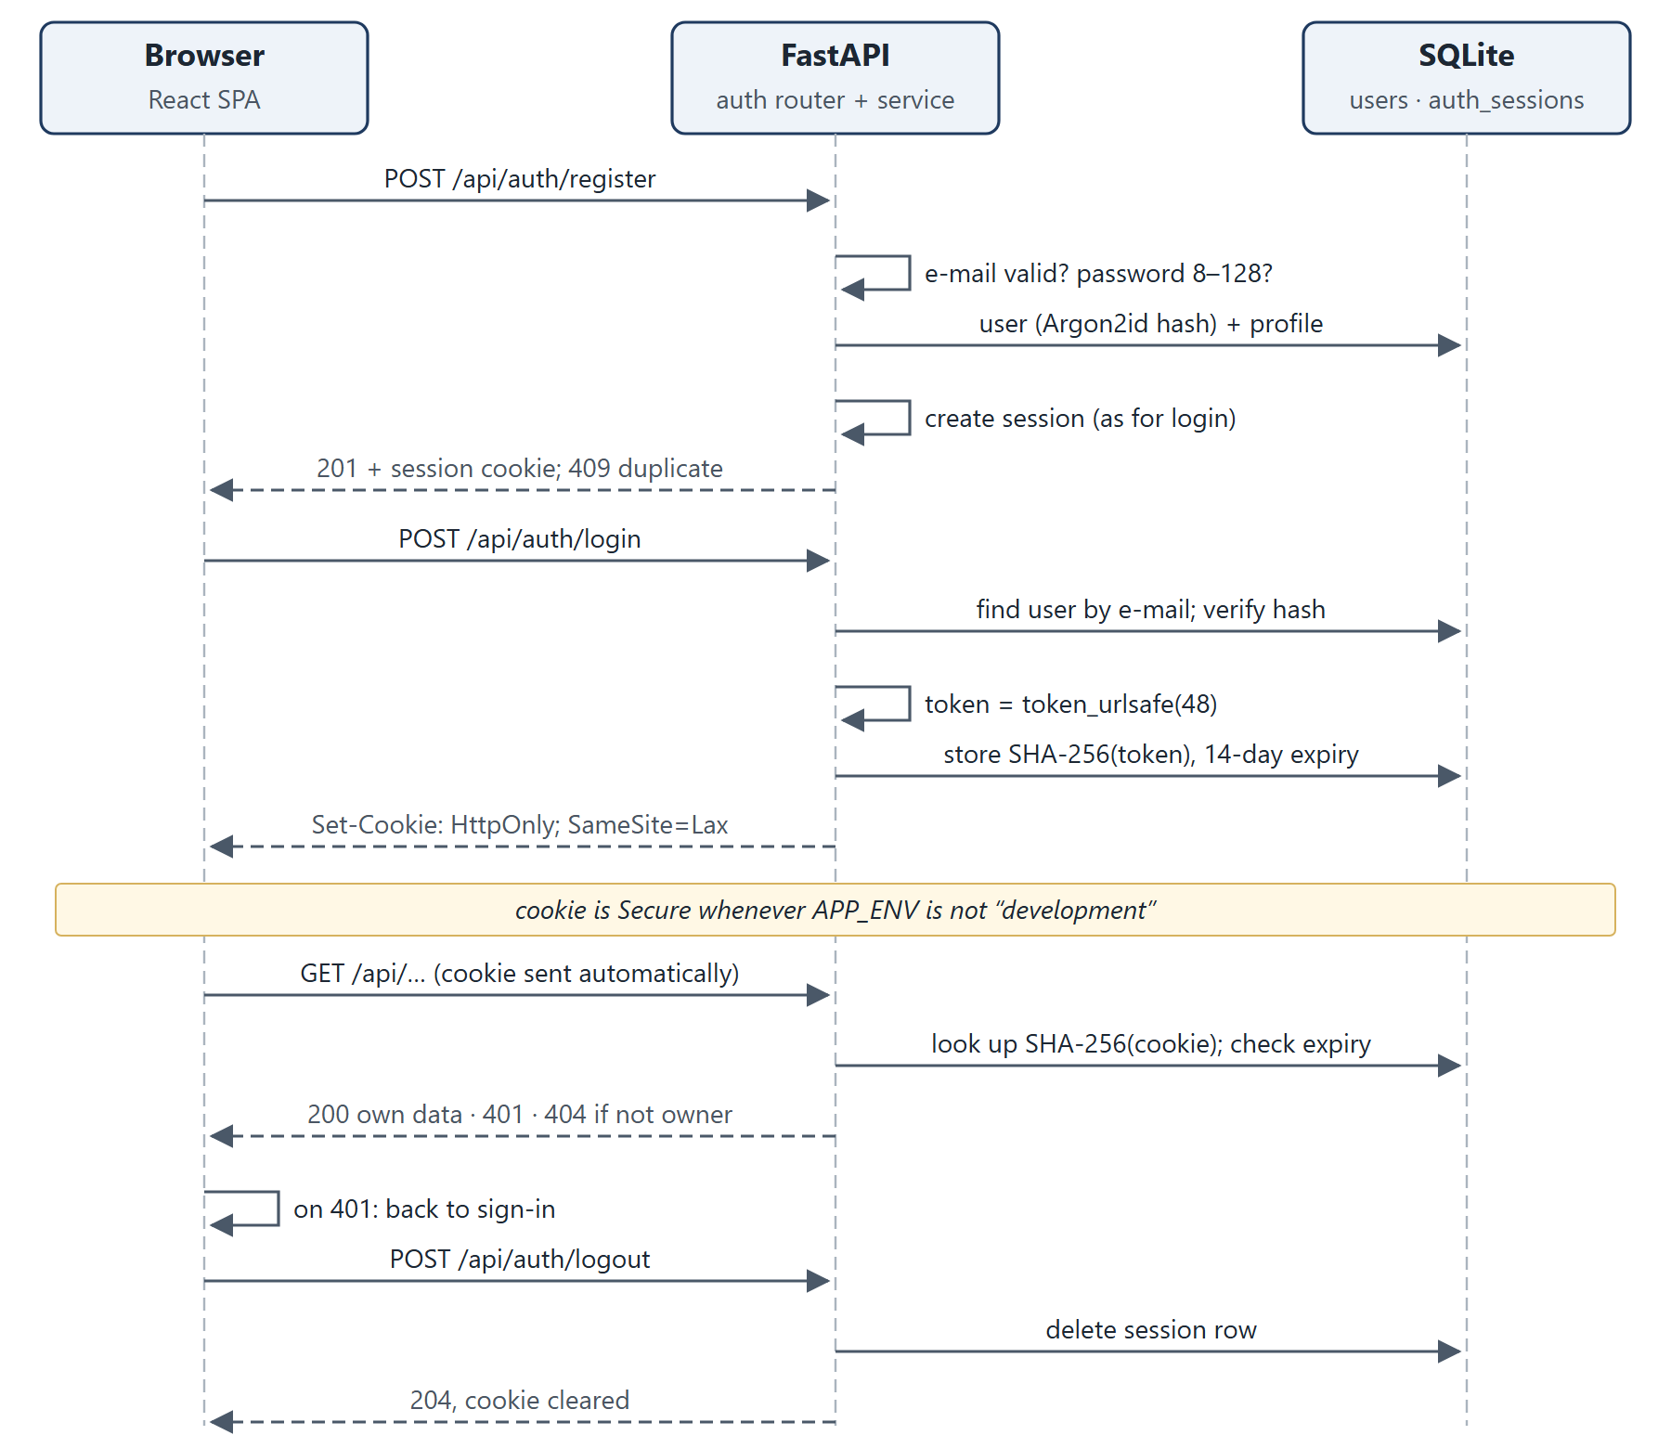
Figure 4.7: Authentication and session sequence

4.8 Key Design Decisions and Rationale
Table 4.3: Key design decisions
Decision | Rationale | Trade-off
Deterministic core, optional LLM | Reproducible, explainable, testable offline, no API cost; avoids fabricated claims | General career questions are answered only with a capability message in deterministic mode
Retrieval selects records; structured data drives reasoning | Scores and gaps are computed from canonical requirements, not from retrieved text | Quality depends on the curated schema and skill vocabulary
Exact IndexFlatIP on normalised vectors | 960 vectors are small enough for exact cosine search | Would need an approximate index at much larger scale
Three chunks per posting with title/type prefix on the overview | Accepted in experiment E8-V3: improved Hit@1 without diluting skill chunks | Requires index rebuild when the template changes
Components without evidence are excluded from the score | Avoids penalising a candidate for information that cannot be assessed | Scores from different evidence sets are not strictly comparable
Related-skill credit only for preferred skills | A hard requirement needs direct evidence | Some semantically related candidates still score low
Opaque server-side sessions, not JWT | Logout and expiry are enforced server-side; token never readable by scripts | Requires a database lookup per request
404 for foreign objects | Does not reveal whether another user's object exists | Slightly less specific error
SQLite with create_all | Zero-configuration local persistence | No migration framework (Chapter 10)

Chapter 5: Methodology and Algorithms

5.1 Resume Upload and Validation
Upload validation (resume_validation.py) checks content rather than trusting the file name. A file must have a .pdf or .docx extension, be non-empty and at most 10 MiB (MAX_RESUME_SIZE = 10 * 1024 * 1024), and its bytes must match the declared type: PDFs are opened with pypdf, and DOCX files are checked as ZIP archives containing the required XML parts. A valid file is stored under a generated name in RESUME_STORAGE_DIR; the internal path is never returned to the client. Invalid files are rejected without being persisted.

5.2 Text Extraction and Normalisation
PDF text is extracted with pypdf. Some generators (notably documents exported from Google Docs) draw every word as a separate text object, which makes the default extraction emit one word per line; when this "word-fragmented" pattern is detected, each page is rebuilt from the positions of its text runs in content-stream order. DOCX extraction reads the page header, body paragraphs, table rows and floating text boxes in document order. The text is then normalised: ligatures are expanded, invisible and zero-width characters are removed, typographic spaces are converted, and lone bullet glyphs are reattached to their lines. Image-only PDFs fail explicitly, because OCR is not implemented.

5.3 Section Detection and Structuring
Section detection is deterministic and alias-based: recognised headings include summary, skills, education, experience, internships, projects, certifications and languages. An unrecognised all-caps line becomes a custom heading only when its context reads like one — it contains no digits, does not continue a wrapped all-caps line, is not the first line under another heading, and is followed by content.
The structuring step extracts skills, education, experience, projects, certifications, languages and a summary into JSON, stamped with a parser_version (currently 4) and a list of parser_warnings. Project records that look like parsing fragments are kept in the stored data but excluded from evidence by every downstream service through one shared rule (is_reliable_project). Results produced by an older parser are served with an outdated_parser_version warning and can be reprocessed from the stored original file; stored data is never rewritten silently.

5.4 Candidate Context
The candidate context combines the saved career profile with the structured resume and is the input to every later service. Skills that appear only in the profile, and not in the resume's skills, projects or experience, are treated as self-reported: they still count for matching, but they are listed separately and are described with lower confidence in the skill-gap analysis (0.70 instead of 0.95).

5.5 Sentence Embeddings and Opportunity Representation
The embedding model is sentence-transformers/all-MiniLM-L6-v2, a compact Sentence-Transformers model [1], [3] that maps text to a 384-dimensional vector; the dimension is recorded in the index metadata (embedding_dimension: 384). Vectors are L2-normalised, so the inner product of two vectors equals their cosine similarity. The model is loaded from the local Hugging Face cache first and downloaded only on a cache miss when EMBEDDING_ALLOW_DOWNLOAD is true.
Each opportunity in the catalogue is split into three chunks — overview, requirements and responsibilities — with stable identifiers such as JOB-0001::requirements. Since index version 1.2 the overview chunk begins with the title and employment type (for example "Data Analyst Intern (Internship). "). The 320 records therefore yield 960 chunk vectors.

5.6 FAISS Indexing and Similarity Retrieval
The vectors are stored in an exact FAISS IndexFlatIP [2]. Let eq be the normalised embedding of the query q and ec the normalised embedding of chunk c. The chunk similarity is
s(q, c) = eq · ec = cos(eq, ec)
Every chunk is searched. For an opportunity j with chunks Cj, let s(1) ≥ s(2) ≥ … be its chunk similarities in descending order. The opportunity's retrieval score is
S(q, j) = s(1) + 0.05 Σk ≥ 2 s(k)
so the best-matching chunk dominates and the other chunks act as a small tie-breaker. Opportunities are sorted by S and the top k are returned (1 ≤ k ≤ 20; the default is 5 for search and 10 for matching). This aggregation is implemented in job_search_service.py:
best_score = matches[0][0]
additional_score = sum(score for score, _ in matches[1:]) * 0.05

5.6.1 Query-Confidence Flag
Similarity scores alone cannot separate off-topic queries from genuine ones: in the M4.2 baseline, an out-of-coverage query ("UI UX design") scored higher than some genuine skill-only queries. Instead, retrieval_confidence.py measures query-term coverage. Let Tq be the content words of the query after removing stop words and generic opportunity words (such as "internship" or "graduate"), and let V be the vocabulary of words found in catalogue titles, domains and required and preferred skills. Then
coverage(q) = (|{t ∈ Tq : t ∈ V}|) / (|Tq|)
with a plural-tolerant membership test and coverage(q) = 0 when Tq is empty. A query is labelled confident if coverage is at least 0.5 and unsupported_area otherwise. The label is a notice only: results are never suppressed.

5.7 Deterministic Matching and Ranking
Retrieval decides which opportunities are considered; a deterministic scorer decides their order and explanation (Figure 5.1). The retrieval query is either an explicit query (for example, a discovery request to the assistant) or the first 40 normalised candidate terms (skills, target roles, interests, education and project text). Each retrieved opportunity j is scored on six components i, each giving a score si ∈ [0, 1] or "not applicable".
Table 5.1: Matching components and weights (MATCH_WEIGHTS in job_matching.py)
Component i | Weight wi | Component score si
Required skills | 0.35 | share of required skills matched exactly or by alias
Preferred skills | 0.15 | (exact matches + 0.5 × related-skill matches) / preferred skills
Experience | 0.15 | rule-based: 1.0 when no prior experience is required or the stated duration is met; 0.6 for partial evidence; 0.0 when no evidence exists
Project relevance | 0.15 | overlap between the job's terms and the candidate's project terms
Education | 0.10 | shared education assessment: met 1.0, partial 0.5, not met 0.0; unknown → not applicable
Qualifications | 0.10 | share of the job's qualification terms found in certifications and achievements; no such evidence → not applicable

With A the set of applicable components, the match score is
M(j) = 100 × (Σi ∈ A wi si) / (Σi ∈ A wi)
rounded to one decimal place. Results are then sorted by match score (descending), retrieval score (descending) and job_id. The code is short enough to quote in full:
def _match_score(components: dict[str, ComponentResult]) -> float:
active = {name: result for name, result in components.items() if result.score is not None}
total_weight = sum(MATCH_WEIGHTS[name] for name in active)
weighted = sum(result.score * MATCH_WEIGHTS[name] for name, result in active.items() if result.score is not None)
return round(weighted / total_weight * 100, 1) if total_weight else 0.0
Related-technology credit, from a shared table in skill_relationships.py, is given only to preferred skills; a related skill remains listed as missing, with an explanation. Experiment E3 (Section 7.7) showed that granting the same credit to required skills let a candidate with one of four required skills overtake a candidate with three of four, so that variant was rejected.
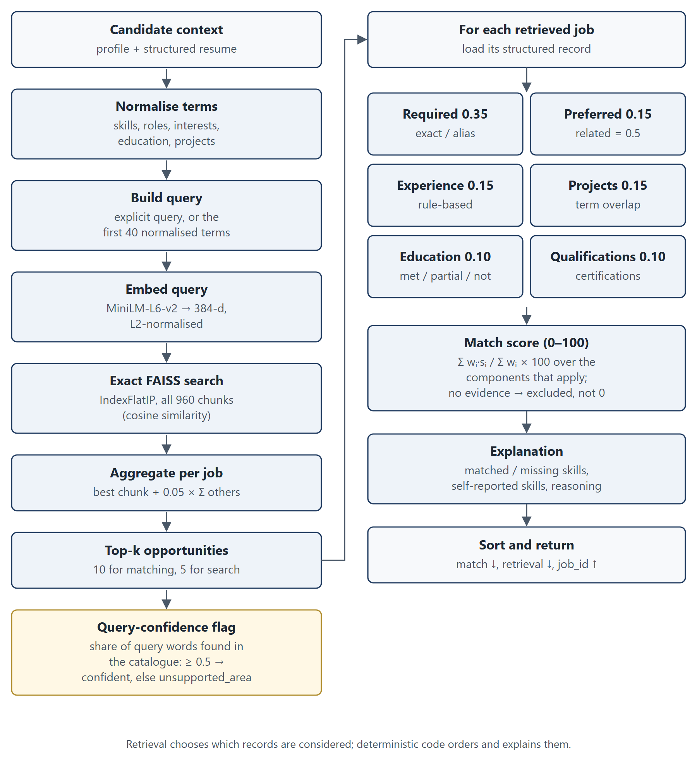
Figure 5.1: Retrieval and deterministic matching pipeline

5.8 Skill Extraction and Skill-Gap Generation
The skill-gap analysis (skill_gap_service.py, skill_gap_evidence.py) compares the candidate with one selected opportunity, requirement by requirement. The candidate's evidence is broken into evidence units (resume skills, reliable projects, experience, education, certifications and profile fields). Each required skill, preferred skill and qualification is classified as demonstrated, partial (supported by a related technology), learning only (mentioned only as something being learned) or missing, with quoted evidence, a severity and a recommendation. Learning-only mentions never count as demonstrated, and a missing preferred skill is never reported as a critical gap.
Readiness is a separate deterministic score, intentionally different from the match score. Each component k receives the mean partial credit rk of its items (demonstrated 1.0, partial 0.5, learning only 0.1, missing 0.0), and
R = round(100 × (Σk ∈ K vk rk) / (Σk ∈ K vk))
where K is the set of components with evidence and the weights vk are: required skills 0.40, preferred skills 0.15, experience 0.20, education 0.10 and qualifications 0.15. Education is assessed by the same education_assessment module as matching, so the two services cannot disagree about the same pair.
Algorithm: skill-gap analysis for resume r and opportunity j
units <- evidence units from the structured resume
(reliable projects only) and the profile
for each requirement x in required(j), preferred(j), qualifications(j):
if exact or alias evidence for x exists: demonstrated (quote it)
else if a related technology is evidenced: partial (name it)
else if x appears only as "learning": learning_only
else: missing
add severity (missing required = critical) and a recommendation
assess experience and education (shared education_assessment)
readiness <- weighted mean of component credits (components with evidence)
persist the (user, job) analysis; mark it stale if r is reprocessed

5.9 Grounding and Evidence Validation
Customization and interview preparation are first produced deterministically from evidence records that carry identifiers. Keyword alignment labels each job keyword as supported (direct evidence), partially supported (related evidence) or unsupported. The grounding validator (customization_validator.py) then checks every generated sentence (Figure 5.2) for:
- unsupported keywords — a job term that the evidence does not support (the target job title and company name are allowed);
- fabrication patterns — invented metrics (percentages, "by 3×"), leadership claims ("led a team", "team of 5") and "N years of experience";
- unsupported claims — technologies, degrees, employers, awards and quoted project names absent from the evidence.
A sentence that fails any check is removed and recorded in removed_claims with a warning. A result is reported as passed only if nothing was removed and no parser-warning notice applies. User edits are re-validated on save, and generation is refused with HTTP 409 when only unreliable project fragments remain.
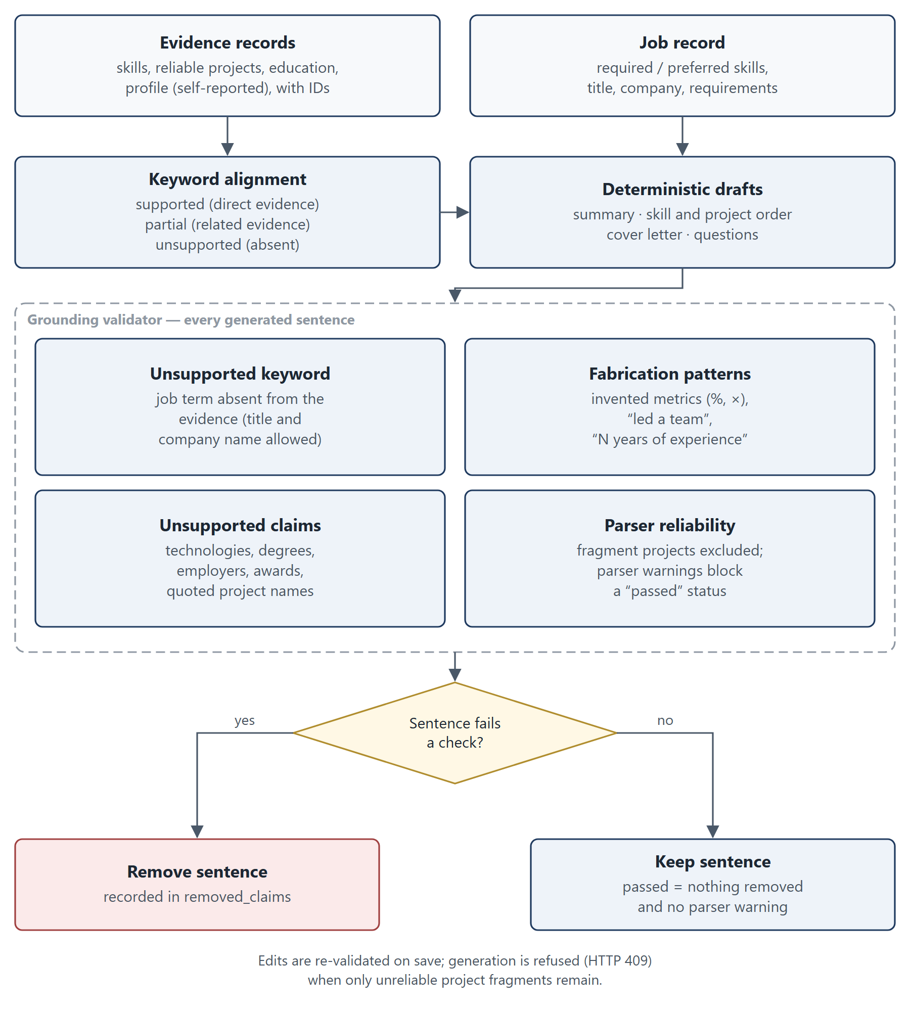
Figure 5.2: Grounding validation of generated content

5.10 Semantic Similarity, Deterministic Scoring and LLM Wording
Three different mechanisms are often conflated, so they are distinguished here:
1. Semantic similarity (embeddings and FAISS) measures how related two texts are. It is used only to choose candidate opportunities and to order search results.
2. Deterministic scoring (match score, readiness, keyword support, reminders) applies explicit rules to structured data. It produces every number the user sees.
3. Optional LLM wording rephrases text that has already been produced and grounded. It never chooses opportunities, computes scores, decides gaps, manages the tracker or authenticates users. The source code supports no stronger claim than this.

5.11 Optional LLM-Assisted Rewriting and Fallback
The LLM provider (llm_provider.py) is a small httpx client for any OpenAI-compatible /chat/completions endpoint; no vendor SDK is used. It is used by customization, interview preparation and assistant answer synthesis. The algorithm, for each generation request, is:
result <- deterministic grounded result
if provider is NullLLMProvider:
return result (fallback_reason = no_provider_configured)
try:
raw <- provider.generate_json(grounded input, JSON contract, timeout)
except timeout, HTTP error or invalid JSON:
return result (fallback_reason recorded)
violations <- schema, evidence-ID, unsupported-keyword, fabrication checks
if violations:
raw <- one repair call with the violations (failure -> fallback)
violations <- the same checks
if violations: return result (fallback_reason = validation failure)
return LLM-assisted result (generation_mode = "llm")
The provider records token usage when the endpoint reports it; nothing is estimated. The API key is read from the environment and never logged.

5.12 Conversational Assistant
The assistant classifies each message deterministically into one of eleven intents: job discovery, match explanation, skill gap, resume customization, cover letter, interview preparation, learning guidance, job comparison, profile summary, next best action and general career chat. A context resolver carries the active resume and the job in focus across turns without leaking a previous job. Handlers call the same matching, skill-gap, customization and interview services, so the assistant never computes its own scores. Discovery retrieves the requested area while scoring against the resume. General career questions (for example, salary negotiation) receive a fixed capability message in deterministic mode — limitation CV06.

5.13 Data Persistence and Retrieval
All persistent state is stored through SQLAlchemy sessions in SQLite. Pipeline results are upserted per resume; generated materials are versioned per (resume, job), with version allocation retried on a concurrent conflict; skill-gap analyses are unique per (user, job) and are flagged stale when the resume is reprocessed. The opportunity dataset and the vector store are cached in-process, keyed by file path, modification time and size (plus the model name for the index), and are re-validated when a file changes. No user data is cached.

5.14 Error Handling and Validation
Request bodies and query parameters are validated by Pydantic; for example, top_k must lie between 1 and 20 and passwords must have 8–128 characters. Domain errors map to explicit HTTP codes (400 for invalid files, 404 for missing or foreign objects, 409 for duplicates and insufficient evidence, 422 for schema violations). Unexpected exceptions are logged and returned as a generic JSON 500 inside the CORS layer, so the browser can read the error instead of reporting a network failure. On the client, apiDetailMessage turns FastAPI 422 lists into readable text and replaces 5xx details with a generic message.

Chapter 6: Implementation

6.1 Frontend Architecture and Major Screens
The frontend is a React 19 + TypeScript single-page application built with Vite 6 and styled with plain CSS. There is no router library: src/App.tsx maps URLs to views and drives the browser History API. Feature services in src/services/*.ts call the backend through apiFetch in src/config/api.ts, a credentialed fetch wrapper that dispatches a session-expired event on HTTP 401. Figure 6.1 shows the screen map.
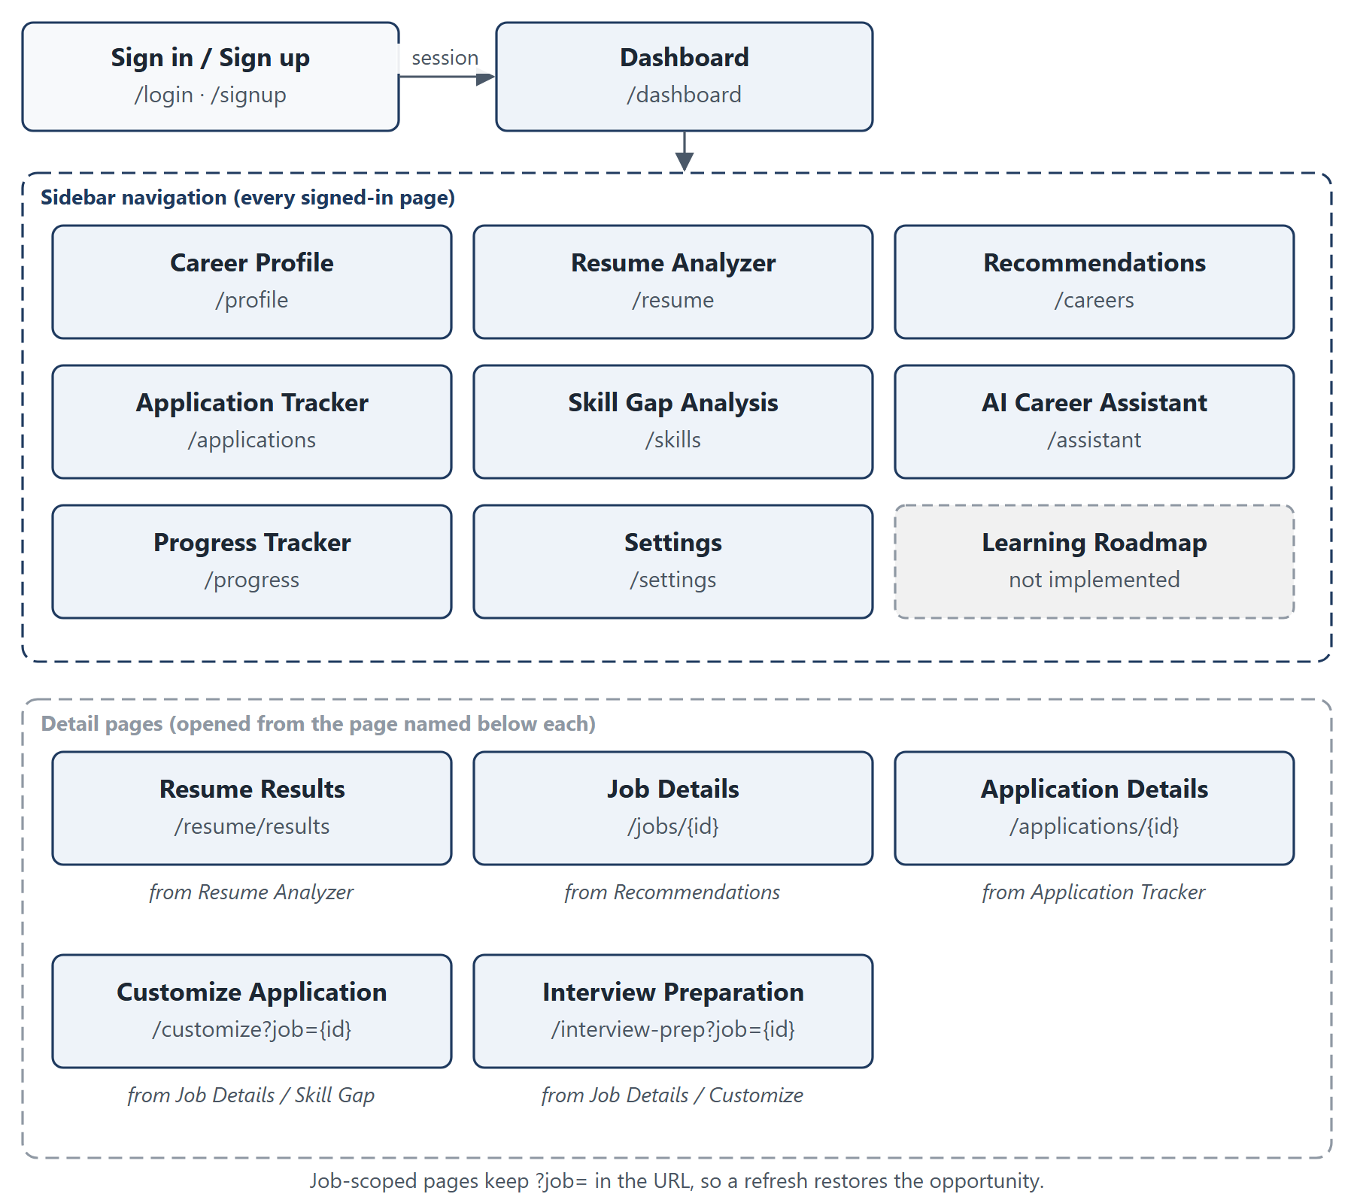
Figure 6.1: Screen and navigation map of the frontend
Table 6.1: Major screens
Screen | Purpose
Dashboard | Next best action, resume status, extracted skills, matches and application activity — all from real data
Career Profile | Edit education, degree, interests, target roles, skills and goals
Resume Analyzer / Results | Upload, process and review the structured resume; reprocess outdated results
Career Recommendations | Ranked matches for the resume and free-text opportunity search with the confidence notice
Job Details | Full opportunity record, "Check my match", links to gap analysis, customization, interview prep and the tracker
Skill Gap Analysis | Readiness, critical, partial and preferred gaps with quoted evidence
Customize Application | Keyword alignment, tailored summary, ordered skills and projects, cover letter, export
Interview Preparation | Categorised questions, revision topics, mock-answer practice
AI Career Assistant | Persisted conversations with intent-routed answers
Application Tracker / Details | Summary cards, filters, upcoming actions, status, dates, notes, linked materials
Progress Tracker | Profile and resume completion from saved fields
Learning Roadmap | States that roadmap generation is not available (not implemented)

UI screenshots are not included in this report because none were captured from the canonical baseline; Figure 6.1 is a structural diagram, not a screenshot.

6.2 Backend Structure and API Design
The backend (backend/app) is organised into api (11 routers), schemas (Pydantic request and response models), services (business logic), models (SQLAlchemy entities) and core (settings and database). Settings are read from backend/.env through pydantic-settings, with process environment variables taking precedence. The API exposes 47 operations (Appendix A), documented interactively at /docs with the schema at /openapi.json. The API is resource-oriented: resume-derived resources are nested under /api/resumes/{resume_id}, and tracker resources live under /api/applications.

6.3 Authentication and Session Handling
Registration (POST /api/auth/register) validates the name, e-mail (Pydantic EmailStr) and password (8–128 characters, confirmed), case-folds the e-mail, rejects duplicates, hashes the password with Argon2id and creates an empty career profile in the same transaction. Login creates a server-side session as described in Section 4.7; the relevant code is:
raw_token = secrets.token_urlsafe(48)
session = AuthSession(user_id=user.id, token_hash=_token_hash(raw_token),
expires_at=datetime.now(timezone.utc) + timedelta(days=SESSION_DAYS))
...
response.set_cookie(SESSION_COOKIE, raw_token, httponly=True, samesite="lax",
secure=session_cookie_secure(), max_age=SESSION_DAYS * 86400)
Logout deletes the session row and clears the cookie. Ownership helpers (get_owned_profile, get_owned_resume and service-level filters) ensure that every query is restricted to the current user.

6.4 Resume Upload and Analysis
The Resume Analyzer accepts a file through the browser's file input and mirrors the backend limits for faster feedback; the backend remains authoritative. Processing runs the five pipeline calls in order with a visible stage indicator. The Results page shows extracted skills, education (with parsed degree and graduation badges), experience or "No experience extracted", structured project entries with a "Not used as evidence" badge for unreliable fragments, languages and parser warnings, and offers Reprocess with current parser for results from an older parser version. Limitations: no OCR; experience is one entry per section rather than per role; the position-based PDF rebuild is heuristic and was verified on the observed Google Docs layout and on synthetic fixtures only.

6.5 Career and Opportunity Recommendations
GET /api/resumes/{resume_id}/job-matches returns up to 20 (default 10) ranked matches, each with the match score, component scores, matched and missing required and preferred skills, related-skill explanations, self-reported skills and a reasoning string that names the supporting project by title. The Careers page also offers free-text search through the public GET /api/jobs/search endpoint and shows a notice when a query is labelled unsupported_area. Limitations: recommendations come only from the curated 320-record catalogue in 15 technology domains; within a domain, postings share the same skill lists, which limits how finely the ranking can separate them.

6.6 Skill-Gap Analysis
POST /api/resumes/{resume_id}/skill-gap analyses one opportunity and persists the result; GET …/skill-gap/{job_id} reloads it and reports whether it is stale. The page shows overall readiness, required and preferred counts, critical and partial gaps with quoted evidence, and recommendations. Limitation: recommendations are rule-based text; there is no learning-resource catalogue.

6.7 Resume Customization and Cover Letter
POST /api/resumes/{resume_id}/application-customizations produces a versioned result containing keyword alignment, a tailored professional summary, reordered skills, ranked projects with tailored skill lists and a cover letter, each item listing its evidence IDs. Results can be edited (edits are re-validated), regenerated and exported as PDF (reportlab) or DOCX (python-docx) via GET …/{customization_id}/export?format=pdf|docx, and linked to a tracker entry. The UI labels each result "Grounded Fallback" or LLM-assisted and shows whether the grounding check passed. Limitation: deterministic wording is template-based and therefore less varied than human writing.

6.8 Interview Preparation
POST /api/resumes/{resume_id}/interview-preparations generates questions in six categories — technical, resume, project, role, HR and skill-gap — with easy, medium and hard difficulty levels and prioritised revision topics, each question carrying its source. POST …/{prep_id}/mock-answer returns structured feedback on a practice answer (strengths, improvements, missing points and a suggested structure). The optional LLM layer follows the same contract as customization. Limitation: mock-answer feedback is rule-based in deterministic mode and is not a substitute for human assessment.

6.9 Application Tracking and Persistence
The tracker (application_service.py, /api/applications) supports two sources: an opportunity tracked from Careers (source = dataset), whose company, title, type, location, work mode and description are copied server-side from the catalogue, and a manual entry (source = manual). Ten statuses are supported: saved, planning, applied, under_review, shortlisted, interview_scheduled, interview_completed, offer, rejected and withdrawn. Users enter the application date, deadline, follow-up date, interview date-time (stored in UTC) and interview status, together with notes. A dataset opportunity can be tracked once per user (a second attempt returns 409), while manual entries are unlimited. Customizations and interview preparations can be linked only if they belong to the same user and job.
The summary endpoint returns total, active, completed, upcoming-deadline, scheduled-interview, offer and rejected counts. The reminders endpoint (?days=1–60, default 7) applies four date rules: deadlines within the window for pre-application items, interviews within the window, due or overdue follow-ups, and applied or under-review items unchanged for 14 days. Limitation: deadlines are never inferred, because the catalogue contains none; reminders are shown in the application only (no e-mail or push notifications).

6.10 Career Assistant and Opportunity Discovery
/api/career-assistant/conversations stores conversations and messages per user. Each message is classified, its context resolved and the matching handler invoked; responses can carry suggested actions that navigate to the relevant page. Discovery requests such as "Find internships in cybersecurity" strip the discovery wording, retrieve opportunities for the remaining area words and score them against the resume. Limitations: intent classification uses deterministic rules, so unusual phrasing may be routed to general chat; general career questions are limited in deterministic mode (CV06).

6.11 Database Models and Relationships
The models and relationships are shown in Figure 4.4 and Table 4.2. Tables are created at startup with create_all; a small helper in backend/app/core/database.py adds columns that older local SQLite files lack. Relative SQLite and resume-store paths are resolved against the backend directory, so launching the server from a different working directory cannot silently create a second database.

6.12 Configuration and Optional LLM Integration
Table 6.2: Principal configuration settings (backend/app/core/config.py)
Setting | Default | Effect
APP_ENV | development | Enables the localhost CORS rule and a non-Secure cookie in development
FRONTEND_URL | http://localhost:5173 | Exact allowed CORS origin
SESSION_COOKIE_SECURE | automatic | Overrides the Secure-cookie default
DATABASE_URL | SQLite file under backend/data | Database location
RESUME_STORAGE_DIR | ./data/resumes | Private resume store
EMBEDDING_MODEL_NAME | sentence-transformers/all-MiniLM-L6-v2 | Embedding model
EMBEDDING_ALLOW_DOWNLOAD | true | Allow a one-time model download on a cache miss
LLM_PROVIDER | none | none or openai_compatible
LLM_MODEL, LLM_BASE_URL, LLM_API_KEY | unset | Provider details (key read from the environment only)
LLM_TIMEOUT_SECONDS | 20 | Per-call timeout

The frontend reads VITE_API_BASE_URL at build time (default http://localhost:8000).

6.13 Error Handling, Validation and Security-Related Choices
Uploads are validated by signature and structure; malformed or oversized files return 400 without persistence. Customization and interview generation return 409 when the evidence is insufficient. Concurrent generation requests that collide on a version number are retried rather than failing with a 500. The frontend uses fetchWithTimeout for long generation requests and tells the user honestly that aborting does not cancel server work. No browser storage holds account data. Security mechanisms are described in Chapter 9.

Chapter 7: Testing and Evaluation

7.1 Testing Methodology
Testing combined four layers: (i) unit and service tests for each backend module; (ii) API tests through FastAPI's TestClient, including authentication and cross-user isolation; (iii) evaluation-backed tests that encode the M4.2 baseline as invariants, regression floors and strict expected failures (xfail); and (iv) an offline evaluation framework that measures retrieval, matching, consistency, grounding, service hand-off and conversation behaviour. The frontend was checked with strict TypeScript type checking, ESLint, a production build and a manual browser walkthrough.

7.2 Test Environment and Configuration
Tests run against per-test temporary SQLite databases and resume folders. A suite-wide guard replaces every LLM-provider binding with NullLLMProvider, so a real key in backend/.env can never be used; LLM behaviour is tested with explicit fake providers. The evaluation framework forces LLM_PROVIDER=none, sets HF_HUB_OFFLINE=1 and uses an in-memory database. The M4.4 verification was performed on 2026-10-05 on Windows 11 with Python 3.12.3; the re-runs reported in this chapter were performed on 2026-10-16 on the same development setup.

7.3 Unit, Integration, API and Regression Tests
Table 7.1: Backend test coverage by area (backend/tests)
Area | Representative test modules
Authentication and sessions | test_auth_api.py, test_auth_persistence.py, test_session_cookie.py, test_cors.py
Resume pipeline | test_resume_api.py, test_pdf_extraction.py, test_docx_extraction.py, test_section_detection.py, test_structured_resume_parser.py, test_resume_parser_robustness.py, test_resume_parser_real_world.py
Retrieval | test_job_dataset_service.py, test_job_chunking.py, test_job_vector_store.py, test_job_search_service.py, test_job_retrieval_integration.py, test_jobs_api.py
Matching | test_job_matching.py, test_job_matching_api.py, test_job_matching_integration.py
Skill gap | test_skill_gap_service.py, test_skill_gap_evidence.py, test_skill_gap_api.py
Customization and LLM layer | test_customization_service.py, test_customization_validator.py, test_customization_llm.py, test_customization_quality.py, test_customization_api.py
Interview preparation | test_interview_prep_service.py, test_interview_prep_api.py
Assistant | test_assistant_intent.py, test_assistant_service.py, test_assistant_api.py
Tracker | test_application_service.py, test_applications_api.py
Evaluation and regression | test_m4_2_evaluation_framework.py, test_m4_2_baseline.py, test_m4_2_e2e_workflow.py, test_m4_3_optimizations.py, test_resume4_regressions.py, test_video_audit_regressions.py

7.4 Representative Test Cases
Table 7.2 lists representative test cases and Table 7.3 names the automated test behind each one; "Actual" records the outcome of the 2026-10-16 suite run, in which every listed test passed.
Table 7.2: Representative test cases
ID | Precondition | Steps | Expected | Actual
TC-01 | Empty database | Register a user | One user and exactly one linked profile | Pass
TC-02 | Logged-in user | Log out, call /api/auth/me | Session removed; 401 | Pass
TC-03 | User with profile | Upload mismatched, corrupt and oversized files | 400 for each; nothing persisted | Pass
TC-04 | Two users | User B accesses user A's profile and resume | 404 | Pass
TC-05 | Index loaded | Search a query | Unique jobs, chunk scores aggregated | Pass
TC-06 | Structured resume | Request matches | Ordered by match score | Pass
TC-07 | Resume, job | Analyse gap | Missing preferred skill not critical | Pass
TC-08 | Resume, job | Analyse twice | Identical readiness | Pass
TC-09 | Evidence corpus | Validate a sentence with an invented metric | Sentence removed | Pass
TC-10 | Fake provider that times out | Generate | Deterministic fallback, no repair | Pass
TC-11 | Fake provider returning bad JSON | Generate | One repair, then fallback | Pass
TC-12 | Tracked job | Track it again; add manual lookalike | 409; manual allowed | Pass
TC-13 | Catalogue job | Track it | No deadline set | Pass
TC-14 | Empty database | Register → … → tracker → logout/login; second user probes | Every step succeeds; second user gets 404 | Pass
TC-15 | Development settings | Preflight from an unknown origin | Rejected | Pass
TC-16 | Deterministic mode | Ask a general career question | Recorded known failure | Expected failure (xfail)

Each test case is implemented by the automated test listed in Table 7.3 (all in backend/tests).
Table 7.3: Automated tests implementing the test cases
ID | Automated test (module :: function)
TC-01 | test_auth_api :: test_register_creates_user_and_one_linked_profile
TC-02 | test_auth_api :: test_logout_invalidates_session
TC-03 | test_resume_api :: test_rejects_mismatched_corrupt_and_oversized_uploads_without_persistence
TC-04 | test_resume_api :: test_user_cannot_access_or_upload_to_another_users_profile_or_resume
TC-05 | test_job_search_service :: test_search_aggregates_chunks_into_unique_jobs
TC-06 | test_job_matching :: test_matching_service_ranks_by_match_score_not_retrieval_order
TC-07 | test_skill_gap_service :: test_preferred_missing_skill_never_lands_in_critical_gaps
TC-08 | test_skill_gap_service :: test_determinism_same_inputs_produce_identical_score
TC-09 | test_customization_validator :: test_fabricated_metric_is_rejected
TC-10 | test_customization_llm :: test_provider_timeout_falls_back_without_a_repair_attempt
TC-11 | test_customization_llm :: test_malformed_json_shape_triggers_repair_then_fallback
TC-12 | test_applications_api :: test_duplicate_dataset_application_is_rejected_but_manual_lookalikes_are_allowed
TC-13 | test_applications_api :: test_dataset_application_never_derives_a_deadline
TC-14 | test_m4_2_e2e_workflow :: test_complete_student_workflow_from_profile_to_application_tracking
TC-15 | test_cors :: test_options_preflight_rejected_for_unknown_origin
TC-16 | test_m4_2_baseline :: test_general_career_question_gets_a_substantive_answer (strict xfail)

7.5 Test Results
Table 7.4: Backend test-suite results over the project history
Run | Date | Code state | Result | Source
M4.2 baseline | before M4.3 | develop before optimisation | 374 passed, 6 xfailed | Final technical documentation, §1
M4.4 release audit | 2026-10-05 | develop, M4.4 | 464 passed, 0 failed, 1 xfailed, 2 warnings (39.2 s) | Final technical documentation, §21
After resume-parsing audit | 2026-10-10 | develop (commit 4699c7c) | 547 passed, 1 xfailed | README.md; docs/RESUME_PARSING_AUDIT.md
Re-run for this report | 2026-10-16 | current checkout (develop plus test-isolation work) | 555 passed, 0 failed, 1 xfailed, 2 warnings (33.4 s) | Re-run during report preparation

The single expected failure is the strict xfail for CV06. The two warnings are third-party deprecation notices (the Starlette httpx-based TestClient and an anyio alias). The increase from 464 to 547 tests reflects the regression tests added in the resume-parsing audit; the further 8 tests in the current checkout come from test-isolation work that is not yet merged into develop (Section 7.12).

7.6 Retrieval-Quality Evaluation
The M4 evaluation framework (backend/app/services/m4_evaluation.py, backend/scripts/run_m4_evaluation.py) uses 26 labelled positive queries with 136 relevant and 612 acceptable job labels, 12 off-topic queries, 5 synthetic candidates forming 8 candidate–job pairs, 4 matching scenarios, 7 scripted conversations with 16 turns and 3 job-discovery probes. Labels are derived from explicit rules (domain plus exact titles and/or employment types), and a test re-derives every label from its rule. The metrics follow standard information-retrieval definitions [4], [5]: Hit@k is 1 if a relevant job appears in the top k; Precision@k and Recall@k count relevant jobs in the top k relative to k and to all relevant jobs; MRR@10 averages the reciprocal rank of the first relevant job; and nDCG@k uses graded gains of 3 for relevant and 1 for acceptable jobs.
Table 7.5: Retrieval metrics on 26 labelled queries
Metric | M4.2 frozen baseline | M4.3 final
Hit@1 / @3 / @5 / @10 | 0.885 / 1.000 / 1.000 / 1.000 | 1.000 / 1.000 / 1.000 / 1.000
Precision@1 / @3 / @5 / @10 | 0.885 / 0.833 / 0.654 / 0.396 | 1.000 / 0.846 / 0.662 / 0.404
Recall@1 / @3 / @5 / @10 | 0.314 / 0.738 / 0.874 / 0.926 | 0.404 / 0.751 / 0.883 / 0.936
nDCG@1 / @3 / @5 / @10 | 0.923 / 0.968 / 0.961 / 0.938 | 1.000 / 0.984 / 0.969 / 0.938
MRR@10 | 0.942 | 1.000
Top-1 domain accuracy | 1.000 | 1.000

Precision@5 is 0.6615 in the result file; it is shown as 0.662 here (rounded half-up) and as 0.661 in the final technical documentation. Recall@k is bounded by k divided by the number of relevant labels, because many queries have more relevant jobs than k. Figure 7.1 compares the principal metrics.
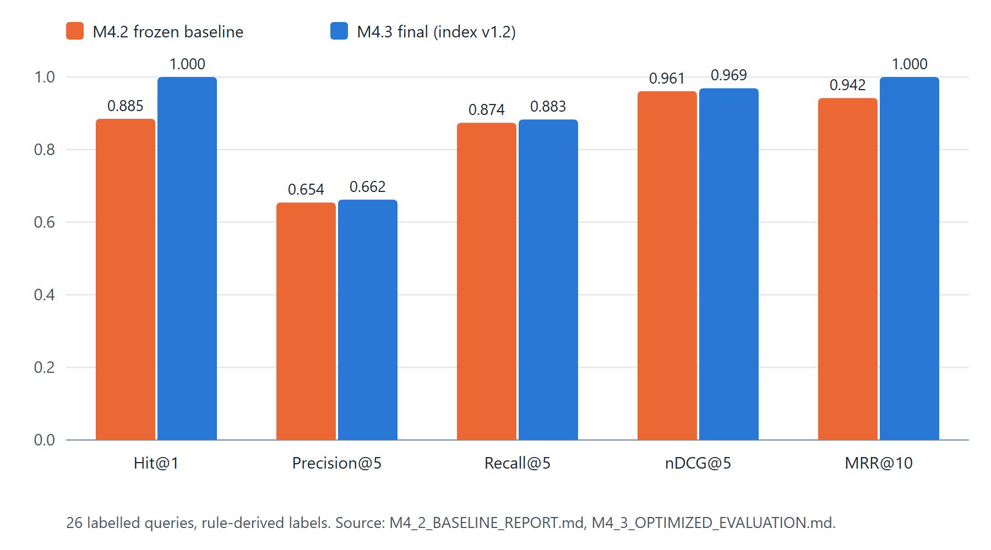
Figure 7.1: Retrieval metrics, M4.2 baseline versus M4.3 final

7.7 Optimisation Experiments and Performance Measurements
Milestone 4.3 tested each change in isolation against the frozen M4.2 baseline and accepted or rejected it on the measured result. Table 7.6 summarises the decisions; the full log is backend/data/evaluation/m4/results/m4_3_experiments.json.
Table 7.6: Summary of M4.3 controlled experiments
ID | Change | Outcome | Decision
E1 | Discovery retrieves the requested area, scores against the resume | Expected-domain hit 0.0 → 1.0 | Accept
E2a | Deterministic intent rules for comparison, learning-priority and discovery wording | Conversation turns 12/16 → 15/16 | Accept
E2b | General-question handling | Not implementable offline without overfitting | Reject / deferred
E3a–E3c | Related-skill credit for required skills; gating; weight changes | Ordering inversions or M2 regressions | Reject
E3e | Related credit for preferred skills only; node.js normalisation fix | C > D now holds; margins still below target | Accept
E4 | Shared education assessment | Matching ↔ skill-gap disagreements 2 → 0 | Accept
E5 | Allow job title and company in validator | Review items 1 → 0; faults 10/10 | Accept
E6 | Query-term coverage flag (variant C) | 11/12 off-topic, 0/26 genuine flagged | Accept as flag only
E7 | Profile-only skills shown as self-reported | Review items 3 → 0 | Accept
E8-V1, V2 | Extra title chunk; prefix on all chunks | Precision/recall or integration regressions | Reject
E8-V3 | Title/type prefix on overview chunk; index v1.2 | Hit@1 1.0, MRR 1.0, nDCG@5 0.969 | Accept
E9 | Load embedding model from local cache first | Cold load 12.1–12.3 s → 7.3 s | Accept
E10 | In-process caches for dataset and index | e.g. search_jobs 46.71 → 9.44 ms | Accept

Table 7.7: Performance before and after M4.3 (medians of repeated warm calls on the single development machine; deterministic pipeline; no LLM)
Stage | Before M4.3 | After M4.3
Dataset load and validation | 17.87 ms | 0.24 ms
Vector-store load | 4.94 ms | 0.14 ms
Query embedding | 7.67 ms | 5.27 ms
FAISS search (960 vectors) | 0.39 ms | 0.09 ms
search_jobs total | 46.71 ms | 9.44 ms
match_jobs_for_resume (top 10) | 78.05 ms | 16.31 ms
Skill-gap analysis | 27.61 ms | 3.07 ms
Customization (deterministic) | 20.04 ms | 4.57 ms
Cold embedding-model load (network allowed) | 12.1–12.3 s | 7.3 s

These timings come from M4_3_OPTIMIZATION_REPORT.md. They were measured on one development machine and are not production latency guarantees. The large reductions in dataset, index, search, matching, skill-gap and customization times come from caching (E10), which removes repeated file loading and validation; embedding and FAISS code were unchanged, so their small differences are run-to-run variation. LLM latency and token usage were not measured.

7.8 Grounding and Failure-Handling Evidence
Table 7.8: Grounding, consistency, conversation and discovery results
Measure | M4.2 baseline | M4.3 final
Grounding violations (structured checks) | 0 (921 checks) | 0 (926 checks)
Needs-review items | 4 | 0
Fault injections detected by the evaluator | 9/9 | 10/10
Matching ↔ skill-gap consistency findings | 2 | 0
Service hand-off chain (same resume and job through every service) | all hold | all hold
Conversation turns / full conversations with desired behaviour | 12/16 / 5/7 | 15/16 / 6/7
Job discovery: requested area retrieved | 0/3 | 3/3
Off-topic queries flagged / genuine queries flagged | 0/12 / 0/26 | 11/12 / 0/26
Matching scenarios A / B / C / D | 54.8 / 52.0 / 21.1 / 21.1 | 56.5 / 52.0 / 26.1 / 21.1

Failure handling of the LLM layer is evidenced by fake-provider unit tests (for example TC-10 and TC-11): timeouts, malformed JSON, unknown evidence IDs, fabricated metrics and leadership claims, and unsupported technologies all fall back to the deterministic result.
Re-run on 2026-10-16. The evaluation was re-run on the current checkout into a scratch directory, leaving the tracked results unchanged. All retrieval, off-topic, matching, consistency, hand-off, conversation and discovery values were identical to Tables 7.5 and 7.8, and grounding violations remained 0. Three values differed from the tracked M4.3 file: 892 instead of 926 grounding checks were run; one needs-review item appeared (the validator removed one generated cover-letter sentence for one pair); and the per-pair validation_passed flags were false. The flags are explained by the stricter rules added in the resume-parsing audit: the evaluation's synthetic candidates carry no parser_version, so the services attach the outdated-parser notice, which by design prevents a "passed" status. The tracked M4.3 values therefore describe the code at the M4.3/M4.4 milestone, and the evaluation fixtures need a parser_version before they fully reflect the current code. This is recorded here as an open item rather than resolved by changing the fixtures.

7.9 Results Summary
Table 7.9: Summary of verified results
Item | Result | Evidence
Backend tests (M4.4 release audit) | 464 passed, 0 failed, 1 xfailed, 2 warnings | Final technical documentation, §21
Backend tests (current checkout) | 555 passed, 0 failed, 1 xfailed, 2 warnings | Re-run, 2026-10-16
Retrieval Hit@1 / @3 / @5 | 1.000 / 1.000 / 1.000 | M4_3_OPTIMIZED_EVALUATION.md
MRR@10 | 1.000 | same
Precision@5 / Recall@5 / nDCG@5 | 0.662 / 0.883 / 0.969 | same
Grounding violations | 0 | same; re-run 2026-10-16
Fault injections detected | 10/10 | same
Conversation turns | 15/16 | same
Discovery probes | 3/3 | same
Dataset | 320 records, 15 domains, 0 duplicates; SHA-1 d9401f90… | validation_report.json; hash re-checked 2026-10-16
Index | IndexFlatIP, 960 vectors, 384 dimensions, version 1.2 | index metadata, re-checked 2026-10-16

7.10 Test Success Versus Real-World Effectiveness
Passing tests show that the implementation behaves as specified on the cases that were written; the evaluation shows how the pipeline performs on a small set of synthetic, rule-labelled fixtures. Neither shows that recommendations are useful to real students, that generated documents improve application outcomes, or that the system generalises to resumes and opportunities unlike those in the fixtures. No user study, A/B test or field trial was conducted.

7.11 Limitations of the Evaluation
- Small, synthetic data. 26 labelled queries, 12 off-topic queries, 5 synthetic candidates (8 pairs) and 16 conversation turns. The labels are rule-derived, not human judgements.
- Catalogue structure. Postings within a domain share identical skill lists, so job-level relevance is distinguished only by title and type; this makes some retrieval metrics easier to saturate.
- General career questions (CV06) still fail in deterministic mode.
- Matching margins. The required-strong versus preferred-strong margin (A − B = 4.5) and the semantic versus unsuitable margin (C − D = 5.0) remain below the target of 10 points.
- Confidence heuristic. One off-topic query ("UI UX design internship with Figma") is not flagged because its words exist in the catalogue, and on a held-out check one genuine query ("Linux system administration trainee") was flagged.
- No live-LLM evaluation. LLM output quality, latency, cost and token usage were not evaluated; a single manual spot check on one synthetic resume is not an evaluation.
- Frontend testing on the canonical baseline was manual (type check, lint, build and a 13-step browser walkthrough).

7.12 Work Beyond the Canonical Baseline
The checkout used to prepare this report is a feature branch (feature/ui-redesign-skill-graph) that is not yet merged into develop. It adds a UI redesign, stronger enforcement of test isolation (8 additional backend tests that prove the test suite cannot open the real database or resume store or reach the network) and a Playwright browser-test suite. Its backend application code is identical to develop. Because this work is outside the finalised baseline, it is not described or evaluated further in this report, and the Playwright suite was not run for it.

Chapter 8: Results and Discussion

8.1 What the System Demonstrates
The implemented system demonstrates that a complete student career workflow — resume parsing, opportunity retrieval, explainable matching, gap analysis, grounded document tailoring, interview preparation, conversational access and application tracking — can be built on a deterministic core that works without any language model. Every number shown to the user is computed by explicit code from persisted data, every generated sentence is checked against evidence, and every user's data is isolated.

8.2 Fulfilment of the Objectives
Table 8.1: Objectives and how they were addressed
Objective | Status | Evidence
1. Structured context without OCR or LLM | Met, with documented parsing limitations | Resume pipeline; parser tests; manual walkthrough
2. Semantic retrieval from a validated knowledge base | Met | Retrieval metrics (Table 7.5)
3. Transparent, deterministic scoring | Met; margins below target | Matching tests; scenarios A–D
4. Traceable generation without unsupported claims | Met on the evaluation fixtures | 0 grounding violations; validator tests
5. Subordinate LLM with fallback | Implemented; live quality not evaluated | Fake-provider tests
6. Per-user ownership | Met | API isolation tests; end-to-end second-user probes
7. Measured improvement and honest reporting | Met | Frozen baseline, experiment log, this chapter

8.3 Interpretation of Retrieval and Performance Results
The retrieval results show that, on the evaluation queries, the first-ranked opportunity was always relevant (Hit@1 = 1.000, MRR@10 = 1.000), and the ranking of relevant and acceptable jobs was close to ideal (nDCG@5 = 0.969). Precision@5 of 0.662 means that, on average, about two-thirds of the top five results are labelled relevant; most of the remainder are labelled acceptable rather than wrong, which the graded nDCG reflects. The improvement from the baseline came mainly from experiment E8-V3, which helped the model distinguish postings by title and type within a domain. Because the catalogue is small and labels are rule-based, these values should be read as evidence that the pipeline is correctly assembled and tuned for its fixtures, not as an estimate of performance on real job markets.
The performance results show that once the dataset and index are cached, deterministic operations complete in milliseconds on the development machine, and that loading the embedding model from the local cache roughly halves cold-start time. These figures support the responsiveness requirement (NFR-08) for a single-user local setting; no load or concurrency testing was performed.

8.4 Practical Benefits and Usability Observations
The M4.4 manual walkthrough (13 steps on a fresh database with a synthetic resume) confirmed that empty states are truthful on a new account, that extracted data drives the dashboard, that off-topic searches show a notice while still listing results, that skill-gap and customization outputs pass the grounding check, that tracker data and reminders persist across reloads, and that the Learning Roadmap page states that the feature is unavailable. These are observations by the developer, not measurements of usability or user satisfaction.

8.5 Trade-offs of the Deterministic-plus-Optional-LLM Design
The deterministic core gives reproducibility, explainability, offline operation, zero API cost and strong protection against fabricated claims, and it makes the system testable with exact assertions. The cost is flexibility: wording is template-based, unusual phrasings may be misrouted by rule-based intent classification, and open-ended career questions cannot be answered in deterministic mode. The optional LLM layer is designed to recover fluency without giving up grounding, but it adds latency, external dependency and cost, and its benefit has not been measured. Retrieval-augmented generation [6] and the risk of unfaithful generation in language models [7] motivate the decision to let the model rewrite only validated content.

8.6 Threats to Validity and Generalisability
- Construct validity. Rule-derived labels approximate relevance; a human judge might rate some "acceptable" jobs as relevant, or the reverse.
- Internal validity. Experiments were evaluated on the same fixtures that revealed the weaknesses, so some tuning to the fixtures is possible despite the use of held-out checks for E6 and E8-V3.
- External validity. The catalogue covers 15 technology domains with synthetic postings; results do not transfer to other fields, to live postings or to resumes with unusual layouts.
- Measurement. Timings come from one machine and are medians of warm calls; they vary with hardware and load.
- Evaluation currency. As noted in Section 7.8, the tracked evaluation predates the parser-version rules added later, and a re-run differs in three grounding-related values.

Chapter 9: Security, Privacy and Reliability

9.1 Password Hashing
Passwords are hashed with PasswordHash.recommended() from pwdlib, which produces Argon2id hashes (stored values begin with $argon2id$) [8]. Plain-text passwords are never stored or logged. Verification uses the same library.

9.2 Session-Token Generation and Storage
A session token is generated with secrets.token_urlsafe(48) (48 random bytes). Only its SHA-256 digest [9] is stored in auth_sessions.token_hash, so a database leak does not reveal usable tokens. Sessions expire after 14 days and are deleted on logout. The token is sent as the ai_career_session cookie [10] with HttpOnly (not readable by scripts), SameSite=Lax and a 14-day Max-Age; the Secure attribute is set automatically whenever APP_ENV is not development and can be overridden with SESSION_COOKIE_SECURE. In local development over plain HTTP the cookie is not Secure.

9.3 Authentication, Authorisation and API Access Control
Every user-data router (profiles, resumes, candidate context, skill gap, customization, interview preparation, assistant and applications) depends on require_current_user. Unauthenticated requests receive 401. Queries are filtered by the current user, and objects belonging to another user return 404, not 403, so their existence is not disclosed. /health and the read-only opportunity catalogue (/api/jobs/*) are public by design. CORS allows the configured FRONTEND_URL exactly, with credentials, and allows any localhost/127.0.0.1 port only when APP_ENV=development.

9.4 User-Data Ownership and Cross-User Isolation
Ownership is enforced in two places: helper functions that load a profile or resume only if it belongs to the caller, and service-level filters on user_id. Linked tracker artifacts must belong to the same user and job. Isolation is covered by API tests in each feature area and by the end-to-end workflow test, in which a second user is denied access to every object created by the first. In the M4.4 manual check, a second user received 404 for the first user's application (GET, PATCH and DELETE), resume, structured resume, profile, candidate context, customizations, skill gap and conversation.

9.5 Input and File Validation
All request bodies and parameters are validated by Pydantic schemas. Uploaded files are checked by extension, size (≤ 10 MiB), emptiness and content signature or structure, stored under generated names outside any served path, and never returned by internal path. Generated text is validated for grounding before it is stored or displayed.

9.6 Error Handling and Fallback Behaviour
Unhandled exceptions are logged and returned as a generic {"detail": "Internal server error"} with CORS headers, so internals are not exposed and the browser can show a readable message. LLM failures always fall back to deterministic results. The client turns 401 responses into a return to the sign-in page and replaces 5xx details with a generic message.

9.7 Data Handling and Privacy Assumptions
Resumes, the database and .env files are stored locally and excluded from version control. No browser storage holds account data. When an LLM provider is configured, grounded excerpts of the candidate's evidence are sent to that provider; the user's operator is responsible for choosing a provider whose data-handling terms are acceptable. The LLM API key is read from the environment only, and startup logs record only whether a key is present. Test data is synthetic, and the test suites are prevented from reading the real database or resume store.

9.8 Remaining Security Limitations
The following are not implemented: OAuth or single sign-on, CSRF tokens (mitigated only by SameSite=Lax), rate limiting and login throttling, account lockout, e-mail verification, password reset, encryption at rest, HTTPS configuration (the project runs over local HTTP), audit logging, and penetration testing. No formal security audit was performed, and no regulatory compliance is claimed. The single-process caches assume one server process.

Chapter 10: Limitations and Future Enhancements

10.1 Current Limitations
1. General career questions (CV06). Free-form questions such as salary negotiation receive a fixed capability message in deterministic mode; the strict xfail remains.
2. Matching margins below target. A − B = 4.5 and C − D = 5.0 against a target of at least 10; variants that widened the margins caused ordering inversions or regressions and were rejected.
3. Heuristic confidence flag. 11/12 off-topic and 0/26 genuine evaluation queries are flagged, but one held-out genuine query was flagged and one off-topic query is missed. It is a notice only.
4. Limited evaluation coverage. Small, synthetic, rule-labelled fixtures; results are not statistically representative.
5. No comprehensive live-LLM evaluation. Quality, latency, cost and token usage of the LLM path were not evaluated.
6. Learning Roadmap not implemented. The page states that roadmap generation is unavailable; legacy roadmap tables exist without an active feature.
7. No database migration framework. Tables are created with create_all, plus one ad-hoc column helper; there is no Alembic.
8. Curated catalogue. 320 project-authored postings in 15 technology domains; no live feeds, application links or deadlines.
9. Rule-based resume parsing. No OCR; unusual layouts may extract imperfectly; experience is one entry per section.
10. Local security scope. See Section 9.8.
11. Single-process design. Caches and SQLite assume one process; the system is not deployed.
12. Evaluation fixtures predate parser versioning. The tracked evaluation results differ from a re-run on current code in three grounding-related values (Section 7.8).

10.2 Future Enhancements
The following items are proposals. None of them is implemented.
- Larger, more diverse and independently evaluated data: a bigger catalogue across more career domains and human-judged retrieval and matching benchmarks.
- Better-calibrated ranking and confidence: revisit matching margins with more scenarios and replace the coverage heuristic with a trained or calibrated out-of-coverage detector.
- Live-LLM evaluation: a fixed, reviewed prompt set measuring grounding violations, quality, latency and token usage, and a resolution of CV06.
- Learning Roadmap: roadmap generation from skill gaps, with progress tracking.
- Deployment hardening: HTTPS with Secure cookies, CSRF protection, rate limiting, password reset, Alembic migrations, structured logging and monitoring, containerisation and continuous integration.
- Data and parsing: real job-feed integration with deadlines and application links, OCR for scanned resumes and per-role experience extraction.
- Accessibility, usability and broader user testing, including a study with real students under appropriate consent.
- Evaluation maintenance: add parser_version to the synthetic evaluation candidates and regenerate the tracked results.

Chapter 11: Conclusion
Students entering the job market need to know which opportunities fit them, what they are missing, and how to present their real experience — and general-purpose generators can answer these questions fluently but without grounding. This project set out to build a system that answers them from the student's own evidence.
AI Career Companion implements that system as a React and FastAPI web application with a deterministic core. A resume is parsed into a structured candidate context; sentence embeddings and an exact FAISS index retrieve related opportunities from a curated 320-record catalogue; a weighted, explainable scorer ranks them; a requirement-level skill-gap analysis, grounded resume and cover-letter customization, interview preparation, a conversational assistant and an application tracker build on the same context; and an optional LLM can only rewrite validated content, with a deterministic fallback.
The key engineering contributions are the separation of semantic selection from deterministic reasoning, a sentence-level grounding validator, a shared reliability rule for parsed evidence, strict per-user ownership, and an evaluation methodology based on a frozen baseline and controlled, individually measured experiments, with rejected experiments recorded alongside accepted ones. On its evaluation fixtures the final system reached Hit@1 and MRR@10 of 1.000, nDCG@5 of 0.969, zero grounding violations, 10/10 detected fault injections, 15/16 correct conversation turns and 3/3 discovery probes, and the backend test suite passed with only the known CV06 expected failure.
The practical significance is a demonstration that useful, explainable career assistance can be delivered without depending on a language model, and that generation can be made safe by validating it against evidence. The evidence is, however, limited to small synthetic fixtures. Realistic next steps are a larger human-judged benchmark, a live-LLM evaluation, better-calibrated ranking and confidence, an implemented learning roadmap, migrations and deployment hardening, and a properly designed study with real users.

References
[1] N. Reimers and I. Gurevych, "Sentence-BERT: Sentence embeddings using Siamese BERT-networks," in Proc. 2019 Conf. Empirical Methods in Natural Language Processing and 9th Int. Joint Conf. Natural Language Processing (EMNLP-IJCNLP), Hong Kong, China, 2019, pp. 3982–3992, doi: 10.18653/v1/D19-1410.
[2] J. Johnson, M. Douze, and H. Jégou, "Billion-scale similarity search with GPUs," IEEE Trans. Big Data, vol. 7, no. 3, pp. 535–547, Jul. 2021.
[3] W. Wang, F. Wei, L. Dong, H. Bao, N. Yang, and M. Zhou, "MiniLM: Deep self-attention distillation for task-agnostic compression of pre-trained transformers," in Advances in Neural Information Processing Systems 33 (NeurIPS 2020), 2020.
[4] K. Järvelin and J. Kekäläinen, "Cumulated gain-based evaluation of IR techniques," ACM Trans. Inf. Syst., vol. 20, no. 4, pp. 422–446, Oct. 2002, doi: 10.1145/582415.582418.
[5] C. D. Manning, P. Raghavan, and H. Schütze, Introduction to Information Retrieval. Cambridge, U.K.: Cambridge Univ. Press, 2008.
[6] P. Lewis et al., "Retrieval-augmented generation for knowledge-intensive NLP tasks," in Advances in Neural Information Processing Systems 33 (NeurIPS 2020), 2020, pp. 9459–9474.
[7] Z. Ji et al., "Survey of hallucination in natural language generation," arXiv:2202.03629, 2022.
[8] A. Biryukov, D. Dinu, D. Khovratovich, and S. Josefsson, "Argon2 memory-hard function for password hashing and proof-of-work applications," IETF, RFC 9106, Sep. 2021.
[9] National Institute of Standards and Technology, "Secure Hash Standard (SHS)," FIPS PUB 180-4, Aug. 2015.
[10] A. Barth, "HTTP state management mechanism," IETF, RFC 6265, Apr. 2011.
[11] FastAPI documentation. [Online]. Available: https://fastapi.tiangolo.com/
[12] SQLAlchemy 2.0 documentation. [Online]. Available: https://docs.sqlalchemy.org/
[13] React documentation. [Online]. Available: https://react.dev/
[14] Sentence-Transformers documentation. [Online]. Available: https://www.sbert.net/
[15] "sentence-transformers/all-MiniLM-L6-v2," model card, Hugging Face. [Online]. Available: https://huggingface.co/sentence-transformers/all-MiniLM-L6-v2
[16] FAISS library repository and documentation. [Online]. Available: https://github.com/facebookresearch/faiss
[17] Pydantic documentation. [Online]. Available: https://docs.pydantic.dev/
[18] pypdf documentation. [Online]. Available: https://pypdf.readthedocs.io/
[19] python-docx documentation. [Online]. Available: https://python-docx.readthedocs.io/
[20] J. Jarald, "AI Career Companion — Final Technical Documentation (Milestone 4.4)," project document docs/FINAL_TECHNICAL_DOCUMENTATION.md, AI Career Companion repository, Oct. 2026.

Appendix A: API Endpoint Summary
All paths are relative to the API base URL. "Session" means a valid session cookie is required; another user's resources return 404. The schema is served at /openapi.json and interactive documentation at /docs.
Table A.1: API operations (47)
Group | Operations | Access
Health | GET /health | Public
Auth | POST /api/auth/register, POST /api/auth/login, GET /api/auth/me, POST /api/auth/logout | Public / session
Profile | POST /api/profiles, GET /api/profiles/{profile_id}, PATCH /api/profiles/{profile_id} | Session
Resume | POST/GET /api/profiles/{profile_id}/resumes, GET /api/resumes/{resume_id}, POST …/extract-text, GET …/extraction, POST …/detect-sections, GET …/sections, POST …/structure, GET …/structured | Session
Candidate context | POST/GET /api/profiles/{profile_id}/candidate-context?resume_id= | Session
Jobs | GET /api/jobs/search?q=&top_k= (1–20), GET /api/jobs/{job_id} | Public, read-only
Matching | GET /api/resumes/{resume_id}/job-matches?top_k= | Session
Skill gap | POST /api/resumes/{resume_id}/skill-gap, GET …/skill-gap/{job_id} | Session
Customization | POST/GET …/application-customizations, GET/PATCH …/{customization_id}, POST …/{customization_id}/regenerate, GET …/{customization_id}/export?format=pdf|docx | Session
Interview prep | POST/GET …/interview-preparations, GET …/{prep_id}, POST …/{prep_id}/regenerate, POST …/{prep_id}/mock-answer | Session
Assistant | POST/GET /api/career-assistant/conversations, GET/DELETE …/{conversation_id}, POST …/{conversation_id}/messages | Session
Applications | POST/GET /api/applications, GET /api/applications/summary, GET /api/applications/reminders?days= (1–60), GET/PATCH/DELETE /api/applications/{application_id} | Session

Appendix B: Dataset Provenance and Evaluation Fixtures
Table B.1: Opportunity dataset
Property | Value
File | backend/data/internships/career_opportunities_320.json (CSV mirror and JSON Schema alongside)
Origin | Curated, project-authored synthetic records for academic development and evaluation; company names are not real employers; not live vacancies
History | 180 internship records (Milestone 2.1), expanded with 140 records in the career-opportunity generalisation
Records / domains | 320 / 15, with 21–22 records per domain
Domains | Cloud Computing, Cybersecurity, Data Analytics, Data Science, Database / SQL, DevOps, Frontend Development, Full Stack Development, Generative AI / NLP, Java Backend, Machine Learning, Mobile Development, Python Backend, Software Development, Software Testing / QA
Opportunity types | Internship 170, Entry Level 80, Graduate Role 45, Trainee 15, Apprenticeship 10
Validation | 0 missing required values, 0 duplicate IDs, 0 duplicate content (PASS)
Integrity | SHA-1 d9401f9085e7edd9ee9dd8725f344e38ef07aa30 (re-checked 2026-10-16)

Table B.2: Evaluation fixture sizes (backend/data/evaluation/m4/cases)
Section | Size
Positive retrieval queries | 26 (136 relevant + 612 acceptable job labels, rule-derived)
Negative / off-topic queries | 12 (unrelated, nonsense, out-of-coverage)
Synthetic candidates / candidate–job pairs | 5 / 8
Matching scenarios | 4 (required-strong, preferred-strong, semantic-not-exact, unsuitable)
Conversations / turns | 7 / 16
Job-discovery probes | 3

Appendix C: Selected Configuration and Reproduction Commands
The following commands reproduce the verification steps on Windows PowerShell from the repository root. They do not modify tracked evaluation results when --output-dir points to a scratch folder.
cd backend
..\.venv\Scripts\python.exe -m pytest -q
..\.venv\Scripts\python.exe scripts\validate_job_dataset.py
..\.venv\Scripts\python.exe scripts\run_m4_evaluation.py `
--output-dir $env:TEMP\m4_eval
cd ..
npx tsc -b
npm run lint
npm run build
Running the application requires the FAISS index, which is not committed and is built once with scripts\build_job_vector_index.py; the backend is started with ..\.venv\Scripts\python.exe -m uvicorn app.main:app --reload from backend, and the frontend with npm run dev.

Appendix D: Glossary
Table D.1: Glossary
Term | Meaning in this report
Candidate context | The combined career profile and structured resume used as input by all services
Chunk | One of three text segments (overview, requirements, responsibilities) of an opportunity, embedded separately
Deterministic fallback | The rule-based result returned when no LLM is configured or the LLM output fails validation
Evidence ID | An identifier attached to a piece of candidate evidence and cited by generated content
Grounding | The property that every generated claim is supported by the candidate's evidence or the job record
Match score | Weighted 0–100 score of fit between a candidate and an opportunity
Readiness | Separate weighted 0–100 score from the skill-gap analysis
Self-reported skill | A skill listed only in the profile and not demonstrated in the resume
Strict xfail | A test marked as an expected failure that fails the suite if it unexpectedly passes
unsupported_area | Query-confidence label for a search whose words are mostly absent from the catalogue

