Devops Case Study1

1) Master Server:

Java and jenkins are installed

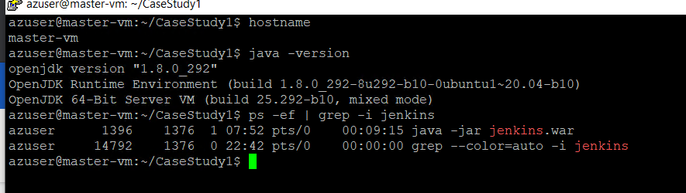

2) Slave Server

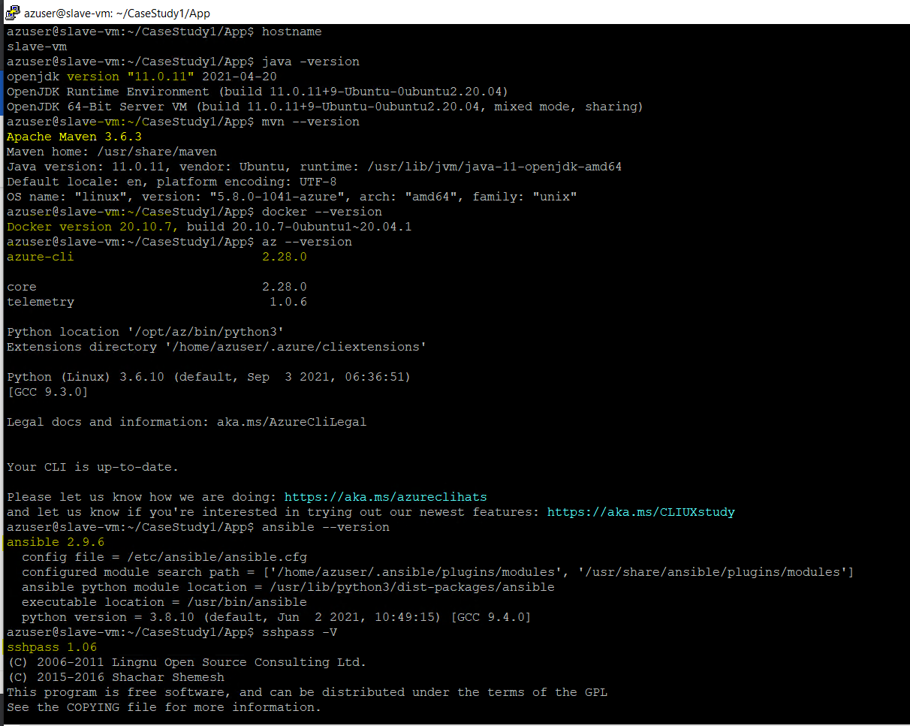

3) Jenkins Master Slave configuration

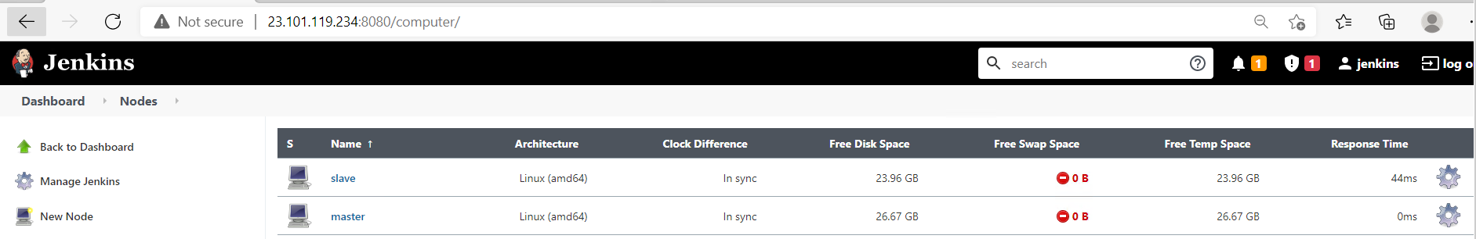

4) Ansible playbook creation and pushing to git repository using VS code.

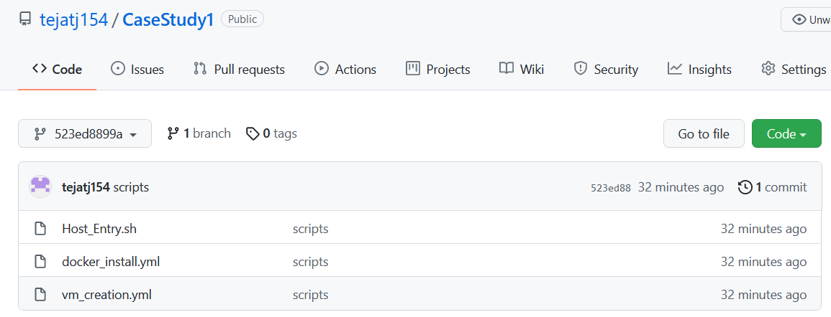

5) Maven Webpage code creation and pushing to git repository using eclipse.

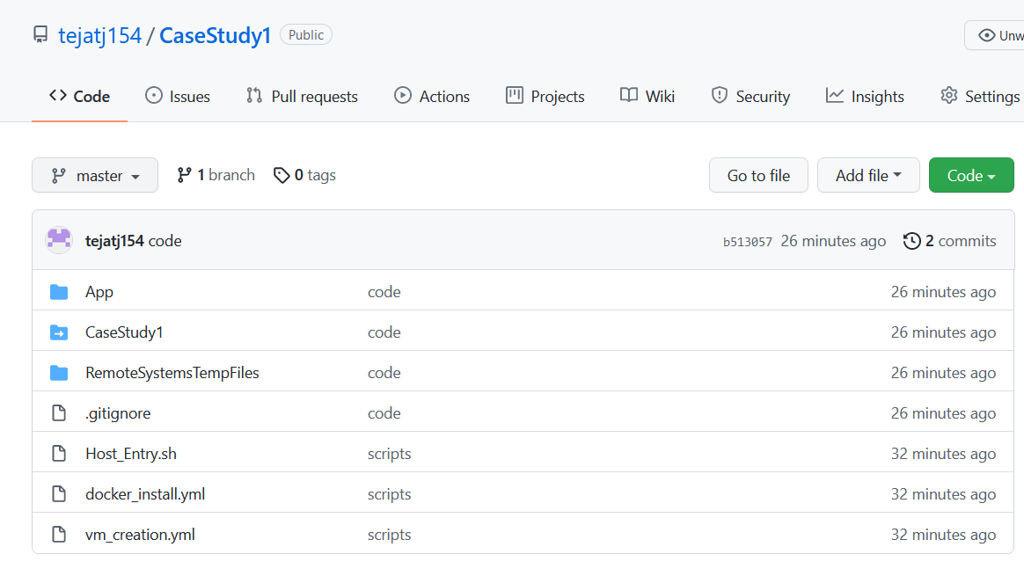

Jenkins Pipeline.

I have done the project in two different ways.

1) First Approach:

Single pipeline which involves configuring the GIT repository, application packaging, docker build and push to docker hub, Creation of VM and installing docker using ansible and deploying the container with application image on the new vm.

2) It consist of 2 pipelines

**Pipeline 1** will be running on slave node which involves configuring the GIt repository, maven build, docker image build and push to docker hub, Creation of VM and installing docker using ansible.

**Pipeline 2** will execute docker commands to kill, remove the earlier running container, removing the old images and running the container with new updated docker image.

**First Approach:**

Jenkins pipeline:

1) Configuring the pipeline to execute on slave node in custom workspace.

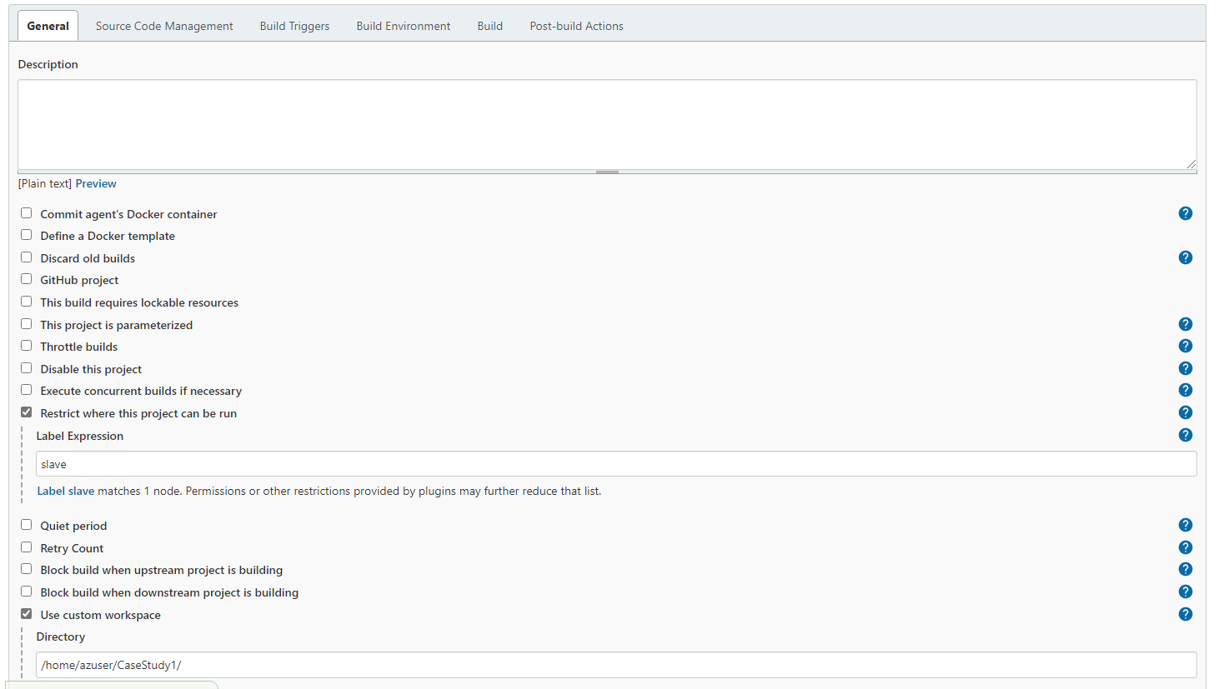

2) Configuring the git repository as source code management.

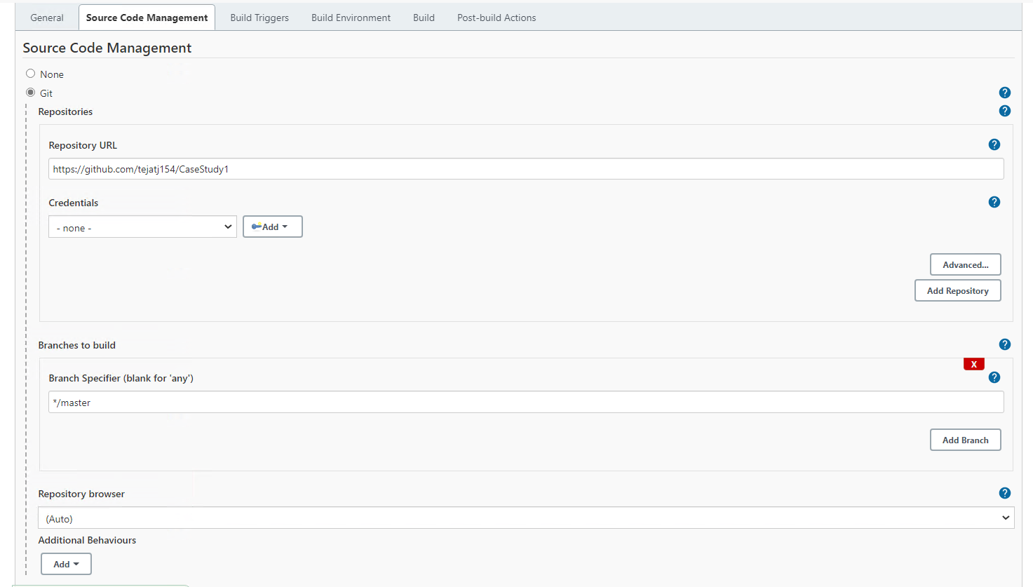

3) Configuring the build trigger with webhook.

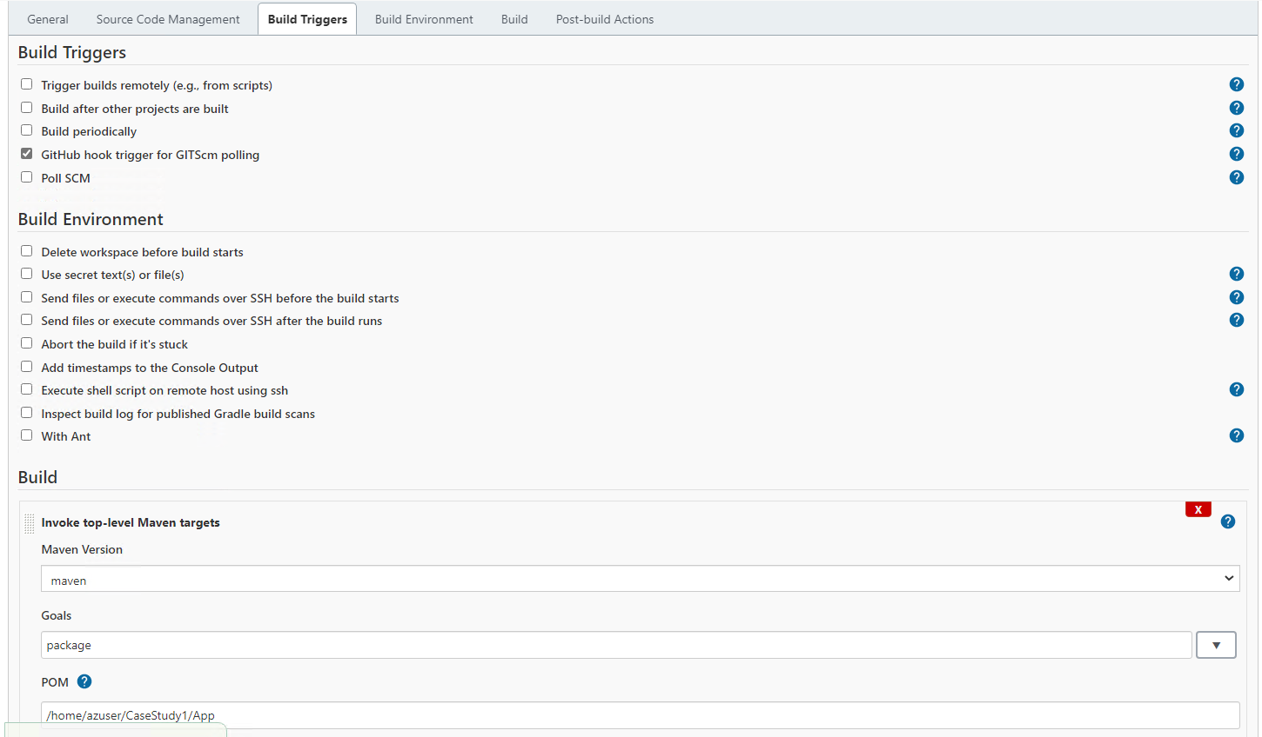

4) Docker image build and push to dockerhub

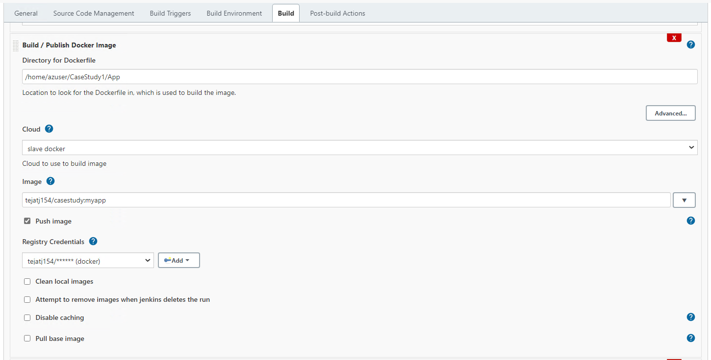

5) For running ansible playbook to create vm

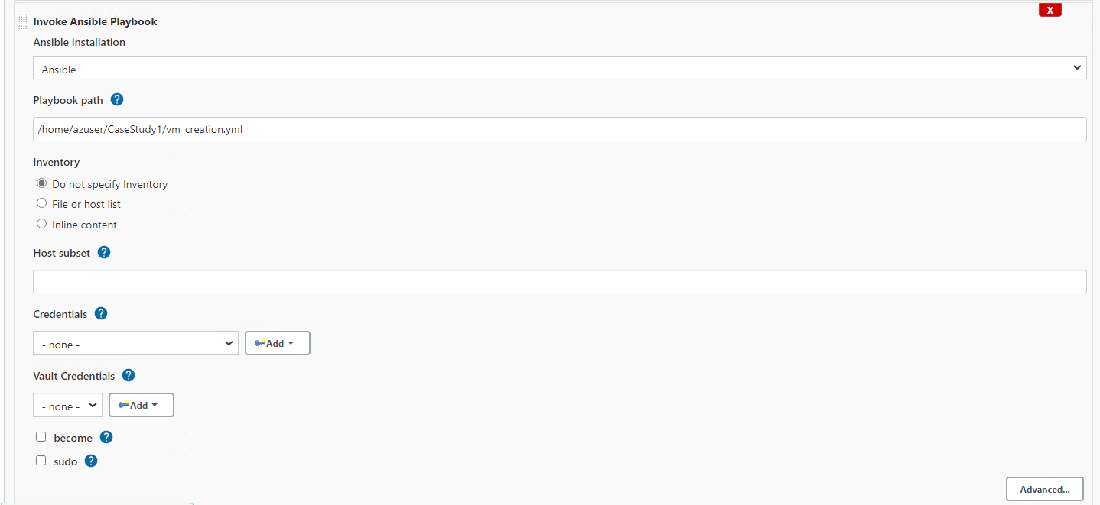

6) for executing shell script which will grep and add the new VM IP in hosts file.

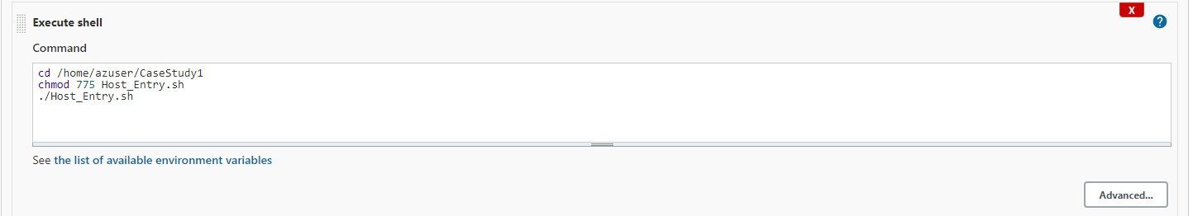

7) For running ansible playbook to install docker.

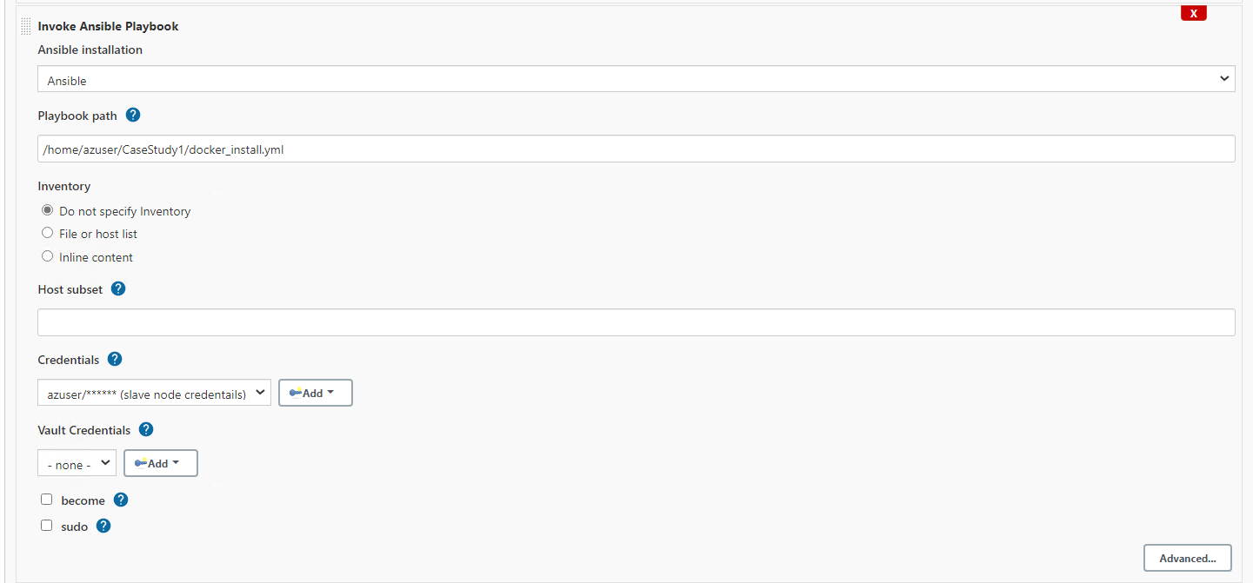

8) for executing the shell script on remote host using ssh and running docker commands to remove old containers and images and run a container with newly updated image.

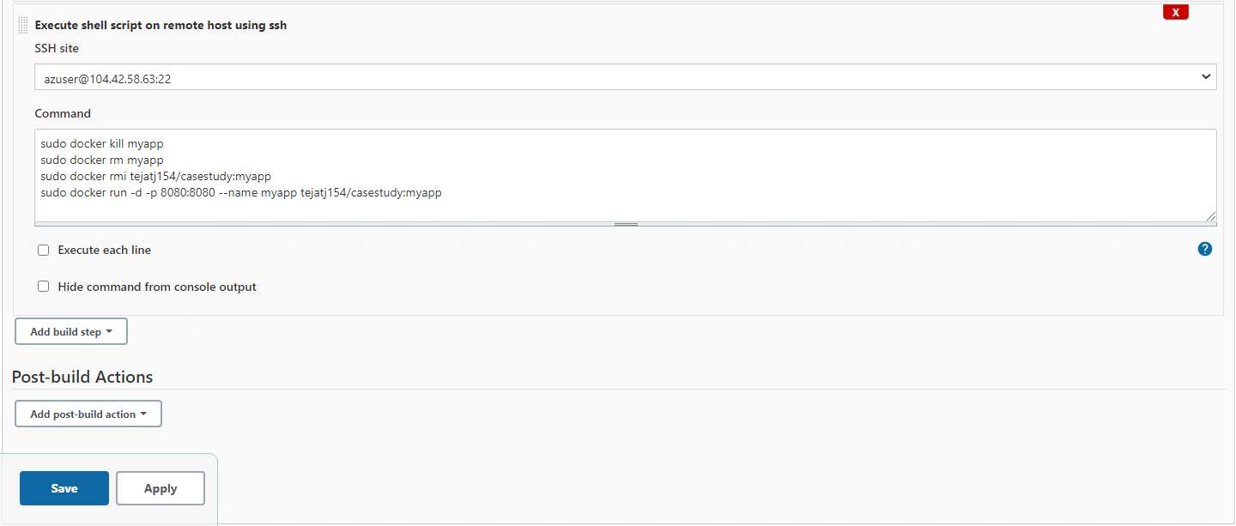

Second Approach:

Pipeline 1:

1) Configuring the pipeline to execute on slave node in custom workspace

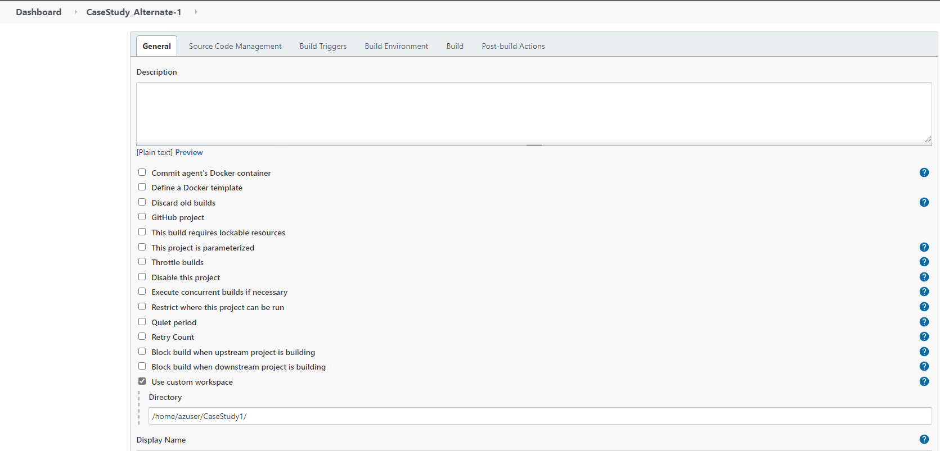

2) Configuring the git repository as source code management.

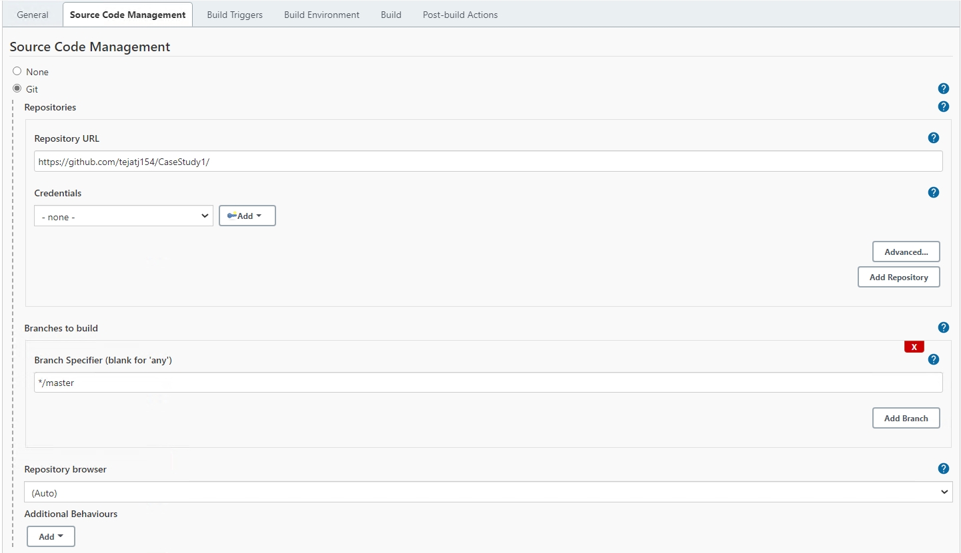

3) Configuring the build trigger with webhook and maven build.

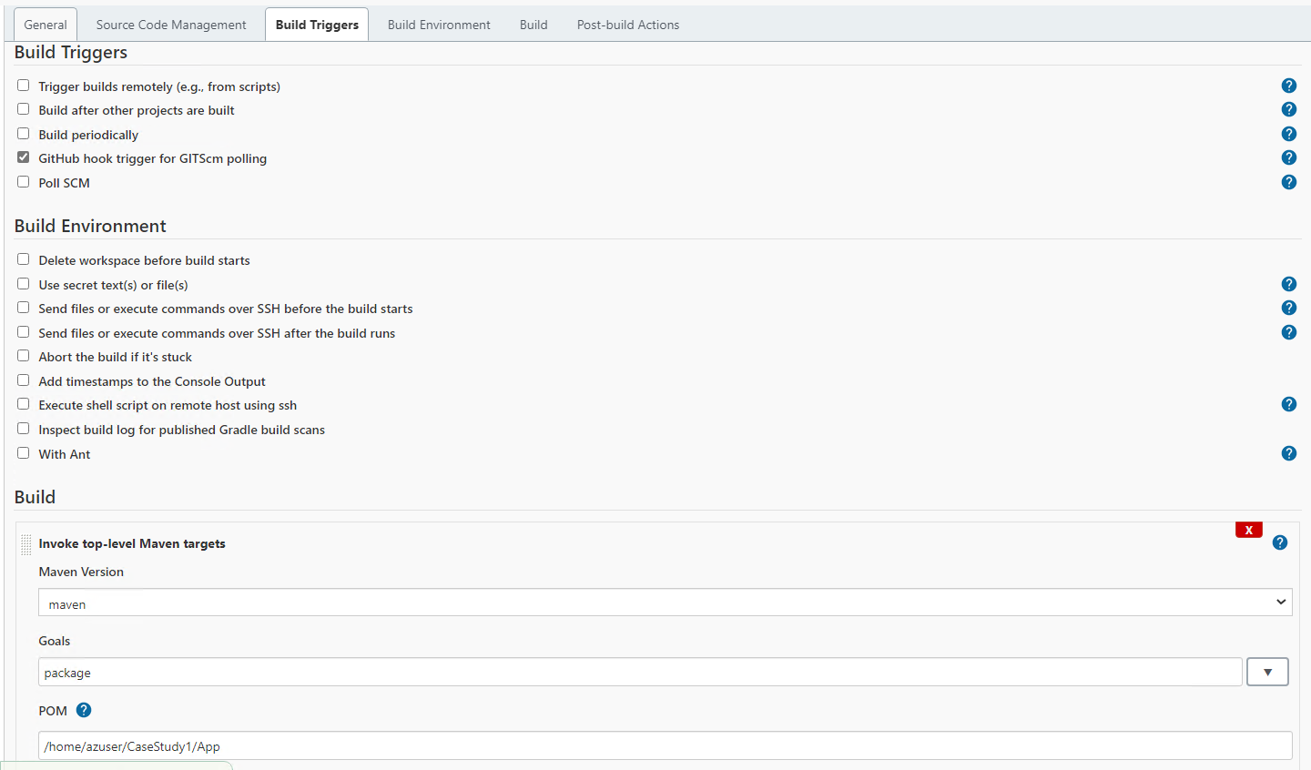

4) Docker image build and push to dockerhub

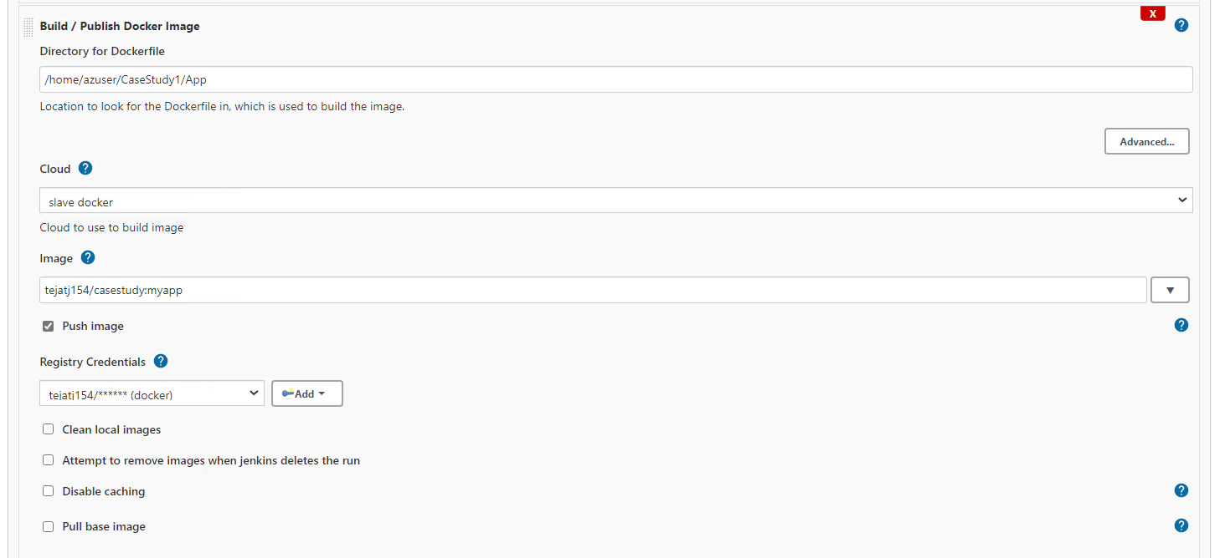

5) For running ansible playbook to create vm

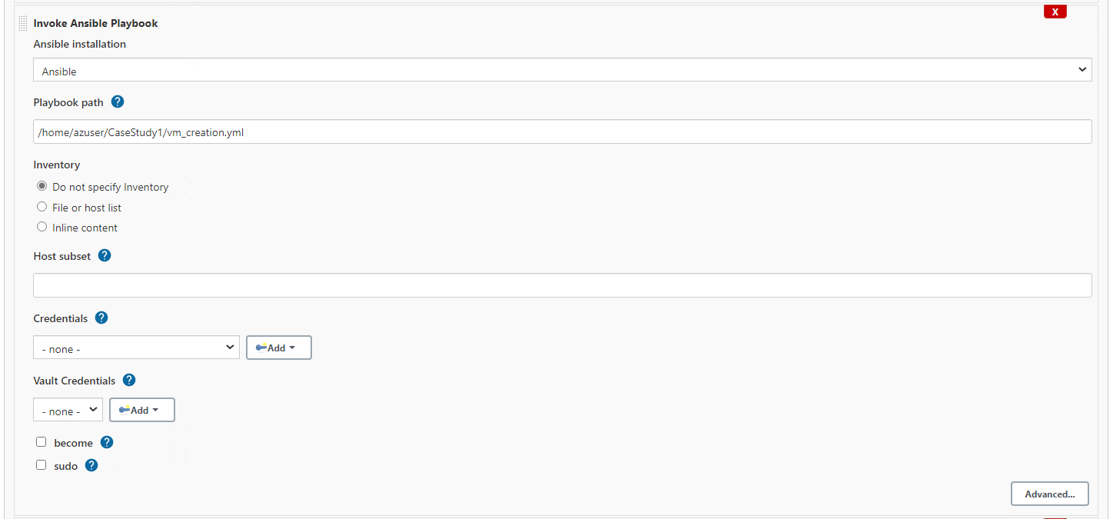

6) for executing shell script which will grep and add the new VM IP in hosts file.

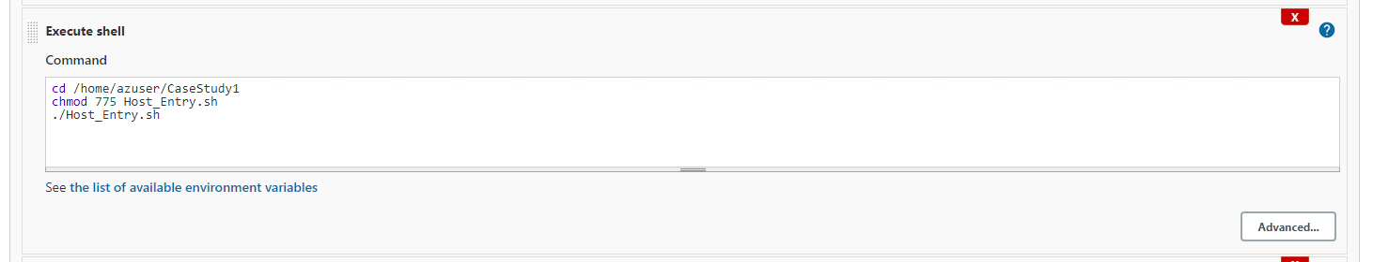

7) For running ansible playbook to install docker.

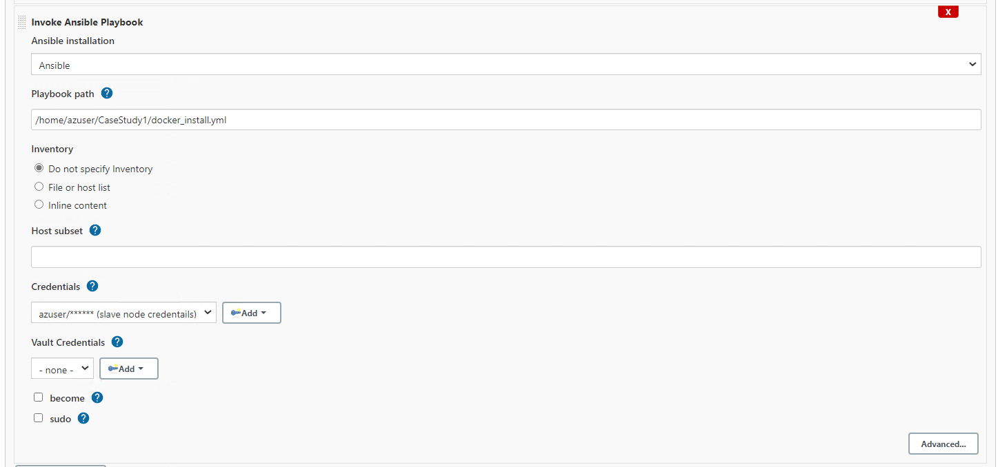

Pipeline 2:

1) Create a freestyle pipeline and restrict it run on docker vm

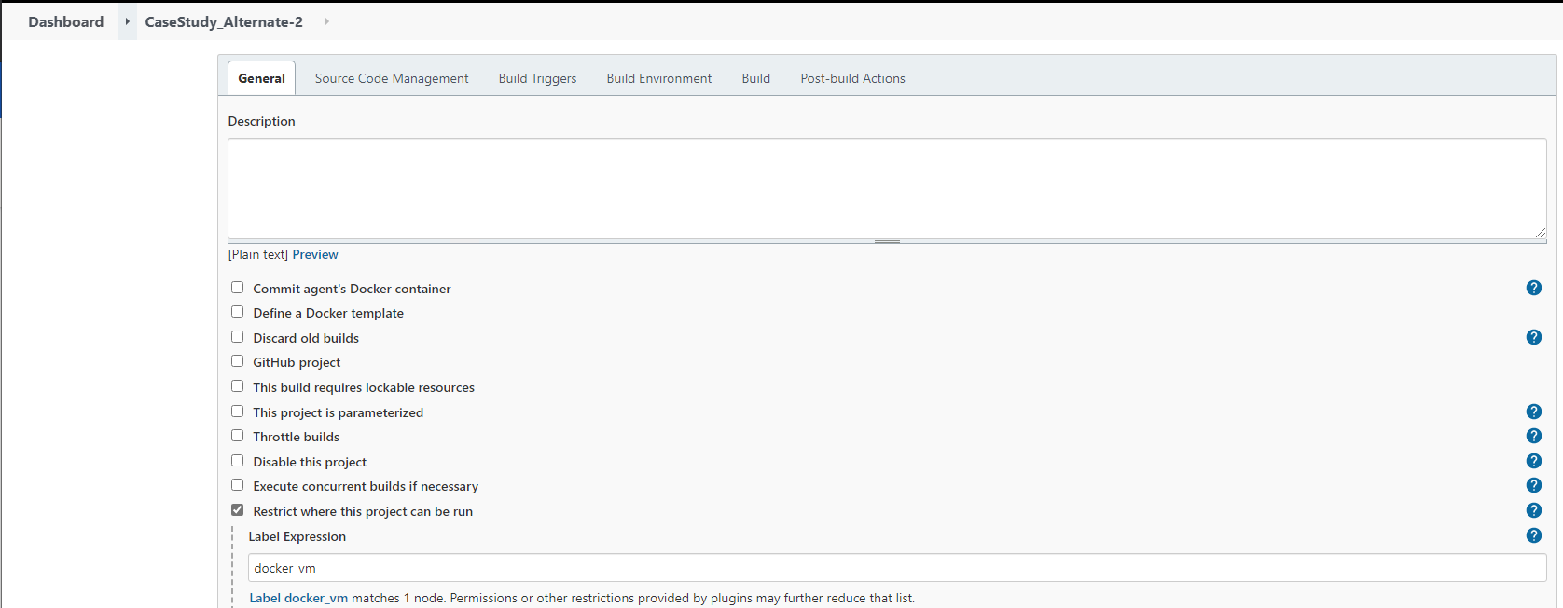

2) select build trigger to execute this pipeline after pipeline 1 is build stable.

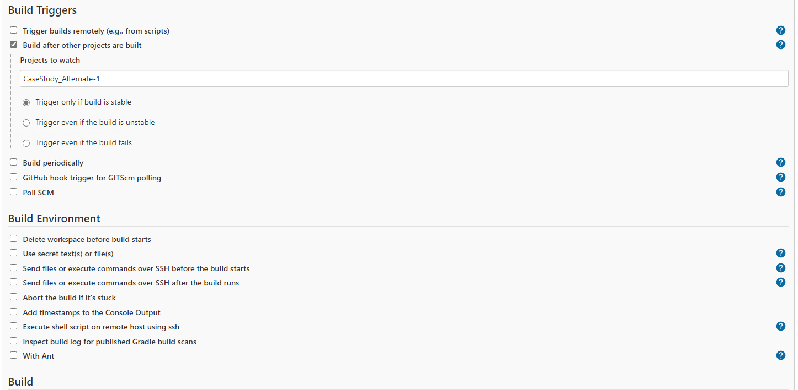

3) Execute a docker command to stop and remove the running container

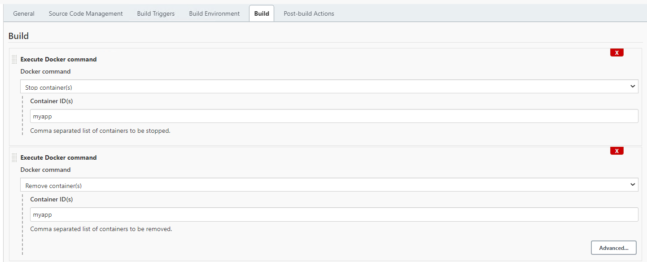

4) Execute a docker command to remove the old image and start a container with newly updtaed image.

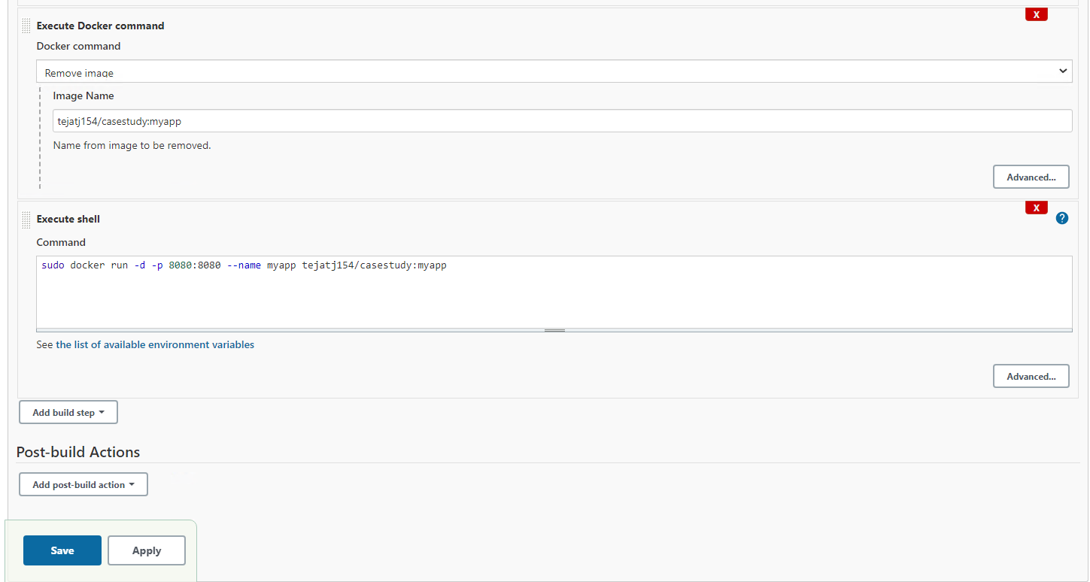

Pipeline testing:

Initial Webpage

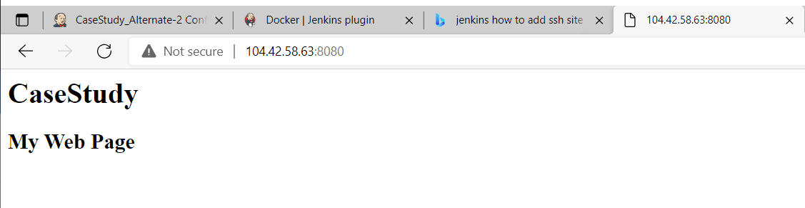

Modify the code in eclipse and push to git hub.

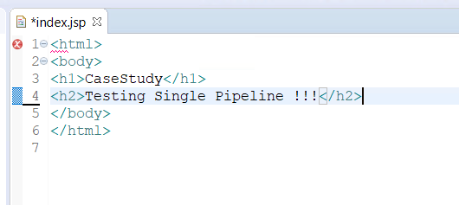

Changes in the webpage

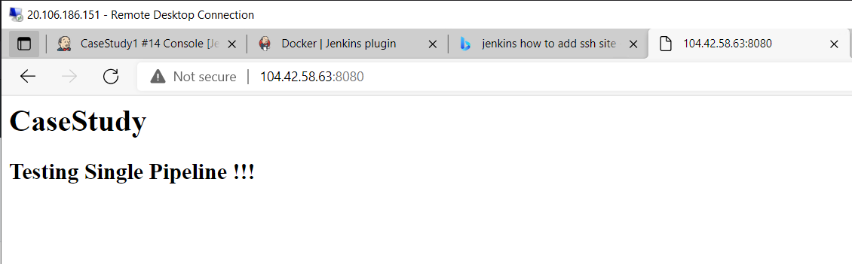

Testing Second Approach:

Modifying the code in eclipse

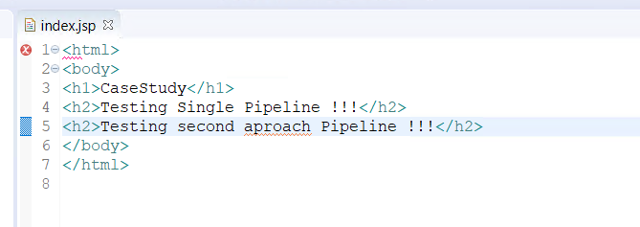

Changes in the webpage.

