**:::MongoDB:::**

It is a data management tool. It is a NoSQL database. It can deal with big data. This provides good performance and reduces complexity.

**Setup & Installation:**

Download MongoDB(compass) from official site. Choose MSI installer to install.

We need to download the required installer package as well for using the compass.

Compass is IDE for MongoDB which was designed to handle big data.

MongoDB provides with good performance and reduces lot of complexity.

In MongoDB we don’t need create a database explicitly, the compass creates that for us.

To use MongoDB we need to setup path first. We need to use command promt for this

For setting up path we need to local folder where MongoDB is installed and choose path till bin folder and use cmd command to open command promt.

We can use these following commands to connect to mongoDB server.





After successfully connecting to server we can either manage(CRUD) our documents through command promt or Compass tool.

We can directly create and use the database by using **use database_name** to create and use database. Implicitly a new db is created for use.



We also can create multiple documents to add data

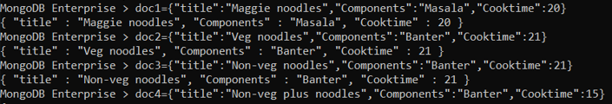

Here we need to add above data into a collection in Mongodb.

Collections are similar to tables like in MySQL.

We deal with documents in MongoDB not with tables.

To insert a document into a database: Syntax is 

Here recipes is collection

Here we can add a single doc or multiple docs at a time. After inserting al docs we can access info by using find() method.

The above mentioned method is used to add or insert new documents into collection in a database

To insert multiple docs at a time. We need to pass array of docs to the method().

Syntax: **db.recipes.insert(Allrecipes);**

Find is a method here, where we use it to access data.

The syntax is **db.recipes.find();** this returns all the records of the documents.

**db.recipes.find().count(); :** To know the count of records we use this

Inside this find method we can also pass fields to return something based on some conditions.



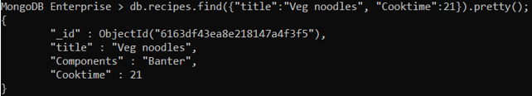

Here we can see al the document content is displayed but if you want restrict any data the we can use

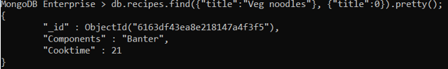

Title : 0 , So title is not included in the result

To display only a particular fields data, we can use

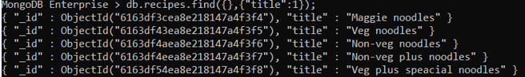

For matching words to better access or visibility we use %like operator in MongDB





To see what all databases present we can use **show dbs;**

This returns all present databases.

To see what all collections present we can use **show collections;**

This is returns all present collections in the database.

To know in which database you are present you can use **show.getName();**

To add a new collection we use

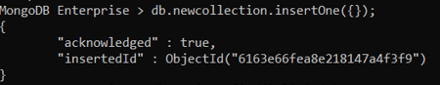

**Upsert:**

**Upsert means update or insert. It mainly has 2 methods db.collection.update() and db.collection.save().**

Both these serve the same purpose. Here either updating or inserting is done

We have various functions like limit, sort and skip

1)

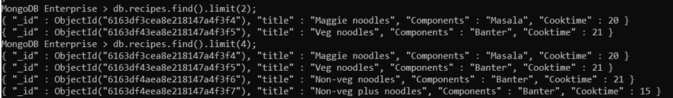

2) & 3)

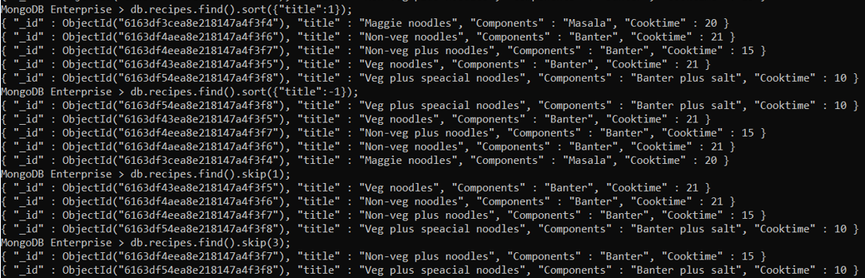

We also have less than or greater than or less than equal to or greater than or equal to:  
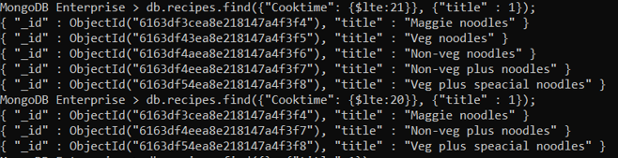

Let’s see how to update a record:

Updating means you can change a small data in the document

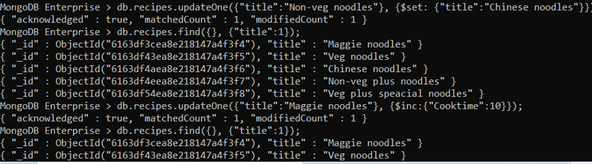

We also deleteOne record or whole records of a doc

For that we have to use

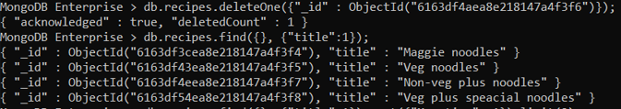

To find which dish takes long time to prepare. We can use

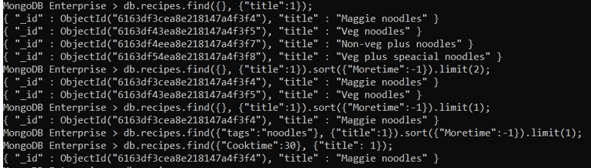

To know what all methods are possible on a collection we can use the command **db.recipes**

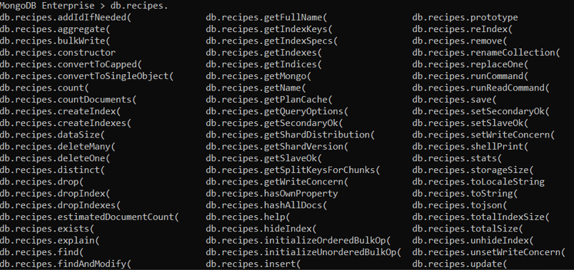

**Indexing is one of the important feature where we don’t need to search all record of we have properly indexed a particular which u need.**

**Aggregate functions(Match & Group)**

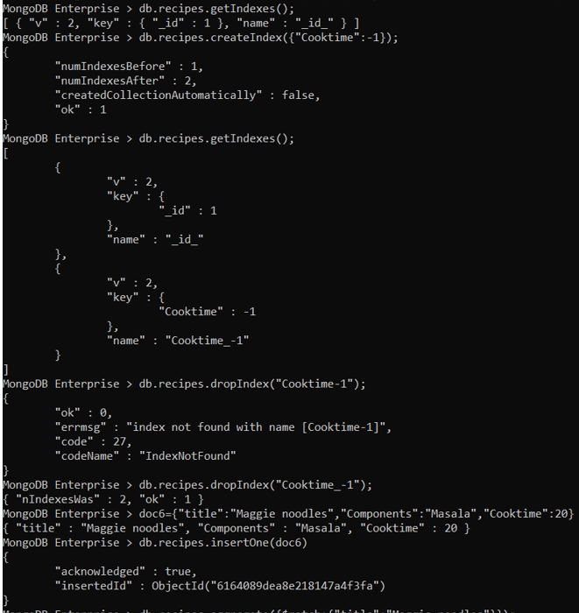

**Pipeline:**

It is a series of process. Where the next stage starts after previous stage is done.

**Aggregate():**

MongoDB is best for aggregation

These are functions that allow you to manipulate data and return data from a mongoDB query.

Matching includes where clause

This helps us to combine or perform any operations between documents.

**$group & $match:**

Here we have methods like $group(), $match etc. Lets see an example using $match. Where we matched 2 records of same title.

Using match we can filter documents based on a condition.

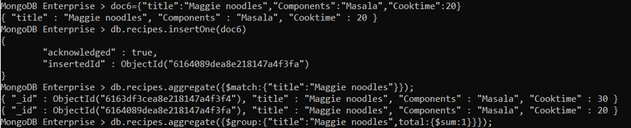

**$group**

Group is for grouping similar type of data based upon a condition. We can performs operations across fileds in the docs. We have other methods like sum(), min(), max(), Avg()… etc.

_id is must to use in syantax, ISODate() is a helper function that's built into to MongoDB and wraps the native JavaScript Date object. When you use the ISODate() constructor from the Mongo shell, it actually returns a JavaScript Date object. ... The ISODate() constructor is clearly easier to read at-a-glance for developers.

