**SBA_Assesment_1**

**1)**

**package** com.ust.sba;

**public** **class** Example1 {

**public** **static** **void** main(String[] args) {

**int**[] numbers = {1,2,3,4,5,6,7,8,9,10};

**for**(**int** i : numbers) {

System.***out***.println(i);

}

}

}

Output:

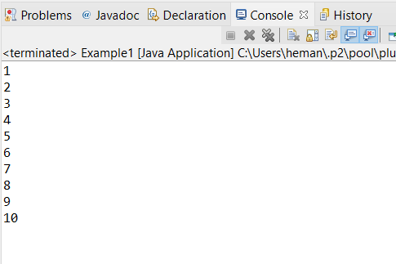

**2)**

**package** com.ust.sba;

**import** java.util.*;

**public** **class** Example2 {

**public** **static** **void** main(String[] args) {

**int**[] numbers = **new** **int**[20];

**int** sum=0;

System.***out***.println("Enter numbers");

Scanner sc = **new** Scanner(System.***in***);

**for**(**int** i=0;i<10;i++) {

numbers[i]=sc.nextInt();

**if**(numbers[i]>0) {

sum=sum+numbers[i];

}

}

System.***out***.println(sum);

sc.close();

}

}

Output:

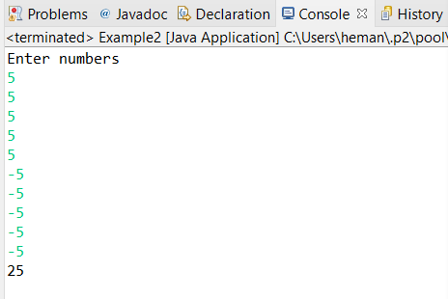

**3)**

**package** com.ust.sba;

**public** **class** Example3 {

**public** **static** **void** main(String[] args) {

**int** count=1;

one:

**for**(**int** i=1;i<5;i++)

{

**for**(**int** j=0;j<1;j++)

{

**if**(i==3)

**break** one;

System.***out***.println(i);

System.***out***.println(j);

}

System.***out***.println("We are outside");

}

}}

Output:

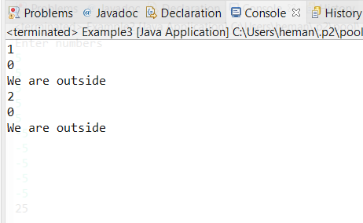

**4)**

**package** com.ust.sba;

**import** java.util.*;

**public** **class** Example4 {

**public** **static** **void** main(String[] args) {

**int** sum = 0;

**int** i =0,num,n;

Scanner sc = **new** Scanner(System.***in***);

System.***out***.println("Enter the limit" );

n = sc.nextInt();

**for**(i=1;i<=(2*n);i++)

{

**if**(i%2 == 0)

sum = sum +i;

**else**

**continue**;

}

System.***out***.println("Total Sum of first " +n+ " even numbers is "+sum);

}

}

**Output:**

