Performance Testing:

[Performance Testing Tutorial: What is, Types, Metrics & Example (guru99.com)](https://www.guru99.com/performance-testing.html)

JMeter helps load test web servers, websites, and web applications by simulating real-user behaviors and testing environments. JMeter provides a user-friendly GUI, easy installation, testing strategies, simulation, and many other performance testing features.

Jmeter is provided by Apache and needs Java to install and run.

Download [Apache JMeter - Download Apache JMeter](http://jmeter.apache.org/download_jmeter.cgi)

A test plan can be visualized as your JMeter script for**running tests**. A test plan consists of test elements such as thread groups, logic controllers, sample-generating controllers, listeners, timers, assertions, and configuration elements. A test plan consists of all steps which execute the script.

The different components of JMeter are called Elements. Each Element is designed for a specific purpose.

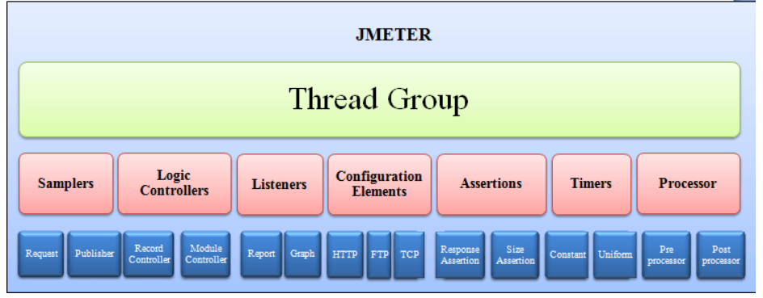

**Thread Group:**

Thread Groups is a collection of Threads. Each thread represents one user using the application under test. Basically, each Thread simulates one real user request to the server.

The controls for a thread group allow you to Set the number of threads for each group.

**Samplers**:

 Thread Groups simulate user request to the server.

But how does a Thread Group know which type of requests (HTTP, FTP etc.) it needs to make?

The answer is Samplers

The user request could be FTP Request, HTTP Request, JDBC Request…Etc.

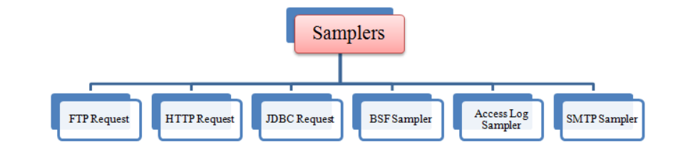

**Listeners:**

Listeners: shows the results of the test execution. They can show results in a different format such as a tree, table, graph or log file.

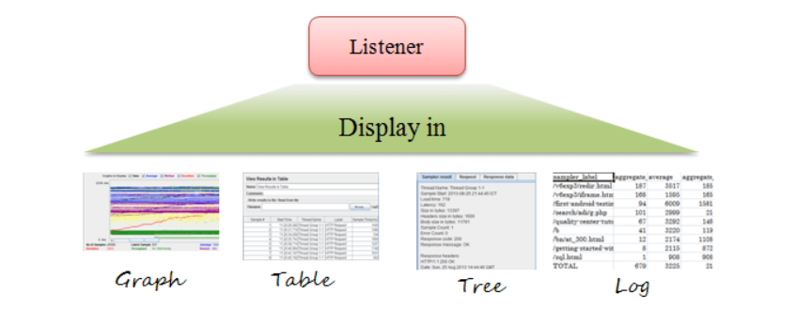

Configurations Elements:

To set up defaults and variables for later use by samplers.

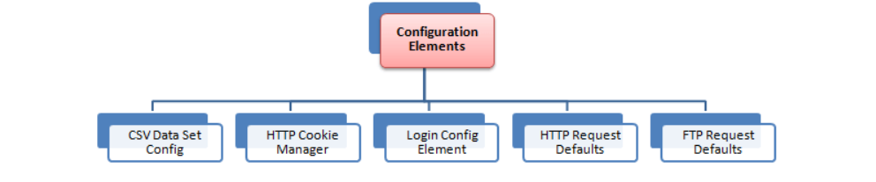

[JMeter GUI: Test Plan & Workbench (guru99.com)](https://www.guru99.com/hands-on-with-jmeter-gui.html)

<https://howtodoinjava.com/java/library/jmeter-beginners-tutorial/>