**Installing nodejs:**

After installing node.js

Open command promt and type the following

To install libraries of nodeJS we need to use npm install npm -global

Use node –v: In terminal(To know the version)

For linking html server

Commands:

1)npm install http-server(npm i http-server –g)

2)npx http-server

Node firstprogram.html(To run file)

**For using selenium, Download Selenium for JAVA 4.0 from the below link.**

Step 1 : download java selenium library

[https://www.selenium.dev/downloads/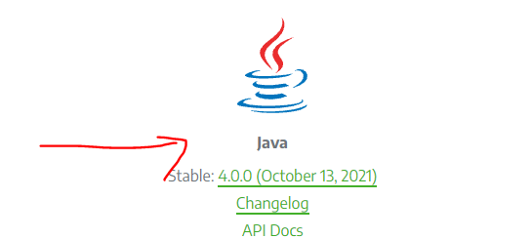](https://www.selenium.dev/downloads/)

**Installing protractor:**

Step 1: Go to command terminal and run code

npm install -g protractor

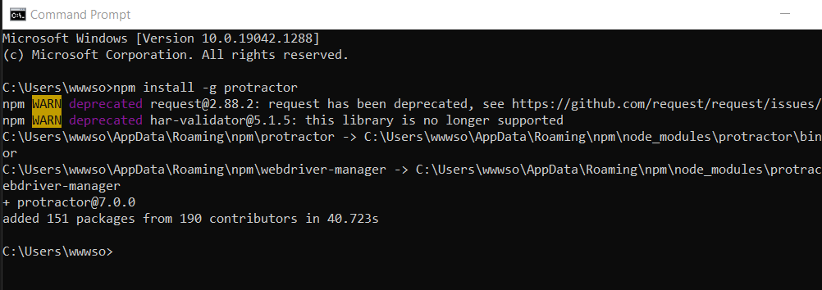

Step 2: Check if it is properly installed using the following command

protractor --version

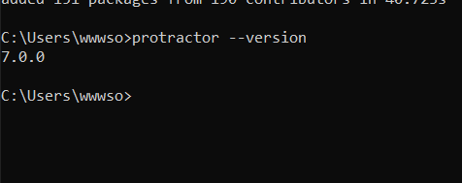

Step 3:

Run command npx webdriver-manager update

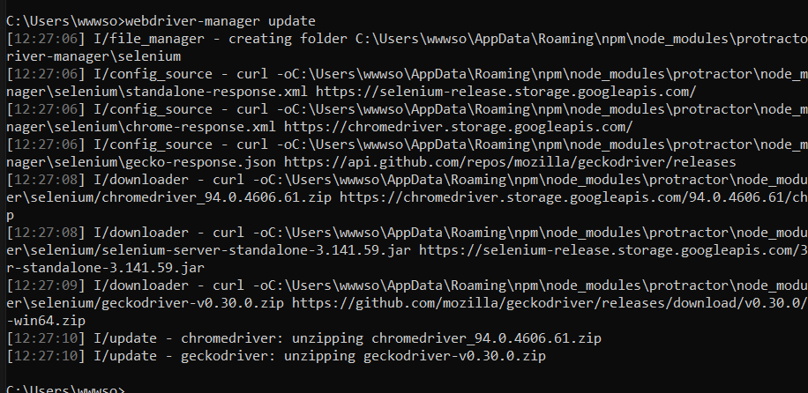

Step 4:run command npx webdriver-manager start

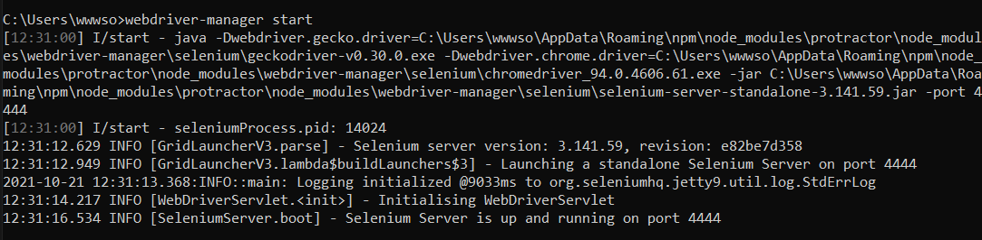

Open VS code

Step1: Create new folder protractor

Step2: Inside it create a folder Specs

Step3: Inside Specs create file spec.js and enter the below given code

describe('Protractor Demo', () => {

    it('Should navigate to Demo Page', () => {

        browser.get('https://material.angularjs.org/latest/getting-started');

        browser.getCurrentUrl().then((url) => {

            expect(url).toBe('https://material.angularjs.org/latest/getting-started');

        });

    });

});

Step 4: Inside protractor create a file confi.js and enter the below given code

exports.config = {

    framework: 'jasmine',

    specs: ['./Specs/spec.js'],

    directConnect: true,

}

In the terminal enter the command npx protractor confi.js

**Cypress commands:**

Open Vscode, create a new folder by name of or your wish.

Open terminal and do the following commands:

1. npm init(Fill necessary details) – This creates new package or project
2. npm install cypress –save-dev (double underscore infront of save)
3. npx cypress open
4. npx cypress run <path of file>

**Jasmine commands:**

Need node js

npm install -g jasmine-node

npx jasmine init

**Karma commands:**

karma installation

npm install -g karma karma-chrome-launcher karma-jasmine

karma init

npx karma start