# Reproducible Research: Peer Assessment 1

library(lattice)

## Loading and cleaning the data

activity_data <- read.csv("activity.csv")  
activity_data$date <- as.Date(activity_data$date,"%Y-%m-%d")

## Mean total number of steps taken per day

total_steps_per_day <- tapply(activity_data$steps, activity_data$date,sum)

## Histogram of total number of steps per day

hist(total_steps_per_day,col="blue",xlab="Total Steps per Day",   
 ylab="Frequency", main="Histogram of Total Steps taken per day")

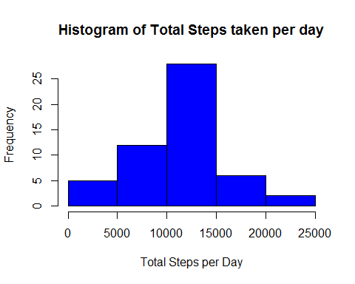 Compute Mean total steps taken per day

mean(total_steps_per_day,na.rm=TRUE)

## [1] 10766.19

Compute Median total steps taken per day

median(total_steps_per_day,na.rm=TRUE)

## [1] 10765

## Average daily activity pattern

Compute mean of steps over all days by time interval

mean_steps_by_interval <- tapply(activity_data$steps,activity_data$interval,  
 mean,na.rm=TRUE)

Timeseries plot of of the 5-minute interval and the average number of steps taken, averaged across all days

plot(row.names(mean_steps_by_interval),mean_steps_by_interval,type="l",  
 xlab="Time Intervals",   
 ylab="Mean number of steps taken (all Days)",   
 main="Average number of Steps Taken at different 5 minute Intervals",  
 col="darkblue")

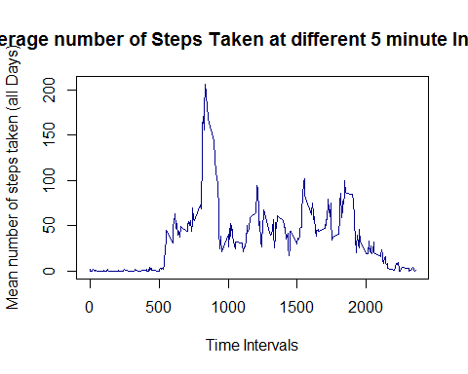 Time interval that contains maximum average number of steps over all days

interval_num <- which.max(mean_steps_by_interval)  
interval_max_steps <- names(interval_num)  
interval_max_steps

## [1] "835"

The r interval_max_steps minute or ** 104th ** 5 minute interval contains the maximum number of steps on average across all the days

## Inputing missing values

Compute the number of NA values in the activity dataset

num_na_values <- sum(is.na(activity_data))  
num_na_values #Print number of NA values

## [1] 2304

Fill in missing values using the **average interval value across all days**

na_indices <- which(is.na(activity_data))  
imputed_values <- mean_steps_by_interval[as.character(activity_data[na_indices,3])]  
names(imputed_values) <- na_indices  
for (i in na_indices) {  
 activity_data$steps[i] = imputed_values[as.character(i)]  
}  
sum(is.na(activity_data)) # The number of NAs after imptation should be 0

## [1] 0

## Finding differences in activity patterns between weekdays and weekends

days <- weekdays(activity_data$date)  
activity_data$day_type <- ifelse(days == "Saturday" | days == "Sunday",   
 "Weekend", "Weekday")  
mean_steps_by_interval <- aggregate(activity_data$steps,  
 by=list(activity_data$interval,  
 activity_data$day_type),mean)  
names(mean_steps_by_interval) <- c("interval","day_type","steps")  
xyplot(steps~interval | day_type, mean_steps_by_interval,type="l",  
 layout=c(1,2),xlab="Interval",ylab = "Number of steps")

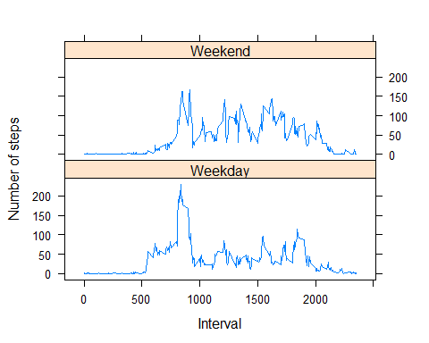 Mean, median, max and min of the steps across all intervals and days by Weekdays/Weekends

tapply(mean_steps_by_interval$steps,mean_steps_by_interval$day_type,  
 function (x) { c(MIN=min(x),MEAN=mean(x),  
 MEDIAN=median(x),MAX=max(x))})

## $Weekday  
## MIN MEAN MEDIAN MAX   
## 0.00000 35.61058 25.80314 230.37820   
##   
## $Weekend  
## MIN MEAN MEDIAN MAX   
## 0.00000 42.36640 32.33962 166.63915